Web Pages in zLinux

Module Objectives:
- Be able to create and run HTML only Web pages in the zLinux environment (Linux, Apache, MySQL, PHP)
- Become proficient using basic PHP in Web pages

Background:PHP.ppt, Request-response model.ppt, Web pages in Linux.ppt, Styles and CSS.ptt, HTML folder, http://www.htmlgoodies.com/, http://php.net/manual/en, http://www.w3schools.com/tags/default.asp, http://www.w3schools.com/css/

HTML Basics
HTML uses tags to define the format of a Web page. For example, tags are used to indicate text that should appear in bold or italic, or as a heading or as part of a paragraph. HTML tags are predefined and have no relationship to the text they are making. Tags consist of a left angle bracket <, a tag name, and a right angle bracket >. Many tags come in pairs; a start tag and an end tag. The end tag uses a slash / to differentiate it from a start tag, and tags may have attributes. For example,

<H1 ALIGN = “CENTER”>This text has been set to heading one format </H1>

H1 is the tag name.
ALIGN is the attribute name.
CENTER is the attribute value.
This text has been set to heading one format is the affected content.
The entire string is an HTML element.

HTML documents are text or ASCII files that you can create using any text editor. An HTML document template would look similar to the following:

<--! This is a comment line in an HTML file -->
<html>
<head>
<title>This appears on the browser title bar</title>
</head>
….other relevant header information goes here…
<body>
… the main part of the Web page goes here …
</body>
</html>

The HTML tag page, <html></html> designates the beginning and the end of the HTML document. The HEAD element provides a section for documentation. The content between the TITLE tags will be displayed on the browser’s title bar. Although optional, the web page usually needs the BODY element. There can only be one BODY element in an HTML document. The next page contains a list of common HTML tags and their usage.

Browsers ignore blank spaces (white space) and line breaks created with a text editor, and the text is also left-justified. You use HTML tags and codes to control text line spacing (<br> for line breaks), horizontal spacing (&nbsp; for a space), a ALIGN =..for aligning to the left, center, or right margin.

Common HTML Tags
Tag | Meaning | Useful Attributes
CHARACTER LEVEL
<i></i> | Italic
<b></b> | Bold
<big></big> | Font size one size larger than the current font
<cite></cite> | Citation from published material (italic)
<code></code> | Programming code
<em></em> | Emphasis, usually bold
<s></s> | Alternate for strikethrough
<small></small> | Font size one size smaller than the current font
BLOCK LEVEL
<a></a> | Anchor tag used for links | HREF, SRC
<blockquote></blockquote> | Indents and encloses a block of text in quotes, requires <BR>
<br> | Line break (carriage return) | ALIGN, FONT
<div></div> | Section or division | ALIGN, FONT
<h1></h1>…<h6></h6> | Six headline font size, H1 being the largest | ALIGN, FONT
<hr> | Horizontal rule | ALIGN, NOSHADE, WIDTH, COLOR, SIZE
<ol></ol> | Ordered list | TYPE, VALUE
<p></p> | Logical paragraph | ALIGN
<pre></pre> | Prevents browser formatting
<strike></strike> | Strikethrough content
<sub> | Subscript
<sup> | Superscript
<ul></ul> | Unordered list | TYPE
TABLES
<table></table> | Table | ALIGN, BGCOLOR, BORDER, CELLSPACING, CELLPADDING, WIDTH
<th></th> | Table head | ALIGN, ROWSPAN, COLSPAN
<tr></tr> | Table row | ALIGN, ROWSPAN, COLSPAN, VALIGN
<td></td> | Table data | ALIGN, ROWSPAN, COLSPAN, VALIGN

Web pages in Linux
In your home directory, issue the ls command.
What existing subdirectory looks like it might be a likely place to store web pages?
That’s right! public_html.Cange directory into public_html (cd public_html)

Simple Web Page
Use the jpico editor to create a file in Linux called HTML1.htm. The content is below.

<html>
<head>
<title>Example Html document</title>
</head>
<body>

<h1>Level-1 Heading</h1>
<p>The elements of an HTML document and the resulting Web page are the same as those found in any written document. For example, a paragraph like this one is a common design element.
</p>

<h2>Level-2 Heading</h2>
<p>There are ordered lists: </p>
<ol>
<li>This </li>
<li>That </li>
<li>Another thing </li>
</ol>

<h3>Level-3 Heading</h3>
<p>There are unordered (bulleted) lists: </p>
<ul>
<li>This </li>
<li>That </li>
<li>Another thing </li>
</ul>

</body>
</html>

To view the results running Apache on the System z, use Internet Explorer and type:
http://130.184.27.19:1080/~USERID/HTML1.htm
Note: USERID is your userid!
Note: This assume HTML1.htm is in the public_html folder
Note: Your Websites will be graded using Internet Explorer
To view the code in Internet Explorer, click on View; Source

Results:
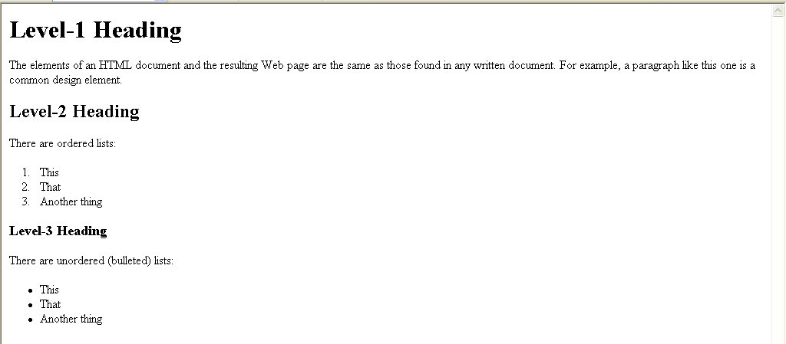

Transferring files to the mainframe
To transfer files to the mainframe, begin by clicking on the New File Transfer Window icon.

You will see the following screen. On this screen, highlight on the left, the files you want to transfer to your Linux account. Click and drag the files to your public_html subdirectory or a subdirectory of public_html under your home subdirectory on Linux.

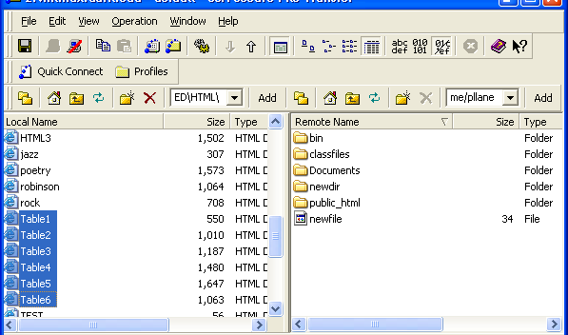

HTML2
This example:
- Changes the color of the text
- Centers data in a heading
- Includes a line under the title
- Centers data in a paragraph
- Forces text to the next line
- Includes a smaller line at the end of the document

View the source code at http://elinux.uark.edu/~USERID/HTML2.htm
Can you find all the pieces of code that perform the above formatting?

Results:
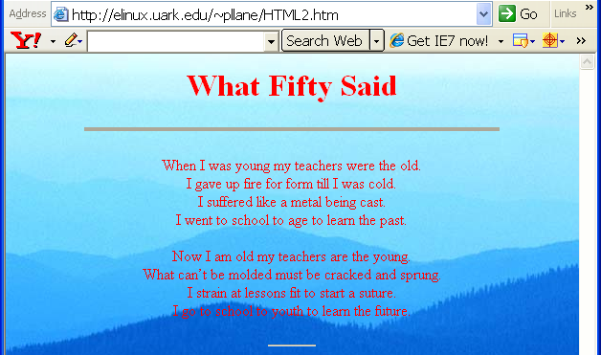
- Changes the color of the text
<body background="Blue hills.jpg" text="red">

- Centers data in a heading
<h1 align="CENTER">What Fifty Said</H1>

- Includes a line under the title
<hr align="CENTER" size="4" noshade width="75%">

- Centers data in a paragraph
- Forces text to the next line with <br>
<p align="CENTER">When I was young my teachers were the old.<br>
I gave up fire for form till I was cold.<br>
I suffered like a metal being cast.<br>
I went to school to age to learn the past.<br>
</p>
- Includes a smaller line at the end of the document
<hr align="CENTER" size="2" width="50">
HTML3
This example includes intra-page links (links to other parts of the current web page)
<a href="#MB">Margaret E. Bruner</a><br>

The portion that is underlined is what displays on the web page.
Notice the MB corresponds with the heading for that section:

<h2><A name="MB"> Margaret E. Bruner</a></h2>

There is also some color formatting included in this example:

<body bgcolor="#FFF33F">
<!-- Background color = gold -->

Frost
Similar to the HTML2.htm, this page includes two links:
- Returns the view to poetry selections(HTML3.htm)
- Allows a viewer to send an e-mail.

The code includes the command to be followed as well as the prompt that appears on the web page. The text in bold below is what appears on the screen.
Look near the end of the source listing after the code for the short line:

<hr align="CENTER" noshade size="2" width="50">

<p align="CENTER">
<a href="HTML3.htm">Poetry Selections</A><BR>
Please send your favorite poem and author to me at
<a href="mailto:ddouglas@walton.uark.edu">ddouglas@walton.uark.edu</a>
</p>

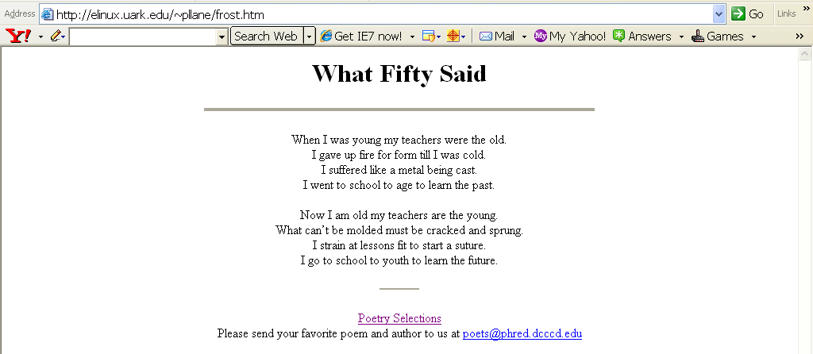
TASK: Include a link in HTML3.htm to return to frost.htm
Be sure to refresh your web page in Internet Explorer so that you can see the change.
Table1
Tables use these basic HTML tags: TABLE, TH (header), TR(row), TD(data).
They are in bold below.

<html>
<head>
<title>Tabular Data-Internet Explorer</title>
</head>
<body>
<! -- table example -->
<table border=1 align=center width = 60%>
<! -- row one spans three columns and is bold, centered (TH)-->
<tr><th colspan=3> 76 - 84mm Socket Pricing</th></tr>
<tr><th>Stock Number</th><th>Description</th><th>List Price</th></tr>
<tr><td>3476-AB</td><td>76mm Socket</td><td>45.00</td></tr>
<tr><td>3478-AB</td><td>78mm Socket</td><td>47.50</td></tr>
<tr><td>3480-AB</td><td>80mm Socket</td><td>50.00</td></tr>
</table>
</body>
</html>

Results:
Task: Add a new part of 3482-AB, 82mmSocket, 55.00

Be sure to refresh your web page in Internet Explorer so that you can see the change to the table!!
Table2
Before you look at the source code, think about how you would change the first example to display the following? Notice the list prices are right aligned and the discount column has been added. The DIV tag is used for the first time.

<html>
<head>
<title>Tabular Data-Internet Explorer</title>
</head>
<body>
<! -- table example -->
<! -- can use Align=Center inside table tags instead of Division tag -->
<div align=center>
<table border=5 cellpadding=5 cellspacing=1 width = 70%>
<! -- row one spans four columns and is bold, centered (TH)-->
<tr><th colspan=4 height=50> 76 - 84mm Socket Pricing</th></tr>
<tr><th width=30%>Stock Number</th><th width=25%>Description</th><th width=20%>List Price</th><th>Discount</th></tr>
<! -- Row 3 contains the row span in the 4th Cell -- >
<tr><td>3476-AB</td><td>76mm Socket</td><td align=right>45.00</td><td rowspan=5>All sockets 20% off list price</td></tr>
<tr><td>3478-AB</td><td>78mm Socket</td><td align=right>47.50</td></tr>
<tr><td>3480-AB</td><td>80mm Socket</td><td align=right>50.00</td></tr>
<tr><td>3482-AB</td><td>82mm Socket</td><td align=right>55.00</td></tr>
<tr><td>3484-AB</td><td>84mm Socket</td><td align=right>60.00</td></tr>
</table>
</div>
</body>
</html>
Table3
This example uses color and fonts.
<html>
<head>
<title>Tabular Data-Internet Explorer</title>
</head>
<body bgcolor="#66CCFF">
<! -- table example -->
<! -- can use ALIGN=CENTER inside table tags instead of Division tag -->
<div align=center>
<table border=5 cellpadding=5 cellspacing=1 width = 70% bgcolor="#FF66FF">
<! -- row one spans three columns and is bold, centered (TH)-->
<tr><th colspan=3 height=60><font size="+1" face="forte" color="gray">76 - 84mm Socket Pricing</font></th>
<td align=center><img src="tips.gif" width=50 height=50 alt="Logo"></td></tr>

Do you see the picture in the upper right corner of your screen? Why not??? Can you make it show?

Table4 introduces formatting with style sheets.
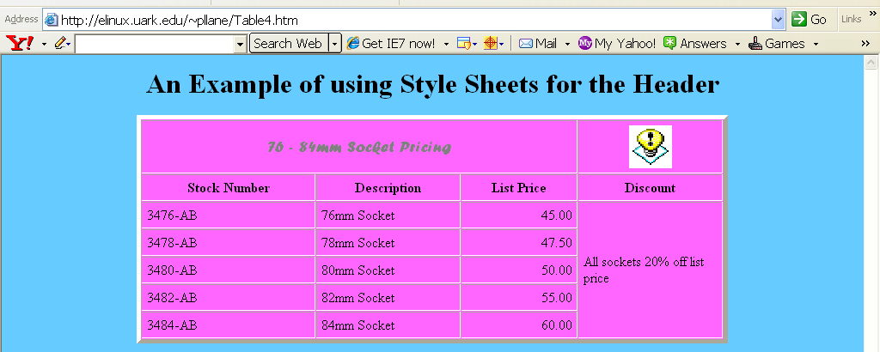
<html>
<head>
<title>Tabular Data-Internet Explorer</title>
<! -- Document level style for headers below -- >
<style>
< !--
h1, h2, h3, h4, h5, h6
{
font-weight: bold;
font-family: sans-serif;
}
h1
{
font-size: 30;
text-align: center;
}
-->
</style>

</head>

<h1> An Example of using Style Sheets for the Header </h1>
<body bgcolor="#66CCFF">
<! -- can use ALIGN=CENTER inside table tags instead of Division tag -->
<div align=center>
<table border=5 cellpadding=5 cellspacing=1 width = 70% bgcolor="#FF66FF">
<! -- row one spans three columns and is bold, centered (TH)-->
<tr><th colspan=3 height=60><font size="+1" face="forte" color="gray">76 - 84mm Socket Pricing</font></th>
<td align=center><img src="tips.gif" width=50 height=50 alt="Logo"></td></tr>
<tr><th width=30%>Stock Number</th><th width=25%>Description</th><th width=20%>list price</th><th>discount</th></tr>
<! -- Row 3 contains the row span in the 4th Cell -- >
<tr><td>3476-AB</td><td>76mm Socket</td><td align=right>45.00</td><td rowspan=5>All sockets 20% off list price</td></tr>
<tr><td>3478-AB</td><td>78mm Socket</td><td align=right>47.50</td></tr>
<tr><td>3480-AB</td><td>80mm Socket</td><td align=right>50.00</td></tr>
<tr><td>3482-AB</td><td>82mm Socket</td><td align=right>55.00</td></tr>
<tr><td>3484-AB</td><td>84mm Socket</td><td align=right>60.00</td></tr>
</table>
</div>
</body>
</html>

Table5
This example “floats” the table to the left so that text can be included right of the table. See the TABLE statement in bold below. The text is included in bold on the following page. Note that the header information from the top of the document and some of the TR lines have been deleted from this page, but the lines are in the document.
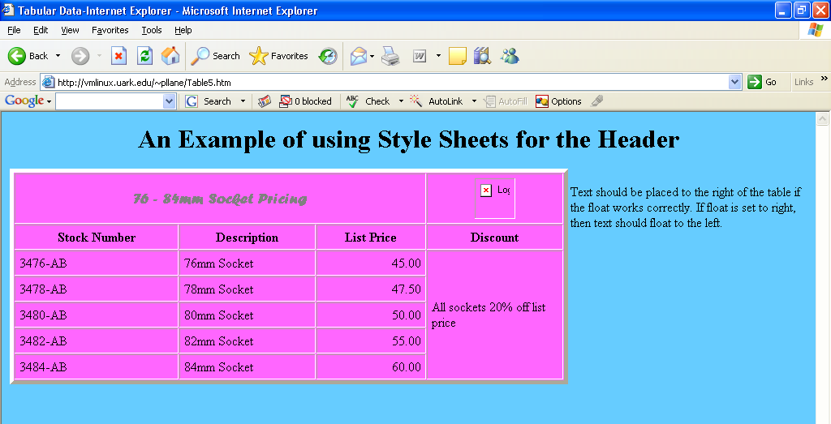
<h1> An Example of using Style Sheets for the Header </h1>
<body bgcolor="#66CCFF">
<! -- table example -->
<! -- can use ALIGN=CENTER inside table tags instead of Division tag -->
<div align=center>
<table border=5 style="float: left" cellpadding=5 cellspacing=1 width = 70% bgcolor="#ff66ff">
<! -- row one spans three columns and is bold, centered (TH)-->
<tr><th colspan=3 height=60><font size="+1" face="forte" color="gray">76 - 84mm Socket Pricing</font></th>
<td align=center><img src="tips.gif" width=50 height=50 alt="Logo"></td></tr>
<tr><th width=30%>Stock Number</th><th width=25%>Description</th><th width=20%>List Price</th><th>Discount</th></tr>
<! -- Row 3 contains the row span in the 4th Cell -- >
<tr><td>3476-AB</td><td>76mm Socket</td><td align=right>45.00</td><td rowspan=5>All sockets 20% off list price</td></tr>
<tr><td>3484-AB</td><td>84mm Socket</td><td align=right>60.00</td></tr>
</table>
</div><br>
Text should be placed to the right of the table if the float works correctly. If float is
set to right, then text should float to the left.
</body>
</html>

Table6
This table displays .jpg files.
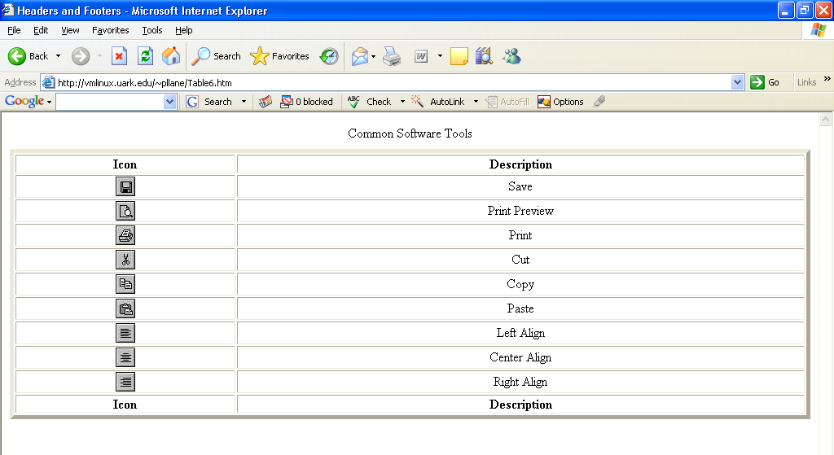
<html>
<head>
<title>Headers and Footers</title>
</head>
<body style="background-color: white">
<table border="5" width="100%">
<caption>Common Software Tools</caption>

<thead>
<tr>
<th>Icon</th><th>Description</th>
</tr>
</thead>

<tfoot>
<tr>
<th>Icon</th><th>Description</th>
</tr>
</tfoot>

<tbody style="text-align: center">
<tr>
<td><img src="save.jpg"></td><td>Save</td>
</tr>
<tr>
<td><img src="preview.jpg"></td><td>Print Preview</td>
</tr>
<tr>
<td><img src="print.jpg"></td><td>Print</td>
</tr>
<tr>
<td><img src="cut.jpg"></td><td>Cut</td>
</tr>
<tr>
<td><img src="copy.jpg"></td><td>Copy</td>
</tr>
<tr>
<td><img src="paste.jpg"></td><td>Paste</td>
</tr>
<tr>
<td><img src="left.jpg"></td><td>Left Align</td>
</tr>
<tr>
<td><img src="center.jpg"></td><td>Center Align</td>
</tr>
<tr>
<td><img src="right.jpg"></td><td>Right Align</td>
</tr>
</tbody>
</table>
</body>
</html>

