SQL Fundamentals – CREATE TABLE
Based on the data model shown here, write the CREATE TABLE commands to build these tables and their relationships. Refer to the first two lessons of the SQL Fundamental series for examples.
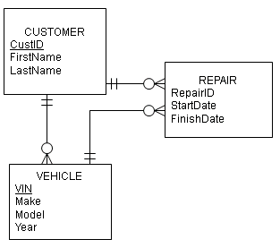
Additional information about columns:
CustID – Integer, primary key, not null
FirstName – variable character, 12 characters, not null
LastName – variable character, 14 characters, not null
VIN – variable character, 10 characters, primary key
Make – variable character, 15 characters
Model – variable character, 20 characters
Year – integer
RepairID – Integer, primary key
StartDate – date
FinishDate – date

Example of inserting the date August 20, 2010 (YYYYMMDD):
INSERT INTO member
(memberID, Fname, Lname,DateJoined)
VALUES ('51341', 'Bill', 'Smith', '20100820');

NOTE: Foreign keys have not been listed but must be included in the SQL commands to create this database.

What to do:
- In one file write the DDL SQL commands to create the tables, their columns and the relationships shown in the data model. Be sure the CREATE TABLES statements are in the correct order.
- In one file write the DML SQL commands to insert two rows of data into each table.
  - Be sure the INSERT INTO statements are in the correct order.
  - All columns must be populated in these INSERT INTO statements.
- The files must be simple text files with a TXT or SQL file extension. Don’t save them as a DOC or DOCX file in MS Word.
- Test these SQL scripts and make sure they are error-free before submitting them. Submit both files.

