**Business Case: Tyson Foods, Inc**

**Topic:**  Tyson Foods Inc Business Case and Metadata

**Scenario** The following Business Case describes the Tyson Foods company and their operations. Metadata for the SAP datasources is also presented.

**Objectives**  This business case has been developed to use with the University of Arkansas SAP Business Intelligence Modules. This case provides background information which will help students understand the data used in the Advanced Analytics, Portal and BI Integration and Building Datasources exercises.

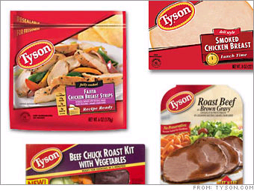

**Background**

Tyson Foods, Inc. [NYSE: TSN], founded in 1935 with headquarters in Springdale, Arkansas, is the world's largest processor and marketer of chicken, beef, and pork, the second-largest food company in the Fortune 500 and a member of the S&P 500. The company produces a wide variety of protein-based and prepared food products, which are marketed under the "Powered by Tyson™" strategy. Tyson is the recognized market leader in the retail and foodservice markets it serves, providing products and service to customers throughout the United States and more than 80 countries. (Tyson Annual Report)

Tyson Foods was founded in the 1935 by John Tyson, who invested his life savings in a truckload of 500 chickens and drove his battered truck north to Chicago to sell them. He made $235 on his first venture and founded Tyson Foods with the proceeds. Over the succeeding 60 years the company has grown to a market leader. The company is also quite vertically integrated, its operations encompassing the entire range of the food process from hatchery to packaging and selling of individual retail proccessed foods.

Tyson operates throughout the United States, and also has a number of International locations. There are more than 300 production facilities and sales offices throughout the United States. Tyson employs over 105,000 people world-wide.

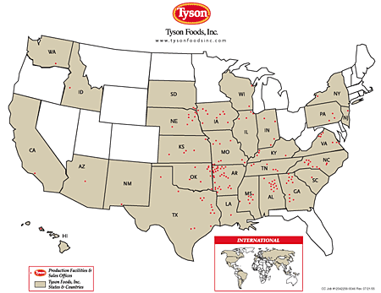

Revenues in recent years have topped $26 billion per years, and reflect a mix of different protien groups and processed foods. Sales of beef and chicken comprise the majority of the company’s sales, but Tyson also sells a variety of processed prepared foods and sauces sold under their own or a number of diffeent customer brand names.

Tyson products are used primarily in two segments: Consumer Products (retail grocery) and Food Service (restuarants, hospitals, etc).

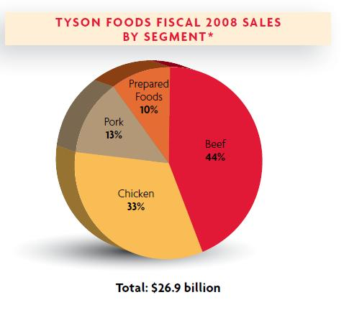

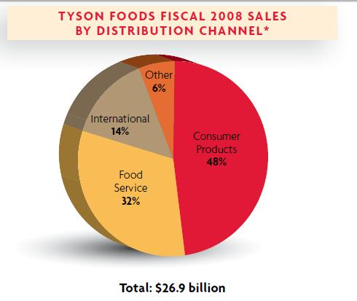

Competitors of Tyson include Cargill, Swift Foods and National Beef, as well as a number of smaller food processors.

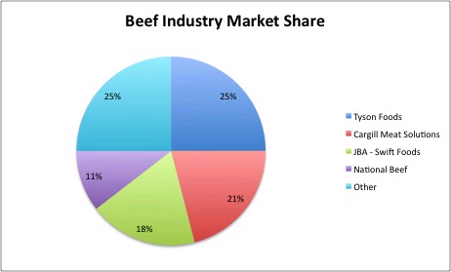

A more detailed document explaining Tyson’s operations and strategies can be found at:

<http://media.corporate-ir.net/media_files/irol/65/65476/FY08_Fact_Book_FINAL.pdf>

**Tyson DataSources**

The University of Arkansas SAP Business Intelligence hub contains serveral InfoSources which have been created from data donated to the University of Arkansas by Tyson Foods. The data covers the period from 2004 to 2005.

**TYSNFFDS**

Tyson Frozen Foods InfoCube is a general purpose cube creates from SAP COPA data. It contains data on company operations, revenues and other operations cost key figures. This InfoSource can be used for accounting or revenue analysis or more specific analysis such as transportation or other logistical costing. It can also be used to create product-line or other product related analysis or to analyze customers, distribution channels or profitability by organizational unit.

The central fact table of the TYSNFFDS cube contains 40 key figures representing details of sales transactions and costs from January 2004 to December 2005.



This cube also contain 6 dimensions: Customer, Product, Distribution, COPA Time, Time, and Organizational. The time and COPA Time dimensions contain the various time characteristics, so the data can be displayed by week, week ended, year, month, quarter, etc. The Distribution Dimension shows us the channels by which the product is taken to market, its salesperson, broker, and sales district. The organizational dimension includes its profit center, pricing segment (which is the set of pricing rules applied to this sale) and its business division. Attribute data is also available for each of these characteristics.

This SAP cube is built using an extended star schema design with many of the characteristics containing master data attributes and texts.

The customer dimension is displayed below.



The customer dimension contains, in addition to the customer number, the sales person associated with the customer and its pricing segment. The customer master data contains the customer name (text), and attributes representing its physical location, sales organization sales group, and business group. Each of these master data items contain texts describing their meaning.

In order to protect confidential information of employees and Tyson partners and customers, several characteristic‘s text or attribute data have been scrubbed: the customer’s actual name the sales persons name, name of the primary and secondary broker, names of brands which are the property of the customer and not Tyson Foods . They have been substituted with a reasonable facsimile. No other data has been changed, however, in some cases reasonable guesses had to be made for some master data items which were longer been maintained.

The product dimension is also created in the star schema format with similar text and attributes maintained.



**EXAMPLE MASTER DATA ATTRIBUTES/TEXTS**

**Brand Code**

Brand name under which the final product is sold at retail

WWPH2 FFDESC6

75 YALLENS

84 KINGS

96 JOHN PAULS

114 GLORY FOODS

115 FRANKS SAUSAGE

121 ABB Extreme Body

157 PICK FRESH

159 Abbelen

171 Aaramark

178 CHI CHIS

**Business Division**

General Segment of the distribution channel.

WWMLG FFDESC11

5 RESTAURANT FRANCHISE

C03 FRZN VALUE ADDED DIV

C04 COMM FRZN VAL ADDED

C05 CASE READY POULTRY

C06 COMM CASE READY POUL

C07 WHOLESALE CLUBS

C08 COMM WHOLESALE CLUBS

C09 MILITARY

**Business Group**

Higher level grouping of the distribution channel

wwbus ffdesc22

20 Food Service

30 Consumer Products

40 Sub-Territory

55 Specialty Products

65 Commodity Sales

70 Retail

**Business Segment**

Product related grouping

WWBRS FFDESC3

0 PORK

1 BEEF

2 BOVINE

3 CHEESE

4 CHICKEN

5 MIXED

6 OTHER

9 SEAFOOD

**Industry Code**

Customer’s Industry category

Ind_code1 Industry_Description

10 Restaurant

20 Retail

30 Food Service

40 Distribution

50 Brokerage and Commodity

60 Bakery

70 Catering

**Part**

The part of the animal from which this product is made

WWPRT FFDESC4

1 LEG QTRS

2 WHOLE LEG

3 DRUM

4 THIGH- BACK IN

5 THIGH-BACK OUT

6 DEBONED THIGH

7 DEBONED LEG

8 FRONT HALF

**Pricing Segment**

How is this product price calculated

WWPRS FFDESC16

0 UNASSIGNED

1 MARKET/SPOT

2 NEGOTIATED/FORWARD

3 PRICE LIST

4 FIXED PRICE

5 COST PLUS

**Sales Organization**

Higest division of the sales channel

VKORG FFDESC25

DFG Employee Sales

TPW Plant Transfers

TYSN Tyson Foods

**Sales Person**

**Note: Names changed to protect personal information

VKBUR FFDESC9

1 JACOB SMITH

100 CHARLES COOPER

101 JUAN RICHARDSON

103 BRAYDEN COX

**Primary/Secondary Broker**

Manufacturers representative responsible for distribution of product

ZZPBK FFDESC12

3 PARKS FOODS

5 DAWSON DISTRIBUTING

6 SANTIAGO SALES

8 NORRIS COMPANY

9 HARDY INC.

10 LOVE & SONS

**Process**

Final process the product is subjected to before shipping

WWPRC FFDESC5

0 MISC

1 ASSEMBLY

2 BAGGED

3 BLAST

4 BUBBLE PACK

5 CVP

6 DEBONED

7 EDIBLE BY PRODUCTS

**Protien Group**

WWPH1 FFDESC2

1 CHICKEN

21 BEEF

31 PORK

61 PREPARED FOOD

91 OTHER

**Selling Group**

Higher level of industry code.

VTWEG FFDEAC8 SIC_Code

11 Food Service Distributor 5499

12 Independent Food Distributor 4222

13 Direct Broker 4222

14 Retail Fresh 4144

15 Bakery Fresh 5145

16 Bakery Other 5145

17 Independent Grocer 5411

18 Club Stores 5411

**Other Tyson DataSources**

In order to facilitate some of the advanced analytic exercises, which can be quite computationally intense, smaller datasources were built to address specific Business problems. These smaller datasources make use of the same characteristics and master data as the general purpose cube described above, so explanations will not be repeated.

**FREEZR**

This DataStore Object is used in the Regression Analysis in the Advanced Analytic module. It contains information about Freezer costs, inside and Tyson freezer costs, as the product moves through the distribution channel. The student uses the data of this source to create an estimate of the freezer costs of the sale, depending on its shipping location, product characteristics, manufacturing process.

**TYSNWHSE**

This DataStore object is a transaction identified InfoSource built as a warehouse instead of in the star schema format. It can be used as an example to compare the difference between a DSO and a InfoCube. Its behavior can be compared to that of TYSNFFDS.

**Note: All Tyson company information contained herein published by Tyson ([www.tyson.com](http://www.tyson.com)) and is used by their kind permission.

**Using SAP’s Business Explorer**

For demonstration purposes, a smaller (less populated) cube with the same specifications as on page 5 was created. The following will illustrate using the BEx Query Designer and Analyzer.

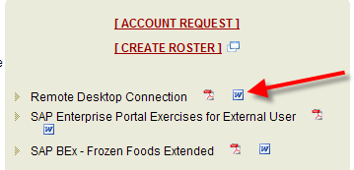Logon to our remote terminal server ts-sap.waltoncollege.uark.edu. See the link below for details.

<http://enterprise.waltoncollege.uark.edu/SAP.asp>

Click Start 🡪 All Programs, click Business Explorer and then click Query Designer. Note that one can get to Query Designer via the Analyzer as well.

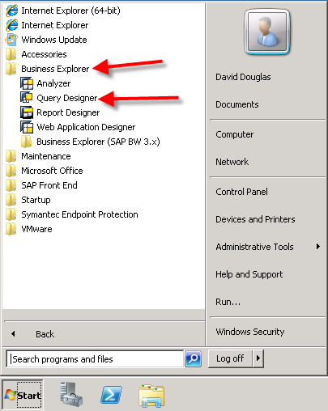

The SAP Logon dialog opens. Ensure you select the BI7 z10 WBI entry and double click it.

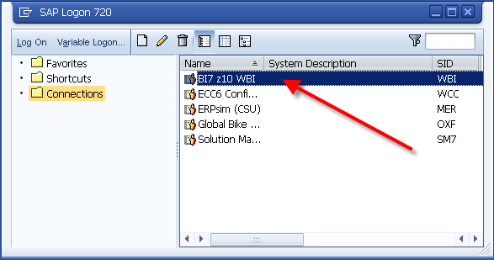

You are then prompted for your logon credentials—enter your credentials and click the OK button

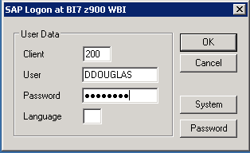

The Query designer opens with no query loaded. Move you mouse as shown to the New Query icon and click to create a new query.

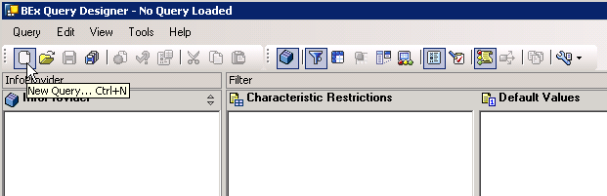

The New Query dialog opens as shown below. Click InfoAreas on the left and then click the Tyson Frozen Foods entry—you may have to scroll down. Click the Open button.

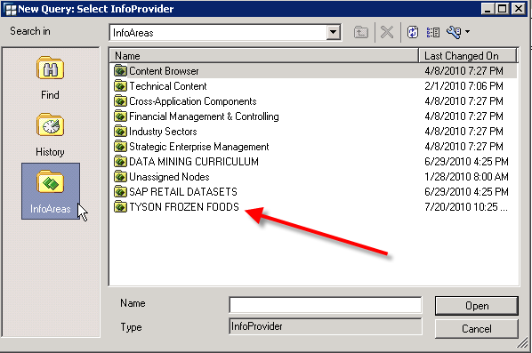

Select the Tyson Demonstration Cube and then click the Open button.

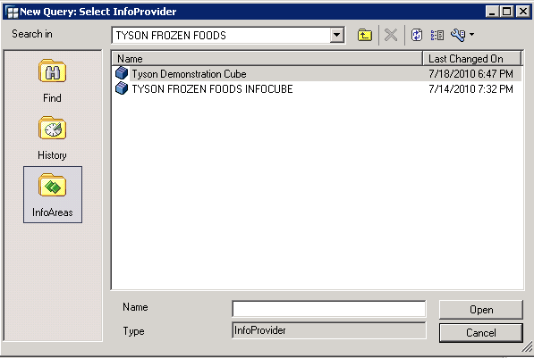

The Query Designer is divided into six sub areas:

1. **Directory tree of the selected InfoCube**

All available objects (key figures and dimensions) of the infocube display in the directory tree in the left screen area of the Query Designer.

1. **Columns**

You define the columns of your report in this area.

1. **Rows**

You define the rows of your report in this area.

1. **Free Characteristics**

You transfer those characteristics into the free characteristics area that do not display in the initial view of the results when you execute the query in the BEx Analyzer or on the Web. You can then integrate these characteristics into the results through the navigation steps. You can also use free characteristics for selecting filter values in the report.

1. **Filter – see filter tab**

The characteristics displayed in the filter appear neither in the drilldown nor as free characteristics in the query analysis. These characteristics are only used as global filters on the infocube data—requires clicking the filter tab.

1. **Preview**

This area provides preview of the query results.

Note the Filter and Rows/Columns tab toward the middle bottom. Ensure that the Rows/Columns tab is selected.

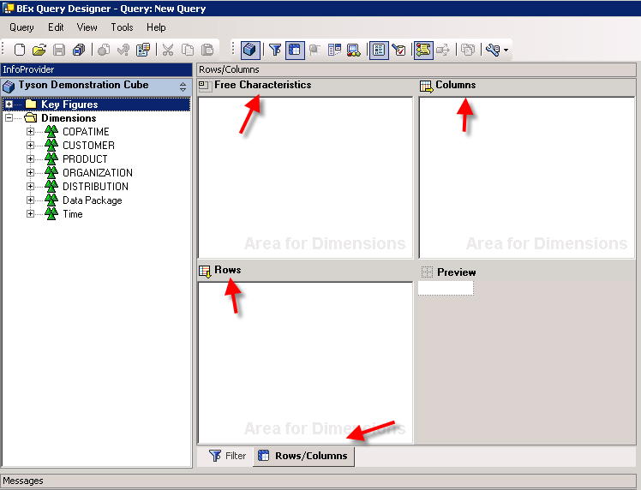

**41**

**2**

**31**

**1**

To create a query, you can expand or collapse the directories as needed to locate the values you wish to include in the query. You can use drag & drop to transfer entries from the directory tree to the desired areas of the query designer. Note that the Preview window provides a skeleton of the resulting query.

For this example, expand the Key Figures and drag the two Key Figures of Gross Sales and Sales Related Expenses to the Columns area. Drag Quarter from the Time dimension and the Protien Group from the Product Dimension to the Rows. Drage the Business Divison to the Free Characteristics area. See below.

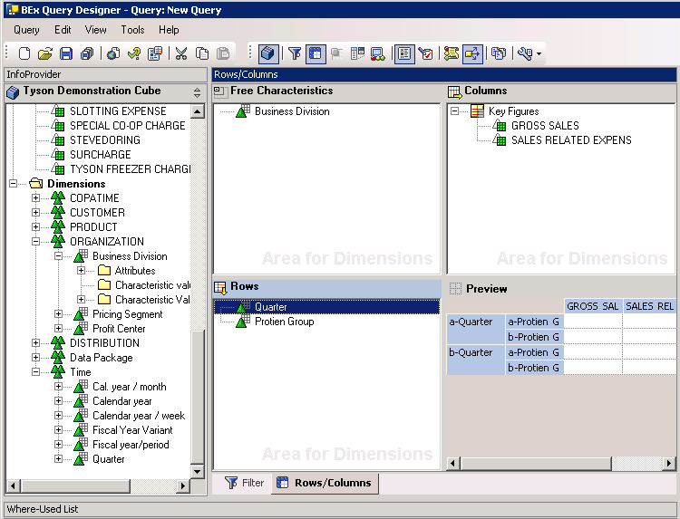

To save the query, click the disk on the menu bar. A Save As dialog box opens with provided name for the Description and Technical name. These names are not meaningful so it is recommended that you provide a meaningful description and Technical name. For this example, AMCIS1 is used for both the description and technical name. Click the Save Button after entering desired descrption and name.

To analysze the results of the query, open the Analyzer (Start🡪All Programs🡪Business Explorer🡪Analyzer) which is an Excel spreadsheet with an Add-Ins tool bar. Click Add-Ins on the main menu. You should have a spreadsheet similar to the following.

The SAP Add-Ins toolbar is shown below. Click the folder to open the query you just saved.

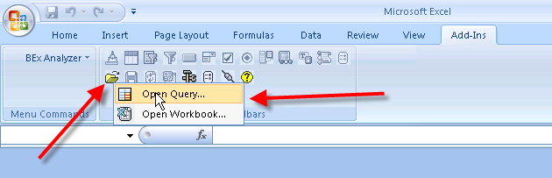

An Open dialog box opens—click the Favorites icon (or use Find) and the query you just created should be visible.

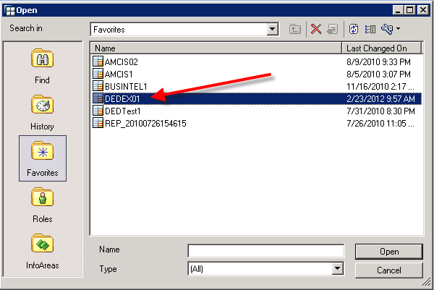

Select the query and click the Open button.

The query is then run with results shown below.

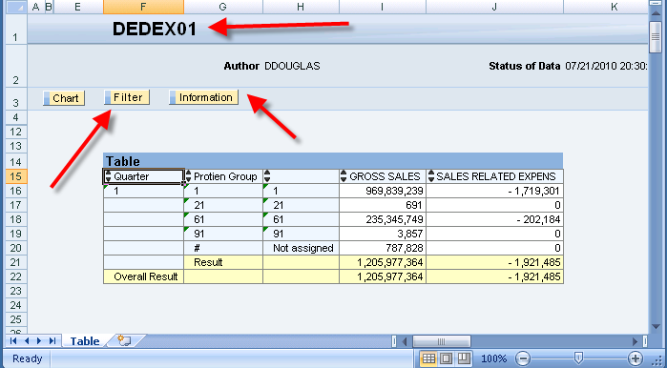

Click the filter button. A filter panel is populated to the left; right-click Business Division and select the drill down option shown.

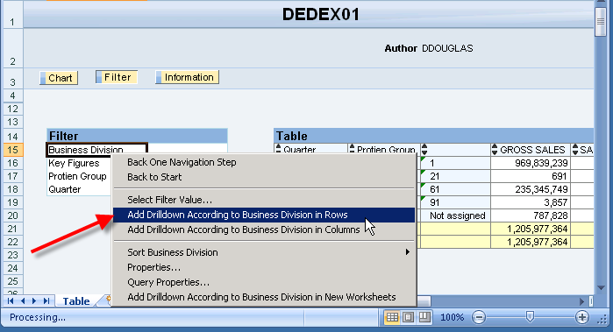

A portion of the resulting output is shown below.

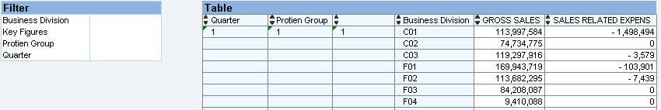

To remove the Drilldown, right-click Business Divsion in the Filter and select Remove Drilldown. Note that this is an Excel spreadsheet so you can manipulate the data as desired—for example, you could add a column that subtracts the SALES RELATED EXPENSES from GROSS SALES.

Final notes:

* To change a query, simply go to the Query Designer and open the Query you wish to alter
* To analyze the altered query, simply open the named query in the Analyzer