An Introduction to Teradata OLAP Capabilities

The Teradata SQL commands, using Teradata SQL Assistant, used for illustrating Teradata OLAP capabilities are based on the following data structure.
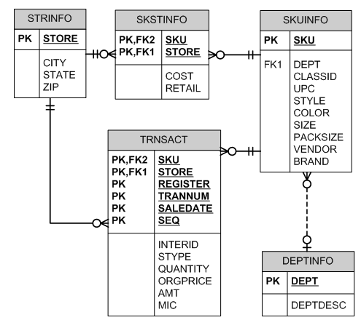
Dillard’s Department Stores Sales Transactions

Academic Units, faculty and students, that are members of the Teradata University Network -- free membership at http://www.teradata.com/t/page/137474/index.html, have access to a year of retail sales data from Dillard’s. Sensitive data has been removed but the data is very realistic and a rich environment for students and faculty for learning data base, data warehousing and OLAP concepts. Practice with larger more realistic datasets provides enriched learning opportunities not otherwise available. The ua_dillards database consists of 5 tables with more than 120 million rows already populated in the TRNSACT table for your use. The data was provided by Dillard’s Department Stores, Inc. and contains the sales transaction data for August 2004 through July 2005 for 453 Dillard’s stores.

Use this link http://enterprise.waltoncollege.uark.edu/membership.asp?show=tunregistration
to get a University of Arkansas Account. From the drop down under Teradata University Network, click Member Information and complete the request forms. You may also refer to the “How to become a TUN member…” documentation up in the University of Arkansas TUN website for more information and Teradata basics. Link specified above.

Once you receive your University of Arkansas Teradata account, access will be via remote desktop connection. Remote access documentation is at the following link: http://enterprise.waltoncollege.uark.edu/Remote_Desktop_TUN.pdf
Example 1 - (Examples 1-3 do not use any special OLAP features)

Dillard’s management wishes to know the best performing stores (by city) in terms of total sales for the period of August 2004 through July 2005 (note that the Dillard’s covers these dates)

SELECT s.store, s.city, sum(amt) as TotalSales
FROM ua_dillards.trnsact t
INNER JOIN ua_dillards.strinfo s
ON t.store = s.store

GROUP BY city, s.store
ORDER BY 3 DESC;

 | STORE | CITY | TotalSales
1 | 8402 | METAIRIE | 27058653.42
2 | 504 | LITTLE ROCK | 25469899.01
3 | 1607 | DALLAS | 24553924.18
4 | 2707 | MCALLEN | 24124962.49
5 | 9103 | LOUISVILLE | 22787327.90
6 | 7507 | HOUSTON | 21536191.60
7 | 2203 | OVERLAND PARK | 20896515.90
8 | 2007 | SAN ANTONIO | 20396931.95
9 | 9304 | OKLAHOMA CITY | 20350217.

Example 2 -- using a WHERE clause to join instead of INNER JOIN

SELECT s.store, s.city, sum(amt) as TotalSales
FROM trnsact t, strinfo s
WHERE t.store = s.store

GROUP BY city, s.store
ORDER BY 3 DESC;

Note that in both cases, the database name was used to qualify the table. In Teradata, one can specify the database which then allows creation of the SQL statements without the database name qualification. The following SQL illustrates this capability.

DATABASE ua_dillards;
SELECT s.store, s.city, sum(amt) as TotalSales
FROM trnsact t, strinfo s
WHERE t.store = s.store

GROUP BY city, s.store
ORDER BY 3 DESC;

The DATABASE statement specifies the current database and remains in effect until another DATABASE statement is executed.

Example 3

Dillard’s management wishes to know the vendors and associated dollar amount of sales for the brand “Liz Clairborne”. The results should be from largest sales to smallest sales.

SELECT k.brand, k.vendor, sum(amt) as TotalSales
FROM ua_dillards.trnsact t
INNER JOIN ua_dillards.skuinfo k ON
t.sku = k.sku

GROUP BY k.brand, k.vendor
ORDER BY 3 DESC;

 | BRAND | VENDOR | TotalSales
1 | CLINIQUE | 5511283 | 244726813.93
2 | POLO FAS | 5715232 | 208298981.49
3 | LANCOME | 0113645 | 165503299.30
4 | EMMA JAM | 3313116 | 74356782.77
5 | LIZ CLAI | 5531254 | 34496517.43
6 | POLO FAS | 5745232 | 33268376.36
7 | BROWN SH | 0060904 | 32418606.10
8 | HART SCH | 7045883 | 30127404.30
9 | CHANEL I | 6041161 | 29571162.76
10

OR

SELECT k.brand, k.vendor, sum(amt) as TotalSales
FROM ua_dillards.trnsact t
INNER JOIN ua_dillards.skuinfo k
ON t.sku = k.sku

WHERE k.brand LIKE '%LIZ CLAI%' (to retrieve only Liz Claiborne)

GROUP BY k.brand, k.vendor
ORDER BY 3 DESC;

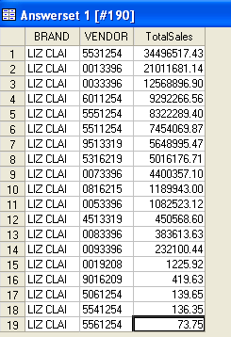

OLAP – On-Line Analytical Processing Functions

Using OLAP to Analyze Data

- On-Line Transactions Processing (OLTP) for recorded transactions from terminals
- On-Line Complex Processing (OLCP) for very complex queries
- On-Line Analytical Processing (OLAP) provide the ability to analyze large amounts of data (historical, transactions, trends, …) and provide data mining capabilities

Similar to Functions, but more…
- Like aggregate functions, OLAP operates on groups of rows and permit qualification and filtering.
- Unlike aggregate functions, OLAP return the individual row detail data and not just a final aggregate value.

Basic Teradata OLAP Functions:

CSUM – (Cumulation)
MAVG – (Moving Average)
MSUM – (Moving Sum)
MDIFF – (Moving Differences)
RANK – (Rankings)
QUANTILE – (Quantiles)
SAMPLE – (Sampling)
MLINREG – (Moving Linear Regression)
ROLLUP –subtotaling groups
CUBE – provides data warehouse type capabilities

One purpose of the Teradata OLAP functions is to allow data mining on a database using SQL. Note that
- OLAP functions are similar to aggregate functions
  - Operate on groups of rows (like GROUP BY clause)
  - Allow filtering groups using QUALIFY (like HAVING clause)
- OLAP functions are unlike aggregate functions
  - Return data value for each qualifying now—not group
  - May not be performed within subqueries
- OLAP functions may be performed on
  - Tables
  - Views
  - INSERT/SELECT populations

OLAP Examples*

Cumulative SUM - Cumulative Sum of Sales for Store 5203 before January 1

General Form: CSUM (colname, sort_item1, sort_item2…)

Example 4

Obtain the sale date, store, department and cumulative sales for Dillard’s department stores for January 1, 2005 for department 1704 in Abilene.

SELECT saledate, amt, city, brand, CSUM(amt, saledate)
FROM ua_dillards.trnsact t, ua_dillards.skuinfo k, ua_dillards.strinfo s
WHERE t.sku = k.sku
AND t.store = s.store
AND t.saledate BETWEEN '2005-01-01' AND '2005-01-02'
AND k.dept=1704
AND s.city='ABILENE';

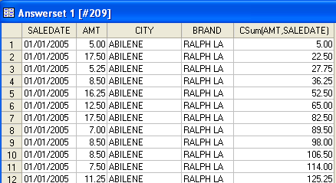

Moving Averages

General form: MAVG(colname, n, sort_item1, sort_item2, etc)

Example 5

This simple example shows a moving average on a 7 day window for sales for SKU of ‘0000180’ which is in department ‘1704’ which happens to be a Ralph Lauren product.

SELECT saledate, k.sku, amt, dept, MAVG(amt,7,saledate)
FROM ua_dillards.trnsact t, ua_dillards.skuinfo k
WHERE t.sku = k.sku
AND t.sku <2000
AND DEPT=7104
AND EXTRACT(MONTH FROM saledate) IN(1,2)
AND EXTRACT(DAY FROM saledate) IN(21,22,23,24,25)
ORDER BY saledate, t.sku

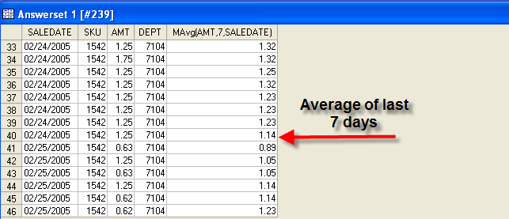

Moving sum and moving difference – replace MAVG with MSUM or MDIFF.

Simple and Qualified Rankings

The Ranking function permits a column to be ranked, either based on high or low order, against other rows in the answer set. By default, the output will be sorted in descending sequence of the ranking column. The Rank function syntax is:

RANK(colname)

The QUALIFY clause allows restriction of the output in the final result.

QUALIFY RANK(amt) <=7
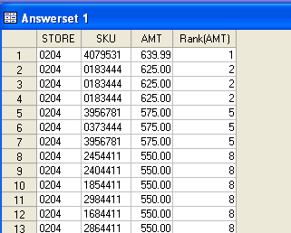
Example 6

Determine the highest selling products for store 204

SELECT Store, sku, amt, RANK(amt)
FROM ua_dillards.trnsact
WHERE store= 204

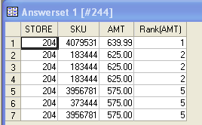
Example 7

Get the top five selling products for store 204

SELECT Store, sku, amt, RANK(amt)
FROm ua_dillards.trnsact
WHERE store= 204
QUALIFY RANK(amt) <= 5

Example 8
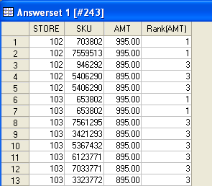
Get the top three selling products for each store

SELECT Store, sku, amt, RANK(amt)
FROm ua_dillards.trnsact
GROUP BY store
QUALIFY RANK(amt) <= 3

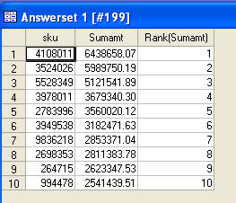
Example 8

Get the top 10 selling products across all stores

SELECT tt.sku, tt.Sumamt, RANK(tt.Sumamt)
FROM (SELECT t.sku, SUM(t.amt)
FROM ua_dillards.trnsact t
GROUP BY 1)
AS tt(sku, Sumamt)
QUALIFY RANK(Sumamt) <= 10

Example 9

Get the ten poorest selling items (greater than $10) across all stores and order by product id -- The only syntax difference between the two queries is the ASC (sort order ascending) on the RANK function.

SELECT tt.sku, tt.Sumamt, RANK(tt.Sumamt)
FROM (SELECT t.sku, SUM(t.amt)
FROM ua_dillards.trnsact t
WHERE amt >10
GROUP BY 1)
AS tt(sku, Sumamt)
QUALIFY RANK(Sumamt ASC) <= 10
ORDER BY 1

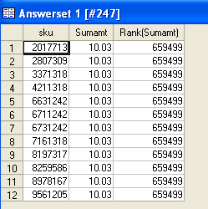

Rollup and Cube OLAP features

General Form: rollup(col1, col2..)

Example 10 -- rollup

Dillard’s management wishes to know the total sales by department, brand and sku number with the highest sales first. After reviewing this information it will be easy to rerun the query for any combination of single or multiple departments, brands, and skus. One can also limit the output by selecting only a predefined number—SELECT TOP 100, for example.

DATABASE ua_dillards;
SELECT k.dept, k.brand, k.sku, sum(t.amt)
FROM skuinfo k, trnsact t
WHERE k.sku=t.sku
GROUP BY ROLLUP(k.dept, k.brand, k.sku)
ORDER BY 4 DESC, k.dept, k.brand, k.sku

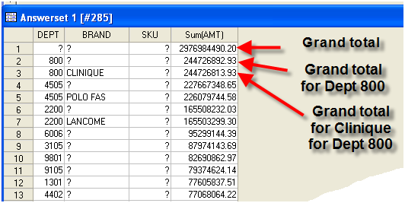

Example 11 -- Cube

Use the cube capability to obtain the top 100 items in terms of total sales for each department and brand. The ? entries means the total for that column—thus, row one is the grand total for all items.

DATABASE ua_dillards;
SELECT TOP 100 k.dept, k.brand, k.sku, sum(t.amt)
FROM skuinfo k, trnsact t
WHERE k.sku=t.sku
GROUP BY CUBE(k.dept, k.brand, k.sku)
Order by 4 DESC, k.dept, k.brand, k.sku;

