Teradata SQL Assistant / Web Edition

Teradata SQL Assistant/Web Edition
This product is designed to provide a simple way to execute and manage your queries against a Teradata, or other ODBC compliant database. SQL Assistant Web stores your queries for easy re-use, and provides you with an audit trail that shows the steps that produced your current results.

Hands-On SQL Assistant!
In this tutorial, experience the simplicity and ease of use of this powerful query tool via a web browser. This hands-on session will show you some of the ways in which you can use this tool in order to maximize your efficiency. Hands-on activities will include connecting to a Teradata database, executing a query, and manipulating the results.

Lesson
In this short lesson we will:
- 1. Start Teradata SQL Assistant/Web Edition
- 2. Connect to a Teradata system
- 3. Demonstrate SQL Assistant Web functions

1. Start Teradata SQL Assistant/Web Edition
To start SQL Assistant Web go to the following website (copy and paste the link below) http://enterprise.waltoncollege.uark.edu/sqlassistantweb12.0

Or click the Teradata SQL Assistant Log-in link on the University of Arkansas TUN website
- Click on the Walton College Teradata Link

- 2. Login to Teradata SQL Assistant/Web Edition
Login using your SQL Login, Password, Default Database (if applicable), and click OK. This is the login you entered when you created your Teradata SQL Assistant/Web Edition account.
Since you have access to all databases, and you do not have an assigned Default Database, you may enter one on the login screen. If you choose not to enter a Default Database, you will need to use the database command to get access (for example, database UA_Dillards). Once you are in SQL Assistant, you may add additional databases (please see section 3 ‘Teradata SQL Assistant/Web Edition’ for more details)
If you wish to see a description of the available databases, you may click on Database Description link.

3. Teradata SQL Assistant/Web Edition

SQL Assistant consists of a left frame to show the tree and a main window divided into 3 areas.
- • A Query section where you enter the SQL query you wish to execute.
- • A History section where information about previously executed queries are displayed.
- • And an Answer Set section where your query results are displayed.

The tree on the left is used to view the databases. By default, you will see DBC and your login. If you entered a Default Database in Step 2, it will also appear in the tree at the left. If you want to add additional databases, click the Add link above the tree on the left, and enter the desired database and click OK. See example screen below.

You will then see a UA_Dillards database added to you list of databases on the left.
If you click on the + sign next to the database you can expand to see the tables, views, macros, and procedures.

. Executing Queries
The top section is used to enter your query. If you have a query stored (query in a text format on your hard drive) you can use the Open Query button and Browse to search. You can Load the query into the query section and click Execute. You may also run the query by clicking Run.

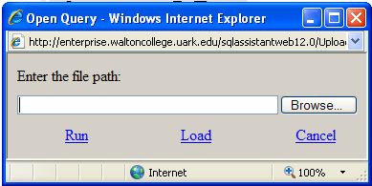

- Another option, enter your query in the query window and click the Execute button.

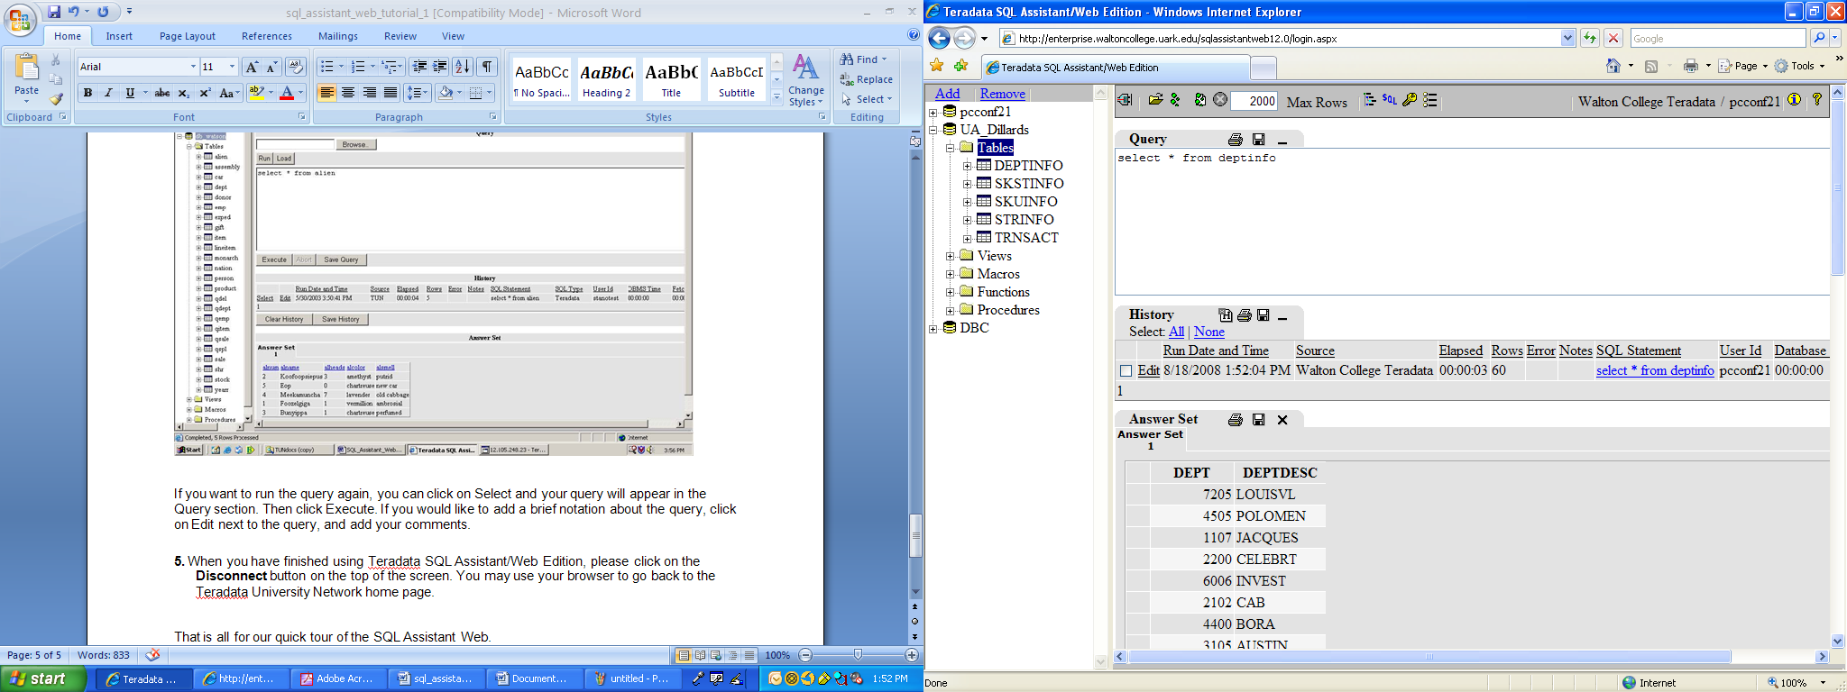
Once you have written a query, you may save it by clicking on Save Query.

When you execute a query, you will see your query in the History section. If there is an error, you will see a brief description of the error on the bottom left of your screen. If you want to see more pages of your history, click on the numbers located above the Clear History button. You may also clear the entire history, or save it to a file.
The results of your query will be displayed the Answer Set section. You can sort the answer set by clicking on the underlined column name of the screen.
If you want to run the query again, you can click on Select and your query will appear in the Query section. Then click Execute. If you would like to add a brief notation about the query, click on Edit next to the query, and add your comments.

5. When you have finished using Teradata SQL Assistant/Web Edition, please click on the Disconnect button on the top of the screen. You may use your browser to go back to the Teradata University Network home page.

That is all for our quick tour of the SQL Assistant Web.
In conclusion, we hope that we have given you a brief insight into some of the capabilities of Teradata SQL Assistant/Web Edition, and that you will be motivated to learn more of its capabilities. The SQL Assistant help file (located in the upper right hand corner of the SQL Assistant screen), and the User Manual (located on the Teradata University Network home page under the Teradata SQL Assistant/Web Edition executable) will give you a detailed description of the product.

