Creating an Event in 25Live

- Log in to 25Live at https://25live.collegenet.com/uark

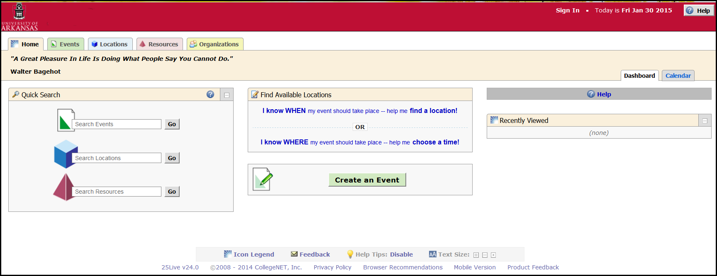

- Click the Sign In Link in the upper right corner.

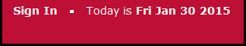

- Enter your UARK username and Password.

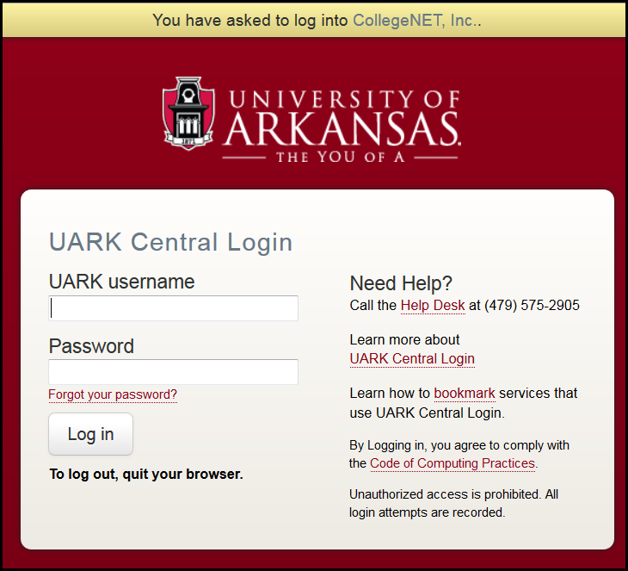

- Click Log in.

- Your Home page is displayed.

- Click the Create an Event button to open the Event Wizard.

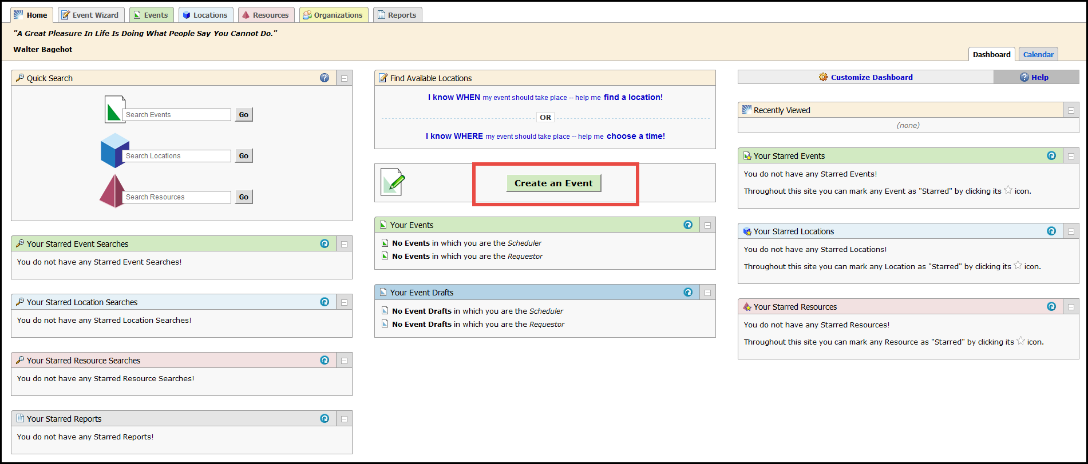

The Events Wizard
The asterisk () indicates a required field. If any required fields are left blank, the message “Events cannot be submitted unless all required fields are completed displays.
- Type the name of the event you are creating in the Event Name field. Use a name that is logical and relevant

- The Event Title is not required but we enter the event requestor’s name in this field for tracking purposes.

- Enter the Event Type. The event type should be “OTHER”.

- Enter the Primary Organization for this event. Select College of Business.

- Click Next.

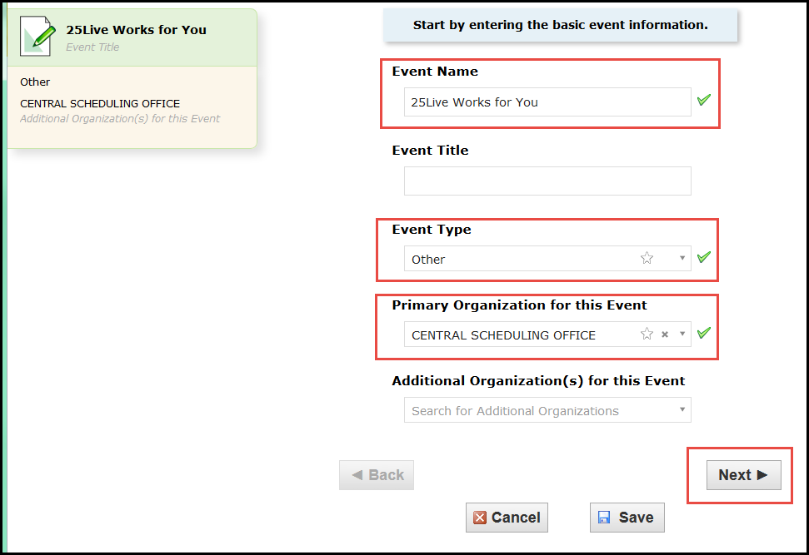

- Enter Expected Head Count information. Enter the number that you expect will attend your event. Example: if you plan for 25 to attend, even though you actually expect only 15 will show up, enter 25.

- Click Next.

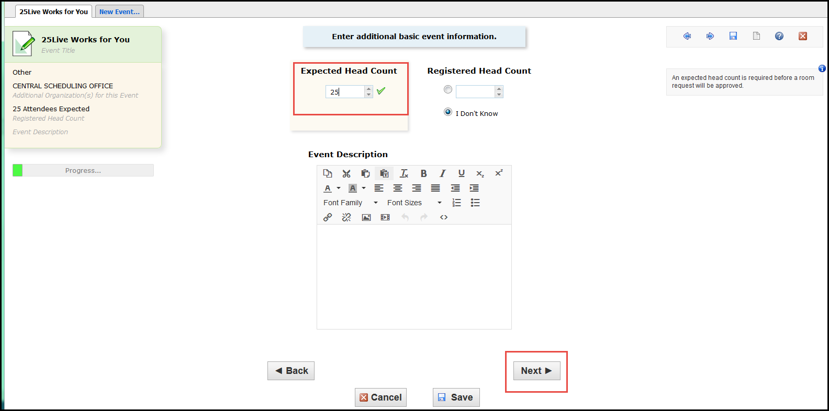

- Enter Event Occurrences.
  - Click the box that is appropriate for your event.

  - Click Next.

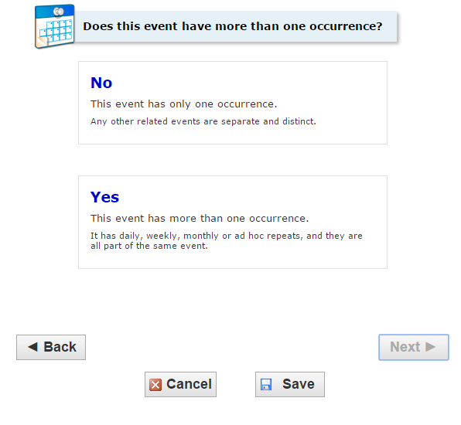
Click No if there are no other occurrences for your event and then move to the next screen.
Click Yes if you will be meeting multiple times. Example: once a week for 4 weeks.
Note: new fields will open if you are meeting multiple times.

  - The Event Start and Event End date and time fields are automatically populated.
- If necessary, change the dates and times for your event.

  - Select the Setup or Takedown time requirements.

  - Click Next.

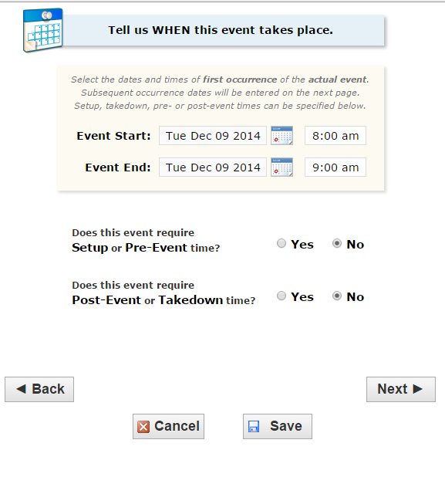
Checking Yes for the Setup or Takedown times will open additional dialog boxes.

- Choose how the event Repeats.

  - Click the box that fits your event.

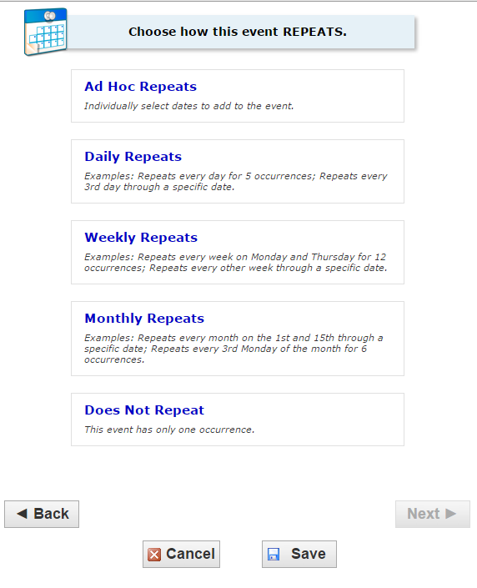
The dialog box that appears next is determined by the selection made here.

Repeat Schedule Options

Ad Hoc Daily
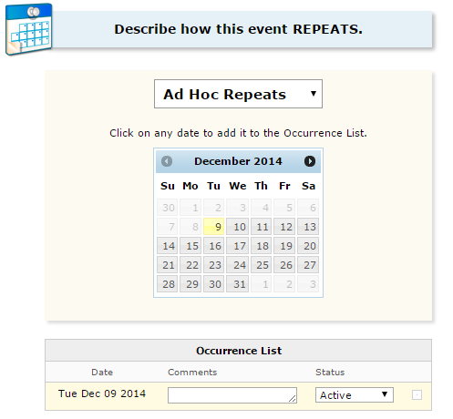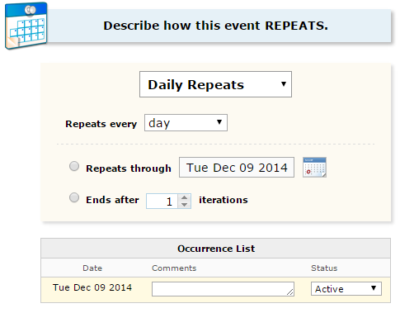

Weekly Monthly
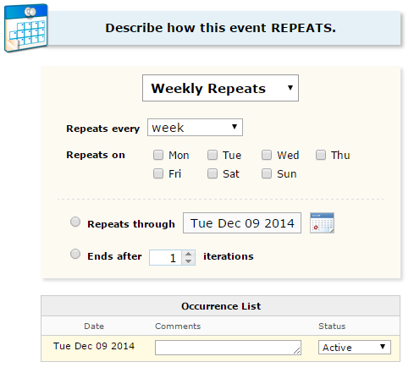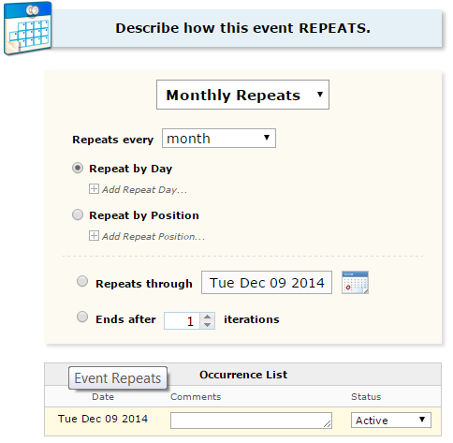

- Select the Event Location

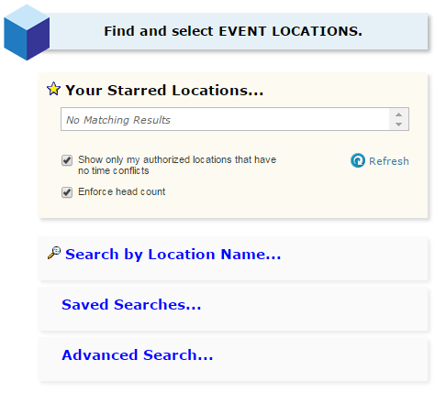
Make sure the SHOW ONLY… and ENFORCE HEAD COUNT check boxes are selected.
Click one of the search options to continue.
The dialog box that appears next is determined by the selection you make here.
ENFORCE HEAD COUNT ensures that the room will hold the number of attendees that was entered in the Expected Head Count box at the beginning of the process.

  - Click Search by Location Name to search by a building code or specific room.

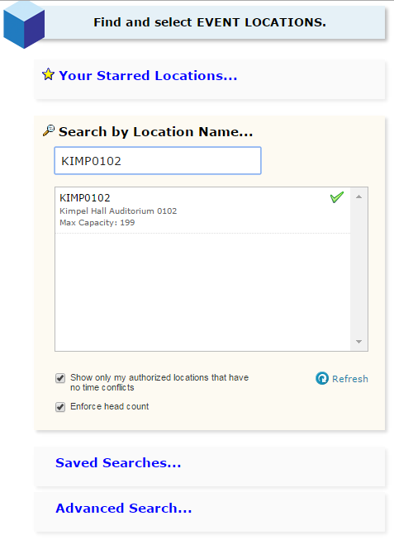
Search by Building Code – (example) Kimpel Hall = KIMP.
Search by Specific Room - (example) KIMP0102. There are no spaces between the building code and the room number.
The dialog box that appears next is determined by the selection you make here.
  - Click the room name to select it for your event.

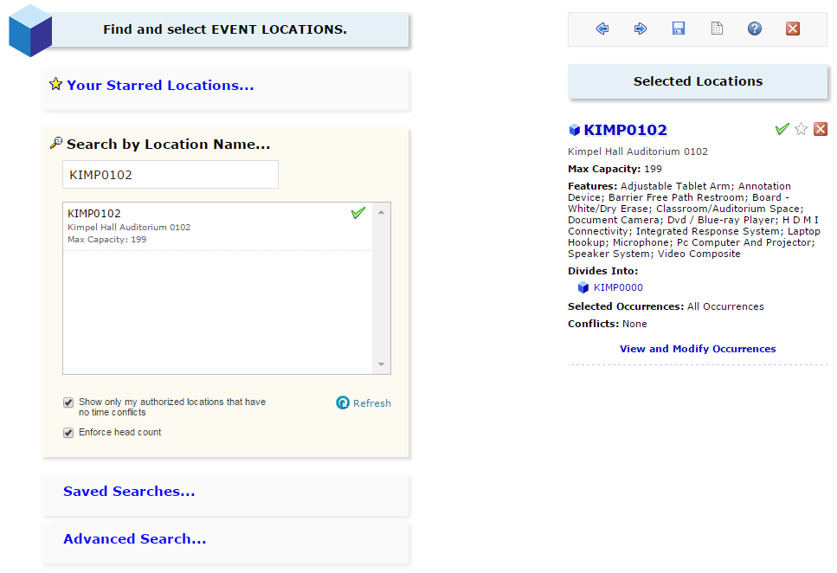
The selected room is now displayed under Selected Locations. This section provides information regarding this room; Capacity, Features, and Conflicts.

NOTE: The UA does not currently use either Event Resources or Event Custom Attributes at this time. Click NEXT to move through these screens.

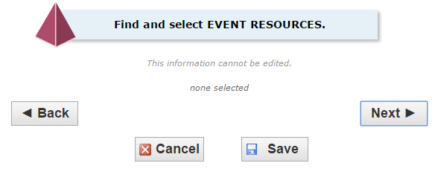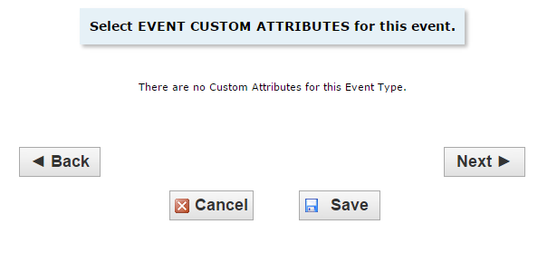

- Select Event Contacts

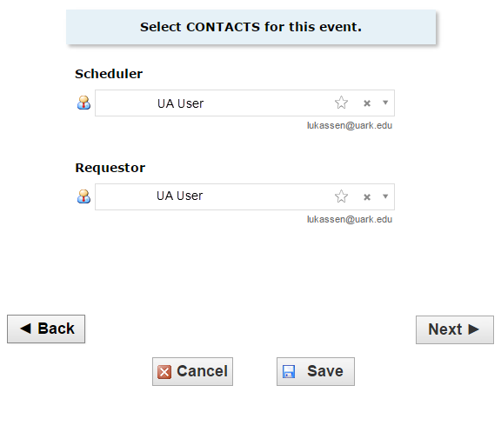
Contact fields are automatically filled in with the user’s name.

- If this information is correct, click NEXT.
- To edit the information, click within the box to access a drop-down menu to select a different scheduler or requestor.

- Select CATEGORIES for this event.
The user’s security access determines the categories that may be selected here.

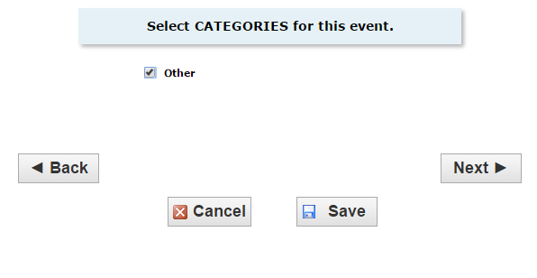
In this example, the only category that can be selected is Other.
Click the check box to select that category.
Click NEXT to continue.

- Add Event Comments and Notes

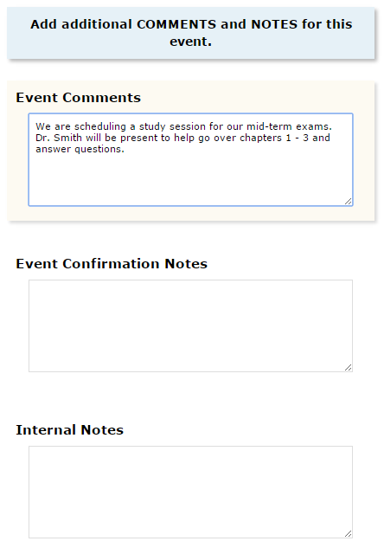
Select Draft or Tentative for your event state.
Draft-if you have entered most of your information, but need to stop for any reason, save your entries by clicking DRAFT. You may come back later to finish entering your information.
Draft events are not in the workflow for approval and specific room requests may not be saved. When the draft is reopened, verify that the room you need is still open. Enter your additional changes. Then select Tentative and SAVE.
Enter any information that might be useful to the office that assigns rooms or the person that will be approving the event.

- Verify or Change the Event State
The system is set for a default of Tentative.

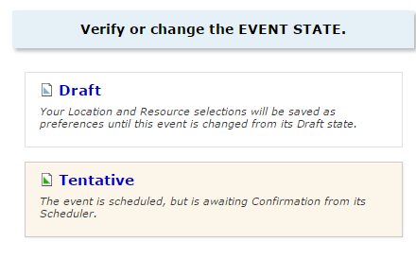

  - Verify that your information is correct by checking the summary on the left side of the screen.
  - If everything is correct, click SAVE.

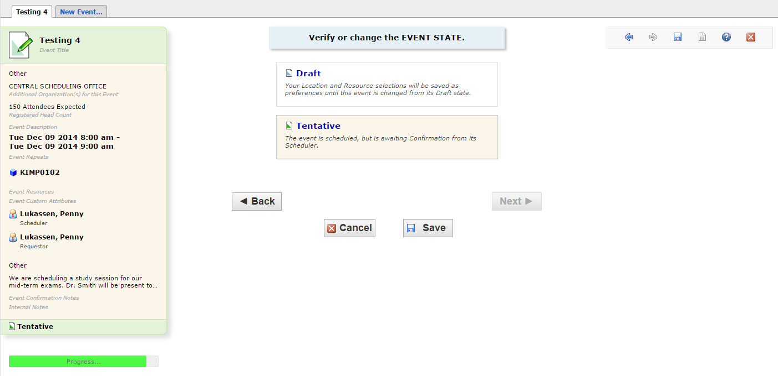

  - It may take several seconds for the event to save.
  - A new screen opens and indicates the event is successfully saved.
  - Click the Close button to close out this event.

