Tentative Course Syllabus (8/25/17)
FRESHMEN AND SOPHOMORES
WCOB 230V: Global Community Development: Vietnam
Sam M. Walton College of Business

Global Community Development: Vietnam  Sam M. Walton College of Business  Tentative Course Syllabus (8/2/17)  Winter 2018 | 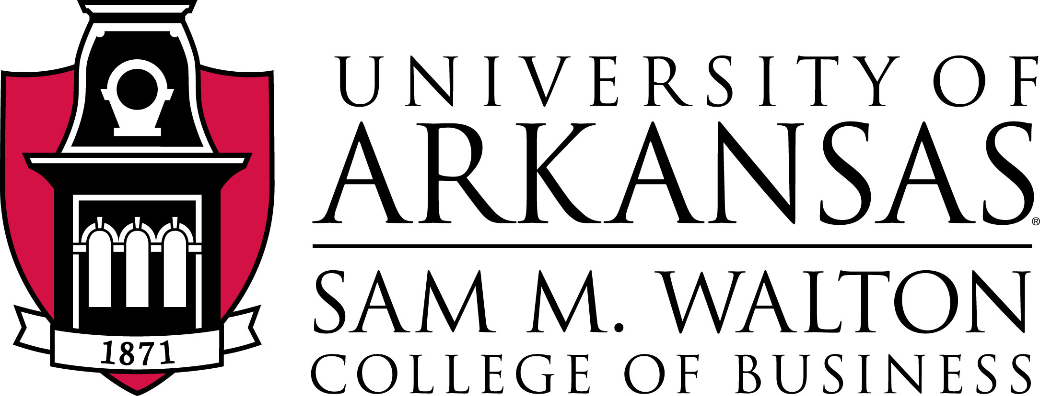
Steven W. Kopp, PhD  Associate Professor  Department of Marketing  Sam M. Walton College of Business —323  University of Arkansas  Fayetteville, Arkansas 72701 | Office Telephone: 479.575.3228  skopp@walton.uark.edu

Course Objectives: For study abroad, the classroom is the real-world experience of living in and working in another culture. This course is designed to inspire intellectual curiosity about the world as it is and foster a deeper understanding of the global condition. The course will assist students to cultivate intercultural understanding, to apply what they learn, and to begin to grasp the role of “business” – locally and globally – in the community. Very specifically, you will:

- Gain knowledge about the norms and cultures of the country and how those affect business
- Develop critical thinking skills, tolerance for ambiguity, and confidence
- Extend your awareness of your own values and culture

Materials:  Two of the four pre-trip meetings will include discussion of required readings.  The list of these are provided in the Appendix. The assigned chapters, articles, and other materials will be made available online at:  Vietnamrazorbacks.com, through Blackboard, and through direct e-mail | Other materials: You will need to bring a laptop. A comprehensive list of suggested materials will be provided at a later date.

Class Parameters

The course consists of three parts:
- A pre-departure component during the Fall semester that will include an introduction to the historical, cultural, social, and economic environments of Vietnam. This will include some individual assignments (write a pre-trip report based on your perspectives and expectations of your experience in-country) and some small-group assignments (finding information to help the group prepare for the trip).
- A two-week-plus field study component in Vietnam. The field study will include community development projects, working in conjunction with faculty and students at Can Tho University, through the Peacework organization. Specific requirements for “in-country” are outlined below.
- A final paper to be submitted after we return

Assessment

Project work, individual assignments, and other activities: Grades will be assigned based on participation in and completion of projects, professionalism, and other criteria. Team projects are extensive, will be submitted as group assignments, and will be presented to Vietnamese faculty, students, and business collaborators. Throughout the course, you will produce short papers – these allow you to solidify your own thinking about our activities by explaining to someone else. Visits to historical, cultural, and religious sites are required.

Grading Scale: Your work will be assessed using the following scale.

90%+ | A | Exceptionally High Quality
80%+ | B | High Quality
70%+ | C | Mediocre Quality
60%+ | D | Low Quality
50%- | F | Failing Quality
N/A | I | Incomplete

Approximate Weights for Assessment (explanations in end notes)t:
Project, Presentations | 40%
Participation | 25%
Short papers | 15%
Attendance/Professionalism | 20%
Total | 100%

Course Policies

Processes: Field work is integrated with lectures (the Vietnamese call them “workshops”) from U of A faculty and Can Tho University faculty. This program thus includes lecture/discussion, cultural exchange activities, individual work, work in small groups, oral reports/presentations, analysis of data, and problem-solving. Because of the long travel time and relatively short in-country time, the program is physically, psychologically, and intellectually demanding.

You are expected to participate in class discussions. At times, students will lead class discussions by investigating, reading, and preparing materials as required and in a voluntary fashion. We will work on assignments and projects in-class and out-of-class.

Attendance: Attendance for all activities, projects, meetings, workshops, and training are required. Students are expected to behave in a professional manner.

Academic Honesty: The application of the College of Business Academic Honesty Policy, as stated in the Catalog, will be fully adhered to in this course. Academic dishonesty involves acts which may subvert or compromise the integrity of the educational honor code pledge which was signed by each student upon on entering the program to indicate their agreement with this policy. Program participants are also required to sign a code of conduct by the dean of students.

Safety: Both the U of A Study Abroad Office and Peacework will provide you with thorough information regarding your behaviors, the local culture, and the necessary precautions for travel abroad generally and Vietnam specifically. Students will always have access to either the instructor or the Peacework Field Manager during the program. Adherence to policies outlined by STAB and/or Peacework will be considered a component of assessment of professionalism.

_______________________

Disclaimers: The instructor reserves the right to make any changes in the syllabus and the requirements for successfully completing the course to the extent necessary to meet the learning objectives for the class. Students will be informed of any substantive changes in a timely manner.

Explanation of weights:

40% projects, presentation: there will be at least two primary projects. There will also be formal and informal presentations. The quality of work (under the circumstances) and debriefings of the activities will be evaluated.

25% Participation: Individual effort in the team’s background research, planning/designing the project, evaluating its feasibility, presentation and report to community, and project implementation.

20% Attendance/Professionalism: Students are expected to be present and prepared for every course session (including cultural activities). You will display, throughout the program, maturity, situation-appropriate behavior, professionalism and cultural sensitivity in all of your communications and actions.

15% short papers: At least three short papers to be submitted by the due dates.
Students with Disabilities: It is the Walton College policy that reasonable accommodations will be made for students with disabilities. Students must request any accommodations from their instructor in addition to requesting accommodations from the Center for Students with Disabilities (CSD). Please contact the CSD for details on seeking accommodations for disabilities. The cities and rural areas where we live and work while in-country tend not to be handicap-accessible – nonetheless, we will reasonably accommodate any student’s needs to participate in and complete the program.

Weather
The University has specific weather-related policies. You can look them up. We will adhere to those as far as whether class is held on campus. In the case of class cancellation, we will work to the best of our abilities to fulfill the course objectives. Weather in Vietnam during January is fairly stable and we will not have icy roads to contend with. Some assignments may be postponed and some may be cancelled, as we remain “on task.”

Appendix TO SYLLABUS: U.S. Itinerary and assignments

Assignments Pre-departure assignments will include reading, research and brief reports about the country and community as well as information to help the group prepare for international travel. Details of these assignments as well as due dates will be provided shortly.

- Pre-trip report will include “my plan for how study abroad in Vietnam fits into my plan for professional career.” Identify and elaborate on five goals. Many times potential employers/interviewers note mention of this Vietnam program on a student’s resume – how do you respond?

- Post-trip report will include “how I fulfilled/did not fulfill the goals I set for this trip.” Elaboration and discussion.

Reflection paper assignments are designed specifically to assess academic, ability and awareness outcomes. Team projects in which the you work with members of the community (Hoa An village, Can Tho University, others) will also be assessed. Oral presentations and discussion will be interspersed throughout. We will all spend dedicated time to documenting our day-to-day activities and to use this material in reflection reports and other assignments. Four sessions/class periods will be held prior to departure.
Pre-trip class sessions
Pre-trip session 1: introductions, background, and team assignments; first self-assessment paper assigned

Pre-trip session 2: history and current issues in Vietnam. Assigned Readings:

Vietnam Today: A Guide to a Nation at a Crossroads (2005) by Mark A. Ashwill
Chapters 3 (A Brief History) & 4 (Vietnam at Peace)

Vietnam: A Natural History (2006) by Eleanor Jane Sterling, Chapters 8 & 9

Pre-trip session 3: business practices in Vietnam. Assigned readings:

Vietnam Today: A Guide to a Nation at a Crossroads (2005) by Mark A. Ashwill
Chapters 5 & 6

Doing Business: Economy Profile Vietnam 2014 (2013) World Bank.

“Vietnam’s Second Revolution” (2014) by Elizabeth Pond, World Policy Journal

“World Factbook: Vietnam” (2015) cia.gov website

