This module is designed for three contact hours of class time

Module Objectives:
- Be able to express the benefits of a mainframe including
  - Z Series architectural concepts
  - Consolidation and TCO advantages of this environment
- Be able to navigate TSO/ISPF
- Be able to create partitioned datasets; create, edit, copy, upload, download files

Basic z/OS Skills
Active learning:

Creating, Copying and Deleting PDS members in ISPF

From the main ISPF menu, select option 3 (Utilities) and then option 3 as shown below.

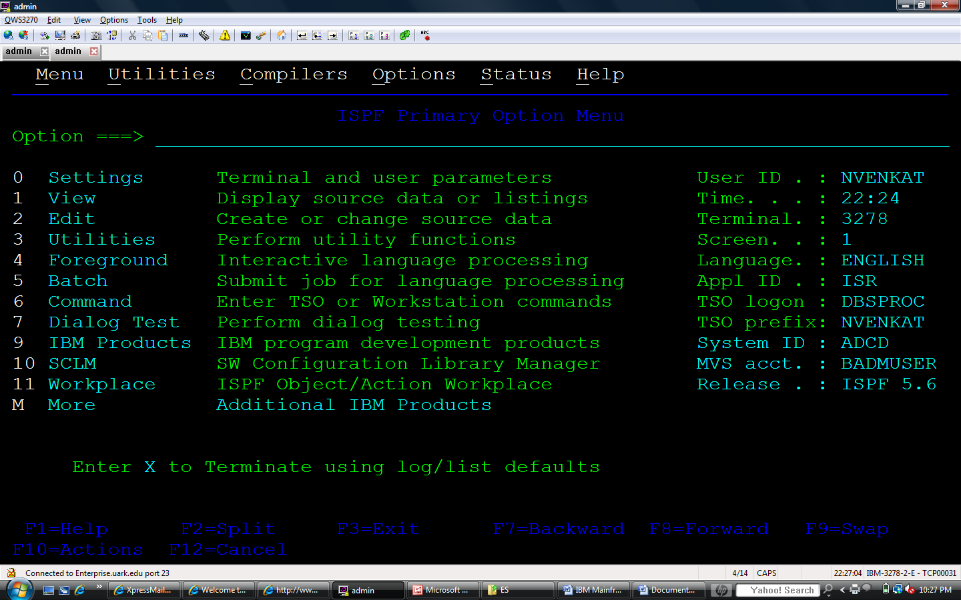

This will take you to the Move/Copy Utility screen shown below. Note option C has been selected. Also notice the word From in the line that specifies that you are copying from this PDS. You will need to correctly enter the PDS and the desired member to copy. In this case, it is DOUGLAS.WORK.DATA(SMPLDATA) –although entered on four lines in the panel.

Notice that after you enter the PDS and member name for copying from and press the enter key, you are then presented a screen that allows you to enter the location of where it will be copied to. In this example, UserName is used. You should of course use you user name. Enter the appropriate location and press the enter key. The system will return to the screen where you entered the copy From information. In the upper right hand corner you will see a message indicating that your member was copied. (See bottom of page 3)

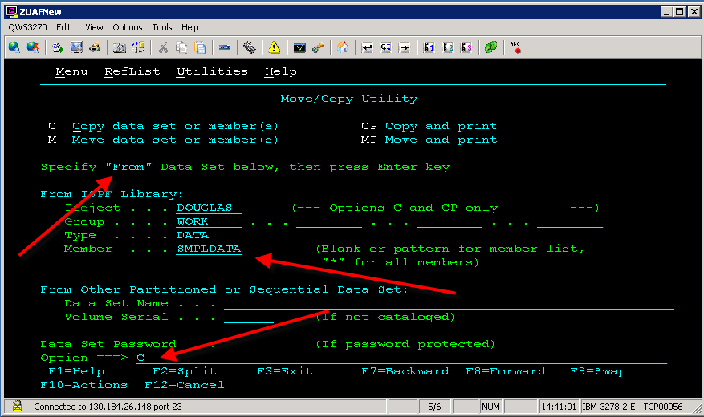

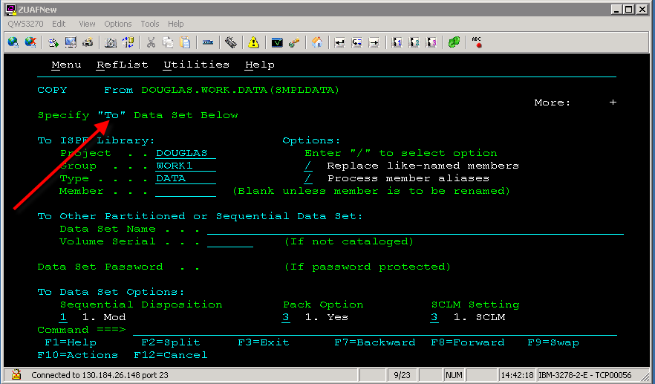

Enter a new member name as directed and press enter. See the results in the bottom screen on this page.

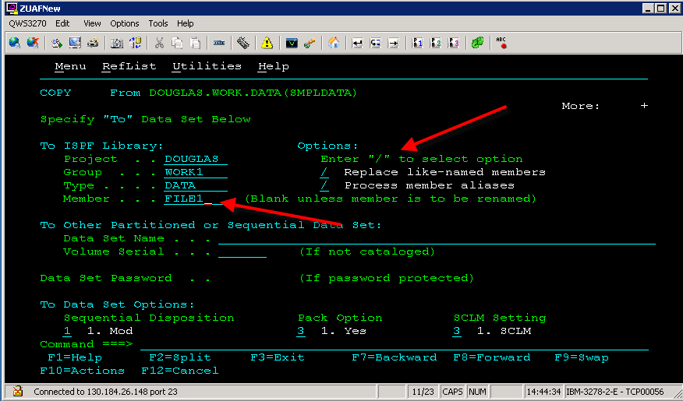

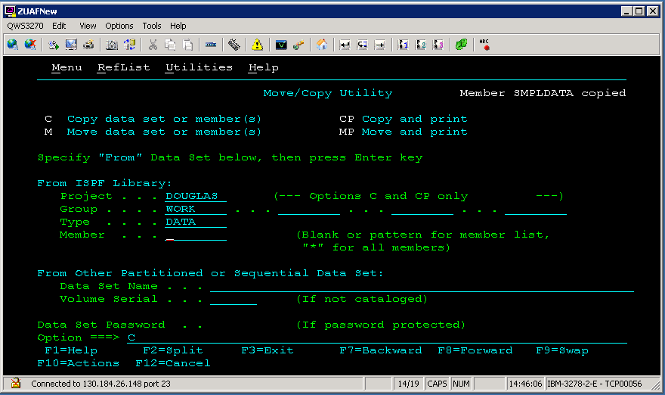

To delete a PDS member or file, first select option 3 (utilities) from the Primary Option Menu and then select 4 (Dslist – Data Set List Utility), 1 (Library) or 2 (Data Set) from the Utility Selection Panel. An alternative is to select option 2 (Edit) from the Primary Option Menu.

In this example, option 3(utilities and then option 2 (Data Set) was selected. You will see the screen below which allows you to specify what you wish to do for the given PDS. Enter D for option and click the enter key.

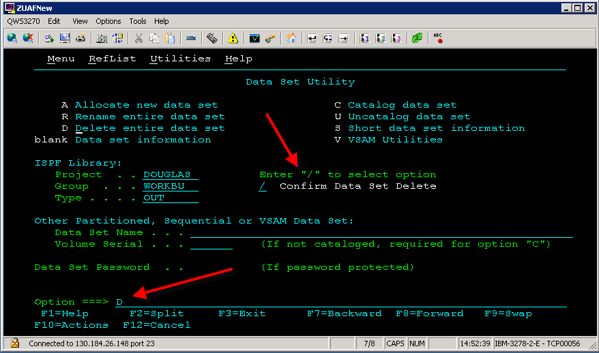

If you select 1 (Library) leave the Member field blank and press the enter key. This will open a screen with all the members listed (see next page). Note the entry column at the left edge of the screen. A number of options can be used in this entry column:

B – Browse
C – Copy the member
D – Delete the member
E – Edit the member
M – Move the member
R – Rename the member
S – Select. This works on the Edit and Dslist options, but not in the Library option.
V – View the member. Note: although it appears you can make changes in this mode, the changes cannot be saved!

If you want to delete a member instead of a PDS, use either DLIST or LIBRARY. Open the PDS and move to the member to be deleted. Enter the letter D in the entry column at the left edge of the screen and press the enter key. A confirmation window will open indicating the member that will be erased. Press the Enter key to erase the member or PF12 to cancel. (See the second screen shot on the next page).

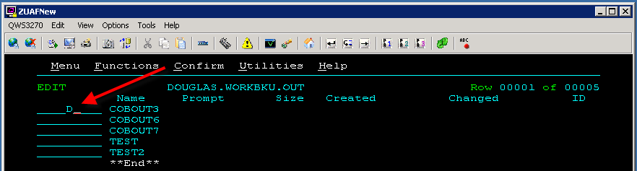

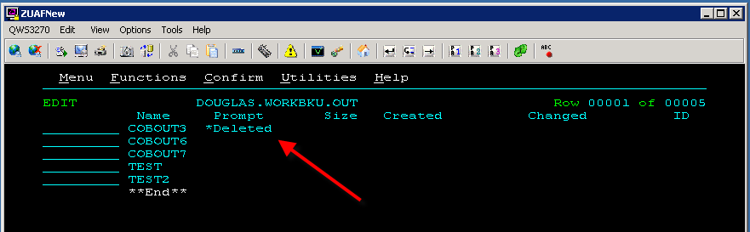

Note the entry column at the left edge of the screen. A number of options can be used in this entry column (S is an option that is not available in the Library Menu):

B – Browse
C – Copy the member
D – Delete the member
E – Edit the member
M – Move the member
R – Rename the member
S – Select
V – View the member. Note: although it appears you can make changes in this mode, the changes cannot be saved!

Moving the Command Line

Moving the Command Line is a setting that can be accessed in one of two ways:
- From the ISPF Primary Option Menu select option 0 for setting OR
- If you are in the Edit or View option (from the Primary Option Menu, select 1 for View or 2 for Edit))….. Put your cursor somewhere on the word Menu in the top left hand corner and click….then press enter. From the menu that appears, select 1 for Settings and press enter.

Either enter a slash (“/”) or remove the slash from the “Command line at bottom” option and press enter. Removing the slash moves the command line to the top.
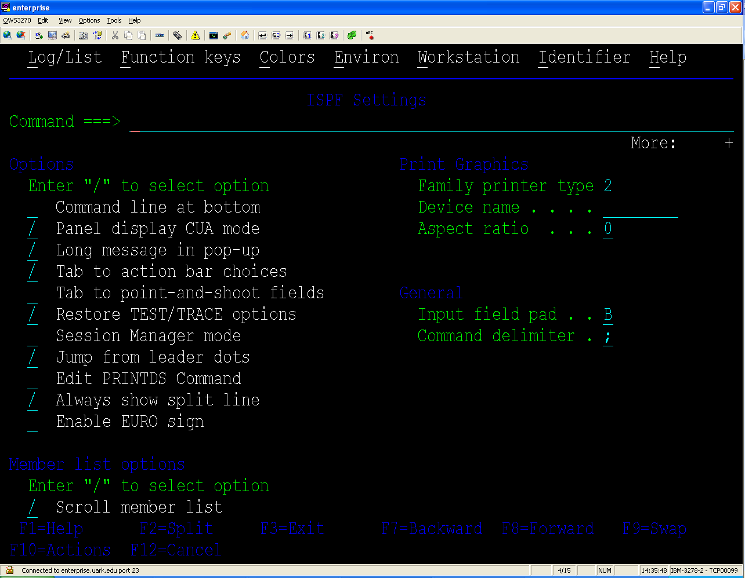3

Press F3 to return to display your previous screen.
Editing Members in ISPF

From the ISPF Primary Option Menu, select option 2 (Edit), press the enter key.
On the Edit Entry Panel, enter the name of the PDS and Member to edit and press the enter key.
If you have forgotten the name of the member you wish to edit, leave the Member field blank as shown below and press Enter.
Note you can also use option 3(utilities) followed by option 1(library)

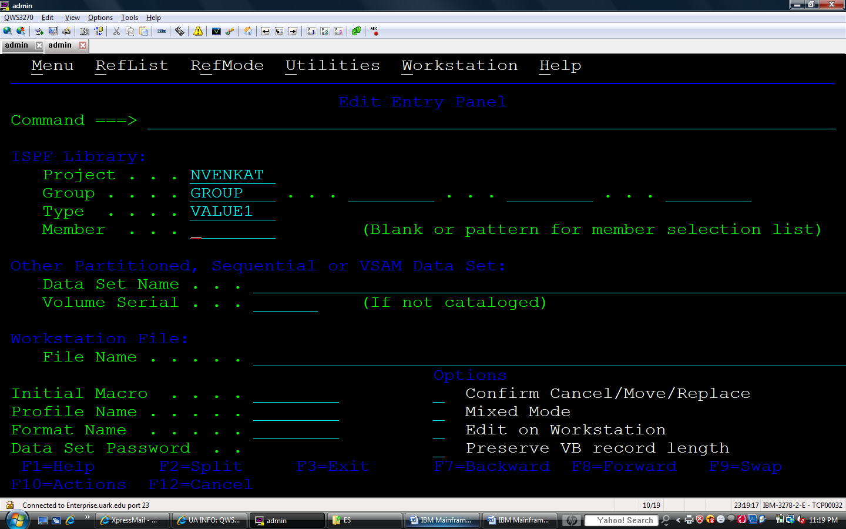

If you leave the member field blank, you will be presented with a list of your members in that PDS with a “.” to the left of each member name (or a _ if you used Utilities followed by Library). To edit a member, on the “.” to the left of the member, type the letter s (for select) or e (for edit) and press the enter key. You can now edit the contents of an existing member. In the example below, the user can now edit the member named OUTPUT as shown on the next page
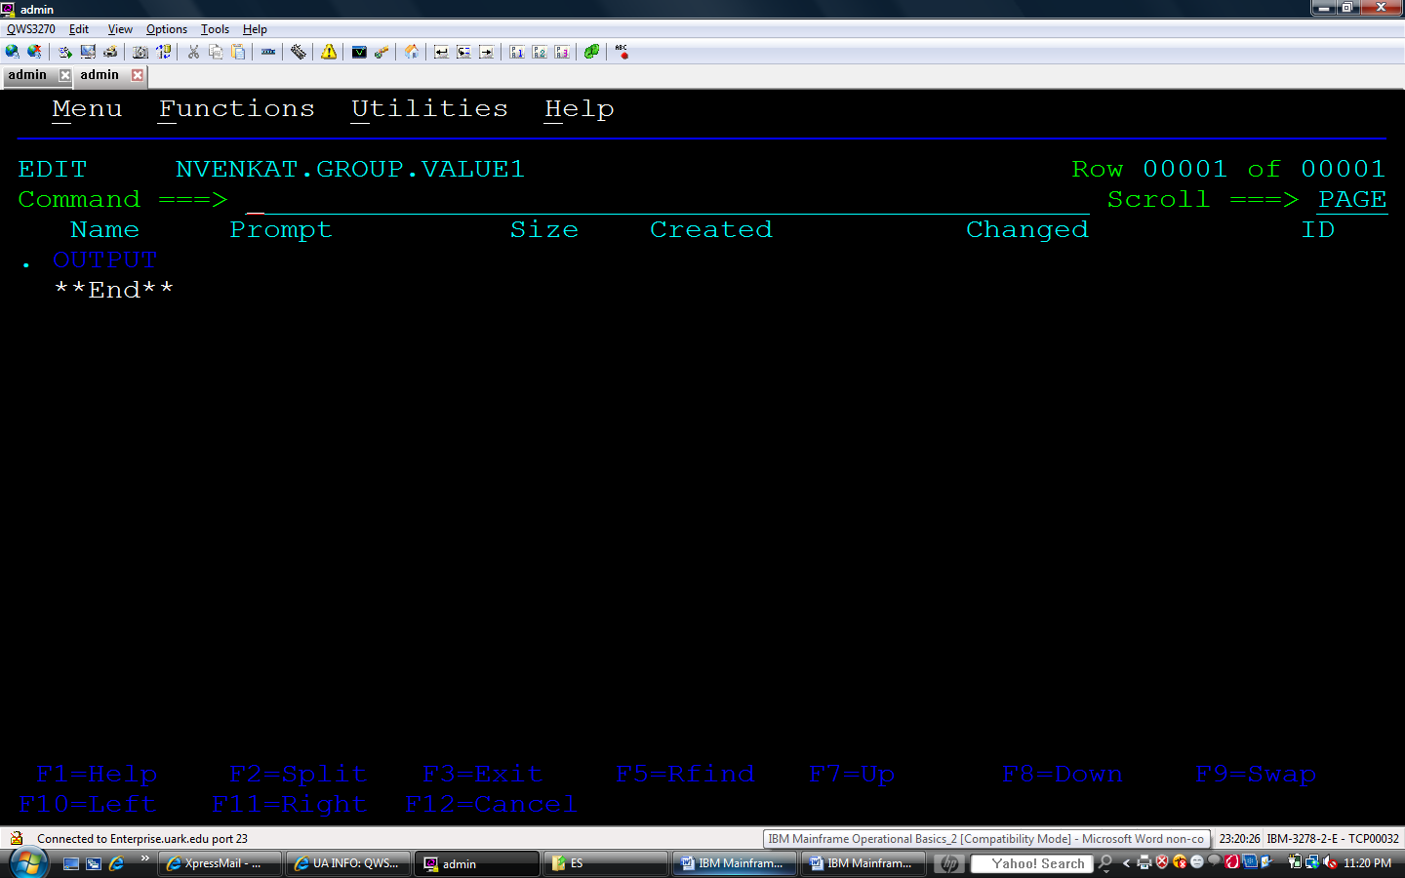

Editing Commands to use when Editing Members in ISPF

Line Commands – used in the editor in the column left of the text.
Inserting lines
i Insert a single line following this line.
in Insert n lines following this line.

Copying lines
c Copy this line
cn Copy n lines starting with this line
cc Copy a block of lines – place cc on the first line in the block and on the last line in the block.

After typing the desired copy line command from the list above, it is necessary to specify where the lines should be placed. To do so, use the following commands:

a Place the copied line(s) after this line.
an Repeat the copied line(s) n times after this line.
b Place the copied line(s) before this line.
bn Repeat the copied line(s) n times before this line.

Example of cc with the a option. The results are on the next page.

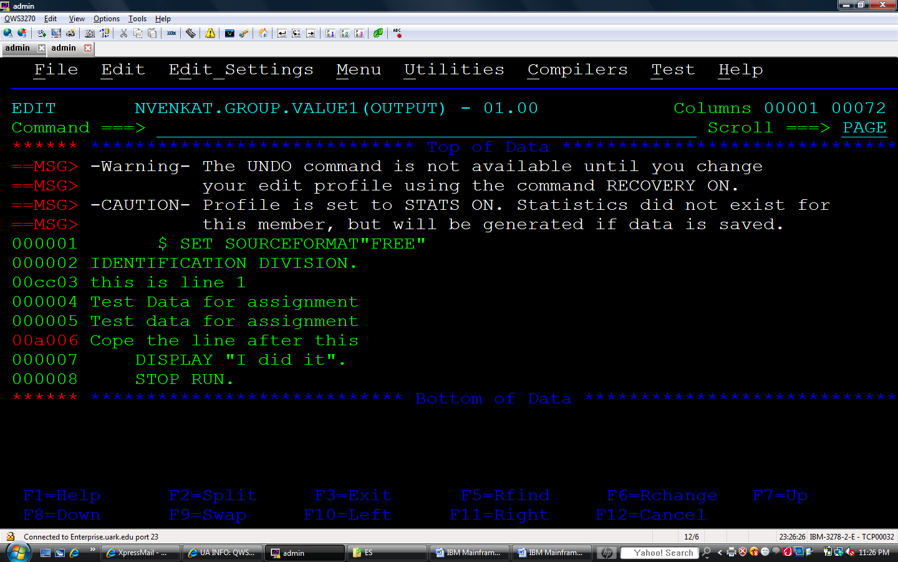

Moving lines
m Move this line
mn Move n lines starting with this line
mm Move a block of lines – place MM on the first line in the block and on the last line in the block.

After typing the desired move line command from the list above, it is necessary to specify where the lines should be placed. To do so, use the following commands:

a Place the moved line(s) after this line.
an Repeat the copied line(s) n times after this line.
b Place the copied line(s) before this line.
bn Repeat the copied line(s) n times before this line.

Deleting lines
d Delete this line.
dn Delete n lines starting with this line.
dd Delete the block of lines beginning with the first DD command and ending with the second DD command.

Repeating lines
r Repeat this line
rn Repeat this line n times.
rr Repeat a block of lines.
rrn Repeat a block of lines n times.

PRIMARY COMMANDS

Commands to use for Moving within the Editor with files larger than one screen:
TOP – returns to the top of the document
BOTTOM – goes to the bottom of the document
DOWN n – goes down n lines
UP n – goes up n lines

The CHANGE command
CHANGE string-1 string-2
Press F6 to repeat the Change to the next instance of string-1

CHANGE “phrase one” “phrase two”
Press F6 to repeat the Change to the next instance of phrase two

The Word ALL at the end of the CHANGE command will change all instances of string-1 to string-2 or all instances of phrase one to phrase two. Use this with caution!!!
CHANGE string-1 string-2 ALL
CHANGE “phrase one” “phrase two” ALL

The FIND command
FIND string
Press F5 to repeat the FIND

RESET will unhighlight the items found.

The NUMBER command
NUMBER ON to make the line numbers increase by 100s
RENUM will renumber the lines if lines have been added.

NUMBER OFF to make the line numbers increase by 1

SAVE
Save and continue work.

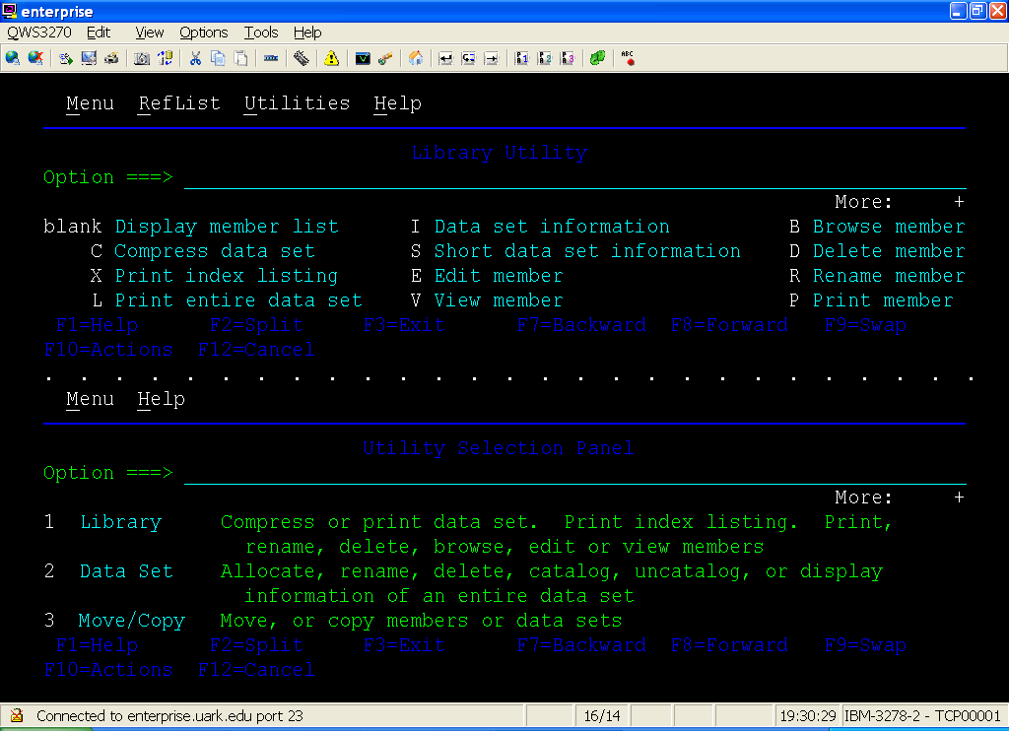

To split the screen, place your cursor on the screen in the vertical position where you want to split the screen and press the F2 key. To toggle between the two sessions, click on the session you want to work in or press the F9 key. To exit the current session, press F3 until you return to the ISPF Primary Option Menu and then press F3 one more time to close that part of the screen. You will then see a single screen again.

In summary, the Function Keys used in split screen are:
F2 to split the screen at the current cursor location
F9 to toggle between the two sessions
F3 to exit the current screen (it may be necessary to press F3 several times to exit back to the ISPF Primary Option Menu before exiting the split screen.)

Creating and Navigating among Multiple Sessions
1. To create a new session, you type Start and press the Enter key. This can be typed on the command or option line of any screen. For this example, choose option 2 from the ISPF Primary Option Menu and then type Start and press Enter. You should notice the white dots at the top of your screen as shown in the second screen shot below.
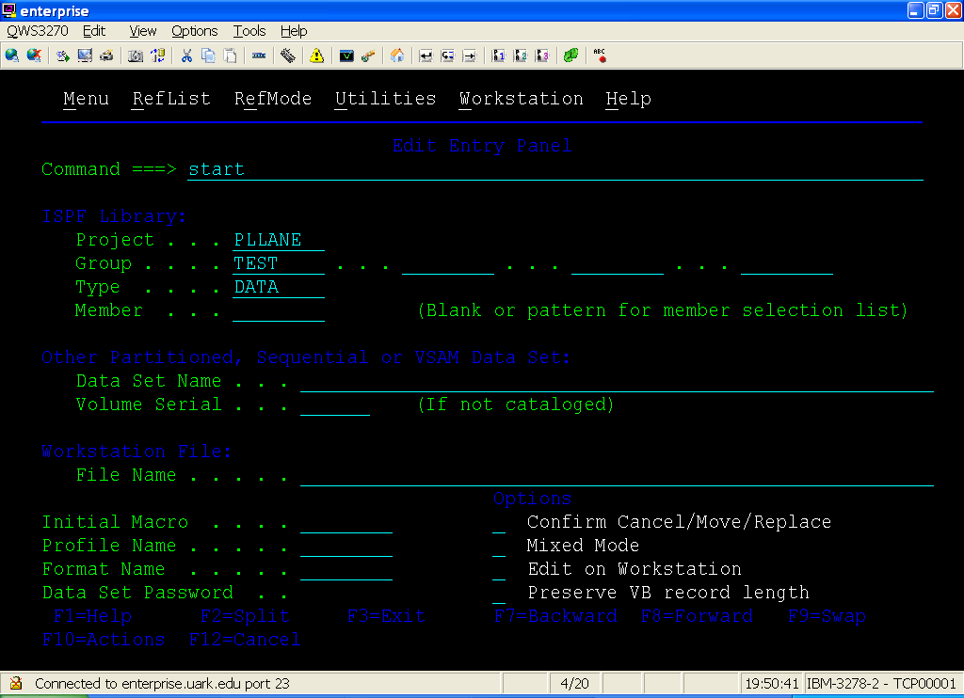

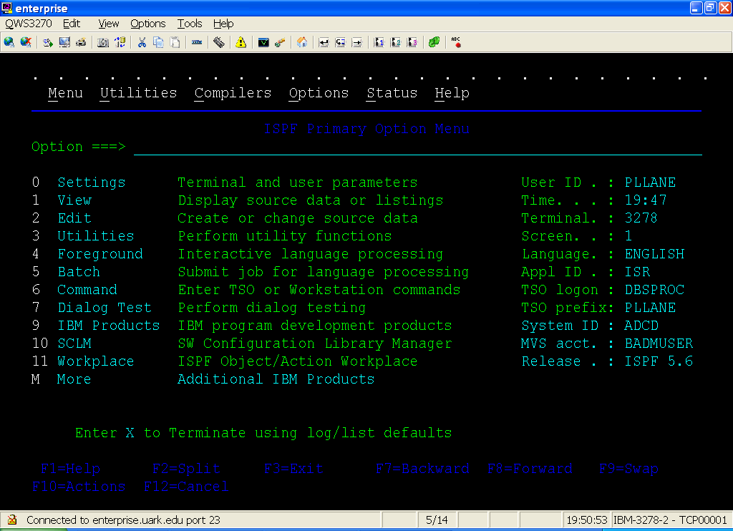
In this session, type 3 and press enter. This will take you to the Utility Selection Panel.
Type Start and press enter again so that you now have three sessions opened. Notice the white dots at the bottom of the screen as shown below:
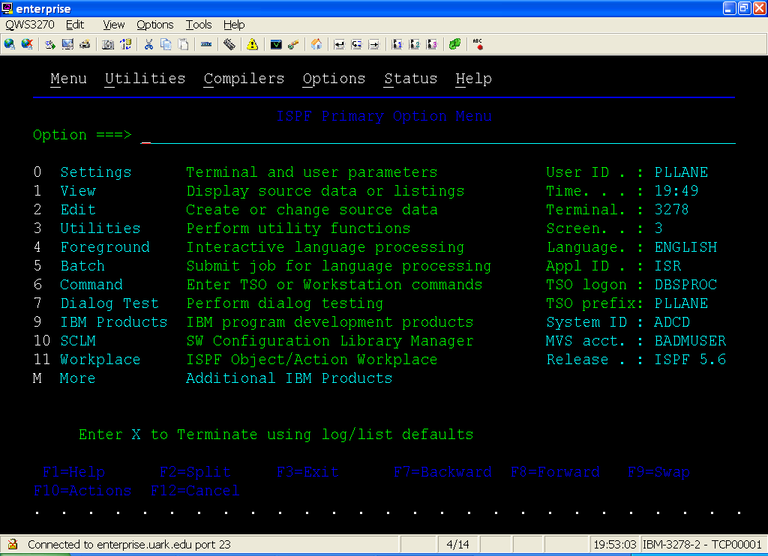

2. Type SWAP LIST and press the Enter key to display a listing of OPEN SESSIONS.
Notice in the second screen shot that the name is the menu name.
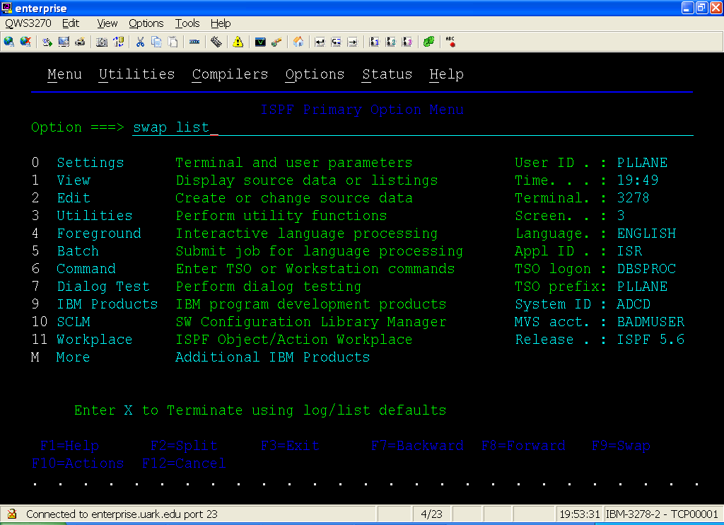
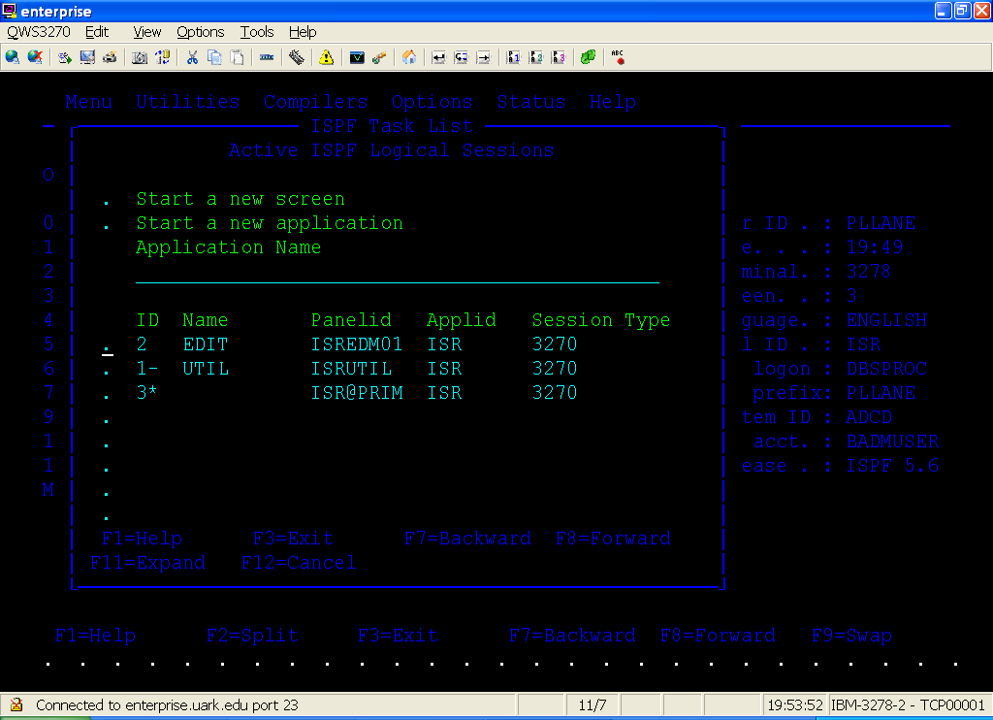
- Press enter on the session you wish to activate. (Choose the session with the Name of EDIT). You should then see the Edit Entry Panel:
- F9 switches between the last two sessions.
- To exit the current session, press the F3 key until you see the ISPF Primary Option Menu. Press the F3 one more time to exit the session.
- Look at the screen shot below –
- How many session are opened?
- Which one is the current session?
- What is the screen of the current session?
- What activity can you perform in the first session?
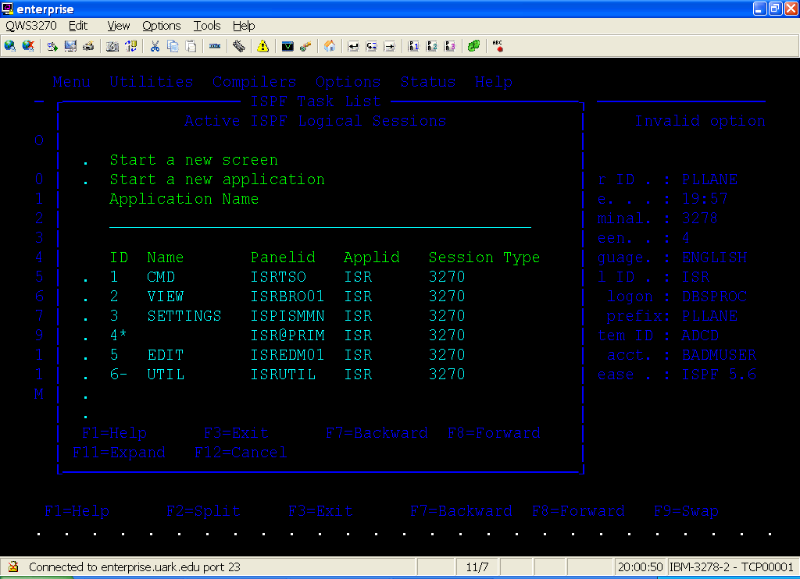

In Summary,
1. To create a new session, type Start and press the Enter key.
2. Type SWAP LIST and press the Enter key to display a listing of OPEN SESSIONS.
3. Press enter on the session you wish to activate.
4. F9 switches between the last two sessions.
5. To exit the current session, press the F3 key until you see the ISPF Primary Option Menu. Press the F3 one more time to exit the session.

BOUNDS
BOUNDS commands can be used to limit the columns to which editing commands apply. BOUNDS can be set in one of two ways. As a primary command, type at the Command Line
BOUNDS 10 80 to set the boundaries between columns 10 and 80. You do not notice anything on the screen, but try using the Find command to find something in a column before column 10. In the example below, BOUNDS 10 80 was entered at the command line. Then the command FIND WILL was issued. Notice the instance of WILL in line 6 was not highlighted.

To change the boundaries back, type BOUNDS and press enter.
To change only the left boundary, use an * in place of the right boundary (BOUNDS 10 *).
To change only the right boundary, use an * in place of the left boundary (BOUNDS * 30).

Another way to change the Bounds is to type BOUNDS on a line as shown below on line 3.

To change the bounds, type a less-than sign to mark the new left boundary and type a greater-than sign to make a new right boundary.

Try issuing a FIND command for something that is not in the Bounds. What happened?

TABS

To activate Tabs, at the Command line, Tabs On and Tabs Off are the commands.
To set Tabs, type Tabs on a line and press Enter.
Type an asterisk (*) immediately to the left of the desired position for the tab stop.
The asterisk defines the position for an attribute byte. The attribute byte actually takes up a position and displays as blank. However, you will not be able to type anything in this position. See lines 4 and 5 below. Notice the spaces after S in START and after P in PRESS.

Using a special character such as @ or # to use the tab stops:
At the Command line, type Tabs @ and press the enter key.

Type a line and insert @ in various places. Notice that after you press enter, the @ is no longer displayed and the text has moved to a tab position at each @.

Typing Tabs and pressing enter without a special character turns this feature off.

Splitting the Screen

It is possible to have two sessions running at the same time in a split screen mode.

