Accessing Linux on the Mainframe
Fall 2010

1. Access the Secure Shell client on your desktop:
Click on Start
Click on All Programs
Click on SSH Secure Shell
Click on Secure Shell Client
The following window will appear:
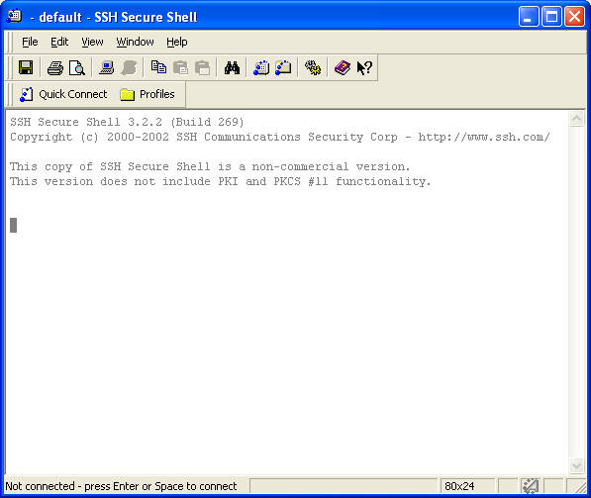

Click on Quick Connect. The following window will appear.
On campus, enter 130.184.26.149 or lnxwalton.waltoncollege.uark.edu as the Host Name. Enter your user id—must be lower case.
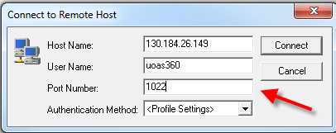
Off campus, you may need to enter the host of comp.uark.edu and your user id and the port must be 1022.

Click on Connect.
Enter the password “Initial1” (that’s the word Initial followed by a 1) and click OK

You will see this box. Click OK to open the default shell (bash)

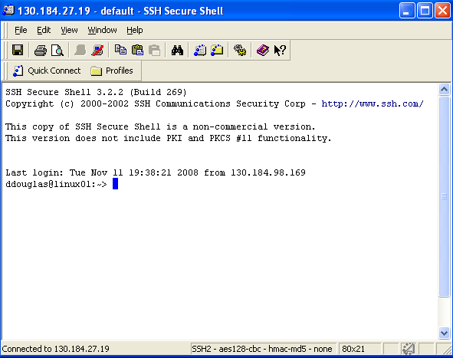
Command line prompt

Type passwd and press enter to change your password.
To exit Linux, type exit and press return. Close the SSH Secure Shell window.

