Microsoft Connection
Microsoft’s SQL Server Management Studio provides access to the following datasets: Sam’s Club, Dillard’s, Nielsen, Hallux Productions, Tyson Frozen Foods and Axciom.

- Log on to VMware

- Once your desktop has loaded, click the search icon on the bottom menu bar and type “SQL server m.” You should see the SQL Server Management icon appear.

- Launch the SQL Server Management Studio application. You will see a Connect to Server dialog box. In the server name box, type essql1.walton.uark.edu and click Connect.
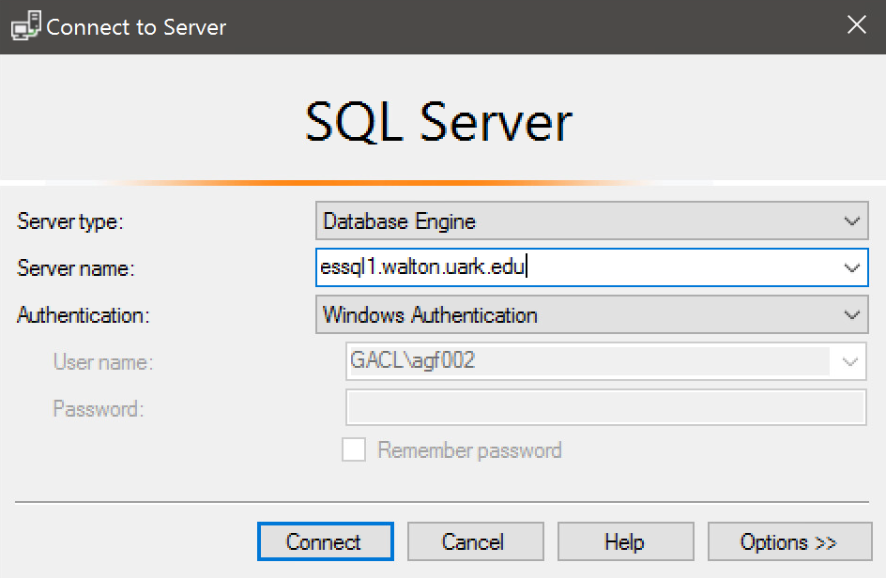

- Expand the Databases folder in the left Object Explorer Menu. From the list, select the database for the dataset you wish to query.
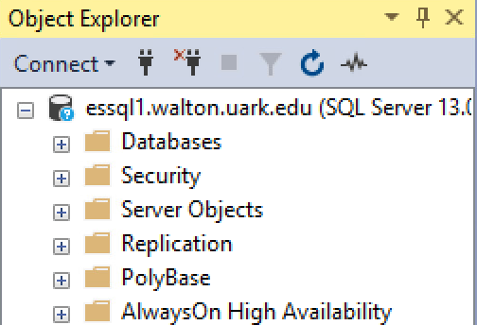

Sam’s Club

- In the databases folder, select the database called UA_SAMSCLUB_STAR. When you expand the Sam’s Club database, you should see a list of tables in the dataset. In order to access data from these tables, we will write queries to select certain data.

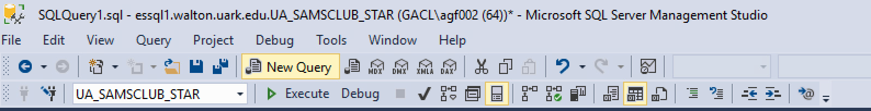
- On the top menu bar, select the New Query button. In the available databases bar, you should see UA_SAMSCLUB_STAR. (NOTE: If you do not see the Sam’s Club database listed, click the dropdown arrow and find it in the list.)

- You will now see a blank query builder window. Next, we’ll write SQL statements to pull out data we want to view. Let’s view data about members.

- Since Sam’s Club is a VERY large dataset, we will narrow the search to only the zip codes associated with Fayetteville, AR (72701, 72702, 72703 & 72704). In the query builder window type SELECT Member_Key, Zip_Code, Member_Status_Code, Elite_Status_Code FROM Member_Dimension WHERE (Zip_Code = ‘72701’) OR (Zip_Code = ‘72702’) OR (Zip_Code = ‘72703’) OR (Zip_Code = ‘72704’). Be sure to enclose the zip codes in single quotes! Your code should look like the picture below:
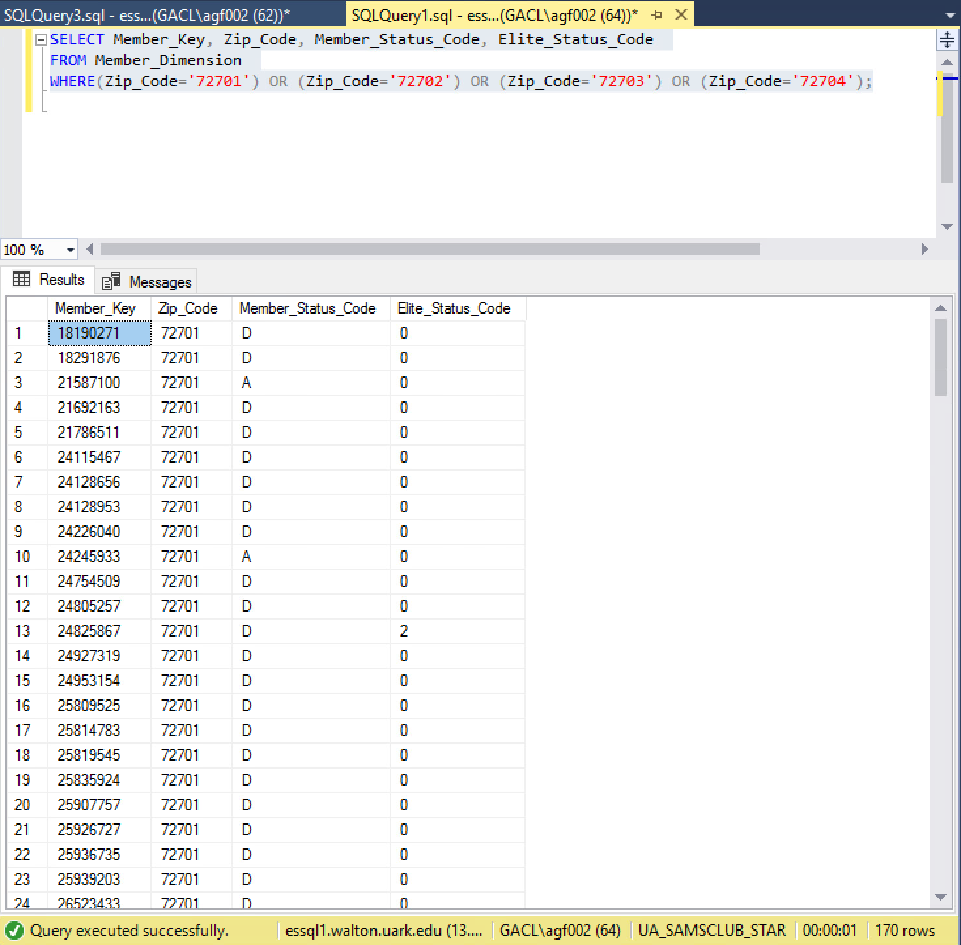
- Click the green execute button on the menu bar 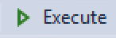 . SQL Server will display the records of any members who have one of the zip codes we specified in our query. You can drag the window to see more of the table. Your table should look like the picture to the right:

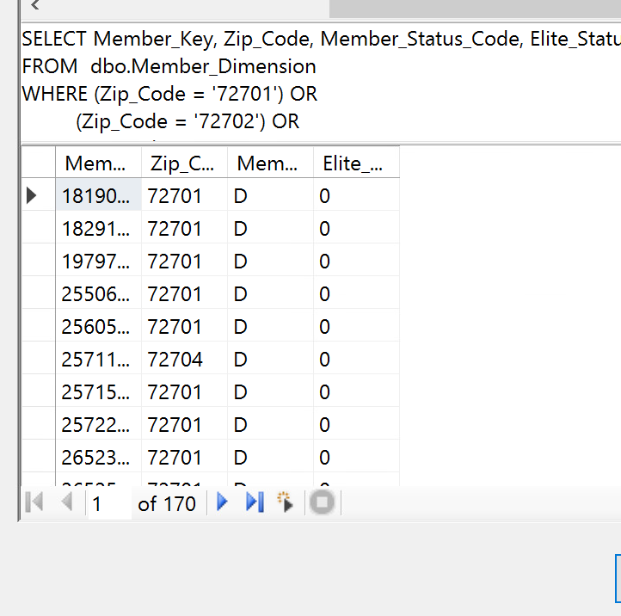

Dillard’s Department Stores

- In the databases folder, select the database called UA_Dillards_2016. When you expand the Dillard’s database, you should see a list of tables in the dataset. In order to access data from these tables, we will write queries to select certain data.

- On the top menu bar, select the New Query button. In the available databases bar, you should see UA_Dillard’s_2016. (NOTE: If you do not see the Dillard’s database listed, click the dropdown arrow and find it in the list.)
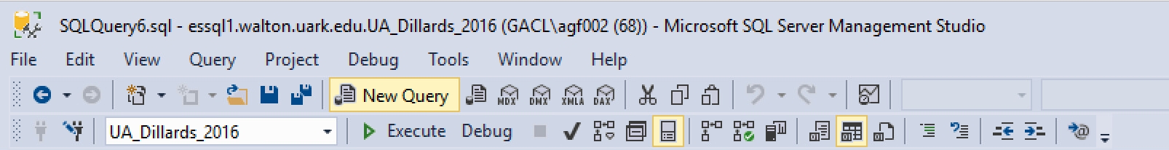
- You will now see a blank query builder window. Next, we’ll write SQL statements to pull out data we want to view. Let’s view data about transactions.

- Since Dillard’s is a VERY large dataset, we will narrow the search to select only transactions from June 30, 2016 where the sales price of the item was between $10 and $20 and the original price was greater than $50. In the query builder window type SELECT TRAN_DATE, ORIG_PRICE, SALE_PRICE, TRANSACTION_ID FROM TRANSACT WHERE SALE_PRICE BETWEEN 10 AND 20 AND ORIG_PRICE>50 AND TRAN_DATE=’2016-06-30’;. Be sure to enclose the date in single quotes! Your code should look like the picture below:
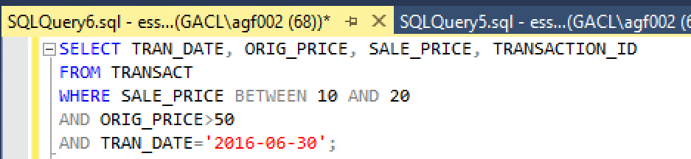

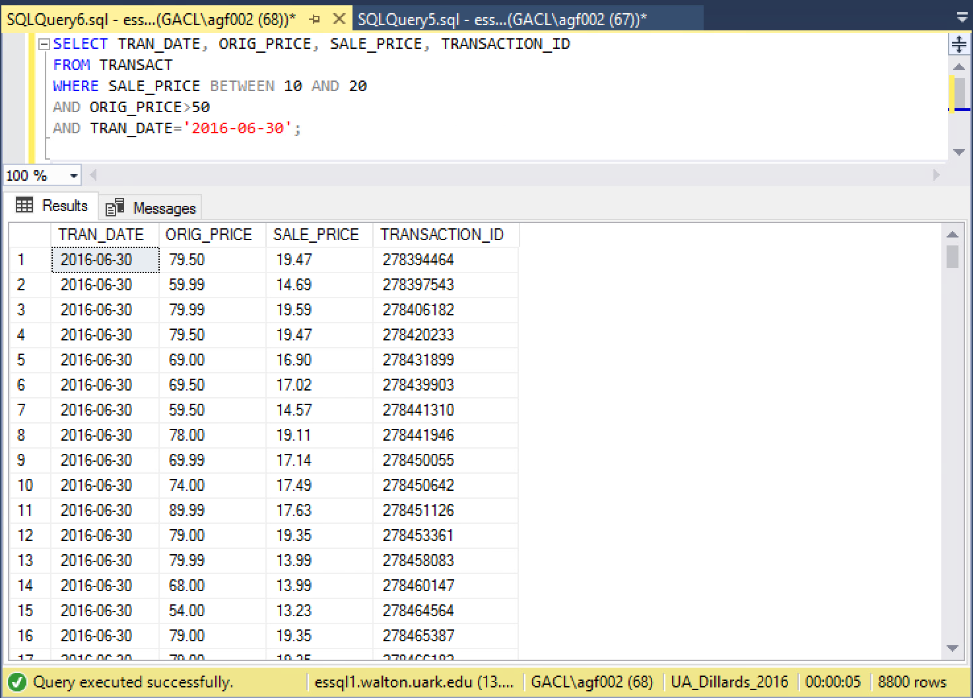
- Click the green execute button on the menu bar . SQL Server will display any transactions that meet the criteria we specified in our query. You can drag the window to see more of the table. Your table should look like the picture to the right:

Nielsen

- In the databases folder, select the database called Nielsen1. When you expand the Nielsen database, you should see a list of tables in the dataset. In order to access data from these tables, we will write queries to select certain data.

- On the top menu bar, select the New Query button. In the available databases bar, you should see Nielsen1. (NOTE: If you do not see the Nielsen database listed, click the dropdown arrow and find it in the list.)
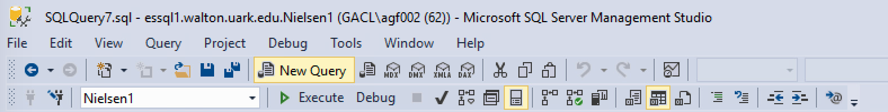
- You will now see a blank query builder window. Next, we’ll write SQL statements to pull out data we want to view. Let’s view data about products.

- Since Nielsen is a VERY large dataset, we will narrow the search to only products that are sold in bottles. In the query builder window type SELECT PROD_BRAND_KEY, PROD_BRAND_DESC, PROD_SHORT_DESC, PACKAGE_SHAPE FROM PRODUCT WHERE PACKAGE_SHAPE=’BOTTLE’ ORDER BY PROD_BRAND_DESC;. Be sure to enclose the word ‘bottle’ in single quotes! Your code should look like the picture below:
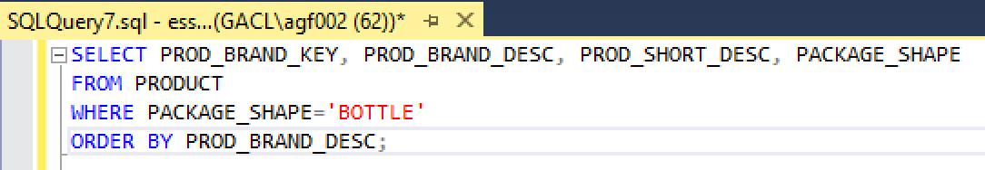
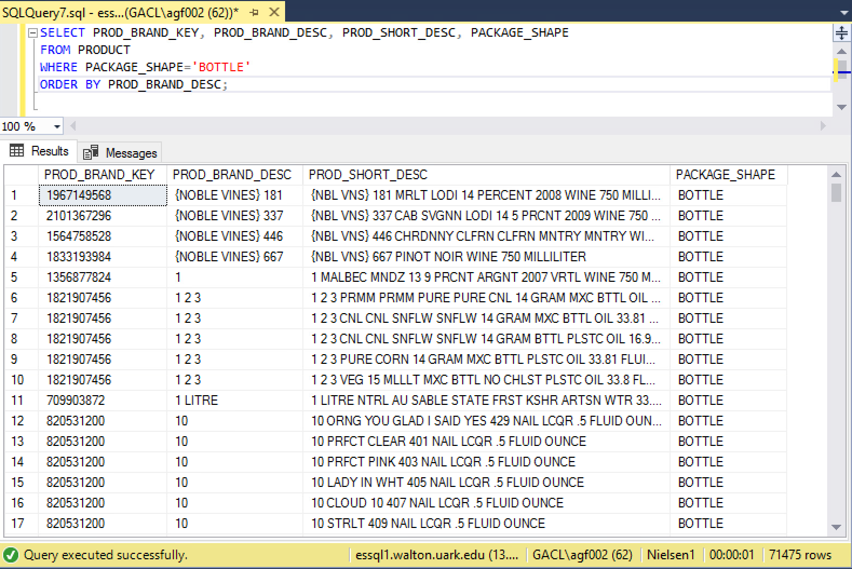
- Click the green execute button on the menu bar . SQL Server will display the records of products with the criteria we specified in our query. You can drag the window to see more of the table. Your table should look like the picture to the right:

Hallux Productions

- In the databases folder, select the database called UA_HALLUX. When you expand the Hallux database, you should see a list of tables in the dataset. In order to access data from these tables, we will write queries to select certain data.

- On the top menu bar, select the New Query button. In the available databases bar, you should see UA_HALLUX. (NOTE: If you do not see the Hallux database listed, click the dropdown arrow and find it in the list.)
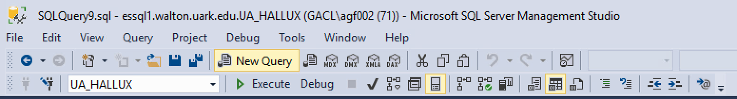
- You will now see a blank query builder window. Next, we’ll write SQL statements to pull out data we want to view. Let’s view data about songs.

- Since Hallux is a VERY large dataset, we will narrow the search to only songs that are longer than 3 minutes. In the query builder window type SELECT * FROM Song WHERE Duration_Seconds>180 ORDER BY Duration_Seconds DESC;. Your code should look like the picture below:
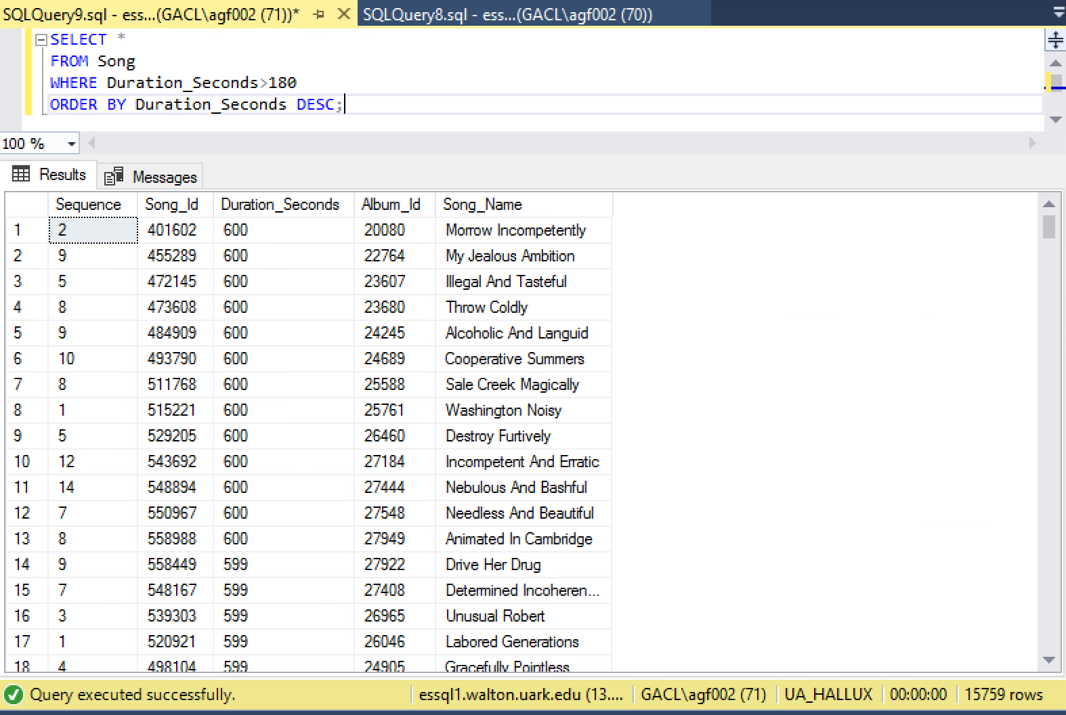
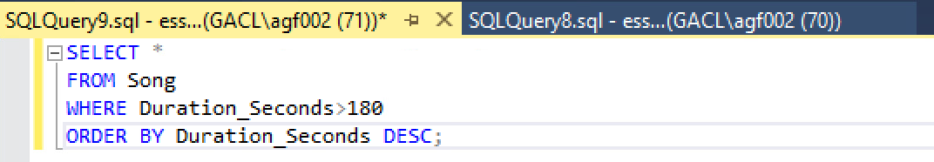
- Click the green execute button on the menu bar . SQL Server will display the records of songs with the criteria we specified in our query. You can drag the window to see more of the table. Your table should look like the picture to the right:

Tyson Frozen Foods

- In the databases folder, select the database called UA_TYSON_FOODS. When you expand the Tyson Foods database, you should see a list of tables in the dataset. In order to access data from these tables, we will write queries to select certain data.

- On the top menu bar, select the New Query button. In the available databases bar, you should see UA_TYSON_FOODS. (NOTE: If you do not see the Sam’s Club database listed, click the dropdown arrow and find it in the list.)
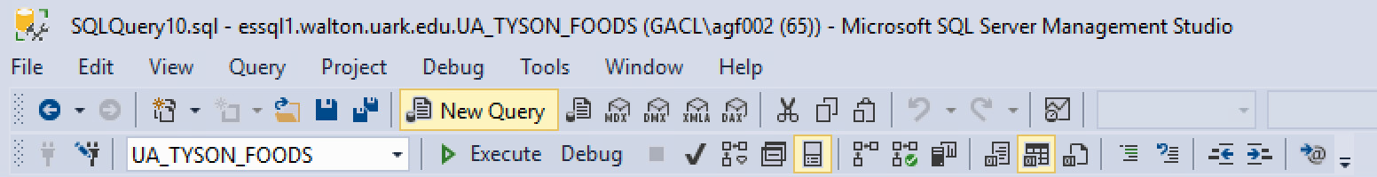
- You will now see a blank query builder window. Next, we’ll write SQL statements to pull out data we want to view. Let’s view data about customers

- Since Tyson Foods is a VERY large dataset, we will narrow the search to only the customers with names that start with “T.” In the query builder window type SELECT * FROM CUSTOMER WHERE CUSTOMER_NAME LIKE ‘T%’; Be sure to enclose the T in single quotes! Your code should look like the picture below:
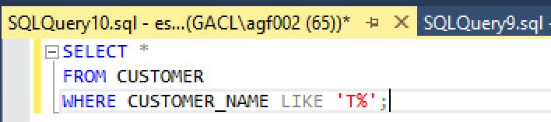

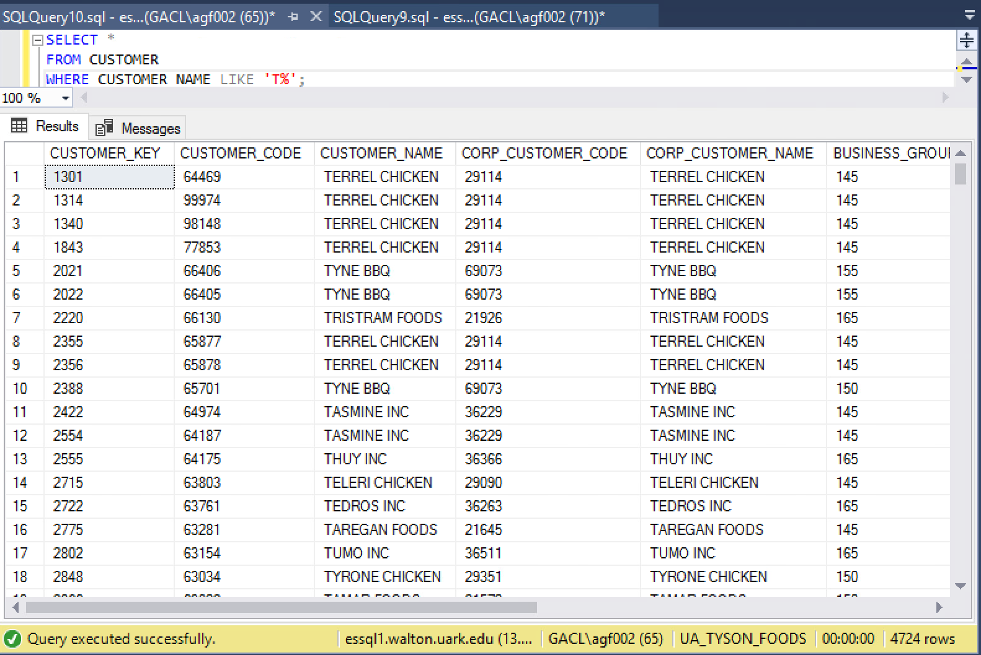
- Click the green execute button on the menu bar . SQL Server will display the records of any customers with a name that starts with T, like we specified in our query. You can drag the window to see more of the table. Your table should look like the picture to the right:

Axciom

