SAS Studio Exercise 02

Utilizing One-Way Frequencies

(7/24/2020)

Sources
Steve Nolan, Ron Freeze, Elizabeth Keiffer, Michael Gibbs, Jorge Moreda
Enterprise Systems, Sam M. Walton College of Business, University of Arkansas, Fayetteville
SAS® Studio. Release 5.2
SAS® VIYA® release V.03.05

Copyright © 2018 For educational uses only - adapted from sources with permission. No part of this publication may be reproduced, stored in a retrieval system, or transmitted, in any form or by any means, electronic, mechanical, photocopying, or otherwise, without the prior written permission from the author/presenter.

Use Case – One Way Frequencies
Razorback Stores is a local department store serving a metropolitan area. As a department store, they offer a wide variety of items and services and track sales through a point of sale system. Over the past several months, Razorback Stores performed a marketing campaign designed to promote and incentivize a loyalty program. Razorback Stores is interested in being more knowledgeable about their customers. More specifically, they want to know the distribution of promotional and regular customers that have shopped at their store. In order to understand this, we will be creating a one-way frequency analysis.

Step 0: Navigate to SAS Studio/Activate CAS Session
Before jumping into the One-Way Frequencies task, please refer back to SAS Studio 01 – Logging into the System to understand how to navigate to SAS Studio, activate a CAS session, and manage your data.
We will be using the Razorback Stores dataset which will be provided by your instructor and/or is available on blackboard. Once you have this dataset loaded on SAS Viya, following SAS Studio 01 – Logging into the System tutorial, load this dataset into memory in your personal user folder.

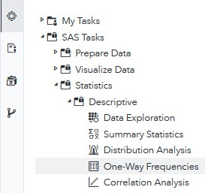
Step 1: Tasks
In order to access the One-Way Frequencies task within SAS Studio:
- Click on the Tasks icon located on the left-panel
- Expand the SAS Tasks folder
- Expand the Statistics folder
- Expand the Descriptive folder
- Double click One-Way Frequencies

Step 2: Select Data
Next, you need to select your data. In this case, we will be choosing Razorback Stores which can be found in our User folder. Under DATA,
- Click on the folder icon located at the right of the current dataset in place
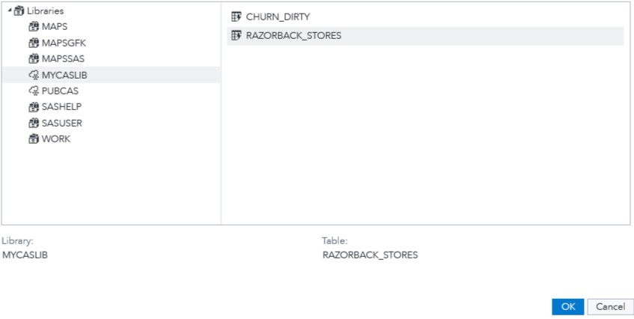
A new Choose a Table window will open,
- Click on Libraries
A list of all the folders available to you will be displayed.
- Click on MYCASLIB which references your User folder
All the different datasets found in your User folder will display.
- Click on RAZORBACK_STORES
- Click OK

Step 3: Select Variables
Once you have Razorback Stores dataset selected, we need to select the variables we want to work with. You will notice red font color text which require you to select a minimum of one variable.
Under ROLES,
- Click on the + sign to the right of Analysis variables
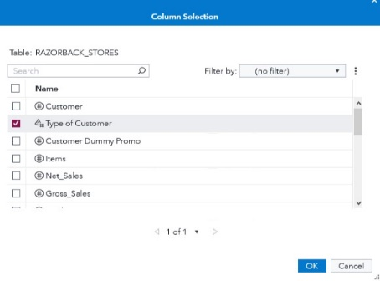
A new window will open, titled Column Selection.
- Select Type of Customer
- Click OK

Step 4: Modify Settings
One you have selected your dataset and variables,
- Click the OPTIONS tab
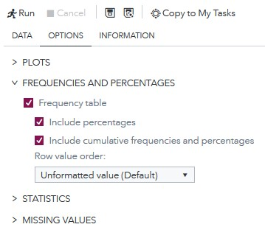
Here you may choose settings that would give you the desired outcome. For this scenario, we will keep the default settings:
- Frequency Table: checked
- Include Percentages: checked
- Include cumulative frequencies and percentages: checked
Once you make sure the above are selected,
- Click Run to execute the task
Notice that as we have selected a dataset, variables, and checked/unchecked settings, there is a code area on the right side of the screen that has been updating as we modified these.

Step 5: Results
Once the task has executed, you will have your One-Way Frequency to view in the right most pane.
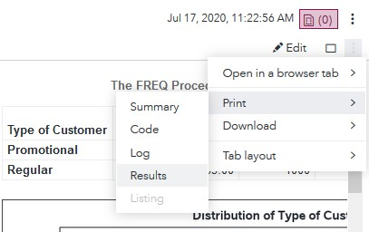
In order to better visualize the results, locate the three dots at the very right end of the screen under the current date and time.
- Click on these three dots and,
- Select Print
- Click on Results
A full-size screen will appear with the results, alongside a pop-up window that allows you to select where to print it.
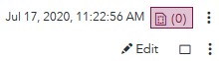
- Alternatively, you can click on the Maximize preview icon
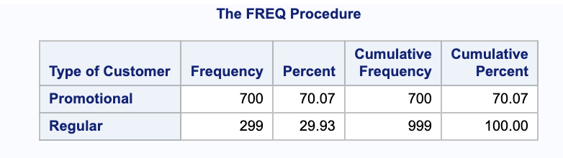
Notice that you have three visualizations to look at:
Table Format Results:

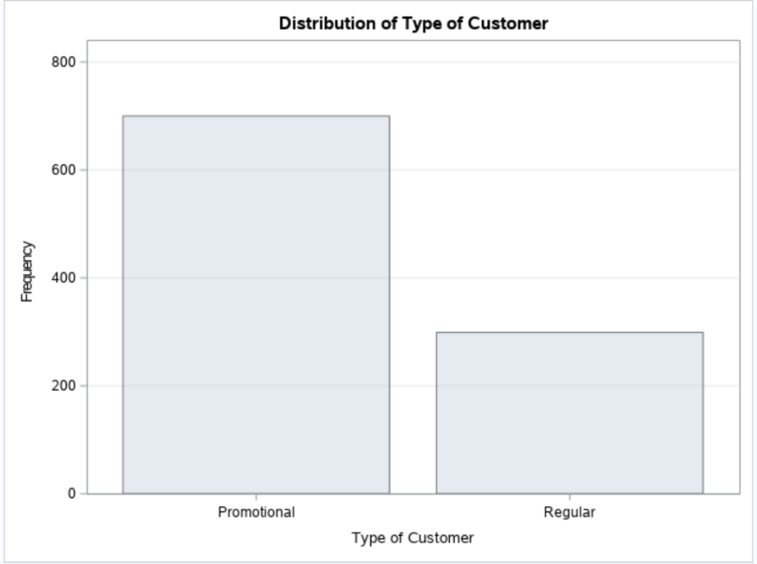
Distribution of Type of Customer:

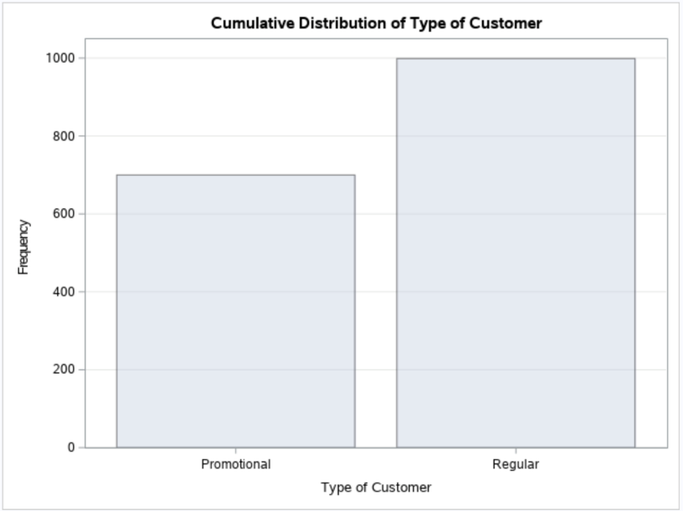
Cumulative Distribution of Type of Customer:

Congratulations, you have created a One-Way Frequency in SAS Studio!

