SAS Studio Exercise 07

One-Way ANOVA

(7/5/2022)

Sources
Steve Nolan, Ron Freeze, Elizabeth Keiffer, Michael Gibbs, Jorge Moreda, Shubhashree Sahoo
Enterprise Systems, Sam M. Walton College of Business, University of Arkansas, Fayetteville
SAS® Studio. Release 5.2
SAS® VIYA® release V.03.05

Copyright © 2018 For educational uses only - adapted from sources with permission. No part of this publication may be reproduced, stored in a retrieval system, or transmitted, in any form or by any means, electronic, mechanical, photocopying, or otherwise, without the prior written permission from the author/presenter.

Use Case – One-Way ANOVA
Razorback Stores is a local department store serving a metropolitan area. As a department store, they offer a wide variety of items and services and track sales through a point of sale system. Over the past several months, Razorback Stores performed a marketing campaign designed to promote and incentivize a loyalty program.
As a recent hire, your boss has asked you to analyze the following:
- Are net sales significantly different between people who pay with different methods of payment (RazorCard, MasterCard, MasterCard, Visa, and Other)?

Step 0: Navigate to SAS Studio/Activate CAS Session
Before jumping into the One-Way ANOVA task, please refer back to SAS Studio 01 – Logging into the System to understand how to navigate to SAS Studio, activate a CAS session, and manage your data.
We will be using the Razorback Stores dataset which will be provided by your instructor and/or is available on blackboard. Once you have this dataset loaded on SAS Viya, following SAS Studio 01 – Logging into the System tutorial, load this dataset into memory in your personal user folder.

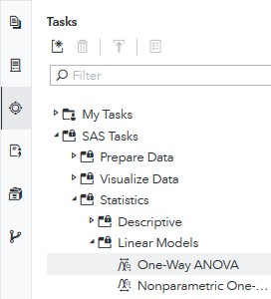
Step 1: Tasks
In order to access the One-Way ANOVA task within SAS Studio:
- Click on the Tasks icon located on the left-panel
- Expand the SAS Tasks folder
- Expand the Statistics folder
- Expand the Linear Models folder
- Find One-Way ANOVA and double click on it

Step 2: Select Data
Next, you need to select your data. In this case, we will be choosing Razorback Stores which can be found in our User folder. Under DATA,
- Click on the folder icon located at the right of the current dataset in place
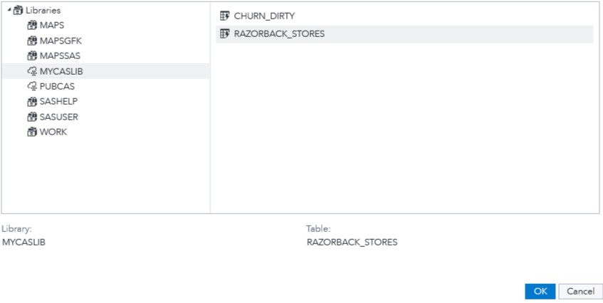
A new Choose a Table window will open,
- Click on Libraries
A list of all the folders available to you will be displayed.
- Click on MYCASLIB which references your User folder
All the different datasets found in your User folder will display.
- Click on RAZORBACK_STORES
- Click OK

Step 3: Select Variables
Once you have Razorback Stores dataset selected, we need to select the variables we want to work with. Notice the red font color text at the bottom. It requires you to select exactly one Dependent and one Categorical variable. Under ROLES, notice you have two subtitles:
  - Dependent variable: what your dependent variable is. For this tutorial: Net Sales
  - Categorical variable: what your categorical variable is. For this tutorial: Method_Payment
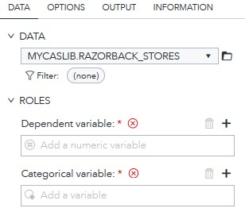
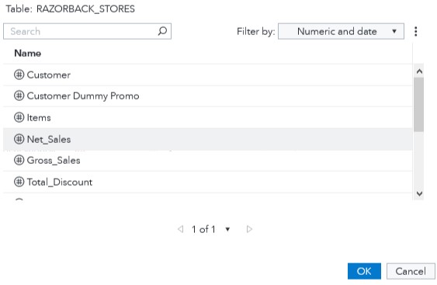
Under Dependent variable:,
- Click on the + sign
A new window will open,
- Select Net Sales
- Click OK
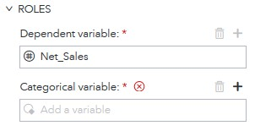
Under Categorical variable:,
- Click on the + sign
In the new window that opened,
- Select Method_Payment
- Click OK
Note that once you have set both dependent variable and categorical variables, the red text that required you to insert variables disappeared and code is automatically created to the right.

Step 4: Modify Settings
Once you have selected your dataset and variables, you can move to the OPTIONS tab where you can modify settings such as the type of test you want to perform and the alternative hypothesis
value you are testing for.
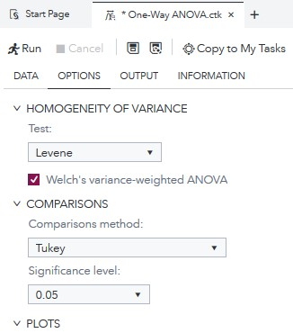
- Click on the OPTIONS tab
Under Test:,
- Select Levene from the dropdown menu
- Click to checkmark Welch’s variance-weighted ANOVA
Under Comparisons method:,
- Select Tukey from the dropdown menu
Under Significance level:,
- Select 0.05 from the dropdown menu
Keep all other settings as default.
Notice that as we have selected a dataset, variables, and checked/unchecked settings, there is a code area on the right side of the screen that has been updating as we modified these.
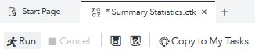
- Click Run

Step 5: Results
Once the task has executed, you will have your One-Way ANOVA results view in the right most pane.
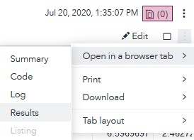
In order to better visualize the results, locate the three dots at the very right end of the screen under the current date and time.
- Click on these three dots and,
- Click on Open in a browser tab
- Click on Results
We see following tables and charts:
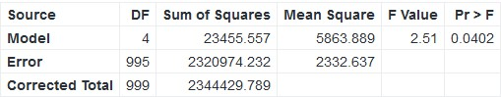
Overall ANOVA:

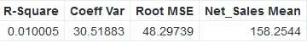
Fit Statistics:

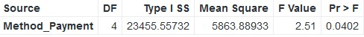
Type I Model ANOVA:
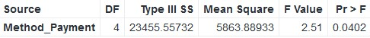
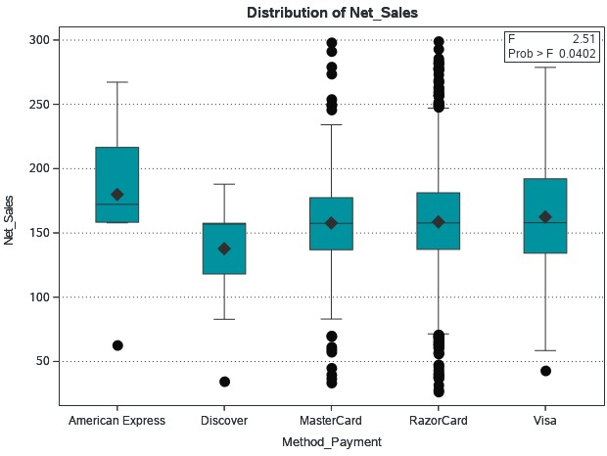
Type III Model ANOVA:

Box Plot:

Under the Results section, we can see the F-value, P-value, and Box plot of our variable. From here, we can accept or reject our null hypothesis.
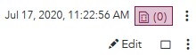
You can also click on the Maximize preview icon to see a clear view of Results

Congratulations, you have successfully performed a One-Way ANOVA on SAS Studio!

