SAS Studio Exercise 08

Two-Way ANOVA

(7/5/2022)

Sources
Steve Nolan, Ron Freeze, Elizabeth Keiffer, Michael Gibbs, Jorge Moreda, Shubhashree Sahoo
Enterprise Systems, Sam M. Walton College of Business, University of Arkansas, Fayetteville
SAS® Studio. Release 5.2
SAS® VIYA® release V.03.05

Copyright © 2018 For educational uses only - adapted from sources with permission. No part of this publication may be reproduced, stored in a retrieval system, or transmitted, in any form or by any means, electronic, mechanical, photocopying, or otherwise, without the prior written permission from the author/presenter.

Use Case – Two-Way ANOVA
Razorback Stores is a local department store serving a metropolitan area. As a department store, they offer a wide variety of items and services and track sales through a point of sale system. Over the past several months, Razorback Stores performed a marketing campaign designed to promote and incentivize a loyalty program.
As a recent hire, your boss has asked you to analyze the following:
- Are Net Sales significantly different between Types of Customers (Promotional and Regular) who pay with different Methods of Payment (RazorCard, Proprietary, MasterCard, and Visa)?

Step 0: Navigate to SAS Studio/Activate CAS Session
Before jumping into the Two-Way ANOVA task, please refer to SAS Studio 01 – Logging into the System to understand how to navigate to SAS Studio, activate a CAS Session, and manage your data.
We will be using the Razorback Stores dataset which will be provided by your instructor and/or is available on blackboard. Once you have this dataset loaded on SAS Viya, following SAS Studio 01 – Logging into the System tutorial, load this dataset into memory in your personal user folder.

Step 1: Tasks
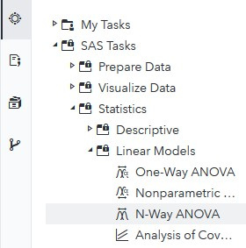
In order to access the Two-Way ANOVA task within SAS Studio:
- Click on the Tasks icon located on the left-panel
- Expand the SAS Tasks folder
- Expand the Statistics folder
- Expand the Linear Models folder
- Find N-Way ANOVA and double click on it

Step 2: Select Data
Next, you need to select your data. In this case, we will be choosing Razorback Stores which can be found in our User folder. Under DATA,
- Click on the folder icon located at the right of the current dataset in place
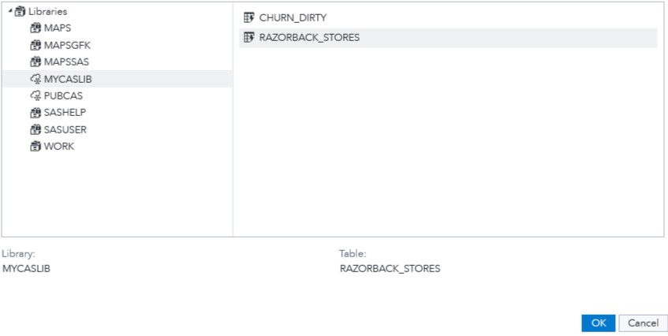
A new Choose a Table window will open,
- Click on Libraries
A list of all the folders available to you will be displayed.
- Click on MYCASLIB which references your User folder
All the different datasets found in your User folder will display.
- Click on RAZORBACK_STORES
- Click OK

Step 3: Select Variables
Once you have Razorback Stores dataset selected, we need to select the variables we want to work with. Notice the red font color text at the bottom. It requires you to select exactly one Dependent variable and 2 Factors. Under ROLES, notice you have two subtitles:
  - Dependent variable: what your dependent variable is. For this tutorial: Net Sales
  - Factors: what your independent variables are. For this tutorial: Type of Customer and Method_Payment
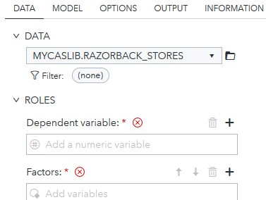
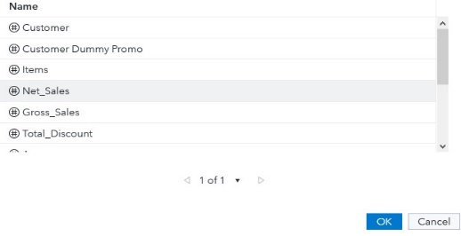
Under Dependent variable:,
- Click on the + sign
A new window will open,
- Select Net Sales
- Click OK
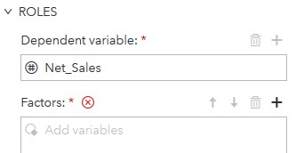
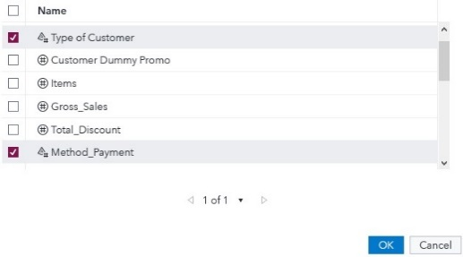
Under Factors:,

- Click on the + sign
In the new window that opened,
- Click to checkmark the boxes to the left of Type of Customer and Method_Payment
- Click OK
Note that once you have set both dependent variable and categorical variables, there is still one red text at the very bottom that asks you to add one or more effects to the model.

Step 4: Modify Settings
Once you have selected your dataset and variables, you can move to the MODEL tab where you will add one or more effects to the model.
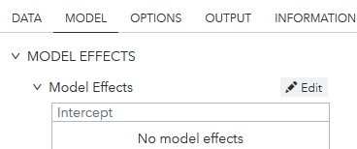
- Click on the MODEL tab
- Click on Edit, located to the right of Model Effects
A new window will open called Model Effects Builder.
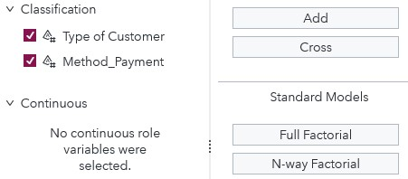
On the left side, under Classification,
- Click to checkmark the boxes to the left of Type of Customer and Method_Payment
Under Standard Models,
- Click on Full Factorial

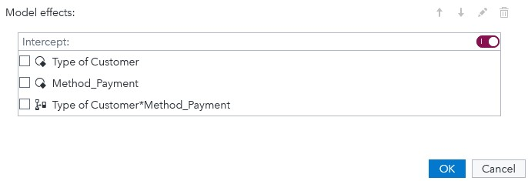
Under Model effects in the right pane you should now see the previous variables added as well as a Type of Customer*Method_Payment effect.
- Click OK
Notice that as we have selected a dataset, variables, and checked/unchecked settings, there is a code area on the right side of the screen that has been updating as we modified these.
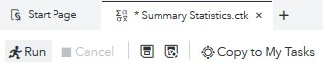
- Click Run

Step 5: Results
Once the task has executed, you will have your Two-Way ANOVA results view in the right most pane.
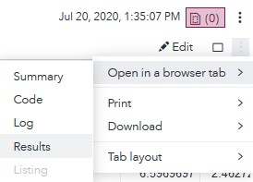
In order to better visualize the results, locate the three dots at the very right end of the screen under the current date and time.
- Click on these three dots and,
- Click on Open in a browser tab
- Click on Results
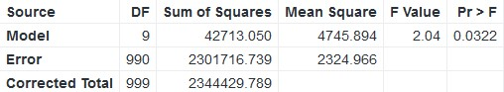
We see following tables and charts:
Overall ANOVA:
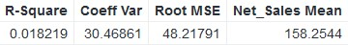
Fit Statistics:
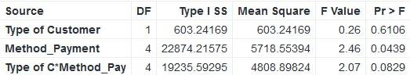
Type I Model ANOVA:
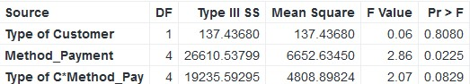
Type III Model ANOVA:
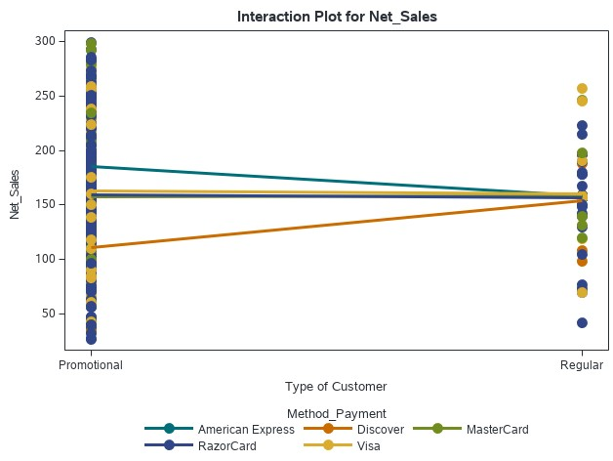
Interaction Plot:

Under the Results section, we can see the F-value, P-value, and Interaction plot of our variable. From here, we can accept or reject our null hypothesis.
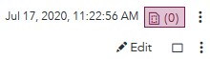
You can also click on the Maximize preview icon to see a clear view of Results

Congratulations, you have successfully performed a Two-Way ANOVA on SAS Studio!

