SAS Studio Exercise 09

Hypothesis Testing for Proportions

(7/23/2020)

Sources
Steve Nolan, Ron Freeze, Elizabeth Keiffer, Michael Gibbs, Jorge Moreda
Enterprise Systems, Sam M. Walton College of Business, University of Arkansas, Fayetteville
SAS® Studio. Release 5.2
SAS® VIYA® release V.03.05

Copyright © 2018 For educational uses only - adapted from sources with permission. No part of this publication may be reproduced, stored in a retrieval system, or transmitted, in any form or by any means, electronic, mechanical, photocopying, or otherwise, without the prior written permission from the author/presenter.

Use Case – Hypothesis Testing for Proportions
Razorback Stores is a local department store serving a metropolitan area. As a department store, they offer a wide variety of items and services and track sales through a point of sale system. Over the past several months, Razorback Stores performed a marketing campaign designed to promote and incentivize a loyalty program.
As a recent hire, your boss has asked you to analyze the following:
- Is the proportion of promotional customers less than 50%?

Step 0: Navigate to SAS Studio/Activate CAS Session
Before jumping into the Hypothesis Testing task, please refer back to SAS Studio 01 – Logging into the System to understand how to navigate to SAS Studio, activate a CAS session, and manage your data.
We will be using the Razorback Stores dataset which will be provided by your instructor and/or is available on blackboard. Once you have this dataset loaded on SAS Viya, following SAS Studio 01 – Logging into the System tutorial, load this dataset into memory in your personal user folder.

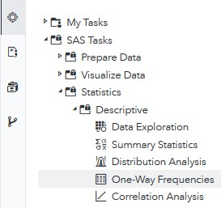
Step 1: Tasks
In order to access the One-Way Frequencies task within SAS Studio:
- Click on the Tasks icon located on the left-panel
- Expand the SAS Tasks folder
- Expand the Statistics folder
- Expand the Descriptive folder
- Double click One-Way Frequencies

Step 2: Select Data
Next, you need to select your data. In this case, we will be choosing Razorback Stores which can be found in our User folder. Under DATA,
- Click on the folder icon located at the right of the current dataset in place
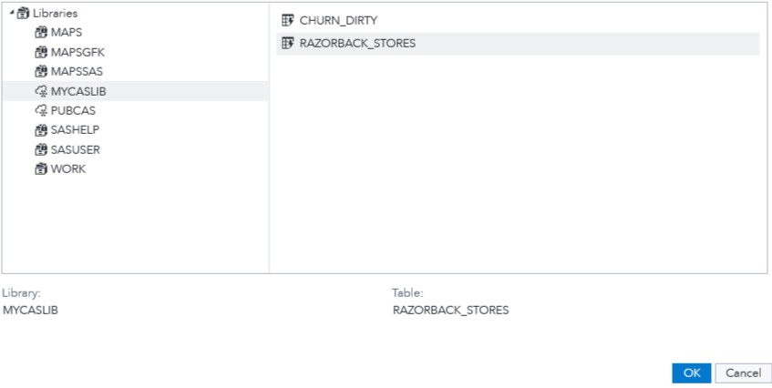
A new Choose a Table window will open,
- Click on Libraries
A list of all the folders available to you will be displayed.
- Click on MYCASLIB which references your User folder
All the different datasets found in your User folder will display.
- Click on RAZORBACK_STORES
- Click OK

Step 3: Select Variables
Once you have Razorback Stores dataset selected, we need to select the variables we want to work with. You will notice red font color text which requires you to select a minimum of one variable. Under ROLES, notice you have one subtitle:
  - Analysis variables: what variable you want to analyze. For this tutorial: Type of Customer
- Click on the + sign to the right of Analysis variables
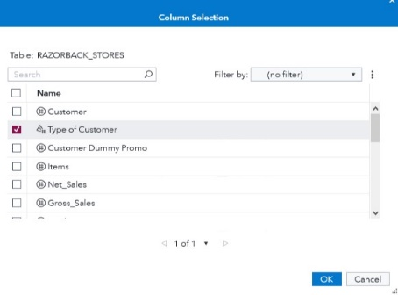
A new window will open, titled Column Selection.
- Select Type of Customer
- Click OK

Step 4: Modify Settings
Once you have selected your dataset and variables, you can move to the Options tab where you will modify the characteristics of the model you want to run:
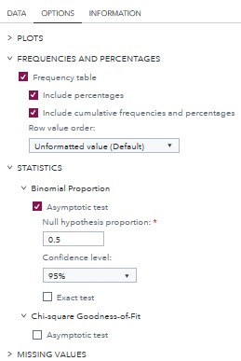
- Click on the OPTIONS tab
- Expand the STATISTICS option
Under Binomial Proportion,
- click on the Asymptotic test box
- Set your Null hypothesis proportion to 0.5
- Set your Confidence level to 95%
Notice that as we have selected a dataset, variables, and checked/unchecked settings, there is a code area on the right side of the screen that has been updating as we modified these.

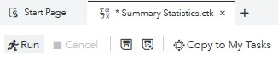
- Click Run

Step 5: Results
Once the task has executed, you will have your One-Way Frequency results view in the right most pane.
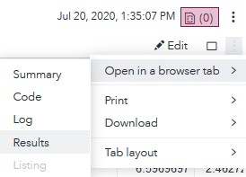
In order to better visualize the results, locate the three dots at the very right end of the screen under the current date and time.
- Click on these three dots and,
- Click on Open in a browser tab
- Click on Results
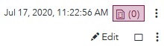
- Alternatively, you can click on the Maximize preview icon
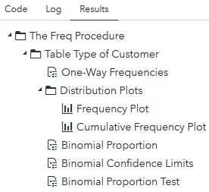
Under Results, notice that you have a folder labeled The Freq Procedure, and two folders under it named Table Type of Customer, and Distribution Plots, where you can find subfolders within.
- Expand all the folders
- Click on the files inside
You will notice that as you click on these files, the tables and plots on the right window will change.
When clicking on any of these sections, SAS Studio will take you to the table/graph to which that section references in the right.
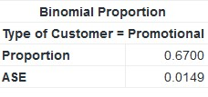
Binomial Proportion:

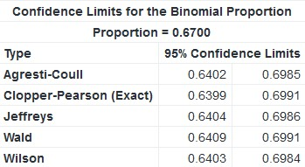
Binomial Confidence Limits:

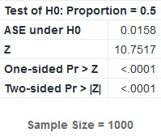
Binomial Proportion Test:

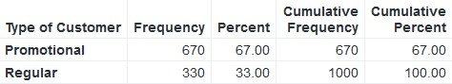
One-Way Frequencies:

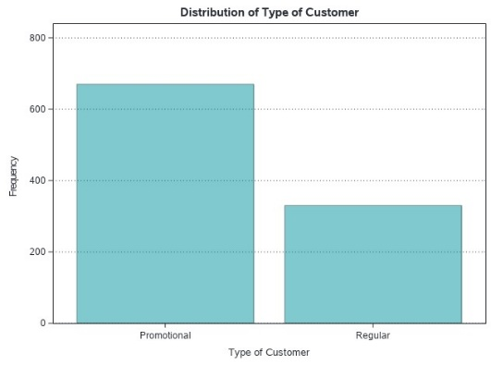
Frequency Plot

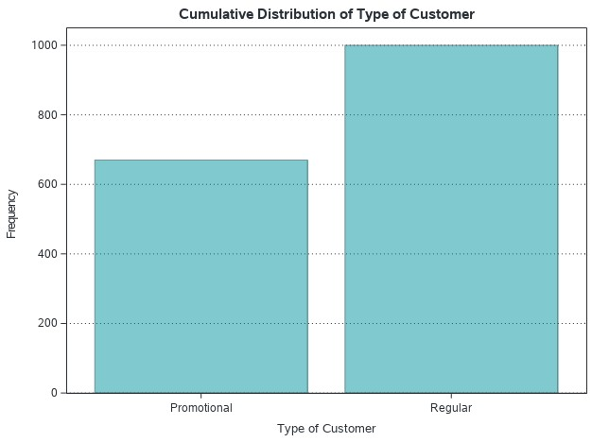
Cumulative Frequency Plot

Under the Results section, we can see the z value and p-value. From here, we can accept or reject our null hypothesis.

Congratulations, you have successfully performed a Hypothesis Testing for Proportions on SAS Studio!

