SAS Studio Exercise 10

Linear Regression with Assumptions

(7/24/2020)

Sources
Steve Nolan, Ron Freeze, Elizabeth Keiffer, Michael Gibbs, Jorge Moreda
Enterprise Systems, Sam M. Walton College of Business, University of Arkansas, Fayetteville
SAS® Studio. Release 5.2
SAS® VIYA® release V.03.05

Copyright © 2018 For educational uses only - adapted from sources with permission. No part of this publication may be reproduced, stored in a retrieval system, or transmitted, in any form or by any means, electronic, mechanical, photocopying, or otherwise, without the prior written permission from the author/presenter.

Use Case – Linear Regression
Razorback Stores is a local department store serving a metropolitan area. As a department store, they offer a wide variety of items and services and track sales through a point of sale system. Over the past several months, Razorback Stores performed a marketing campaign designed to promote and incentivize a loyalty program.
As a recent hire, your boss has asked you to analyze the following:
- Are net sales significantly different between people who pay with different methods of payment (RazorCard, MasterCard, MasterCard, Visa, and Other)?

Step 0: Navigate to SAS Studio/Activate CAS Session
Before jumping into Linear Regression task, please refer back to SAS Studio 01 – Logging into the System to understand how to navigate to SAS Studio, Activate a CAS Session, and Manage your Data.
We will be using Razorback Stores dataset which will be provided by your instructor and/or is available on blackboard. Once you have this dataset loaded on SAS Viya, following SAS Studio 01 – Logging into the System tutorial, load this dataset into memory in your personal User folder.

Step 1: Tasks
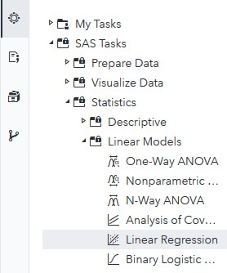
In order to access the Linear Regression task within SAS Studio:
- Click on the Tasks icon located on the left-panel
- Expand the SAS Tasks folder
- Expand the Statistics folder
- Expand the Linear Models folder
- Double click Linear Regression

Step 2: Select Data
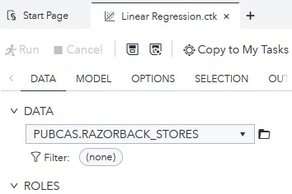
Next, you need to select your data. In this case, we will be choosing Razorback Stores which can be found in our User folder. Under DATA,
- Click on the folder icon located at the right of the current dataset in place
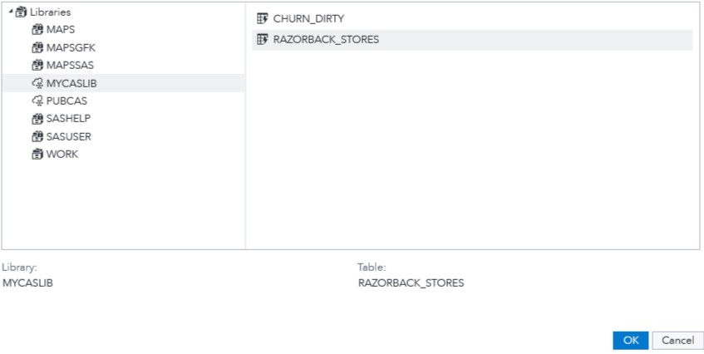
A new Choose a Table window will open,
- Click on Libraries
A list of all the folders available to you will be displayed.
- Click on MYCASLIB which references your User folder
All the different datasets found in your User folder will display.
- Click on RAZORBACK_STORES
- Click OK

Step 3: Select Variables
Once you have Razorback Stores dataset selected, we need to select the variables we want to work with. Notice the red font color text at the bottom. It requires you to select exactly one Dependent and at least one Classification or Continuous variable. Under ROLES, notice you have three subtitles:
  - Dependent variable: what your dependent variable is. For this tutorial: Net Sales
  - Classification variables: (independent variable) what your categorical variable is. For this tutorial: Method of Payment
  - Continuous variables: (independent variable) what your continuous variable is. For this tutorial: none used
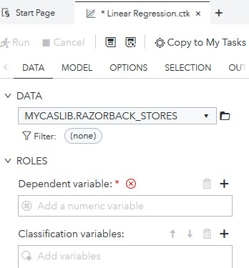
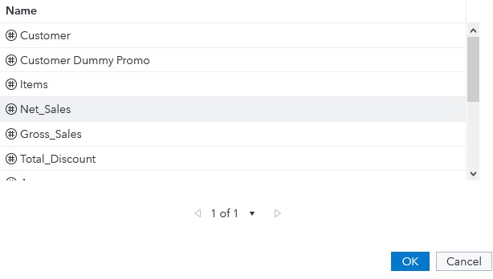
- Click on the + sign to the right of Dependent variable
A new window will open, titled Column Selection.
- Select Net Sales
- Click OK
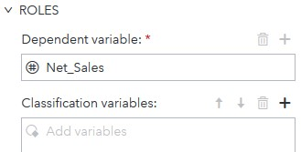
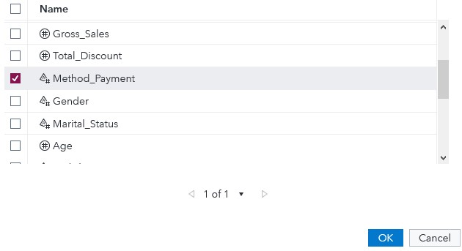
- Click on the + sign to the right of Classification variables
In the new window that opened,
- Scroll down to find Method of Payment
- Click to checkmark the box to the left of Method of Payment
- Click OK
Note that once you have set both a dependent variable and an independent variable, there is still one red text at the very bottom that asks you to add one or more effects to the model.

Step 4: Modify Settings
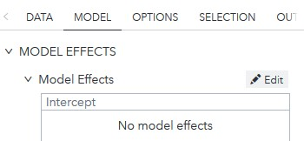
Once you have selected your dataset and variables, you can move to the Model tab where you will add effects to the model.
- Click on the MODEL tab
- Click on Edit next to Model Effects
A Model Effects Builder window will open.
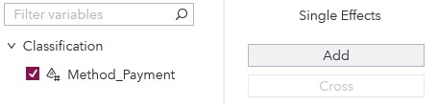
- Click to checkmark the box to the left of Method of Payment
- Click on Add
- Click OK

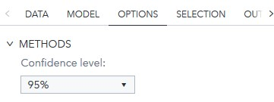
- Click on the OPTIONS tab
- Select 95% from the Confidence level dropdown menu
Notice that as we have selected a dataset, variables, and checked/unchecked settings, there is a code area on the right side of the screen that has been updating as we modified these.
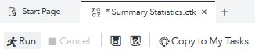
- Click Run

Step 5: Results
Once the task has executed, you will have your Linear Regression results view in the right most pane.
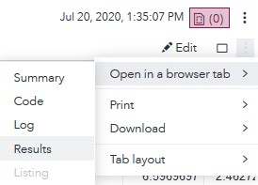
In order to better visualize the results, locate the three dots at the very right end of the screen under the current date and time.
- Click on these three dots and,
- Click on Open in a browser tab
- Click on Results
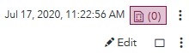
- Alternatively, you can click on the Maximize preview icon
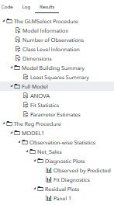
Under Results, notice that you have different folders where you can find subfolders within.
- Expand all the folders
- Click on the files inside
You will notice that as you click on these files, the tables and plots on the right window will change.
When clicking on any of these sections, SAS Studio will take you to the table/graph to which that section references in the right.
For the analysis we will be looking at the Full Model folder files that and the Diagnostic Plots.
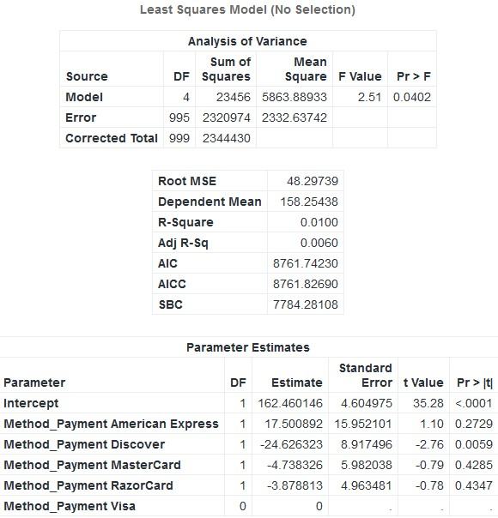
Full Model:

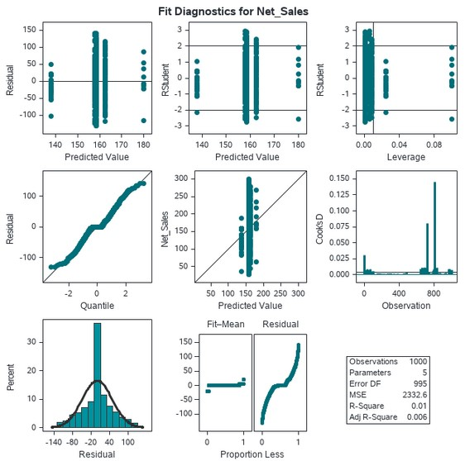
Diagnostic Plots:

Congratulations, you have successfully performed a Linear Regression on SAS Studio!

