

**Guide to Teradata SQL Assistant 12.0**

**After Connecting to Remote Desktop:**

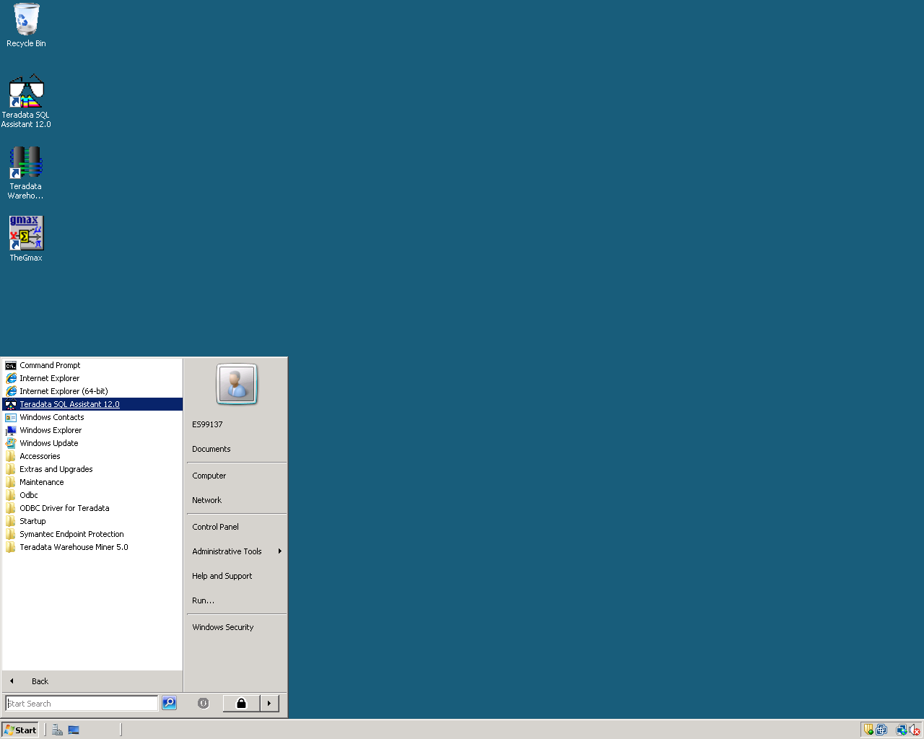Click Start🡪Teradata SQL Assistant 12.0

Next Connect by clicking the connect Icon in the upper left corner of your window.



Click on “Machine Data Source” Tab and select “Walton College Teradata.” Click “OK”

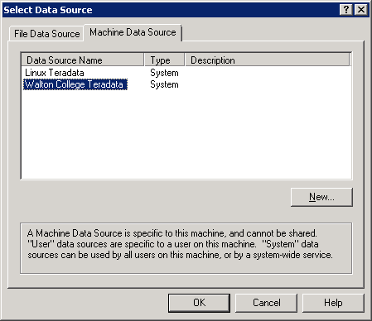

Enter your **Username** and **Password** Click “OK”

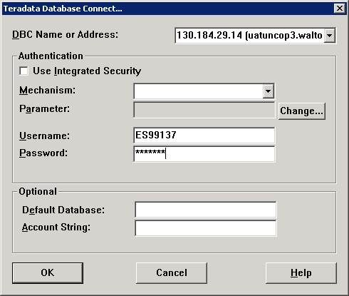

**Adding a Database**

If the desired database does not show up in the Explorer Tree, it can be added to the list of available databases by right-clicking in the Explorer Tree and selecting “Add Database” as shown below. Simply type the name of the database to connect to when prompted (UA_DILLARDS or UA_SAMSCLUB, for example).

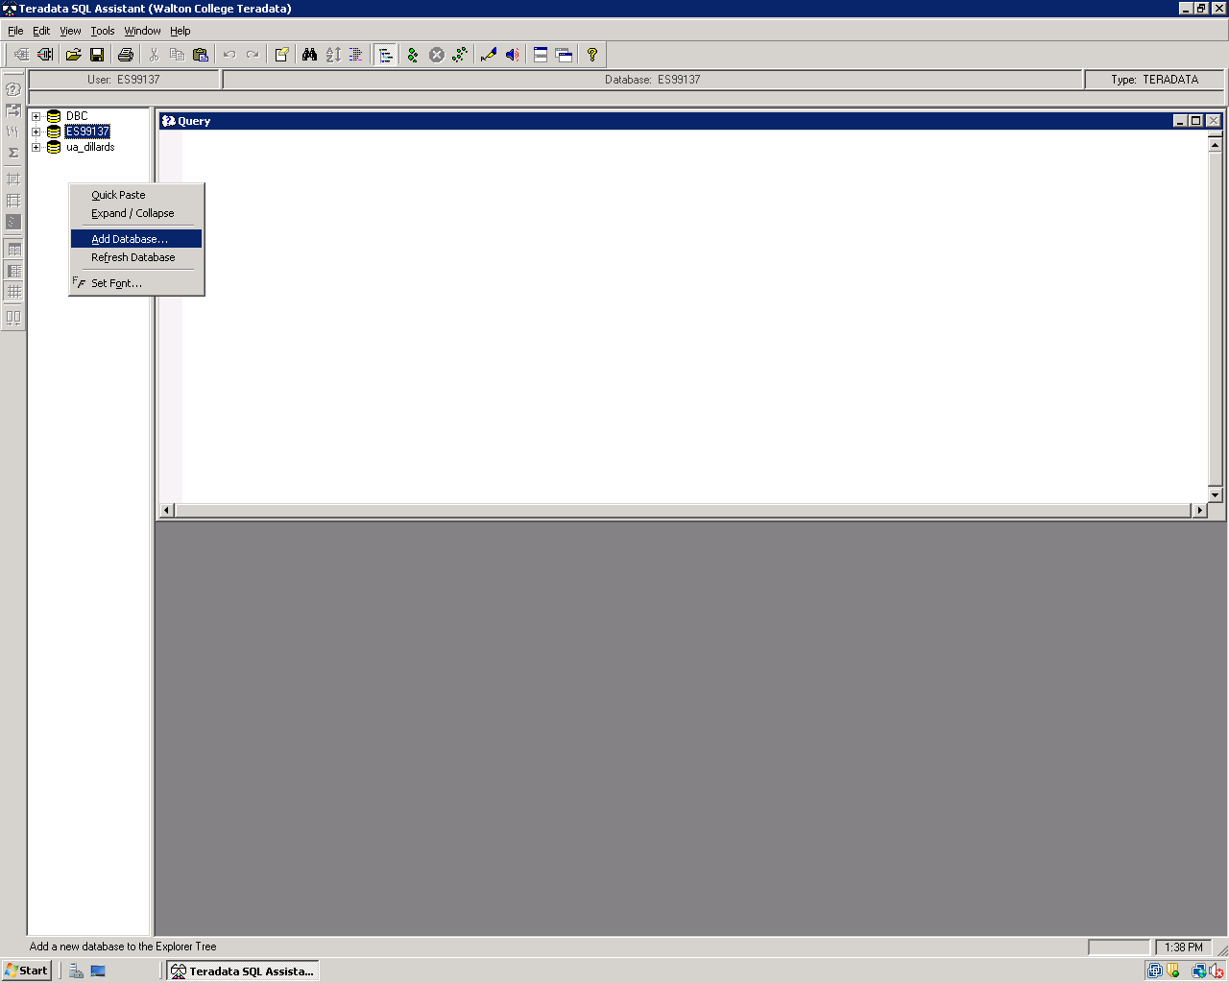

Enter the name of the Database you want to add.

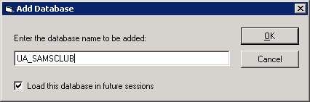

**Executing Queries**

To execute a query, simply type the query into the “Query” window. Then, click on the “Execute” icon (green footprints), press F5, or follow the menu path “Tools→Execute.” A result set will be computed and returned in an “Answer Set” window automatically. Data in the “Answer Set” window can be easily copied into other applications as needed. Note that your query history is saved in the “History” window. To recall a previously executed query, just select the item from the “History” window and the query Window will automatically be populated with the SQL from the selection.

