WCOB Dillard’s Data Model and Data Dictionary

# Background

This document provides information about the Dillards 2018 database (WCOB_DILLARDS) residing on Walton college Teradata server.

# Data model :

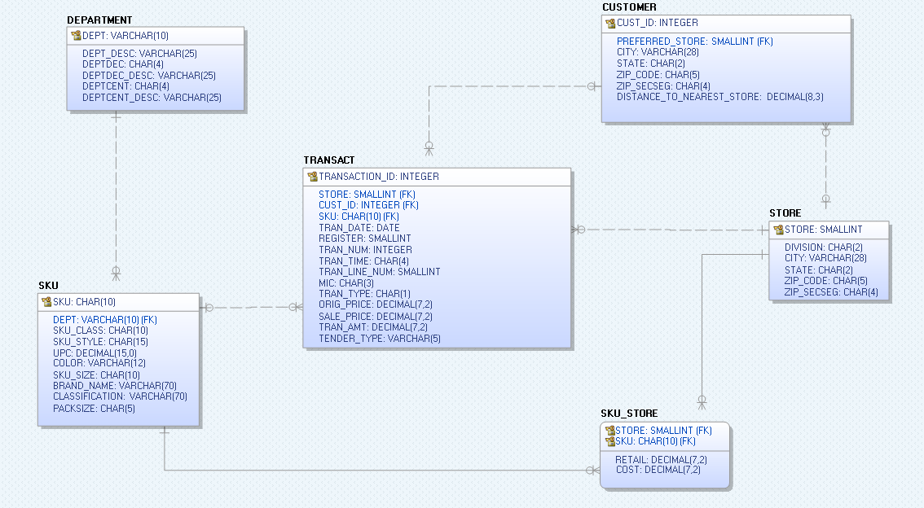

Below is the list of tables on this database, and the number of records in each table:

|  |  |
| --- | --- |
| TABLE NAME | NUMBER OF RECORDS |
| CUSTOMER | 75,544,740 |
| DEPARTMENT | 580 |
| SKU | 6,784,378 |
| SKUSTORE | 164,178,473 |
| STORE | 313 |
| TRANSACT | 107,572,906 |

## CUSTOMER table:

|  |  |  |  |  |  |
| --- | --- | --- | --- | --- | --- |
| Column name | Key specifications | Datatype | Short description | Long description | Sample values |
| CUST_ID | Primary key | Integer (not null) | Customer Identifier | Unique identifier representing a customer instance | 219948527  219930818 |
| CITY |  | Varchar (28) | City | City where the customer lives. | HOUSTON  COOS BAY |
| STATE |  | Char(2) | State | State where the customer lives. | FL  TX |
| ZIP_CODE |  | Char(5) | Zip code | Customer’s 5-digit zip code. | 72701  84770 |
| ZIP_SECSEG |  | Char(4) | Sector segment code | Customer’s geographic segment code | 5052  6474 |
| DISTANCE_TO_NEAREST_STORE |  | Decimal(8,3) | Distance to nearest store for customer | Miles from the customer’s house to the closest Dillard’s store. | 0.687  6.149 |
| PREFERRED_STORE | Foreign Key  (References STORE table) | Small Int | Customer Preferred Store Location | Dillard’s store number the customer prefers to shop at regardless of distance to the customer’s home address. | 910  774 |

## DEPARTMENT table:

|  |  |  |  |  |  |
| --- | --- | --- | --- | --- | --- |
| Column name | Key specifications | Datatype | Short description | Long description/  Additional Details | Sample values |
| DEPT | Primary key | Varchar (10), not null | Department Number | The Dillard's unique identifier for a collection of  merchandise within a store format | 0471  0029 |
| DEPT_DESC |  | Varchar (25) | Department Description | The name for a department collection of merchandise within a store format. | “Christian Dior”  “REBA” |
| DEPTDEC |  | Char(4) | Department Decade | The first three digits of a department code, a way to classify departments at a higher level. | 047X  002X |
| DEPTDEC_DESC |  | Varchar (25) | Department Decade Description | Descriptive name representing the decade to which a department belongs. | ‘BASICS’  ‘TREATMENT’ |
| DEPTCENT |  | Char(4) | Department Century | The first two digits of a department code, a way to classify departments at a higher level. | 04XX  00XX |
| DEPTCENT_DESC |  | Varchar (25) | Department Century Description | The descriptive name of the century. | CHILDRENS  COSMETICS |

## SKU table:

|  |  |  |  |  |  |
| --- | --- | --- | --- | --- | --- |
| Column/ Field name | Key specifications | Datatype | Short description | Long description/  Additional Details | Sample values |
| SKU | Primary key | Char(10), Not null | Stock Keeping Unit | Unique identifier for an item, identifies the item by size within a color and style for a particular vendor. | 0557578  6383039 |
| DEPT | Foreign key (references DEPARTMENT table) | Varchar(10), Not null | Department Number | The Dillard’s unique identifier for a collection of merchandise within a store format. | 0134  0343 |
| SKU_CLASS |  | Char(10) | Stock Keeping Unit Class | Three character alpha/numeric classification code used to define the merchandise. Class requirements vary by department. | K51  220 |
| SKU_STYLE |  | Char(15) | Stock Keeping Unit Style | The Dillard’s numeric identifier for a style of merchandise. | 091923690  LBF41728 |
| UPC |  | Decimal (15,0) | Universal Product Code | A number provided by vendors to identify their product to the size level. | 889448437421  44212146767 |
| COLOR |  | Varchar(12) | Stock Keeping Unit Color | Color of an item. | BLACK  PINEBARK |
| SKU_SIZE |  | Char(10) | Stock Keeping Unit Size | Size of an item.  Product sizes are not standardized and issued by vendor | 6  085M |
| BRAND_NAME |  | Varchar(70) | Brand Name | The item’s brand. | Stride Rite  UNKNOWN |
| CLASSIFICATION |  | Varchar(70) | Classification | Category used to sort products into logical groups. | Dress  Shoe |
| PACKSIZE |  | Char(5) | Item Package Size | Number that describes how many of the product come in a package | 001  002 |

## SKU_STORE table:

|  |  |  |  |  |  |
| --- | --- | --- | --- | --- | --- |
| Column/ Field name | Key specifications | Datatype | Short description | Long description/  Additional Details | Sample values |
| STORE | Primary key,  Foreign key (references STORE table) | Small Int, Not null | Store Number | The numerical identifier for a Dillard's store. | 915  701 |
| SKU | Primary key  Foreign key (references SKU table) | Char(10) | Stock Keeping Unit | Unique identifier for an item, identifies the item by size within a color and style for a particular vendor. | 4305296  6137609 |
| RETAIL |  | Decimal(7,2)  Not null | Retail Price | The price of an item. | 11.90  45.15 |
| COST |  | Decimal(7,2)  Not null | Item Cost | The price charged by a vendor for an item | 8.51  44.84 |

## STORE table:

|  |  |  |  |  |  |
| --- | --- | --- | --- | --- | --- |
| Column/ Field name | Key specifications | Datatype | Short description | Long description/  Additional Details | Sample values |
| STORE | Primary Key | Small Int, Not null | Store | The numerical identifier for any type of Dillard’s location. | 767  460 |
| DIVISION |  | Char(2) | Division | The division to which a location is assigned for operational purposes. | 07  04 |
| CITY |  | Varchar (28) | City | The city where the store is located. | IRVING  MOBILE |
| STATE |  | Char (2) | State | The state abbreviation where the store is located. | MO  AL |
| ZIP_CODE |  | Char (5) | Zip Code | The 5 digit zip code of a store’s address. | 70601  35801 |
| ZIP_SECSEG |  | Char (4) | Zip Code Geographic Segment Code | The 4 digit code of a neighborhood within a specific zip code. | 5052  6474 |

## TRANSACT table:

|  |  |  |  |  |  |
| --- | --- | --- | --- | --- | --- |
| Column/ Field name | Key specifications | Datatype | Short description | Long description/  Additional Details | Sample values |
| TRANSACTION_ID | Primary key | Integer | Transaction Identifier | Unique numerical identifier for each scan of an item at a register. | 40333797  15129264 |
| TRAN_DATE |  | Date in format MM/DD/YYYY, not null | Transaction Date | Calendar date the transaction occurred in a store. | 1/1/2015  5/19/2014 |
| STORE | Foreign key (references STORE table) | Small Int  Not null | Store | The numerical identifier for any type of Dillard’s location. | 716  205 |
| REGISTER |  | Small Int  Not null | Register | The numerical identifier for the register where the item was scanned. | 91  55  12 |
| TRAN_NUM |  | Integer  Not null | Transaction Number | Sequential number of transactions scanned on a register. | 184  14 |
| TRAN_TIME |  | Char(4)  Not null | Transaction Time | Time of day the transaction occurred. | 1839  1536 |
| CUST_ID | Foreign key (references CUSTOMER table) | Integer  Not null | Customer Identifier | Unique identifier representing the instance of a customer. | 118458688  115935775 |
| TRAN_LINE_NUM |  | Small Int  Not null | Transaction Line Number | Sequential number of each scan or element in a transaction. | 3  2 |
| MIC |  | Char (3)  Not null | Manufacturer Identification Code | Manufacturer Identification Code used to uniquely identify a vendor or brand within a department. | 154  128  217 |
| TRAN_TYPE |  | Char (1)  Not null | Transaction Type | An identifier for a purchase or return type of transaction or line item | P  R |
| ORIG_PRICE |  | Decimal(7,2)  Not null | Original Price | The original unit price of an item before discounts. | 20.00  6.00 |
| SALE_PRICE |  | Decimal(7,2)  Not null | Sale Price | The discounted unit price of an item. | 15.00  2.64  6.00 |
| TRAN_AMT |  | Decimal(7,2)  Not null | Transaction Total Amount | The total pre-tax dollar amount the customer paid in a transaction. | 15.00  2.64 |
| TENDER_TYPE |  | Varchar (5)  Not null | Tender Type | The type of payment a customer used to complete the transaction. | BANK  DLRD  DAMX |
| SKU | Index,  Foreign key (references SKU table) | Char (10) | Stock Keeping Unit | Unique identifier for an item, identifies the item by size within a color and style for a particular vendor. | 6107653  9999999950 |