Sam’s Club
Data and SAP BI Infrastructure

Lorraine R. Gardiner, PhD.
lgardiner@csuchico.edu
Professor, Department of Accounting and MIS
California State University, Chico
January 31, 2010

Table of Contents
Faculty Summary 3
Teradata Source Data 3
InfoObject Definitions 5
InfoCubes 7
Query Tips 10
Sam’s Club Small InfoArea 10
No Calculated/Restricted Key Figures 10
Store Visits and Line Item InfoCube Incomparability 11
Store Visit Distribution over Time 12
Metadata Issues 13
Unassigned Values for Characteristics (“#”) 13
Query Performance 14
Technical Appendix 15
DSO Definitions 15
Data Flow 15
Data Source Fields 16
Transformations: PSA to DSO 17
Transformations: DSO to InfoCube 18
Query Performance Enhancement 19

Faculty Summary
The SAP BI infrastructure to support class exercises using Sam’s Club data includes two InfoCubes, one with general store visits data and another with product-related line item details. The InfoCubes are loaded with data extracted from a database on the University of Arkansas Teradata server containing approximately 2.6 million visits with 15.3 million associated line items. For performance and exercise scope purposes, the data loaded into the SAP BI InfoCubes were restricted to 11 of the 72 item categories represented in the line items details. The resulting store visit and line item InfoCubes contain 1.4 and 3.1 million records, respectively.
Using these InfoCubes, Dr. Jim Mensching has created an extensive set of curriculum content emphasizing returns fraud investigation and control. His materials include assignments, solutions and “how to” videos. The data in the InfoCubes is, however, rich enough to support faculty in designing additional cases or exercises with emphases besides returns fraud (e.g., margin analysis).

Teradata Source Data
The University of Arkansas Enterprise Systems Teradata source (UA_SAMSCLUB_SMALL ) contains store visit information of seven stores from 7/31/2005 through 11/03/2006. The ERD and metadata are provided in Figure 1 and Table 1 below, based on a similar dataset (UA_SAMSCLUB).
Figure 1: ERD (Source: http://enterprise.waltoncollege.uark.edu/1682.asp)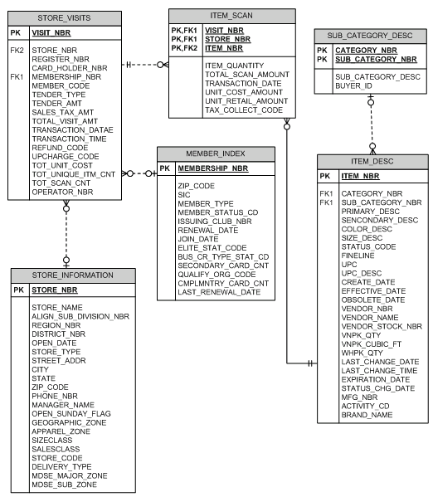
Table 1: Metadata (Source: http://enterprise.waltoncollege.uark.edu/1682.asp)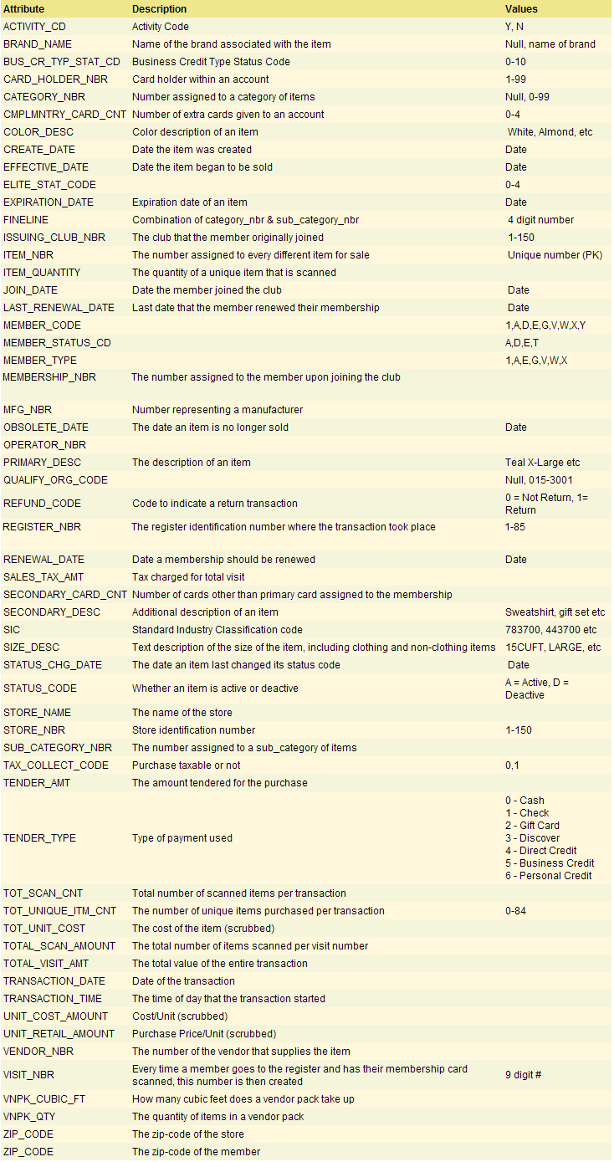
The data scrubbing referenced in the metadata makes it impossible to reconcile some attributes between the Store_Visits and Item_Scan tables. A sample visit (#355486057) made at Store 6 on May 1, 2006 and its associated Store_Visits and Item_Scan data illustrates the problem. The visit contains four unique item numbers (Tot_Unique_Itm_Cnt=4) with a total of eight items scanned (Tot_Scan_Cnt=8). The total unit cost and visit amounts in the Store_Visits table are $42 and $49, respectively. Table 2 contains the Item_Scan data for this visit. Note how the data scrubbing has removed the relationship between the cost, scan and retail totals in the two tables.
Table 2: Item_Scan Data for Visit #355486057

The UA_SAMSCLUB_SMALL dataset does not contain data from all stores over the entire time period. Table 3 below summarizes the distribution of visits by store and fiscal year quarter.
Table 3: Store Visit Distribution

InfoObject Definitions
The Sam’s Club characteristics and key figure definitions, including source data fields, are provided in Tables 4-9. Note that transaction dates are mapped to calendar days, quarters and years versus the Sam’s Club fiscal year definitions.
Table 4: ITEM_SCAN Key Figure Definitions
Table 5: STORE_VISITS Key Figure Definitions
Table 6: ITEM_DESC Characteristic Definitions
Table 7: MEMBER_INDEX Characteristic Definitions
Table 8: STORE_INFORMATION Characteristic Definitions
Table 9: STORE_VISITS Characteristic Definitions

InfoCubes
The data extracted from UA_SAMSCLUB_SMALL includes all stores and dates but is restricted to the 11 item categories shown in Table 10. My teammate on the Sam’s Club project, Dr. Jim Mensching, created the category descriptions based on the associated subcategory descriptions.
Table 10: Item Categories
Both InfoCubes are highly detailed, including data at the transaction level to facilitate drilldowns in student exercises. The store visits and line item InfoCube structures are provided in Figures 2 and 3 below. The characteristic and navigational short names appear in the star schema, BEX Analyzer and Query Designer rather than the longer InfoObject descriptions in Tables 4-9 above.
The Store Visits InfoCube (SCSC2) includes member, store, time, and visit dimensions for analysis of key figures based on the Sam’s Club STORE_VISITS Teradata table attributes. Each dimension includes the base characteristic (e.g., Membership Number) plus its navigational attributes (e.g., Membership Type). It is important to note that the store visit key figures cannot be analyzed by item since they are pre-rolled across all items for each visit in the STORE_VISITS table. As the name suggests, the Line Item InfoCube (SCSC3) includes an item dimension in addition to member, store, time and visit dimensions to facilitate analysis of key figures derived from measures in the Teradata ITEM_SCAN table.

Figure 2: Store Visits InfoCube (SCSC2) Star Schema
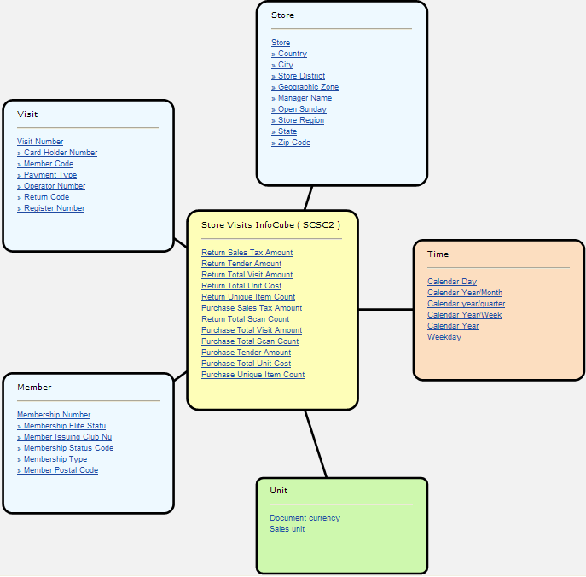
Figure 3: Line Item InfoCube (SCSC3) Star Schema
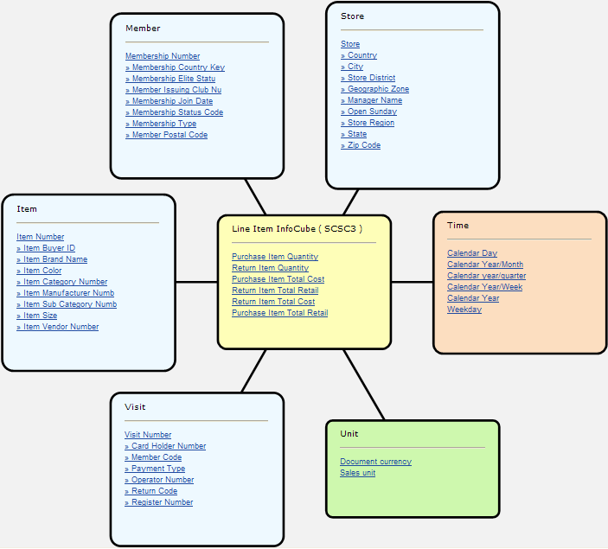

Query Tips

Sam’s Club Small InfoArea
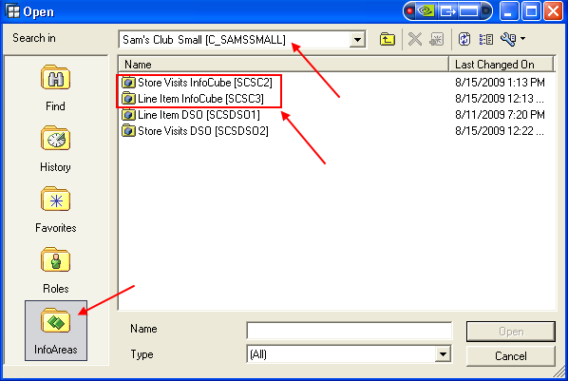
The store visits and line item InfoCubes can be accessed for running existing queries or creating new ones by either searching for the technical names (SCSC2 or SCSC3) or navigating to the Sam’s Club Small InfoArea (see below) on the University of Arkansas BI server.

No Calculated/Restricted Key Figures
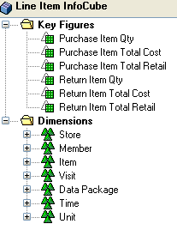
The abbreviated data models from BEx Query Designer (shown below) illustrate that there are no calculated and restricted key figures associated with either InfoCube. The omission of calculated and restricted key figures is intentional to allow faculty to ask students to determine what derived key figures might be useful.
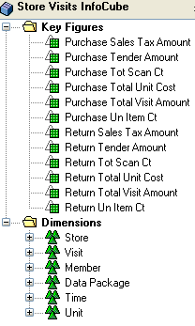

Please ask your students not to create calculated and restricted key figures for these InfoCubes since they will be available for all subsequent queries. Rather, encourage students to use either local formulas in Analyzer or formulas in Query Designer (shown below) since neither will be directly available for other students’ queries.
Local Formula in Analyzer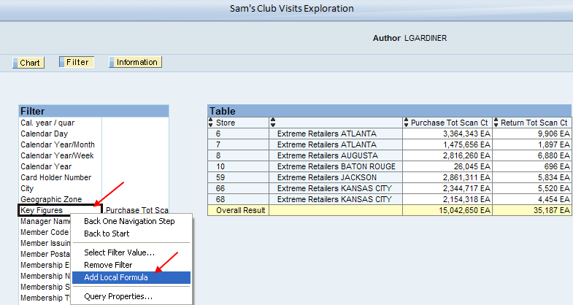
Formula in Query Designer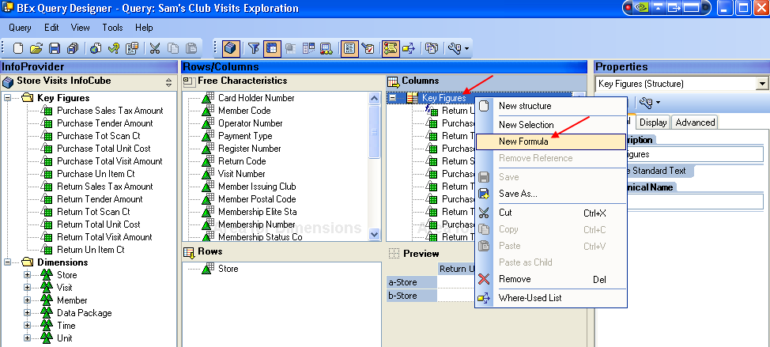

Store Visits and Line Item InfoCube Incomparability
Comparisons between the measurements in the two InfoCubes cannot be made for two reasons. The first is the scrubbing of the cost and sales data inherent in the source Teradata dataset. The second relates to the item category restrictions placed on the data extractions. While the store visit records were restricted to those containing items from the 11 product categories listed in Table 10 above, store visit measurements such as the total scan count could include additional categories. For this reason, the total item quantities are larger in the Store Visits InfoCube, as shown in the query results provided below.
Store Visits InfoCube Totals
Line Item InfoCube Totals

Store Visit Distribution over Time
The uneven distribution of visits by store over time in the Teradata UA_SAMSCLUB_SMALL dataset (Table 3 above) can distort analysis conclusions if not understood. Totals across returns and purchases (calculated with local query formulas) are summarized below by month for each store. Stores 59 and 66 are the only stores with visit data every month. Given that the transaction dates start at 7/31/2005, these two stores have significantly smaller totals for July 2005. All stores have smaller totals for November 2006 due to the end date of 11/03/2006.
Store Visits InfoCube Scan Count Totals
Line Item InfoCube Item Quantity Totals

Metadata Issues
The characteristic master data is limited by the absence or brevity of metadata for certain Teradata dataset attributes. For example, member attributes have values but no description for their meaning (e.g., Membership Type = A). In some cases, only a portion of the characteristic values in the master data have metadata descriptions. For example, the Teradata Tender_Type metadata contains definitions for six values but there are nine values in the UA_SAMSCLUB_SMALL dataset. As a result, the master data for Payment Type contains no descriptions for the last three types, as shown below.
Payment Type Example

Unassigned Values for Characteristics (“#”)
Students will need to understand that “#” as a characteristic value means “unassigned.” The unassigned values occur due to missing data in the Teradata dataset. For example, there are 175,205 members in the Teradata MEMBER_INDEX used to build master data for the Membership Number characteristic but many more (304,327) in the STORE_VISITS table. This results in a significant number of records with unassigned values for important characteristics, as shown in the Membership Type example below.
Membership Type Example

Query Performance
Since the Sam’s Club InfoCubes contain transaction detail, query performance was a high priority in their design. Additionally, pre-filled aggregates for common rollups (e.g., store and month) exist for each InfoCube to improve query speed. If faculty encounter rollups for an exercise that are unreasonably slow, contact the author of this report. If appropriate, additional aggregates will be built. Aggregates, however, cannot improve query performance for transaction detail analysis. To improve the response time for detail requests such as Visit Number or Membership Number, encourage students to filter on characteristics or place restrictive conditions on key figure values.

Technical Appendix
Consistent with industry practice, the architecture includes two DataStore Objects (DSOs) containing historical details from which InfoCube data marts can be built. While the existing Store Visit and Line Item InfoCubes have the same granularity as the DSOs, it is important to note that other, more aggregated InfoCubes could be built and easily loaded from the existing DSOs, if desired.

DSO Definitions
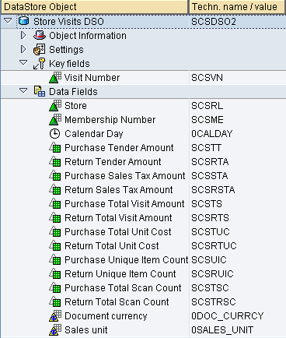
The DSO key fields are consistent with the primary keys in the respective UA_SAMSCLUB_SMALL Store_Visits and Item_Scan tables. Additionally, key figures are populated for purchases and returns using transformations involving the Refund_Code and original quantities from the PSA.
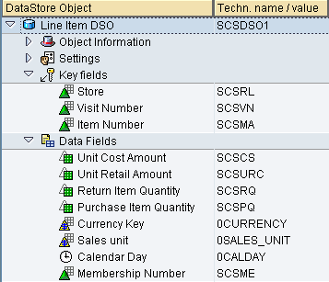

Data Flow
The data flow for each InfoCube is provided below. Transactional data extractions into .csv file from UA_SAMSCLUB_SMALL were used to populate the PSA tables. From there, Data Transfer Processes loaded data into the DSOs and subsequent InfoCubes, executing the necessary transformations. [Master data flows are not shown but were straightforward loads of characteristics with texts and attributes, as needed, from the respective UA_SAMSCLUB_SMALL tables.
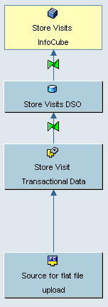
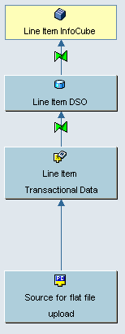

Data Source Fields
For both the store visit and line item PSA tables, all the fields are in internal format except the Membership_Nbr. This field requires the ALPHA conversion method from external to internal format because, as noted in the Faculty Summary, there are many member numbers that are not in the UA_SAMSCLUB_SMALL Member_Index table. For this reason, the ALPHA conversion did not occur in a master data load for the missing numbers. Failure to request the ALPHA conversion results in activation problems in the DSO.
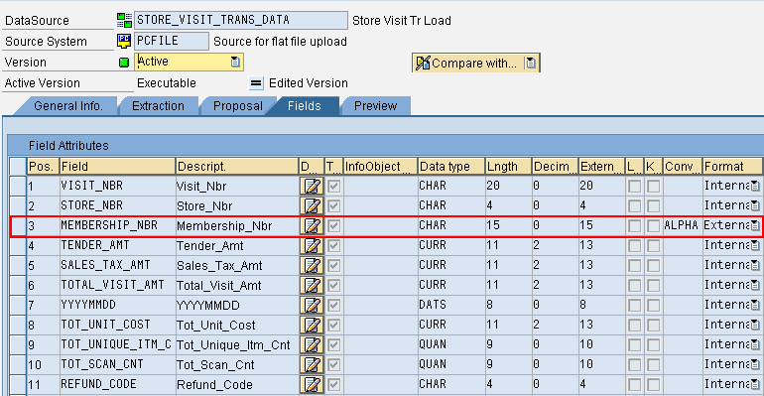
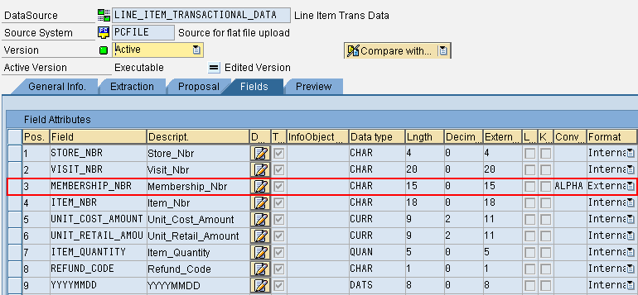

Transformations: PSA to DSO
The transformations for the store visits and line item DSOs are shown below. Of particular note are the transformations using Refund_Code that populate the purchase and return key figure data upon execution. An example is provided for Purchase Tender Amount that typifies the purchase/return key figure transformations.
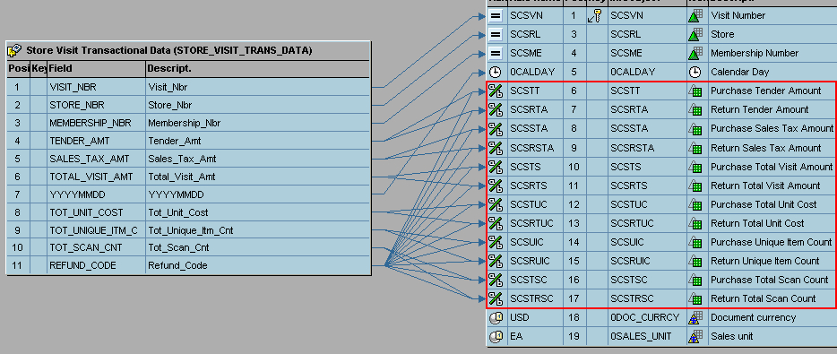
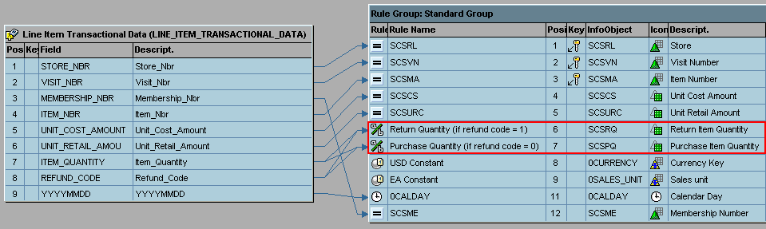
The Purchase Tender Amount formula is conditioned on a Refund_Code value of zero (purchase) and also forces all values to be positive. Formulas for return-based key figures are conditioned on Refund_Code values of 1.
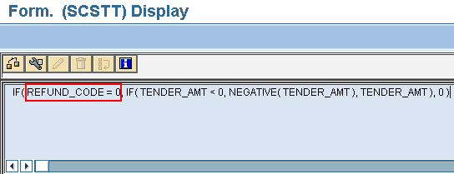

Transformations: DSO to InfoCube
The store visits transformations are all direct or time-based while those for the line item InfoCube require four simple transformation (Quantity*Unit Cost or Unit Retail).
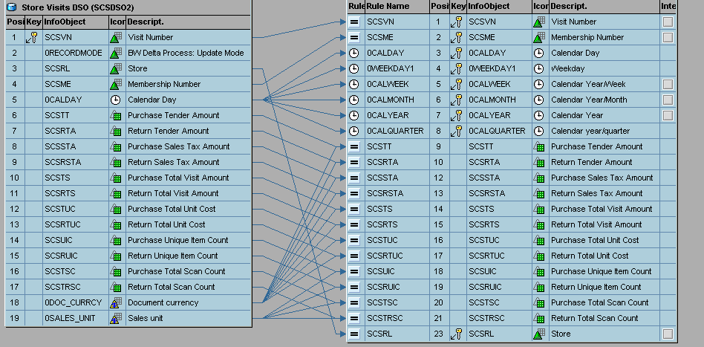
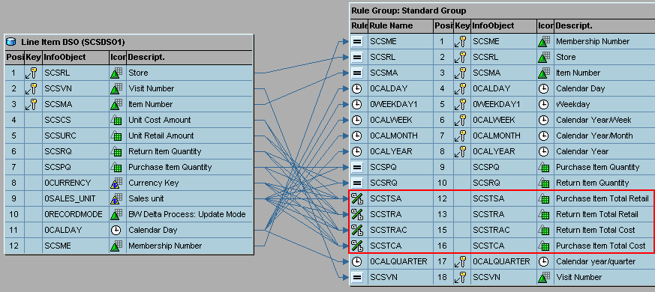

Query Performance Enhancement
Since both InfoCubes are highly granular, particular attention was paid to query speed in the InfoCube design and maintenance of aggregates. All dimensions are designated as line item. As an example, a Store dimension line item designation is shown below.
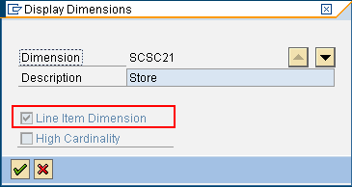
Additionally, each InfoCube is partitioned on month, from May 2005 through November 2006.
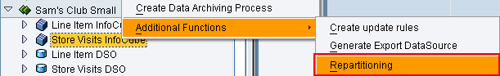
Finally, each InfoCube has a number of aggregates that reflect the most likely query requests. The author will supplement the aggregate collection, as needed, to improve performance. The current set of aggregates for each InfoCube is shown below.

Store Visit InfoCube Aggregates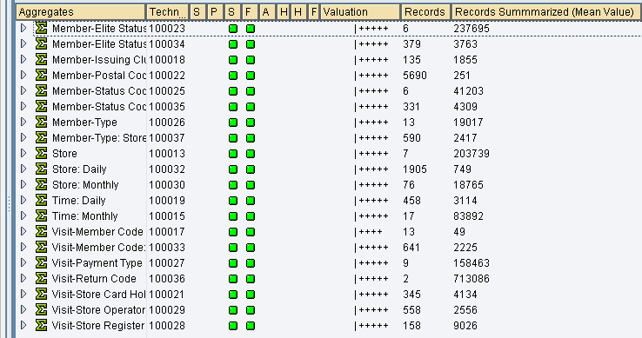
Line Item InfoCube Aggregates
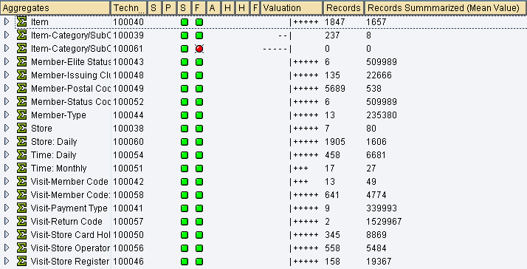

Approximately 2.2 million of the line items are not associated with an item category.

