Topeka Metro Bike: Understanding GPS Visualizers
Last Updated: 10/18/2019

GPS visualizers
Free tools
- https://www.google.com/maps
  - Use Google account to load in GPX files and save layers
  - Ability to change map background (e.g., terrain, satellite, roadmaps, etc.)
- https://www.gpsvisualizer.com/
  - Creates maps and profiles from GPX files
  - Can connect to Google Maps to display visualization, or other application
- https://batchgeo.com/
  - Paste data in almost any format into website and generate maps
  - Includes dynamic thumbnail version of map on your website

Paid tools
- https://www.esri.com/en-us/arcgis/products/arcgis-online/overview
  - Create maps and apps with data
  - Share maps with stakeholders in a variety of ready-to-use applications

Overview of GPX
GPS Exchange Format (GPX) has been around since 2002 and many satnav devices use it to store their map data. Satnav devices that do not produce GPX files natively have options to import them. Logically, GPX files are similar to JPG files – an open-standard that is used almost universally.

Due to it being open-standard, GPX is very popular for creating maps that can be used on a wide array of platforms. If a user wanted to share a GPS trail, they could convert their file to GPX to ensure that whoever is receiving the file can view it on their device of choice, giving users more options and compatibility.

Understanding GPX files
The GPX format is a file type that contains map data including coordinates on the Global Positioning System (GPS). There is no universal standard for map data formats; however, GPX is an open-standard format. Because of this, an increasing number of manufacturers use it as a native format on their devices.

Google Maps primarily uses KML for its map data, but supports GPX formats, as well. Google states that they support all base map data, but certain formats are easier to important than others. GPX is harder to import, but GPX files can be converted into other formats for better results.

Using Google Maps
To import a GPX file into Google Maps, first, sign into My Maps (https://www.google.com/maps/d/u/0/), and then follow the steps outlined below:
- Click on the button labeled Create a New Map in the top-left corner
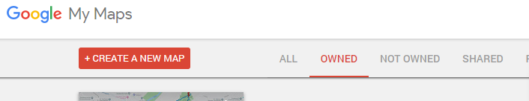

- Feel free to give your new map a title and description

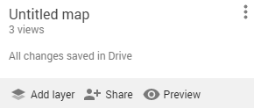

- The map automatically adds an untitled layer for you upon map creation. Click on Import
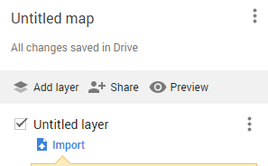

- From here, you may upload a CSV, XLSX, KML, or GPX file
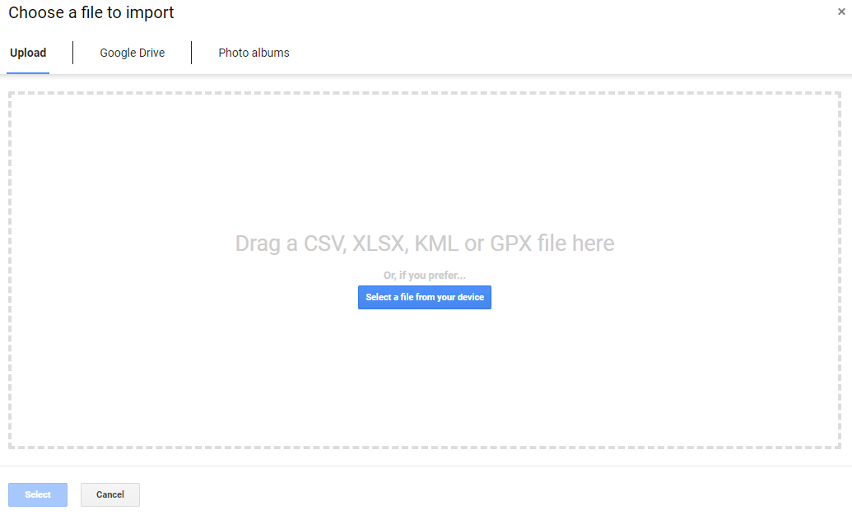

- Once the file has been imported, you will see the map waypoints created by Google Maps
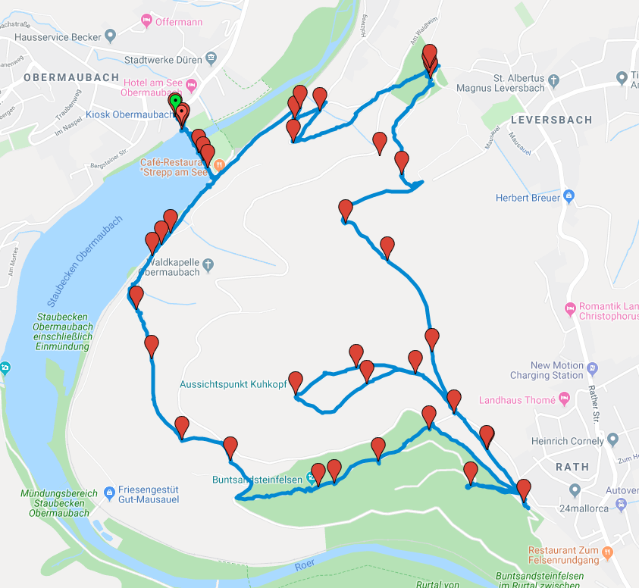

The best way to use Google Maps to visualize map data is to convert the geolocation file you have to the KML format that Google Maps uses. This will alleviate any worry that the GPX file may not fully upload into Google Maps, or that the GPX file will lose some functionality once in Google Maps.

GPX data from: https://software.frankingermann.de/gpxtrackmap/gtm-examples

Converting a GPX file into a KML file
To make sure that the map data from the file is properly loaded into Google, first, the user should convert the file into the preferred format of KML. There is a variety of software that can convert GPX files into KML files; however, the most convenient way it to use an online converter. GPS Visualizer (https://www.gpsvisualizer.com/) is a lightweight, free file converter.

To use GPS Visualizer to convert a GPX file into a KML file, the user should upload the GPX file into the website and then select Google Maps as the output format. Within seconds, a KML format should become available to you. Once the file is converted, download it and follow the steps for uploading a file to Google Maps as detailed in the section above. This extra step does not take much time and ensures that nothing is lost in the upload to Google Maps. Once the file is uploaded, you can share it and perform any actions that you normally would on Google Maps.

Once the data manipulations have been performed in Google Maps, the user may re-download the file as a GPX file. If the user would want to send someone map data that their car’s satnav can read, the GPX format is the best option.

