Topeka Metro Bike: Using GPS Devices
Last Updated: 11/4/2019

GPS Navigators
GPS navigators are devices that work by calculating your exact geographical location. They present a 2D or 3D map to the user, and allows for interaction in that map. It is normally capable of pointing out street names, shortcuts, points of interest, and other landmarks, and they often come with voice navigation (Trackimo, 2016).

GPS Trackers
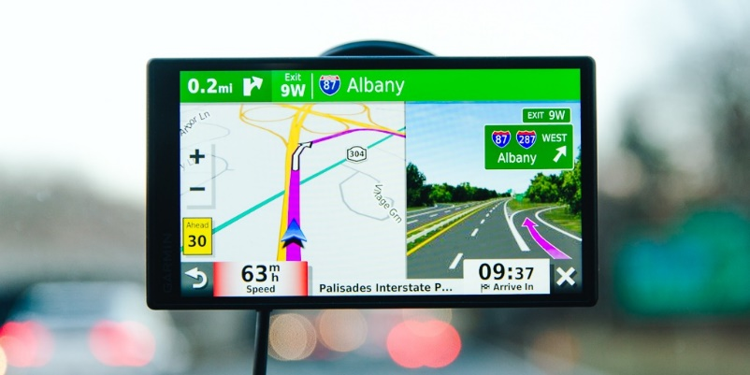
GPS trackers are “normally carried by a person or are attached to a moving vehicle” (Trackimo, 2016). These devices work by determining the exact position of objects, and can be hardwired into an item or a system, “transmitting a variety of data and reports to a central location or database or to any device connected to the internet” (Trackimo, 2016).
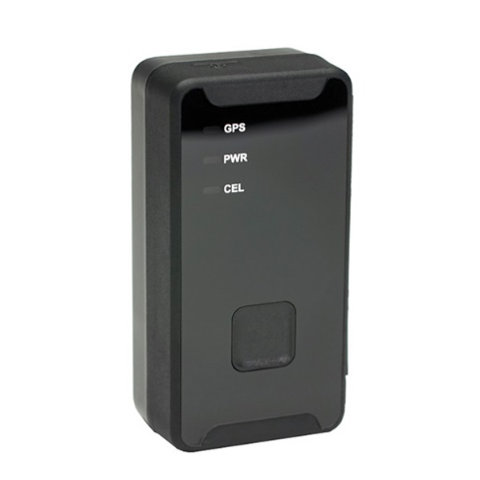
Figure 1. This is an example of a commonly used GPS navigator. Source: https://thewirecutter.com/reviews/best-car-gps/
Figure 2. This is an example of a GPS tracker. Source: https://logistimatics.com/product/micro-420/

Using GPS Navigation Devices
According to wikiHow, there are several steps to take when using simple GPS navigating devices. For this example, we will discuss the build-in or native maps app commonly found on an iPhone or Android.

To use the native maps application on a smartphone:
- Open the “Map”
- Click on “My Location” if you want to see where you are
- Click on “Search for place or address” or similar text in the search bar to enter in an address or location of your choice.
- The Map app will give you choices on which locations are available based on what was searched, and what type of transit method you would like to take (e.g., walking, driving, biking, etc.)
- Click “Start” or “Begin” to begin your navigation to the selected destination. Follow the GPS instructions on how to get to the location, using the map visual as a supplemental function to assist you in going to the correct location. The primary function will be voice navigation, if enabled.
  - Voice navigation does not have to be enabled; however, it is safer to do this when operating a motor vehicle.
- You can use other Map features such as marking a location as a waypoint. This may be presented as “Save Location” “Add to Favorites” or “Mark Waypoint” in the application.

Important: because these devices are operated digitally, it is important to remember that any device may turn off unexpectedly or run out of battery, and therefore backup plans should be made ahead of time to avoid any catastrophic situations (e.g., getting lost while hiking).

Works Cited

4G GPS Tracker: Micro-420 4G Tracker with nearly universal coverage: GPS Trackers: Realtime Asset and
Car Tracking Devices. (n.d.). Retrieved November 4, 2019, from https://logistimatics.com/product/micro-420/.

Paul, R. (2019, May 19). The Best Car GPS for 2019. Retrieved November 4, 2019, from
https://thewirecutter.com/reviews/best-car-gps/.

Person, & wikiHow. (2019, May 2). How to Use a GPS. Retrieved November 4, 2019, from
https://www.wikihow.com/Use-a-GPS.

Thomas, A. (2019, September 10). Introduction to the Different GPS Devices. Retrieved November 4,
2019, from https://trackimo.com/different-gps-devices/.

