Metro Bike Ride Share +: A Data Conversion and Data Analysis Business Case
Utilizing Weather and GPS Source Data*

Provided by Pamela J. Schmidt
Washburn University
8/29/2019

Abstract: Companies collect an ever-increasing amount of Big Data; therefore, developing data
analysis capabilities is paramount to an accounting students’ career success. Strategic decision
making requires managers to analyze useful information. Transforming data into useful
information requires techniques to extract, transform, and load business data into a database,
combine it with external data (geographic, weather, and public or private data), and develop
queries leading to business insights. This analytics case is based on the Metro Bikes ride share
implemented in Topeka, the capital of Kansas. The Topeka Metro Bike (TMB) service utilizes
custom bicycle and web technologies from Social Bicycles (SoBi). TMB’s Director of
Operations has many business questions, but the answers are not apparent from the existing web
dashboard provided by SoBi. In this case, students are given raw data collected by SoBi web
services and from bike electronics. The students are also required to utilize free web services to
obtain supplemental public data and to correlate it with raw data provided. The overall learning
objectives are to develop critical thinking and problem-solving skills and to improve MS Excel
and Access database skills. By providing students with raw data, business questions, but only
general instructions, the case provides a collaborative, constructivist learning opportunity.

+ This case is based on Topeka Metro Bikes ride share service and utilizes modified versions of
actual business data. The authors gratefully acknowledge the assistance and support of Karl
Fundenberger, Director of Bicycle Operations, Topeka Metro.

*Faculty sponsorship and guidance for this paper was provided by Dr. Pamela J. Schmidt,
Assistant Professor at Washburn University.

Learning Approach with its Theoretical Background
This data analysis case uses the learning approach of cooperative learning, along with employing
critical thinking methods based on the Critical Thinking Model from the Foundation for Critical
Thinking (at http://www.criticalthinking.org/ctmodel/logic-model1.htm (Elder and Paul 2010).

The cooperative learning approach is described as a subset of active learning where students
work in a small team to actively process information by peer interaction (Riley and Ward 2017).
This case provides for active processing in teams and follows a constructivist learning approach
where students create their own meaning as they gather an understanding by working with the
case materials and seeking supplemental knowledge when needed. Interactions within the team
provide for joint problem solving, sharing of knowledge, peer support and some peer-to-peer
mentoring. The common element in these approaches is to have direct student to student contact,
active learning and guidance and interactive consultation with an instructor.

In addressing a subset of the Critical Thinking Model (Elder and Paul 2010), this educational
case includes its activities of a) defining questions/problems, b) gathering information (adding in
the steps of extraction, transformation and loading (ETL)) and the building of either Excel
formulas and/or Access DB queries), and then asks students to utilize data analysis methods to
support c) interpretation of the data and to subsequently guide d) making inferences. Once
worthwhile data analysis is done, the last step of ‘making inferences’ can build upon analysis of
data and can be used to inform and support business decisions.

Another very useful framework, more specific to the data conversion and data analysis activities
in this educational case is the Cross Industry Standard Process for Data Mining (CRISP-DM)
(Shearer 2000). This framework provides a well-accepted and utilized approach including the
steps of a) building an understanding of the business situation and goals, b) understanding the
available data and its quality, c) preparing the data, d) selecting modeling techniques and running
models, e) evaluating the results and determining next steps, and finally f) deploying the report
and on-going project plans.

Introduction
In April 2015, Topeka Metro created the first bike share program in Kansas, the Topeka Metro
Bike share program (https://topekametrobikes.org/ ). Topeka Metro (TM) is the city of Topeka’s
transportation system that allows people to travel from one place to another within the city using
busses and/or bikes. According to the most recent census data from 2014, Topeka had a
population of 127,215 people (https://www.census.gov). It is the first city of its size to embrace
the bike share concept. The system spans 65 square miles. TM determined they would power
their ride share system with Social Bicycles (SoBi)
(http://socialbicycles.com/) and placed bike stations around the city for citizens to use.

SoBi delivers the bulk of the bike share services, as they provide the website infrastructure and
build specialized bikes with the technology that make a bike share functional. This adoption of
an existing bike system gives a fast start with reliable bikes, but also makes TM’s transportation
system highly dependent on SoBi.

The initial investment included the purchase of 50 red SoBi bikes and the construction of 7 bike
stations. In addition, TM incorporated use of the 75 existing bike racks already available in the
community. As the system grew, 50 additional red bikes were purchased. In April 2016, a
regional business sponsored the purchase of an additional100 bikes with the agreement of using
their logo’s blue theme color. As of April 2017, TM has 200 bikes within its fleet, 17 TM
Stations, and expanded the use of the community’s existing bike racks to over 100.

The bikes that are supplied by SoBi have different specifications than ordinary bikes that
increase their lifespan and prevent theft. The bikes are propelled by a drive shaft rather than a
chain. The bikes are also equipped with GPS that tracks their location at all times. The bikes
have an adjustable seat, a three-speed gear shift, and a removable locking mechanism that allows
the bike to be locked at most bike racks. The bikes are maintained by TM and have a limited
warranty provided by SoBi.

There are two major differences between the red and blue bikes. The red bike baskets have a
large slotted area in the bottom as well as the back. This allows for smaller items riders may
carry to fall through and get broken or lost. The blue bikes basket is heavy enclosed mesh with
small holes. The blue basket style still allows for drainage of rainwater, but is better for holding
small items. Both baskets are the same size. Another small difference between the red and blue
bikes is a water shield under the system of the blue bikes that is not present on the red bikes.
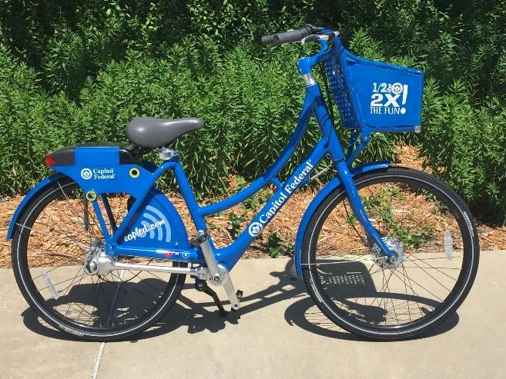
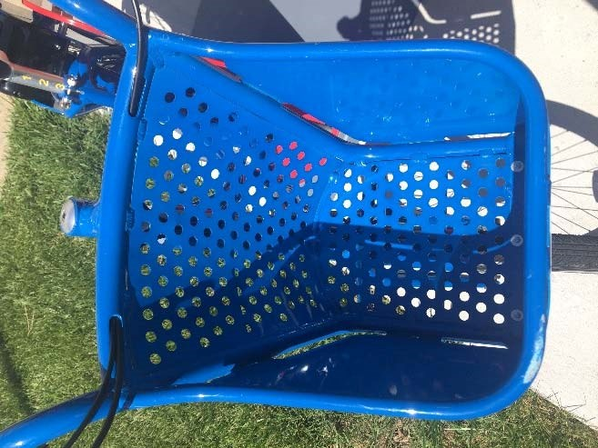
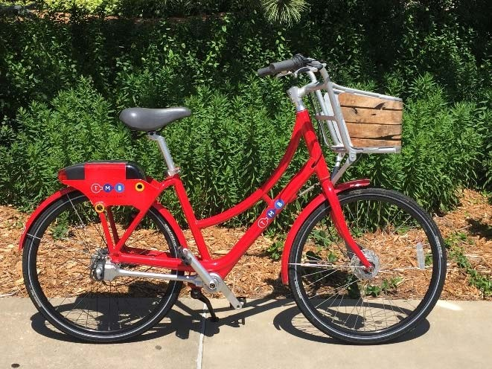
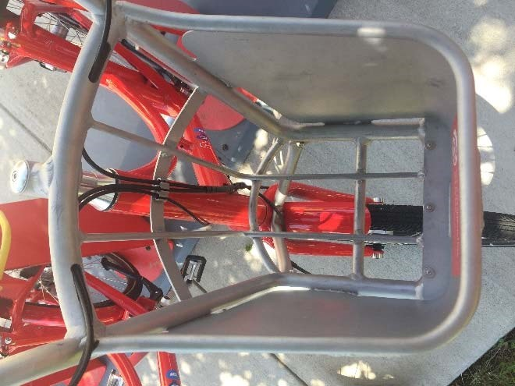
Subscription Process
When ready to ride a TM bike, one must first create an account. Creating an account begins with
navigating to the website www.topekametrobikes.org and clicking “Become a Member”. The
webpage will list the account types and their pricing. Once the plan type is selected, the website
will display boxes for required personal information including name, address, password, phone
number. The website assigns an account number and pin for the user. The pin can be updated as
needed. The website then requires the user to read and accept the Terms of Use and enter
payment information. Once the payment information is validated, the user is able to ride.

There are two different types of subscriptions public and private that a person can choose. Public
subscriptions include Hourly, Annual, University Monthly, and University Annual. The Hourly
and Annual plans is available to all citizens. For the Hourly plan, the account holder adds funds
to their account to get started and is then charged $2.50 per hour of use. For the Annual plan, the
account holder pays $25 for the entire year and receives two free hours of riding time per day.
For any ride exceeding two hours, the user is then charged at the hourly rate. The University
Monthly and University Annual plans are structured the same as the Annual plan, but are only
available to currently enrolled students. The University Monthly plan users pay $5 per month for
two free hours a day and the University Annual plan users pay $20 for the year. The Private
subscriptions are for administrative purposes and include the account type Admin for employees
and the account type Volunteer for special use.

A member can cancel, change, or renew their account at any time. Hourly users will have a
continuous use of bikes as long as they have surplus credit available. Monthly and Annual
subscribers have the option to enroll in automatic payments. With automatic pay selected, the
system will continue to charge the user either monthly or annually until the member cancels their subscription. The system will send receipts for each charge and will contact the member if the
charge does not clear.

Bike Rental
Members can rent a bike through one of two avenues. The first option is for the member to walk
up to the bike rack and choose a bike to ride. The member can type in their 6-digit account
number and their 4-digit PIN on the login module to unlock the bike. The second option for
rental is for the member to make a reservation online. The member can download the SoBi
application on a phone or go to www.topekametrobikes.org website and reserve any available
bike by selecting the location of their choice. Once the location is selected, the system will select
a specific bike and hold it for ten minutes. To unlock, the member must locate the reserved bike
and log in using the same process as indicated with the walk-up option. To return the bike, the
member must simply lock it to an in-market rack or station. If the member locks the bike at an
out-of-market hub, they will be charged a $3 fee. If a member rents a bike that was locked out-of-
market and returns it to an in-market hub, they are awarded a $2 credit. While riding, if a
member needs to make a quick stop, the system allows the bike to be held for up to one hour. To
hold the bike, the member must press the hold button on the login module and lock the bike to a
secure location. To continue the ride, the member enters his or her 4-digit PIN to unlock the bike.
If the bike is left for more than one hour, the member will be automatically logged out and must
begin a new ride.

Case
A large amount of data is collected regarding usage of the bike share service. The majority of the
data is collected through subscriber interactions with the SoBi website and data collected by the
bicycles themselves. While the Sobi website has some administrative data analysis capacity, TM
Bike management is interested in diving deeper into the data to improve the service and better
manage its resources.

Karl Fundenburger, initial Director of TM Bicycle Operations was interviewed and provided the following business questions. New questions provided by current manager, Andrew Escandon:
- New: How many rides are likely extension of Transport system (augment bus routes with bikes as first mile/last mile transport?)
- New: Relationship between metro bus use and bike ride share, specifically what is affect if reduced Topeka Bus -1 hour/day?
- New: Compare using VeoRide system as alternative for Topeka
  - Cost reduction, cost/benefit for breakeven operations, effect on ridership?
- Popular bike start/end locations
- Purpose of bike trips (recreation vs. transportation/extend bus)

Other related questions:
- Locations where new hubs needed
- Which day, time of week (weekend) is more popular for Rides?
- Influence of weather on riding
- Preferred bike model - more popular? Why?

During interviews, Karl also provided the following insights regarding use of the bicycles in Topeka
- Trips in Topeka are generally longer than other bike shares due to the physical size of the Market.
- The bike share programmed is focused around the university campus with international students being a large segment of campus users.
- Membership has a better representation of women than men.
- The largest segment of riders is over the age of 50.
- Almost all existing community bike racks are considered in-market. The reason some bike racks are not included in-market is due to the fact that their design is incompatible with the bike lock system.
- The bikes are under warranty through SoBi. The system is updated approximately every 6 months.

Overall Learning Objectives for the Data Analysis Case:
- Gain appreciation of the important role of data in business decisions and operations
- Exposure to data analysis methods and approaches; for example, creating DFDs and
- Flowcharts to understand business processes
- Gain experience doing file conversion, consolidation, ETL (Extract, Transform, Load)
- into a data warehouse
- Finding useful public data sources (Weather, Latitude/Longitude) and adapting to be
- useful.
- Develop skills in determining data usefulness and reformatting data as needed to resolve
- issues; for example, making do with approximations and determining when to abandon a
- course of direction or approach
- Establishing meaningful database table relationships within the data warehouse to support
- further analysis
- Data Cleanup can be done using Excel or other tools.

Some related business questions posed by the Director of Metro Bike (may repeat some above):
- Which day of the week is more popular for Rides?
- Average expected number of rides on weekday and on a weekend day?
- Which bikes are more popular (more rides: Red vs Blue)?
- Count of “Multiple Rental rides”. (Multiple Renters means a person checked out multiple
- bikes at once)
- What are the popular times of day for Bike trips?
- Do customers have a preference between red and blue bicycles? I.e. What color of bike
- is most popular? (Red or Blue bikes?) Can you explain why?
- What Bike Hub location is the busiest? (plus, has most starts, and has most ends of
- rides?) What Bike Station location is the busiest? (how does each Station compare to
- popular hubs?)
- What is volume of Rides starting at each bike Hub location
- What is volume of Rides Ending at each Bike Hub location?
- How does weather affect usage?
- Can “holds” data be analyzed to determine where new bike racks should be placed?
- Can we determine the proportion of rides that are for transportation versus recreation?
- When are the peak days and times of usage?

Preliminary Data-Dictionary – is available in separate file.

APPENDIX A References

Batch Geo (n.d.). Retrieved June 3, 2017, from https://www.batchgeo.com/

Do-It-Yourself Mapping. (n.d.). Retrieved June 3, 2017, from http://www.gpsvisualizer.com/

Elder, L. and R. Paul, (2010) Analytic Thinking, 2nd edition, Foundation for Critical Thinking

National Centers for Environmental Information (NCEI). (n.d.). Climate Data Online. Retrieved June 3,
2017, from https://www.ncdc.noaa.gov/cdo-web/

Riley, J. and Ward, K. (2017) Active Learning, Cooperative Active Learning, and Passive Learning Methods
in an Accounting Information Systems Course. Issues in Accounting Education, 32(2), 1-16.

Shearer, C. (2000). The CRISP-DM Model: The New Blueprint for Data Mining. Journal of Data
Warehousing, 5(4), 13-22.

Social Bicycles. (n.d.). Retrieved June 3, 2017, from http://socialbicycles.com/

Topeka Metro Bikes. (n.d.). Retrieved June 20, 2017, from https://www.topekametrobikes.org/

United States Census Bureau (n.d.). Retrieved June 3, 2017, from https://www.census.gov

