Topeka Metro Bike: Understanding Latitude and Longitude
Last Updated: 11/4/2019

Basics of Latitude and Longitude
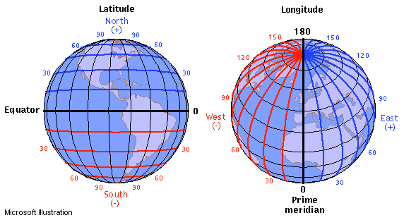
According to the website JourneyNorth.com, “every location on earth has a global address.” The system is based on numbers to transcend any cultural or language barriers to better communicate exact location. The address consists of two different numbers, latitude and longitude, that are coordinates based on a grid system.
Figure 1. This image shows how we generally measure latitude and longitude. Source: https://journeynorth.org/tm/LongitudeIntro.html

Latitude
The horizontal lines are called “latitude”. You can remember this by thinking of the trick: “latitude, flat-itude”. These lines run parallel to the equator, and “are a numerical way to measure how far north or south of the equator a place is located” (JourneyNorth, 2019).

The equator is labeled as 0 degrees and increases with positive numbers the more north you travel and decreases with negative numbers the more south you travel. Using the above picture, you can see that the positive degrees are labeled in blue, and the negative degrees in red. When writing latitude or longitude, make sure to include the correct sign (no sign needed for positive, and “-“ for a negative.

Longitude
The vertical lines are called “longitude”. You can remember this by thinking these lines are “long” as they each measure the same length but in different areas of the globe. “Longitude lines are a numerical way to show/measure how far a location is east or west of a universal vertical line called the “Prime Meridian.”

Note: as an alternative to using degrees or time, latitude and longitude may be measured in decimal degrees. The more decimals are included in the measure, the more accurate the geolocation is.

Figure 2. These are a few different ways that latitude and longitude can be measured – decimal degrees (DD), degrees decimal minutes (DDM), and degrees minutes seconds (DMS). Decimal degrees are denoted by a positive or negative sign, minutes are denoted by one single apostrophe, and seconds by a double quote. Source: https://www.pgc.umn.edu/apps/convert/

Exploring Latitude and Longitude
To better understand these concepts, feel free to travel over to latitude and longitude practice websites such as https://www.latlong.net/ that may give you a better understanding about how this system works.

Works Cited

Coordinate Converter. (n.d.). Retrieved November 6, 2019, from
https://www.pgc.umn.edu/apps/convert/.

Get Latitude and Longitude. (n.d.). Retrieved November 6, 2019, from https://www.latlong.net/.

Understanding Latitude and Longitude. (n.d.). Retrieved November 6, 2019, from
https://journeynorth.org/tm/LongitudeIntro.html.

