Fiori Launchpad: Adding Apps to Fiori Launchpad
The purpose of this demo is to show the process of adding applications or tiles to the Fiori Launchpad. Examples are provided for both successfully and unsuccessfully adding an app. The examples provided are intended for use at the University of Arkansas in the ERP Configuration course. This tutorial also assumes that you know the navigation of Fiori Catalogs and Groups within the Fiori Designer and the navigation of Groups within the Fiori Launchpad.

Fiori Designer: Select Catalog/Group Containing the Tile to Add
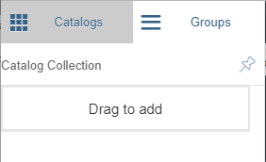
- Navigate to the Catalog/Group containing the app you wish to add. The examples here are using the Catalogue ZFiori_Catalog019 and Group Z_Config019.

- If you are looking to create a Catalogue or Group of your own, simply go to the Designer and on the left hand side you will see 2 tabs, Catalogs and Groups.

- To create a Catalog or Group of your own, click on either tab and on the bottom left of the screen you will see a plus sign in a circle, clicking on that will allow you to create either depending on the tab you have selected.

Adding an App Successfully
For this step, the Catalog and Group being used are “Materials Management - Physical Inventory Management” and “Fiori Launch Config 019”.
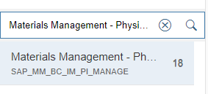
- To add an App from the Fiori Designer to the Launchpad, the app must first either be taken from a Catalog, being a pre-existing app, or created in the Catalog.
- If the User wished to add an app from the Catalog “Materials Management - Physical Inventory Management” they would first search for that Catalog in the Designer under the Catalogs tab.
- Now that they know what app they want from that Catalog, they would then go to the group they wish to add it to.

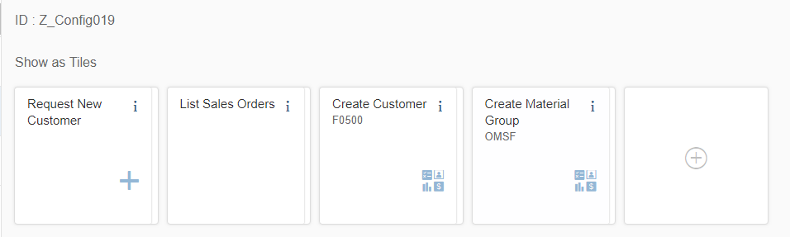
- Once the specified group has been selected, on the main page the user will see a white square with a plus sign in it which will allow them to search for a Catalog and select a tile of their choosing. Click that tile.
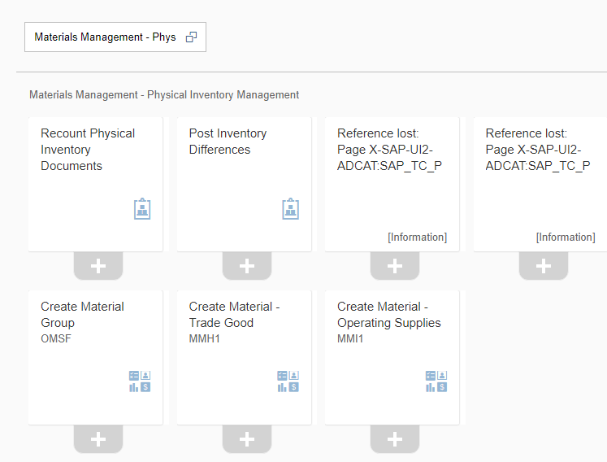
- Select the App you wish to add. For this example “Create Material Group / OMSF” will be selected.

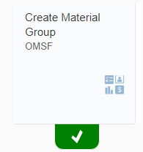
- Clicking the back arrow, the user will then see that tile in the group they had selected.

- The user can now go back to the Launchpad to refresh and should see that tile in their group.

Adding an App Unsuccessfully
Both previously mentioned Catalogs and Groups will be used for this example as well.
  - Group: Fiori Launch Config 019
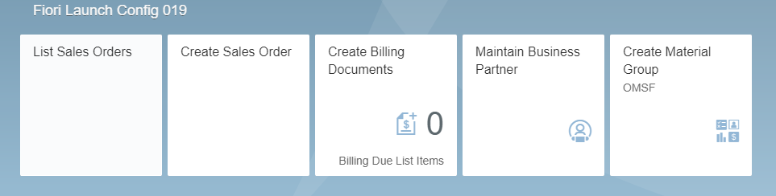
  - Catalog: ZFiorio_Catalog019
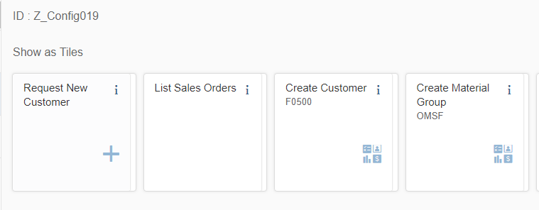
For this exercise, the same steps as previously mentioned will be used but this time the catalog the app will be drawn from does not exist in the App Library in the Launchpad. This in turn could create an issue of User permissions, meaning the app won’t show up.

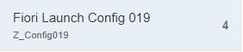
- To begin this process, the Group “Fiori Launch Config 019” will be searched for and selected in the Designer.

Once up, the user would select the white tile containing a + sign in it, this signifies the user would like to add an app.

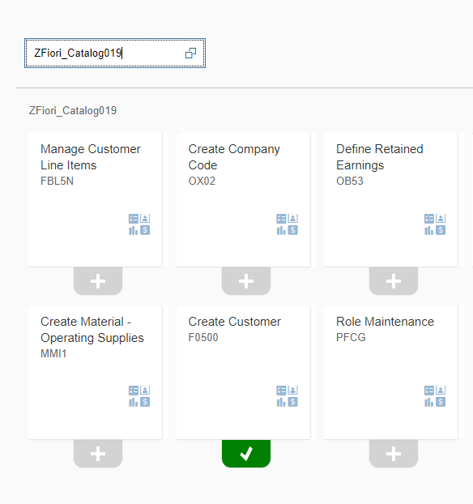

- The user will then be brought to the Catalog search page. For this example, “ZFiori_Catalog019” was entered into the search bar in the top left corner and pulled up

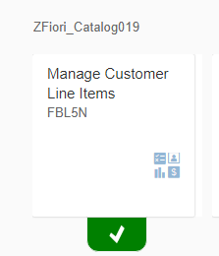
- The tile “Manage Customer Line Items” will be selected. This action will be adding this desired tile to the group “Fiori Launch Config 019”.

- Now that the tile has been added to the group “Fiori Launch Config 019”, from the Catalog “ZFiori_Catalog019” in the Designer, the user would now be able to go to their Launchpad and refresh the page to see the new tile Manage Customer Line Items located within their group on the Launchpad.

For this particular example, the user can add the tile in Designer, but the user did not have permission to access the tile from the catalog which the user referenced the tile. As you can see, the tile isn’t where it’s supposed to be.

- This is a permissions issue and you need to contact the system administrator.
