Fiori Launchpad: Creating Configuration Tiles
The purpose of this demo is to show the process of creating configuration tiles for the Fiori Launchpad. The examples provided are intended for use at the University of Arkansas in the ERP Configuration course. This tutorial also assumes that you know the navigation of Fiori Catalogs and Groups within the Fiori Designer and the navigation of Groups within the Fiori Launchpad.

Preparation
To start, make sure you have logged into the SAP GUI, the Fiori Launchpad and the Fiori Designer with the credentials provided by your instructor
Client: xxx
Username: GBI-xxx
Password: nnnnnnn

In order to create a tile for use in your Launchpad, you must be using Fiori Designer and create the tile in a catalog that your Fiori Launchpad has privileges to access. Use your catalog and group while completing this tutorial. The screen shots in this tutorial will be using the catalog named SPRO Transactions (technical name: ZFiori_SPRO). The configuration tile created in this tutorial will be Create Chart of Accounts. Groups were created for the ERP Configuration course based on the units in the course. Create Chart of Accounts is in Unit 3 – FI Organizational Structure and the Group is named the same.

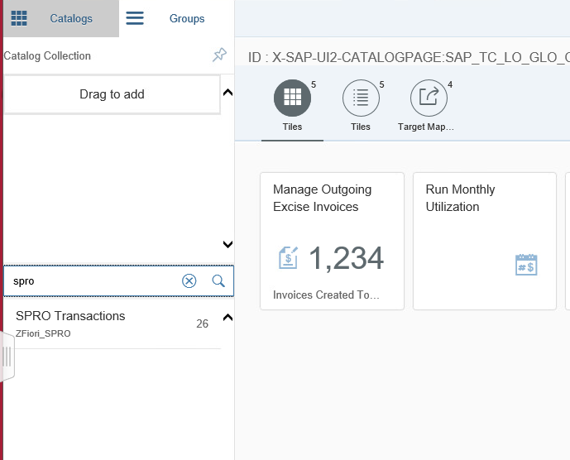
Create Tile in Catalog

Create Dynamic App Tile
Open Fiori Designer and navigate to the Catalogs Menu.
- Search Your catalog (ex. ZFiori_SPRO)

- Open Your catalog

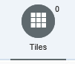
- Select Tiles Tab

- Select Add Tile
- Select App Launcher – Dynamic

Fill out the following information in the appropriate field. NOTE: Showing a * next to a name means field must be filled out. When finished note the screen shot. Your screen should be similar.
General
- *Title Create Chart of Accounts
- Subtitle Unit 3 – Exercise 22
- Keywords: SPRO – OB13
- Icon Any icon you desire
Navigation
- *Semantic Object SPROTransaction
- *Action create
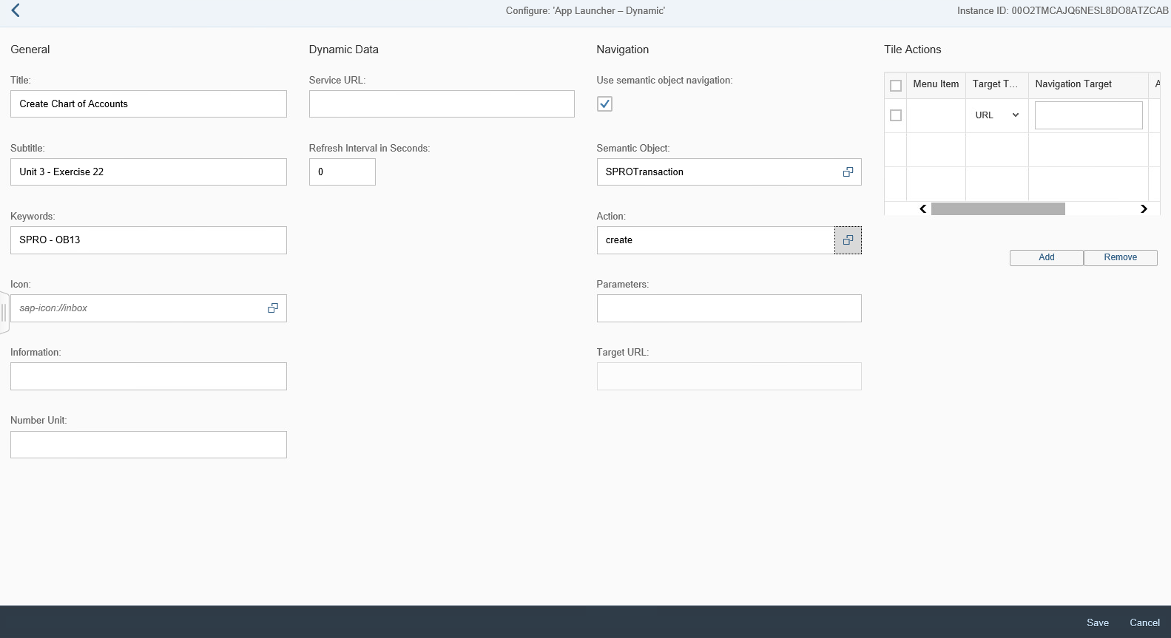
- Select Save
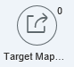

Create Target Mapping for Tile
- Select Target Mapping Tab
- Select Create Target Mapping
Intent
Match the Semantic Object and Action names to the creation of the Dynamic App Tile.
- *Semantic Object SPROTransaction
- *Action Create
Target
- *Application Type Transaction
- *Title Configuration Creation (You determine Title name)
- *Transaction OB13 (Transaction code from SAP GUI)
- Select Save
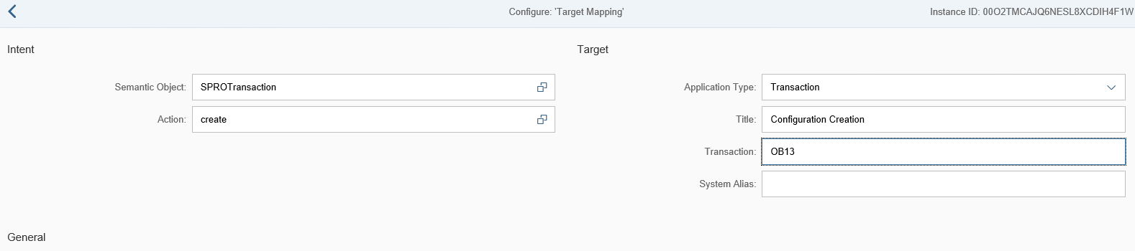
Application Creation is now finished.

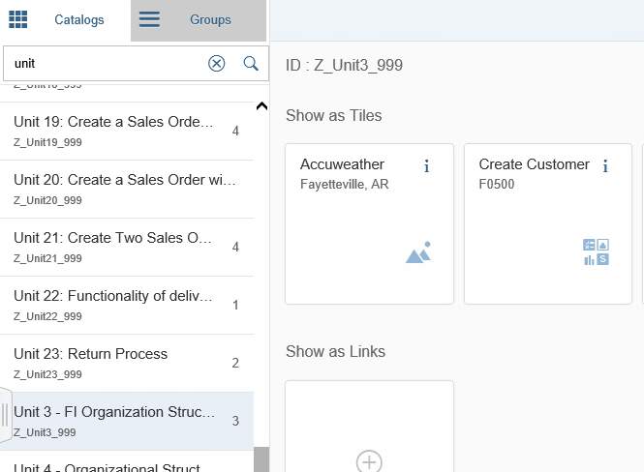
Place Tile in Group (Designer)
Navigate to your group in the Fiori Designer (Unit 3 – FI Organization Structure (Z_Unit3_999)).

- Select Add Tile
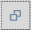
- Select Search

- Search for your Catalog SPRO Transactions

- Select your Catalog SPRO Transactions

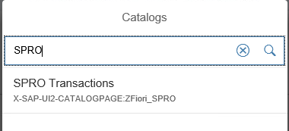

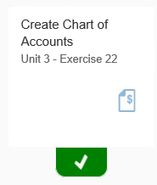
- Select Create Chart of Accounts (New Tile)
- Navigate Back

Verify Tile in Group (Launchpad)
Open Fiori Launchpad and hit F5 to refresh the page. If the new app is in your group, there is no need to continue. Otherwise, we need to locate the catalog and pin the tile to your Fiori Launchpad group. Continue the tutorial for that process. Make sure you know where your group is located on the Launchpad.
- Click User icon (top left)
- Click Edit Home Page

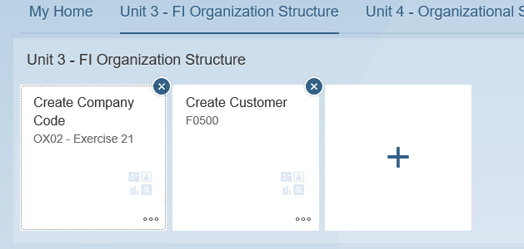
- Navigate Your Group (Unit 3 – FI Organization Structure)

- Select Open App Finder
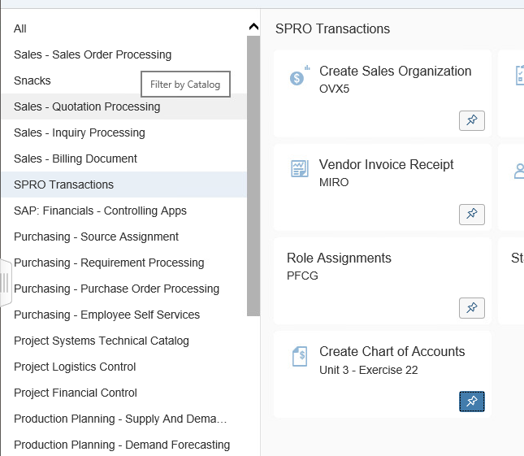

- Select Your Catalog

- Select New Tile
- Navigate Back

Exit Edit mode by reversing the steps from above. Verify that your app is in the correct group and test your application.

