Favorites: Fiori Launchpad, Fiori Designer and Fiori App Library
The purpose of this demo is to show the process of creating Favorites in SAP GUI for the Fiori Launchpad, Designer and App Library. This allows the user to have an easily accessible platform to open up Fiori Launchpad, Fiori Designer, and Fiori App Library quickly. This is extremely helpful, because otherwise the user would have to keep all three links stored somewhere and would take longer to access these portals.

SAP GUI Logon
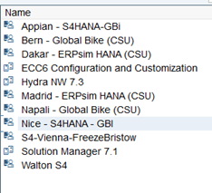
- Logon to the designated server assigned by your instructor.

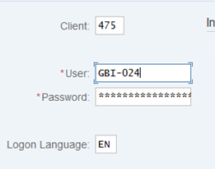
- Logon with your given client number, username, and password assigned by your instructor.

Fiori LaunchPad Favorite:
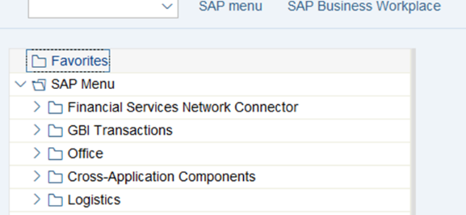
- Right click on the “Favorites” tab
- Click “add other objects” from the tab (at the bottom)

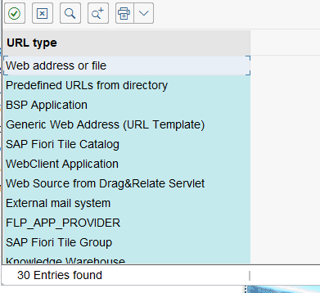
- Double click “web address or file”

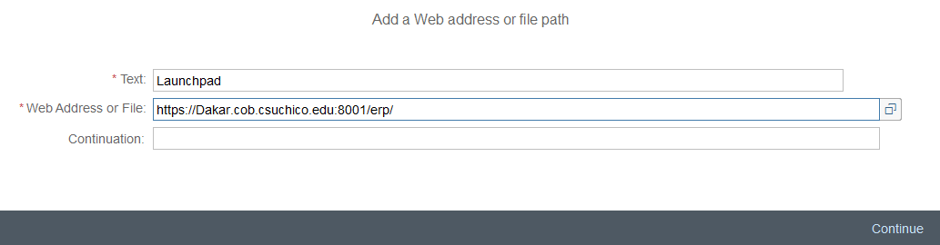
- Type in the title in the “Text” box
Text: Launchpad
- Copy the web URL provided by your instructor into the “Web Address or File” box
Web Address or File: https://Dakar.cob.csuchico.edu:8001/erp/

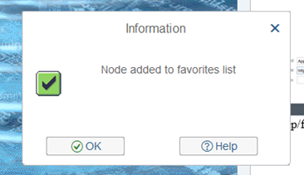
- Click continue
- Click “OK”

Fiori Designer Favorite:
- Right click on the “Favorites” tab
- Click “add other objects” from the tab (at the bottom)

- Double click “web address or file”

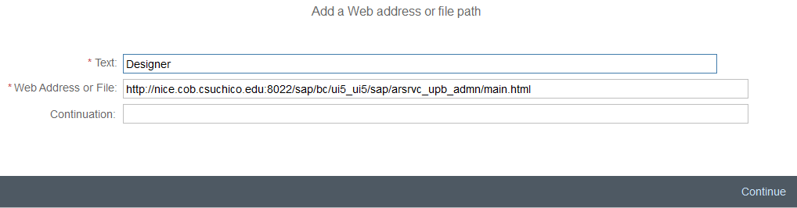
- Type in the title in the “Text” box
Text: Designer
- Copy the web URL provided by your instructor into the “Web Address or File” box
Web Address or File: http://nice.cob.csuchico.edu:8022/sap/bc/ui5_ui5/sap/arsrvc_upb_admn/main.html
- Click continue
- Click “OK”

Fiori Library Favorite:
- Right click on the “Favorites” tab
- Click “add other objects” from the tab (at the bottom)

- Double click “web address or file”

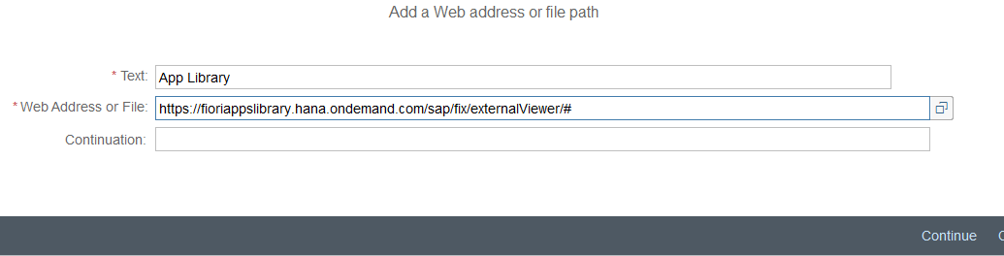
- Type in the title in the “Text” box
Text: App Library
- Copy the web URL into the “Web Address or File” box
Web address or file: https://fioriappslibrary.hana.ondemand.com/sap/fix/externalViewer/#
- Click continue
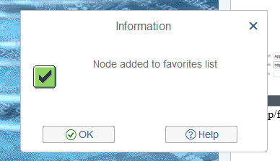
- Click “OK”

Results
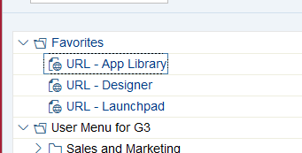
End Result: A link to each application on the favorites board.

