Fiori Launchpad: Creating Transaction Tiles
The purpose of this demo is to show the process of creating a SAP-GUI transaction tiles for the Fiori Launchpad. The examples provided are intended for use at the University of Arkansas in the ERP Configuration course. This tutorial also assumes that you know the navigation of Fiori Catalogs and Groups within the Fiori Designer and the navigation of Groups within the Fiori Launchpad. Pre-created groups and catalogs will be used, but a quick demo on Catalog and Group creation has been provided.

Exercise 1: Create a Catalog
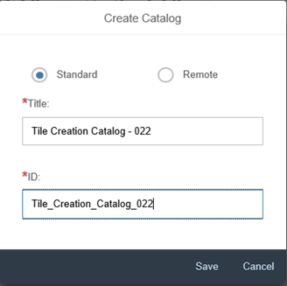
A Catalog is set of apps (Tiles) that you want to assign to a certain role. By assigning the apps to a role, they are accessible to the user on the Fiori Launchpad Dashboard.

Fiori Designer Initial Screen
- Catalog Tab – Click on the bottom of the Tab.
- A pop-up will appear. Use Standard formatting for your new catalog.
  - Enter Title Info – “Catalog name here”
  - Enter ID Info – “Catalog ID here”
  - Save

Exercise 2: Create a Dynamic Tile in a Catalog
Tiles provide a single-point access to all Fiori apps. They are used to display and launch specific apps, which can help the user complete a job or task within their Launchpad.

Fiori Designer Initial Screen
To create a tile, you need to be in a specific catalog.
- Navigate to the catalog tab
- Select the new tile button
- Select the “App Launcher - Dynamic” Format
  - Title - “Change Price List”
  - Subtitle - “VK32”
  - Semantic Object - “ChangePriceList”
  - Action - “OpenVK32”
  - Choose an appropriate Icon
  - Save

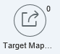
- Navigate to Target Mappings
- On the bottom of the page select Create Target Mapping

  - Semantic Object - “ChangePriceList”
  - Action - “OpenVK32”
  - Application Type - “Transaction”
  - Title - “Change Price List”
  - Transaction - “VK32”
  - Save

Exercise 3: Creating a Group in Designer
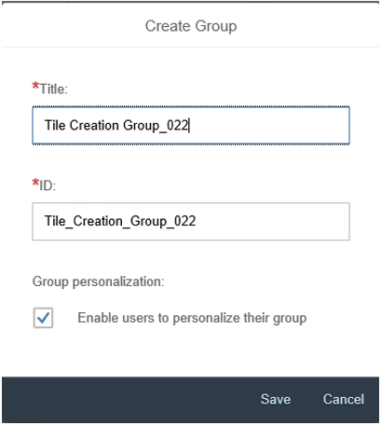
Groups are subsets of apps (Tiles) from catalogs in the Fiori designer. They decide the arrangement and selection of apps on the user’s dashboard.

Fiori Designer Initial Screen
- Select the Group Tab
- Click on the bottom of the Tab
- Use standard formatting for you new group.
  - Enter Title Info – “Group name here”
  - Enter ID Info – “Group ID here”
  - Save

Adding your Dynamic Tile to your Group
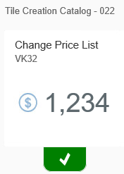
- Navigate to the group tab and find the group you created “Tile Creation Group_022”
- Click the Add Tile Button “+”
- Find the Catalog your Tile is in “Tile Creation Catalog - 022”
- Locate your Tile and Click the “+” button
- The plus sign will change to a green check
- Navigate back to your group using the back button, your tile will now appear in your group.

