SAP Fiori App Library

Details Associated with Implementation Information
The SAP Fiori App Reference Library is used to explore, plan and implement “SAP Fiori”, which is intended to be the new user experience for SAP software. In this tutorial, you will learn how to use the Fiori app library to search for apps that are perhaps not readily available on the Fiori Launchpad. If a particular app cannot be found in the app library, it is safe to assume that there haven’t been one created as yet under that particular name (the name entered in the search). For the apps that are available, the SAP Fiori App Reference Library will provide you with information that should be considered and used to search for desired apps in the Fiori designer, where you will be able to make the app available globally in/on the Fiori Launchpad to foster customization, job/role individualization and completion. Please proceed to following the numbered steps below.

Accessing the Library
Fiori Apps Reference Library link - https://fioriappslibrary.hana.ondemand.com/sap/fix/externalViewer/#

- Go to SAP Fiori Reference App Library (link above) and select “All apps for SAP S/4HANA” from the menu located at the top left of the library home screen.
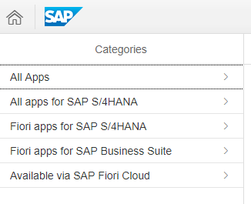
- This will yield results for all apps developed so far for SAP S/4HANA GUI, SAP Fiori, SAP Business Suite, and SAP Fiori Cloud.

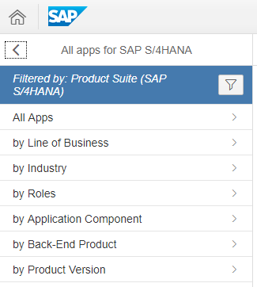
- Select “All Apps” from the menu also located at the top left of the screen.

- Enter in the search “Manage Customer Line Items” and hit enter (two search results should appear).
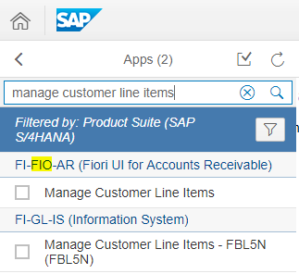
- That is the name of the app you are searching for.
- Select the result under the product suite containing “FIO” in the naming convention.
Important note: Result(s) with product suites containing “FIO” in the naming convention include the Fiori compatible apps.
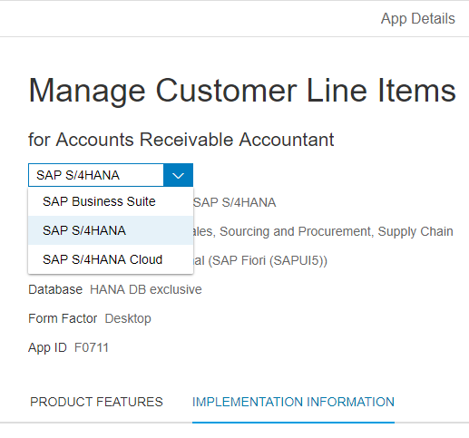
- You are now on the app details page. Ensure “SAP S/4HANA” is selected in the dropdown box beneath where it says “for accounts receivable accountant”. By doing so, the app details displayed will be in reference to SAP S/4HANA in particular.

- Select the tab named “Implementation Information” (the text will turn blue when selected).

Implementation Information
When the “implementation information” tab is selected, you will find all important detailed information about the app that’ll be used to find it in the fiori designer. Such information can also be used as a template to creating other/new apps from scratch.
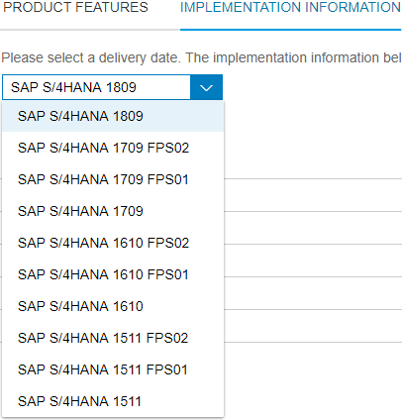
- Ensure that you have the right version selected. In this tutorial, the most recent version (1809) is used.
- The first piece of information noticed is “SAP S/4HANA 1809” on a dropdown box. That is the product version of the selected app, also referred to as the delivery date (delivery dates are not shown for initial versions, but can be found within the contents of the “Important SAP Notes” tab under the “description” column for versions including “FPS01” or “FPS02” at the end of the naming convention).

Important notes: The naming convention may or may not include “FPS01” or “FPS02” after the four digit number within the naming convention (1809 in the screenshot)
- Versions that DO NOT end in “FPS01” or “FPS02” are the first/initial release of a particular version.
- Versions that end in “FPS01” are the releases of a particular version that is considered an add-on to the latest front-end server version of the selected app.
- As for those ending in “FPS02”, the only difference from 01 is that the app is accessible in the SAP Fiori Cloud. This applies to application versions 1610 and up.

- Extend the “Installation” tab and confirm the front-end component product version reads “SAP FIORI FOR SAP S/4HANA (version)” and the back-end component product version reads “SAP S/4HANA (version)”.
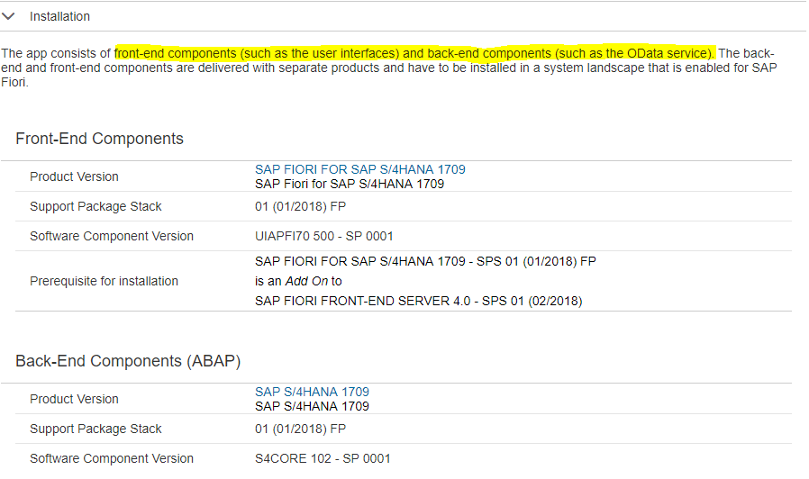
- The software component version for the front-end begins with “UI”, which is an indication that it deals with the User Interface (read highlighted text on the above screenshot).
- The software component version for the back end begins with “S4CORE”, which is an indication that it deals with SAP data. (Read highlighted text on the above screenshot).

- Extend the “Configuration” tab.
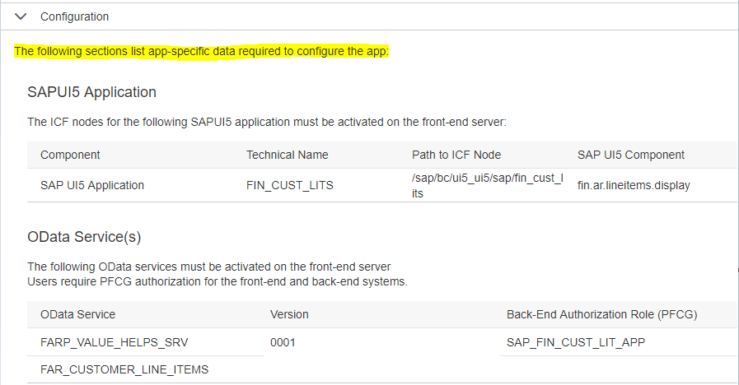
- The screenshot to the right shows the top part of tab 3 (configuration) extended. Within the configuration dropdown, you will see all information needed to set up an app for it to be shown on the Fiori Launchpad. The first two sections of the configuration tab provides more information in relation to the front-end and back-end components.

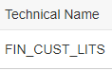
As for SAPUI5 Application (SAP User Interface version 5) section:
- The naming convention is short for Finance_Customer_Line Items

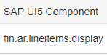
- The naming convention is short for Finance_Accounts Receivable_ Line Items_ Display

As for the OData Service(s) (Open Data Service[s]) section:

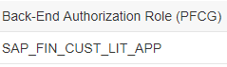
- The naming convention is short for SAP_Finance_Customer_Line Items_Application

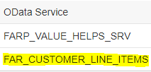
- The naming convention is short for Finance Accounts Recievable_Customer_Line_Items

- *Scroll down to the “SAP Fiori Launchpad” section.
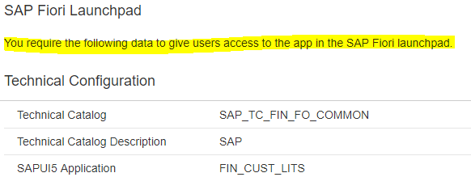
- This is the starting point of all information pertaining to the selected app as it relates to availability and accessibility on the fiori designer, beginning with the technical configuration information.
“SAP_TC_FIN_FO_COMMON” is the name of the technical catalog, which is located in the SAP Fiori Designer, in which the searched and selected app can be found. It is short for SAP_Transaction Catalog_Financials_Financial Operations (Accounts payable and receivable) Common and it houses all related apps.

- Scroll down to the “Target Mapping” section. This is where you’ll find the information needed as it relates to target mapping (the semantic object and semantic action).
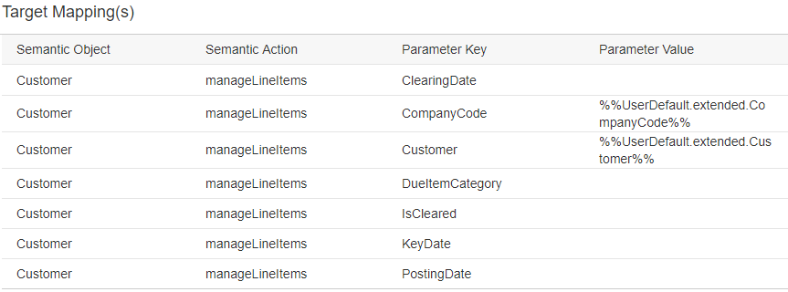
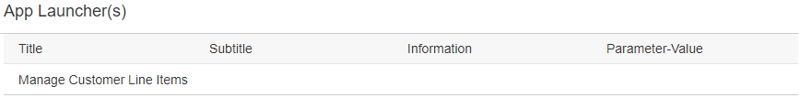
- Scroll down to the “App Launcher” section. This is where you’ll find the full name of the actual application under the column labeled “Title”.
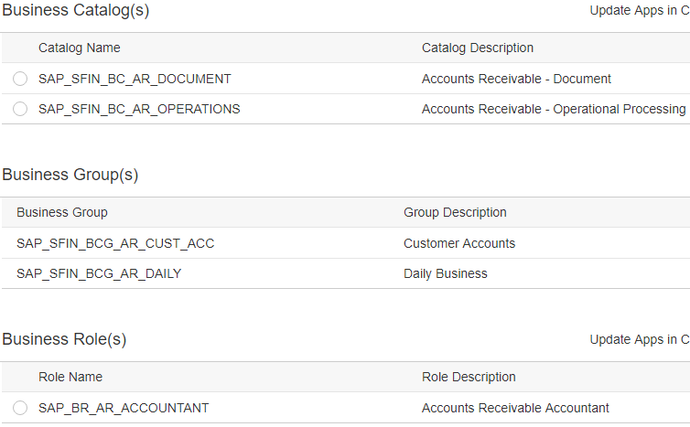
- Scroll down to the “business catalog(s)”, “business group(s)”, and “business role(s)” section of the configuration dropdown.
- This/these sections are where you will find the information needed to effectively search for a particular app in fiori designer.

Important side notes:
- You can search for an app in SAP Fiori Designer via the business group (ensuring the “groups” tab is selected and highlighted grey in the designer before attempting), business catalog name or technical catalog name (ensuring the “catalogs” tab is selected and highlighted grey in fiori designer). However, you cannot search for an app via business role name.
- An app can be found in multiple business catalogs and/or groups, but can only be found in one specific technical catalog.
(Recommendation: Search for apps via business catalog name or business group name)

Naming Conventions
As for the business catalog naming convention:
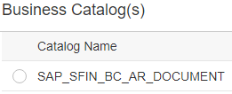
- The “BC_AR” within the naming convention of the catalog name stands for “Business Catalog” and “Accounts Receivable”.
- Ensure the “catalogs” tab is selected in fiori designer when searching this name.
As for the business group(s) naming convention:
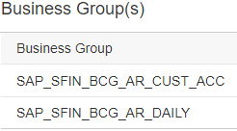
- The “BCG_AR” within the naming convention of the catalog name stands for “Business Catalog Group” and “Accounts Receivable”.
- Ensure the “groups” tab is selected in fiori designer when searching this name.
As for the business role naming convention:
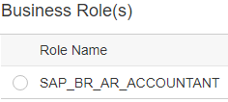
- The “BR_AR” within the naming convention of the catalog name stands for “Business Role” and “Accounts Receivable”.

The screenshot to the right shows tab 4 (extensibility) extended. Within the extensibility dropdown you will find information about an app in the event you’d like to extend the app over to another version. What you’ll need to consider is the component and its version along with the technical name, which can be found under the “Extensibility of the UI5 application in the front-end server” section located at the top part of the extensibility dropdown.
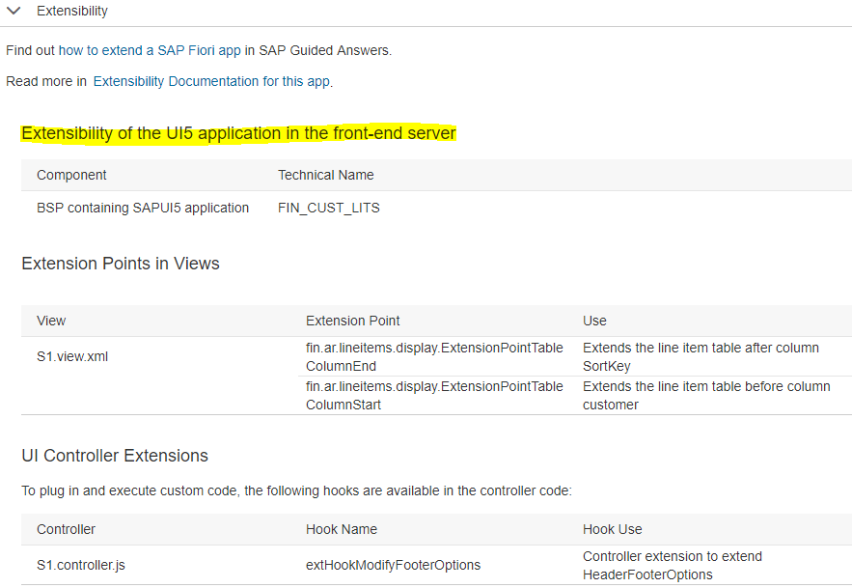

The last two dropdowns under the implementation information tab are the “Support” and “Related Apps” dropdown as shown in the screenshot above. The support dropdown reveals the application component “FI-FIO-AR”. That is also the name of the product suite that the app is located under upon searching for it in the SAP Library. The “FIO” within the naming convention is an indication that it is Fiori compatible. The extended name would perhaps be “Finance-Fiori-Accounts Receivable”.
