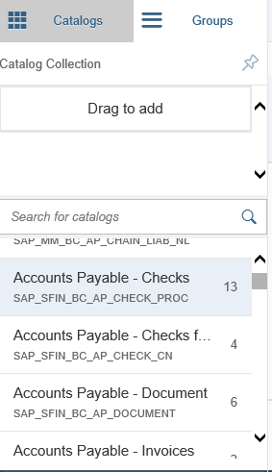
The purpose of this tutorial is to learn how to configure Fiori apps for mobile devices. This tutorial is a universal process for configuring apps among all mobile devices.

Configuring Fiori Apps for Mobile Devices
*Note: This tutorial assumes that you are already logged into SAP Fiori LaunchPad and Designer
- In Fiori Designer, go to the catalog tab and select a catalog that you would like to modify to work on your mobile device.

- Click on Accounts Payable – Checks, which will lead to a configuration screen.

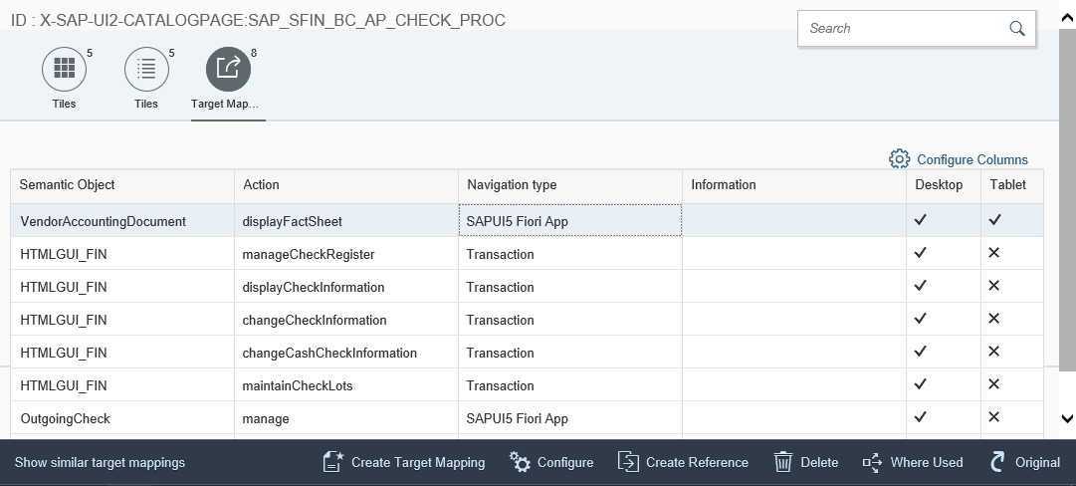
- Click on Target Mapping

- Click on the object to edit

- Click on Configure
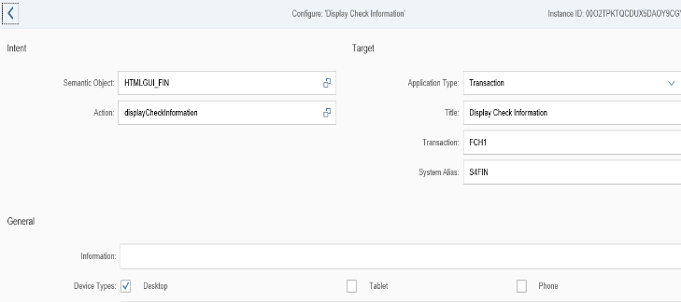

- Scroll to the General header

- Choose the device type that app is being configured for

- Click the save button
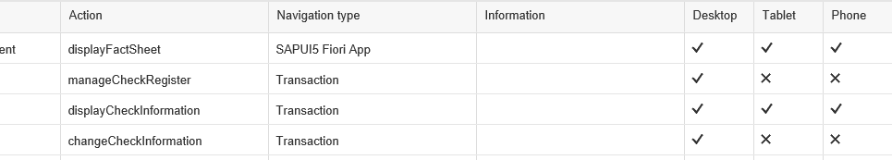
- Device types chosen in step 7 should have check marks in the boxes. Note: The X’s are devices that were not chosen

App Store for Apple devices
The purpose of this tutorial is to show the process of downloading the Fiori Client app from the App Store for Apple devices. If trying to download to an Android device, the same steps apply except you would go to the GooglePlay Store to download the initial app.

Fiori LaunchPad for Apple Devices
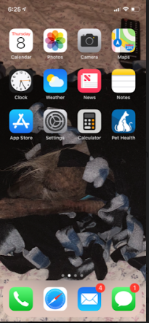
*Note: App should already be configured in order to be able to use in Fiori Client App; App is made for iPhone and Android Devices

- Tap on the App Store icon

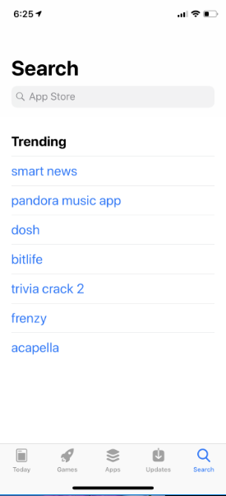

- Tap Search

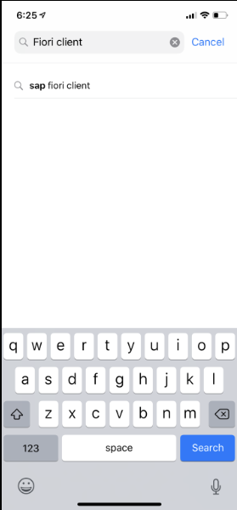
- Type Fiori Client into Search Bar

- Tap Search

- Tap on the cloud icon to download SAP Fiori Client

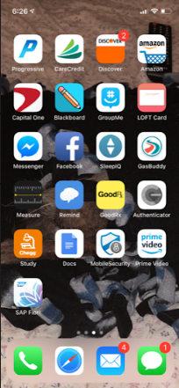

- Tap on Fiori icon

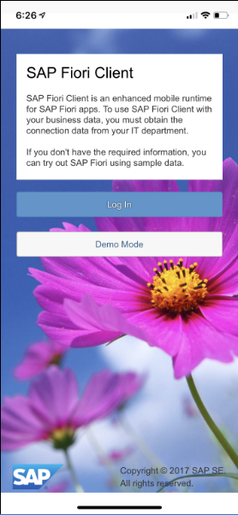

- Tap Login

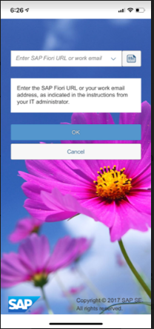
- Type in URL given by instructor

- Tap OK

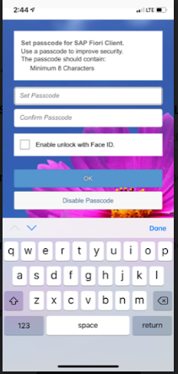
- Create a password
- (optional) Tap to enable Face ID
- Tap OK

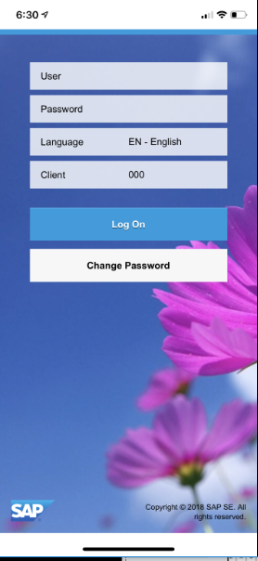

- Enter login information (User, Password, Client #)
*Note: User and Client # should be the same as your GUI interface login

- Tap Log On

Should see a mobile version of Fiori LaunchPad

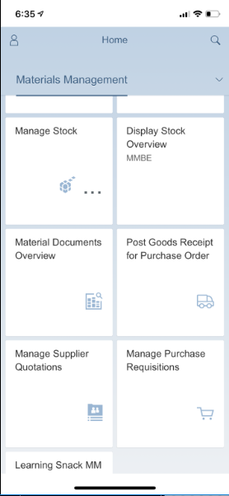
- Tap on Navigation Bar
*Note: Navigation Bar shows all groups on your LaunchPad
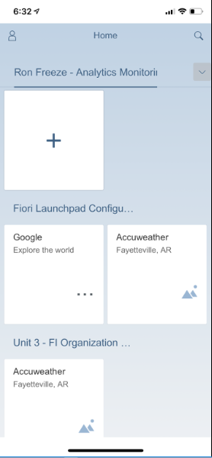

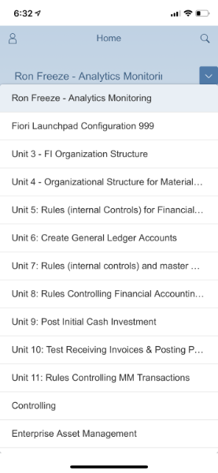
- Tap on the group you placed your app in
*Note: This can be found in Configuration of the app in Fiori Designer

- In the group you selected, tap on the tile that is needed to perform the transaction and start entering in information

