Searching for an App in SAP Fiori Designer

Introduction
SAP Fiori Designer is a tool that allows users to manage their Launchpad by configuring app tiles and maintaining catalogs and groups. Searching for an app in Fiori Designer can be aided by searching for the app in the Fiori App Library and copying the app’s technical catalog ID into Designer’s catalog search bar, but this tutorial will explain how to search for the app without Fiori App Library. This tutorial will demonstrate each step for searching and finding an app in Fiori Designer, explain the use and contrast the differences of the following items:
- Tile View
- List Tile View
- Where Used
- Target Mapping

Logging On

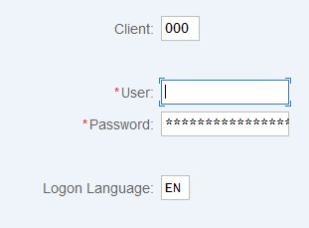
Step 1: Logging on to SAP

Launch the SAP Logon and select your specific connection.

Enter your client, username, and password and hit the enter key.

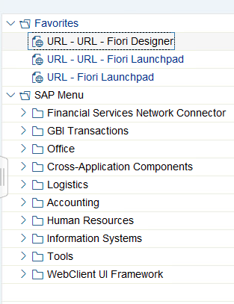
step 2: Logging on to Fiori Designer

Once you have successfully logged into SAP, open the Fiori Designer (you may need to open the Fiori Launchpad prior to this step if you are unable to open Fiori Designer).
In this example, Fiori Designer is already located under the Favorites tab.

When you open Fiori Designer, you will be required to reenter your SAP logon information.

Searching for an App
Searching for an app inside Fiori Designer without using the Fiori App Library or Fiori Launchpad App Finder may take some exploration and applied information about the app you are trying to find. Simply searching for the app’s title will not call up the app. Instead, try searching words associated with the app title.
In this example, the app being searched for is titled Create Purchase Contract.
Possible words or phrases to search for are purchase, contract, or purchase contract.

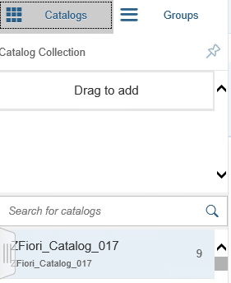
Step 3: Searching for an App in Catalog Search
In Fiori Designer, on the top left of the screen you will see a Catalog tab and a Groups tab.
The grayed out tab is the tab you are currently on.
Select Catalogs, and in the search bar enter your search term (for this example, they are purchase, contract, or purchase contract).
In this example, purchase was entered into the catalog search bar.

Step 4: Finding the Right Catalog
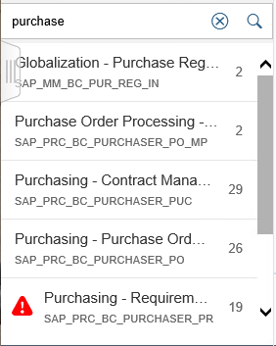
Search word purchase calls up 7 different business catalogs containing the word purchase.
Business catalog titles correspond with the app tiles they contain, so review the catalog titles and find one that relates to the app being searched for, in this instance Create Purchase Contract.
Click open the catalog relating to the app, catalog Purchasing – Contract Management, to check if this catalog contains the app we are looking for.

Step 5: Finding the App within the Catalog
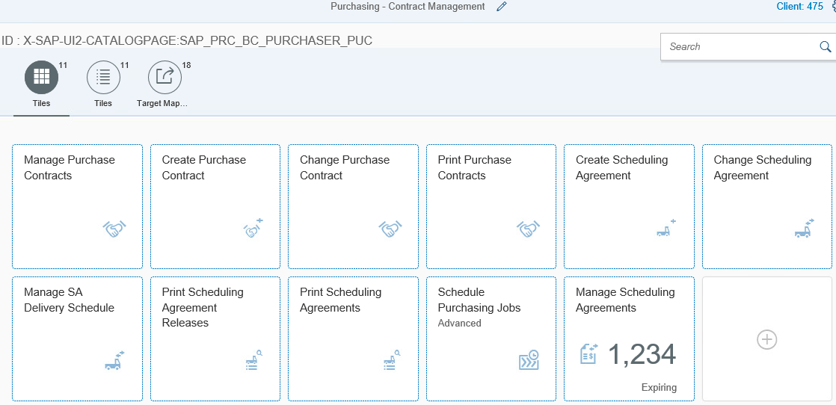
After opening the Purchasing – Contract Management business catalog you can see that this catalog contains the app being searched for, Create Purchase Contract.

Tile View
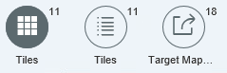
You may notice the 3 icons above the app tiles displayed in the business catalog. The photo from Step 5 is displaying the Tile View, shown by the selected Tiles icon.

Step 6: Tile View
Select the Tiles icon circled in the photo above.

Functions Within Tile View
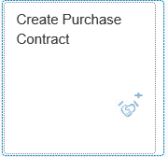
In Tile View in a business catalog, you have the ability to add apps to the catalog by selecting the tile with the add symbol.
You also have the ability to configure the app tiles in this business catalog by clicking on the tile, such as Create Purchase Contract.

Tile List View
Tile List View displays all app tiles in the catalog in a list format.

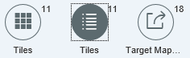
Step 7: Tile List View
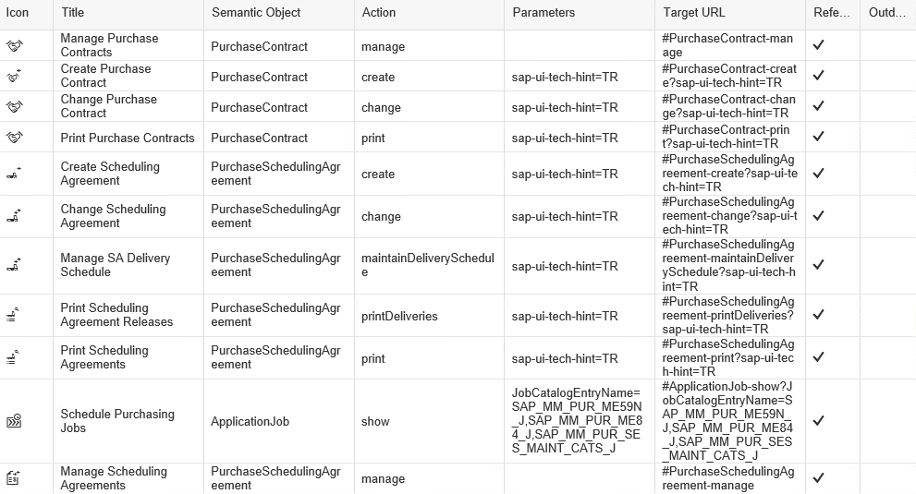
Select the middle Tiles icon on the left side of the catalog.
In Tile List View, you will see every app tile’s Icon, Title, Semantic Object, Action, Parameters, Target URL, whether or not it’s a reference tile, or if it’s outdated in list form on one screen (pictured above).

Functions Within Tile List View
When you select a tile in list view, the following options become available at the bottom of the screen.
In Tile List view, you have the ability to create a tile, configure the selected tile, create a reference, delete the selected tile, find where the tile is used, and find the original tile.

where used icon
After selecting an app tile in the Tile List View, the Where Used icon becomes available at the bottom right of the screen.

Step 8: Find App’s Other Locations
Click the Where Used icon.
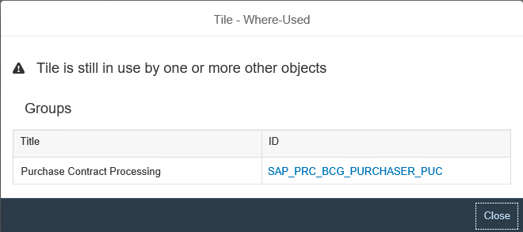
The Tile – Where Used window will pop up. This window shows other catalogs or groups where this App Tile is also located under the ID column.
The app Create Purchase Contract can be found in the group SAP_PRC_BCG_PURCHASER_PUC.

Step 9: Go To Other App Locations
Select the group ID on the Tile – Where Used window to go to the group where the app is also located.
You are now in the group Purchase Contract Processing.
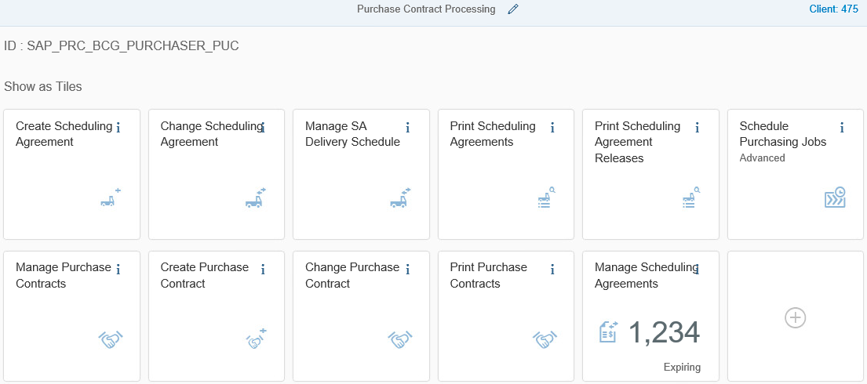
You can find the app you searched for, Create Purchase Contract, in the group it is located in, Purchase Contract Processing.

Step 10: Navigate Back to Catalog
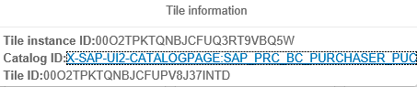
By selecting the Information icon, a Tile Information window will open with the Tile Instance, Catalog ID, and Tile ID of this app tile.
Select the Catalog ID, and you will be back in the catalog you first found the app in.

Target Mapping
When an app tile’s semantic object and action are triggered, the target app is launched due to Target Mapping.

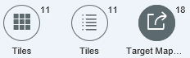
Target Mapping View
Select the Target Mapping icon to view all the target maps in this catalog.
Selecting this displays the target mappings in a list view.
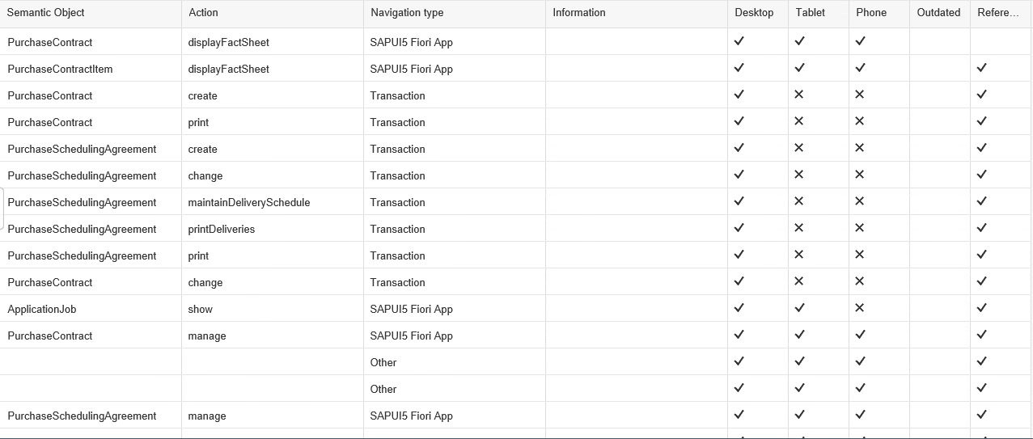
There are 18 target mappings in this catalog, although there are only 11 tiles. You can see the Semantic Object PurchaseContract, the Action create, and the Navigation Type Transaction for the app tile Create Purchase Contract. This target mapping is only available for desktop.

Step 11: Create A Target Mapping
Select Create Target Mapping
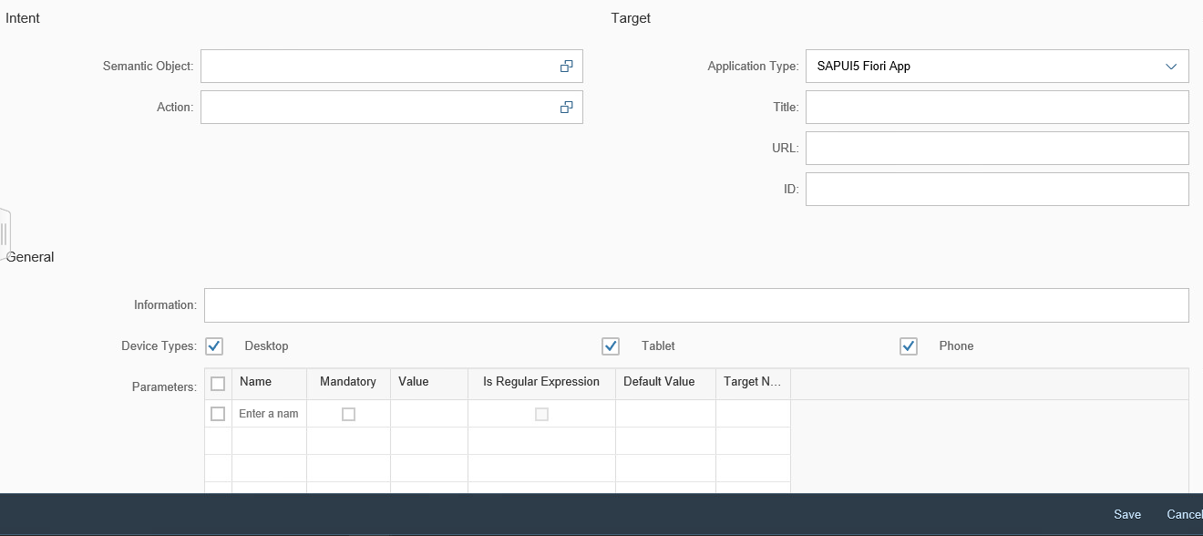
Here you would put in your Semantic Object (PurchaseContract in this example), your Action (create), your Application Type (Transaction), and any additional information you have and click Save.

