SASVIYA Exercise 01

Logging Into the System

(4/13/2020)

Sources
Steve Nolan, Ron Freeze, Elizabeth Keiffer, Michael Gibbs, Matias Delay
Enterprise Systems, Sam M. Walton College of Business, University of Arkansas, Fayetteville
SAS® VIYA 8.2 Release V03

Copyright © 2018 For educational uses only - adapted from sources with permission. No part of this publication may be reproduced, stored in a retrieval system, or transmitted, in any form or by any means, electronic, mechanical, photocopying, or otherwise, without the prior written permission from the author/presenter.

Use Case – Logging into the system
Razorback Stores is a local department store serving a metropolitan area. As a department store, they offer a wide variety of items and services and track sales through a point of sale system. Over the past several months, Razorback Stores performed a marketing campaign designed to promote and incentivize a loyalty program.
Our first step in the process of analyzing and assisting Razorback Stores is signing into the VIYA system. This will give us access to a wide variety of tools and methodologies we can use to analyze the data provided.

Step 1:
Use the following link below to sign in. This link will take you to the main VIYA platform hosted by the University of Arkansas.
https://viya.walton.uark.edu/SASLogon/login

Step 2:
Once you have clicked on the link, login with your University credentials:
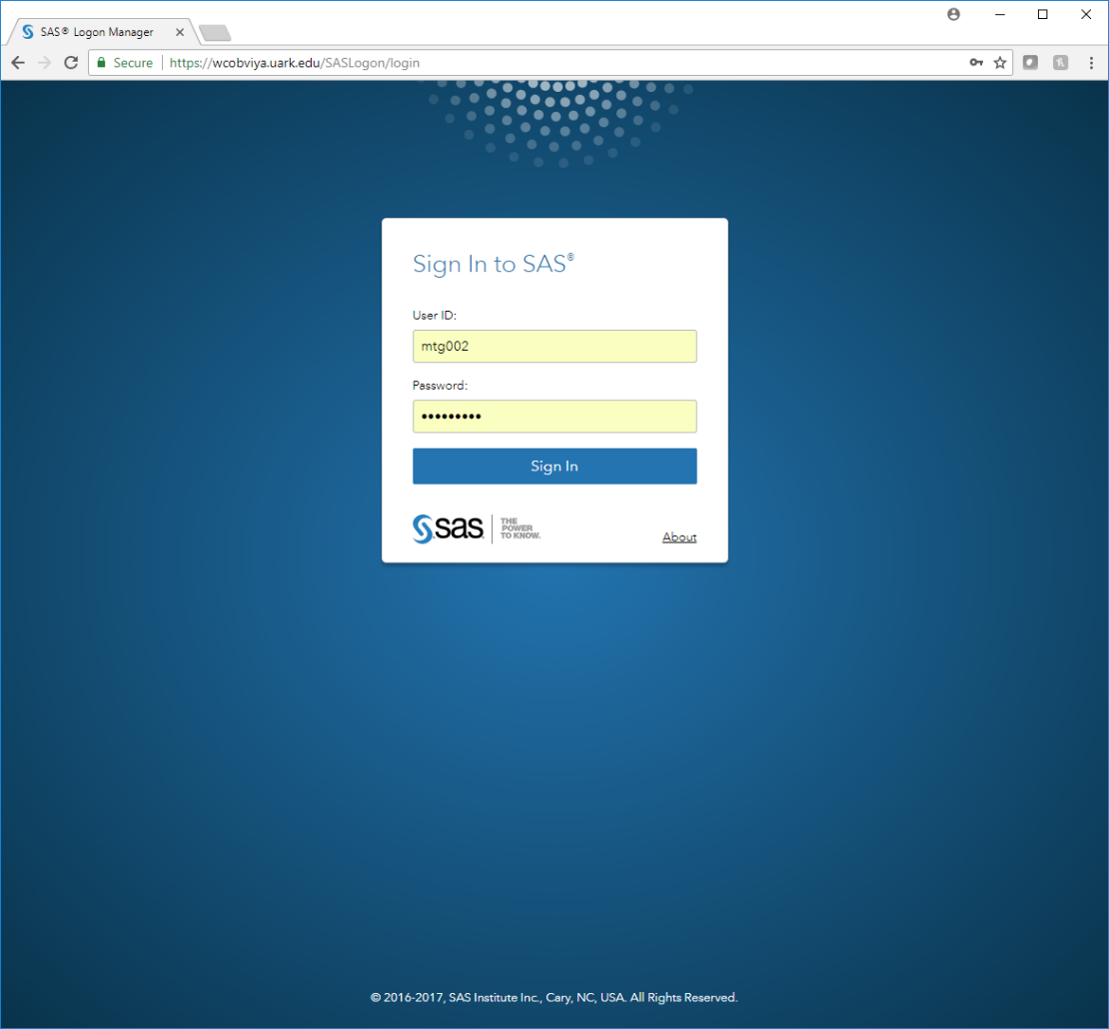

Step 3:
Once you have logged in, you will be presented with the main user interface. From here, you have access to the system.
Please note that your screen may look slightly different depending on the projects and reports that you have worked on.
