SASVIYA Exercise 02

Loading Data into VIYA

(4/13/2020)

Sources
Steve Nolan, Ron Freeze, Elizabeth Keiffer, Michael Gibbs, Matias Delay
Enterprise Systems, Sam M. Walton College of Business, University of Arkansas, Fayetteville
SAS® VIYA 8.2 Release V03

Copyright © 2018 For educational uses only - adapted from sources with permission. No part of this publication may be reproduced, stored in a retrieval system, or transmitted, in any form or by any means, electronic, mechanical, photocopying, or otherwise, without the prior written permission from the author/presenter.

Use Case
Razorback Stores is a local department store serving a metropolitan area. As a department store, they offer a wide variety of items and services and track sales through a point of sale system. Over the past several months, Razorback Stores performed a marketing campaign designed to promote and incentivize a loyalty program.
It is time to import the Razorback Stores data set (or a dataset of your choosing). This guide will help us import the point of sale data provided by Razorback Stores.

Step 1:
Click on the “New” button in the upper left corner of the screen and choose Report:
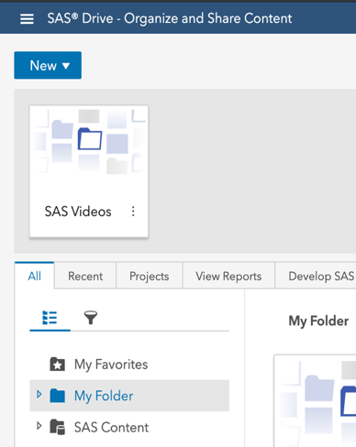

Step 2:
Once you are on the report pane, click on the Data section of the menu on the left-hand side.
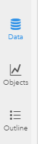
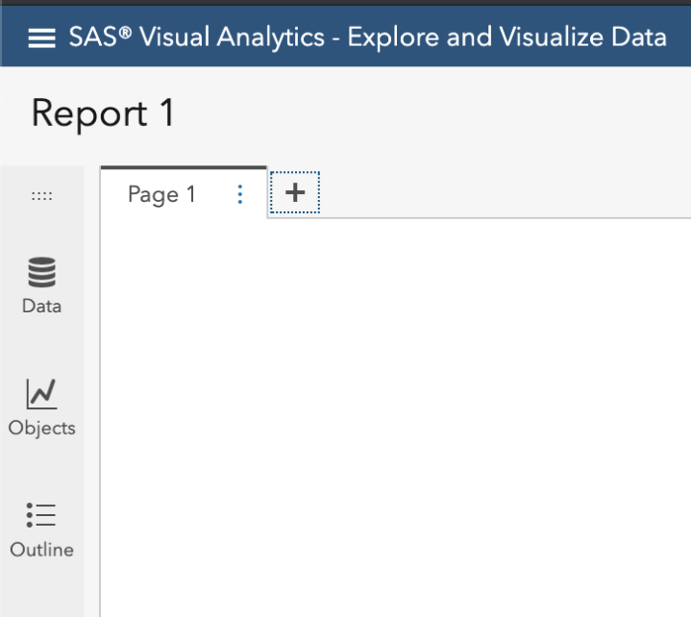

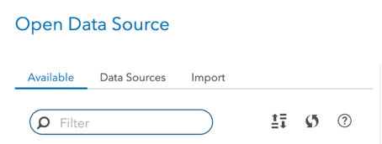
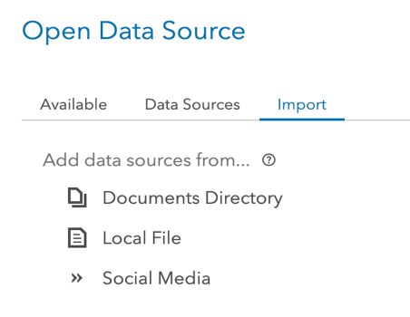
Step 3:
From here, you have three different areas to view data:
- The first is what is currently available. Once you have imported your data, this is where you can select the data for use.
- The next option is data sources. This gives you a “folder” structure of the cloud analytics services, or CAS area. In here, you will have access to various areas such a personal storage area (CASUSER) as well as a public pathway.
- The last option is import. Click on the import tab and you can choose a local file to import. Click on local file in the left-side pane.

Step 4:
Select the file that you wish to import, which in our case is Razorback Stores (If you wish to follow this tutorial, please download or have the Razorback Stores on your computer).
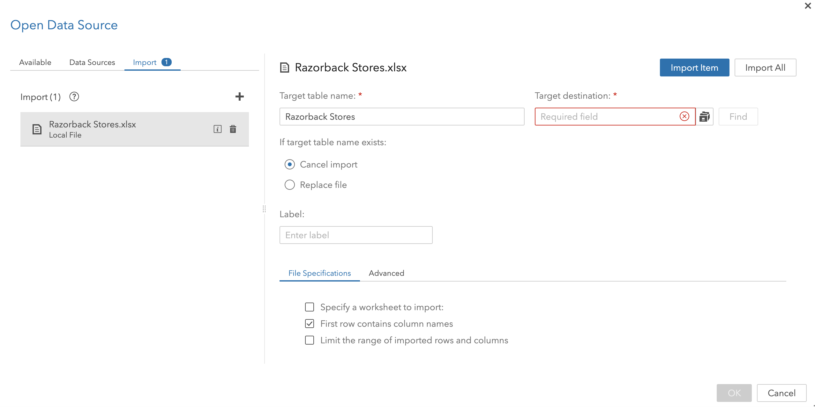
Check Target destination to ensure that CASUSER(username) is selected. If not, click on the “library icon” and select your username CAS library:
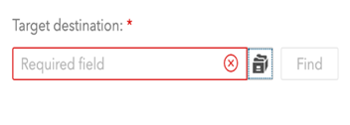
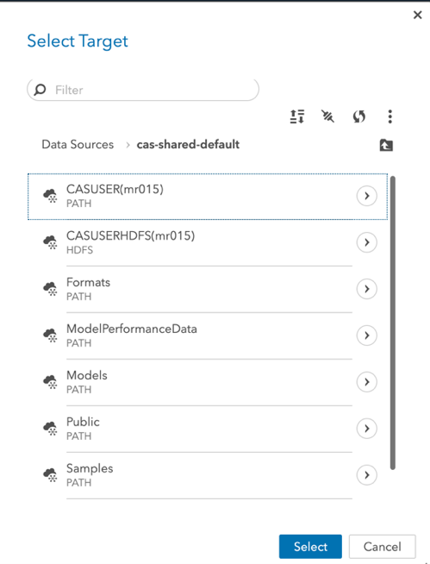

Once finished, your screen should look like the following where the Target destination space is filled with your CAS library folder selected/confirmed:
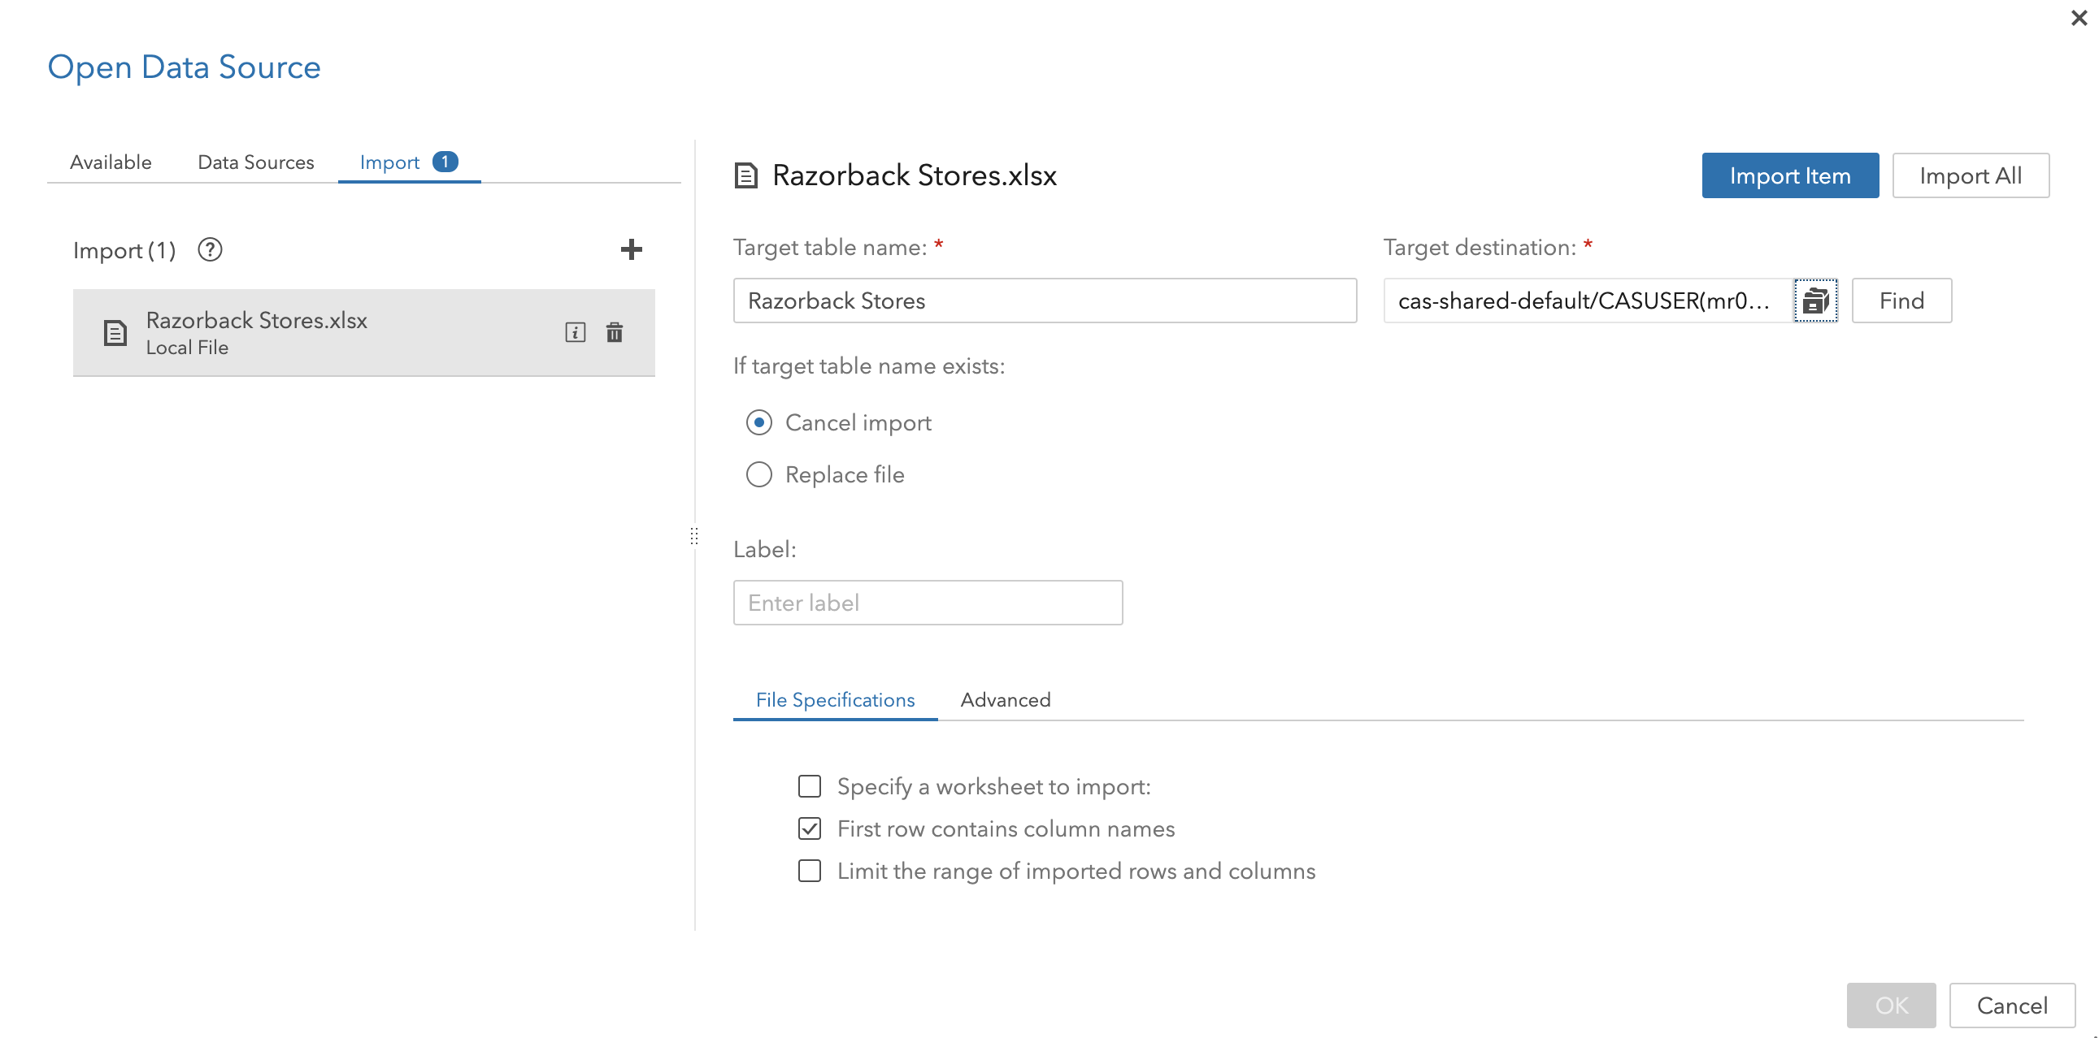
It is also important to note that you have other options to choose as well. As an example, If you wish to update a file currently in your library, you can choose to replace the file rather than cancel import if it exists (radio buttons). If your data has multiple spreadsheets, you will want to select the checkbox “specify sheet to import” to denote which data you are wanting to import. If your data has headers in the first row, ensure that the checkbox is selected called “first row contains column names”. There are also file specifications to choose from depending on what type of file you are importing.

Step 5:
Click on Import Item located in the upper-right corner of the screen:
Click OK in the lower right corner once the file has been imported.
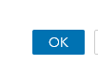
Congratulations, you have imported data into VIYA!

