SAS VIYA Exercise 03

Running Descriptive Statistics

(7/24/2020)

Sources
Steve Nolan, Ron Freeze, Elizabeth Keiffer, Michael Gibbs, Matias Delay, Jorge Moreda
Enterprise Systems, Sam M. Walton College of Business, University of Arkansas, Fayetteville
SAS® Visual Analytics. Release 8.5
SAS® Viya® release V.03.05

Copyright © 2018 For educational uses only - adapted from sources with permission. No part of this publication may be reproduced, stored in a retrieval system, or transmitted, in any form or by any means, electronic, mechanical, photocopying, or otherwise, without the prior written permission from the author/presenter.

Use Case – Descriptive Statistics
Razorback Stores is a local department store serving a metropolitan area. As a department store, they offer a wide variety of items and services and track sales through a point of sale system. Over the past several months, Razorback Stores performed a marketing campaign designed to promote and incentivize a loyalty program.
Razorback Stores is interested in learning some general descriptive information about their data.

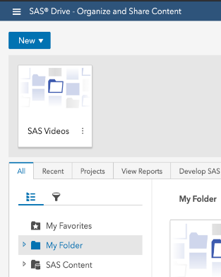
Step 1: New Report
Once you are logged into the VIYA system,
- Click on “New” in the upper left-hand side of the screen and choose Report

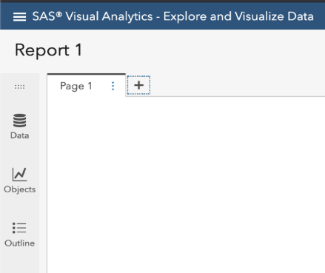
Step 2: Data
You will be now be on the report window. From here, you can choose a new data source, create a new object, or view the outline.
- Click on the Data icon

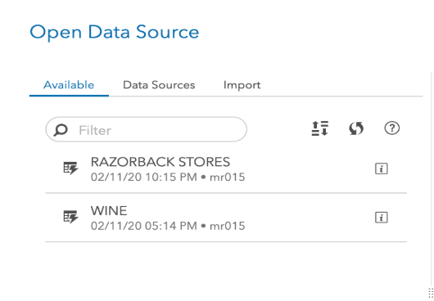
Step 3: Available Data
Once you have clicked on the data, you will be presented with Available data to use.
- Click on your chosen dataset (for this exercise RAZORBACK STORES)
- If no dataset is available, please see our tutorial 02a: Importing data.

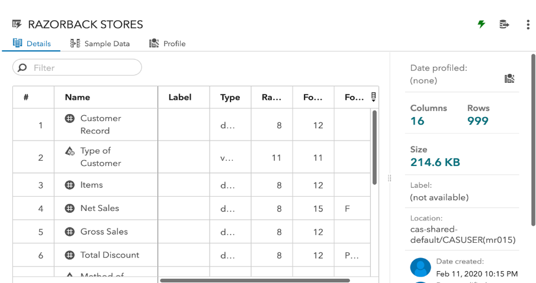
Step 4: Details
Once you have chosen a dataset, in our case the Razorback Stores dataset, the right-hand pane will display a listing of variables from the dataset with corresponding datatypes under the Details tab. This will show you the various variables from your dataset and the datatypes that have been denoted by the system:

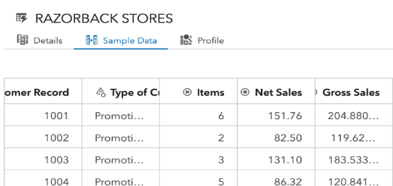
Step 5: Sample Data
- You can also click on the Sample Data tab to get a snapshot of the data:

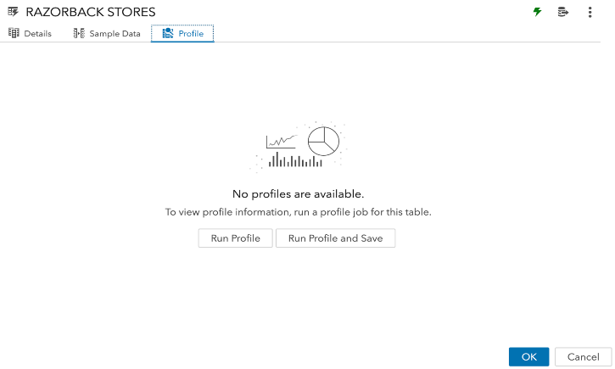
Step 6: Profile
- Now, click on the Profile tab and then run the profile by
- Clicking on Run Profile

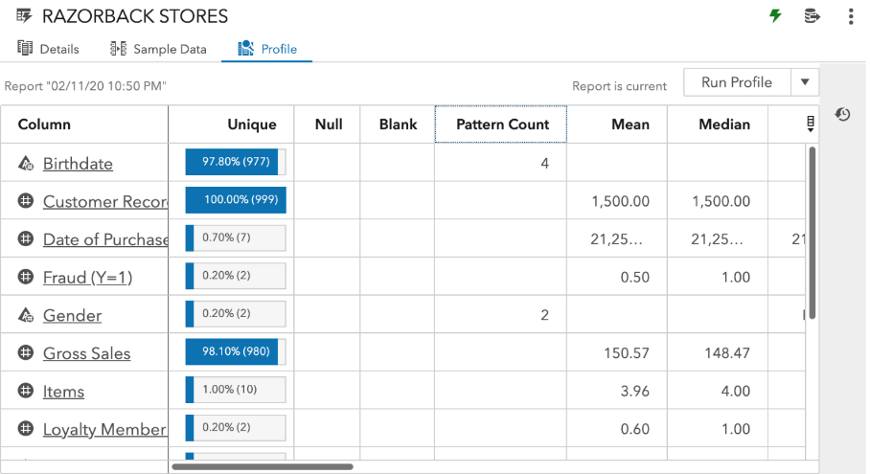
Step 7: Statistics
The outputed report will provide you basic descriptive statistics such as mean, median, and mode,
It will also give you unique counts and other useful descriptive statistics.
- Click OK to create the report
Congratulations, you have successfully ran descriptive statistics in VIYA!

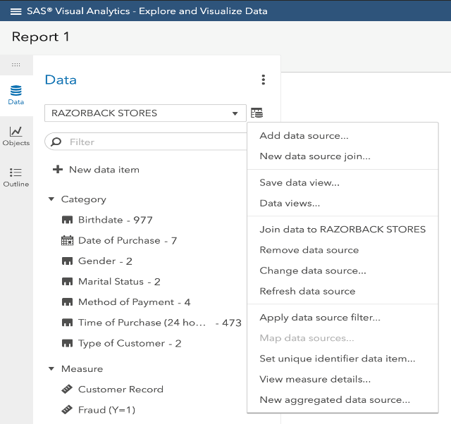
Step 8: View Measure Details
If at any point in time you wish to re-run or forgot to run descriptive statistics, you can always:
- Click on the data icon located on the Data tab and
- Choose view measure details…

Congratulations, you have learned how to run descriptive statistics in VIYA!

