SAS VIYA Exercise 03

Running Descriptive Statistics

(8/18/2022)

Sources
Steve Nolan, Ron Freeze, Elizabeth Keiffer, Michael Gibbs, Matias Delay, Jorge Moreda, Tal Miranda
Enterprise Systems, Sam M. Walton College of Business, University of Arkansas, Fayetteville
SAS® Visual Analytics. Release 8.5
SAS® Viya® release V.03.05

Copyright © 2018 For educational uses only - adapted from sources with permission. No part of this publication may be reproduced, stored in a retrieval system, or transmitted, in any form or by any means, electronic, mechanical, photocopying, or otherwise, without the prior written permission from the author/presenter.

Use Case – Descriptive Statistics
Razorback Stores is a local department store serving a metropolitan area. As a department store, they offer a wide variety of items and services and track sales through a point of sale system. Over the past several months, Razorback Stores performed a marketing campaign designed to promote and incentivize a loyalty program.
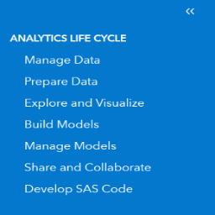
Razorback Stores is interested in learning some general descriptive information about their data.

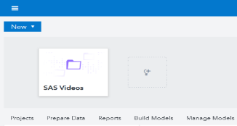
Step 1: New Report
Once you are logged into the VIYA system,
- Click: the three parallel lines
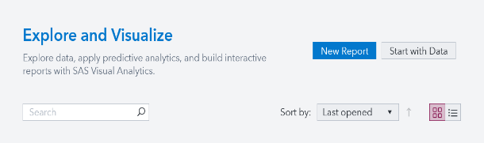
- Click: Explore and Visualize
- Click: New Report

Step 2: Data
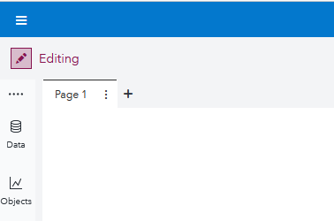
You will be now be on the report window. From here, you can choose a new data source, create a new object, or view the outline.
- Click: the Data icon

Step 3: Available Data
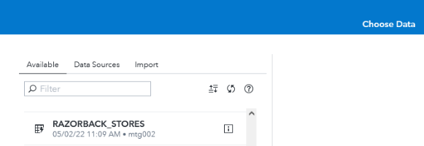
Once you have clicked on the data, you will be presented with the Choose Data pop-up.
- Select: the Available tab,
- Click: your chosen dataset (for this exercise RAZORBACK STORES)
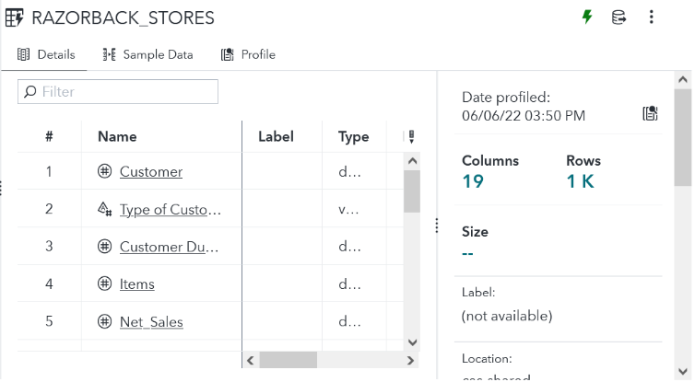
If no dataset is available, please see our tutorial 02a: Importing data.

Step 4: Details
Once you have chosen a dataset, in our case the RAZORBACK STORES dataset, the right-hand pane will display a listing of variables from the dataset with corresponding datatypes under the Details tab. This will show you the various variables from your dataset and the datatypes that have been denoted by the system:

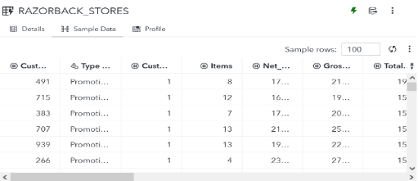
Step 5: Sample Data
- Select: the Sample Data tab to get a snapshot of the data:

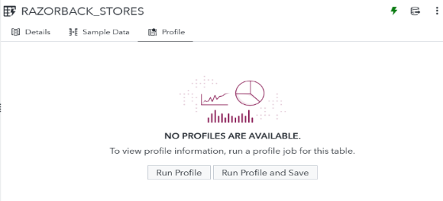
Step 6: Profile
- Select: the Profile tab
- Click: on Run Profile

Step 7: Statistics
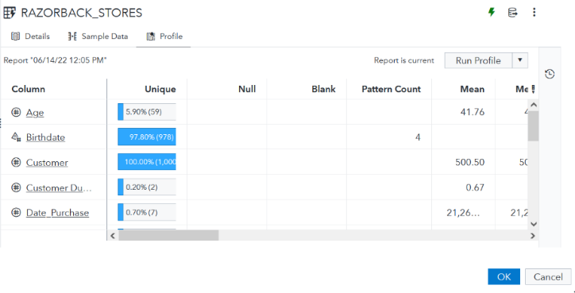
The outputed report will provide you basic descriptive statistics such as mean, median, and mode.
It will also give you unique counts and other useful descriptive statistics.
- Click: OK to create the report

Step 8: View Measure Details
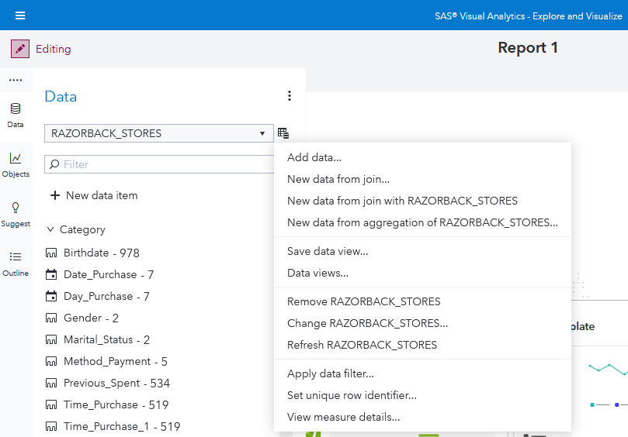
If at any point in time you wish to re-run or forgot to run descriptive statistics, you can always:
- Click: on the Data icon
- Click: on the Actions icon located to the right of RAZORBACK STORES
- Click: View measure details…
Congratulations, you have learned how to run descriptive statistics in VIYA!

