SAS VIYA Exercise 04

Creating Crosstabulation

(6/28/2022)

Sources
Steve Nolan, Ron Freeze, Elizabeth Keiffer, Michael Gibbs, Matias Delay, Jorge Moreda, Shubhashree Sahoo
Enterprise Systems, Sam M. Walton College of Business, University of Arkansas, Fayetteville
SAS® Visual Analytics. Release 8.5
SAS® Viya® release V.03.05

Copyright © 2018 For educational uses only - adapted from sources with permission. No part of this publication may be reproduced, stored in a retrieval system, or transmitted, in any form or by any means, electronic, mechanical, photocopying, or otherwise, without the prior written permission from the author/presenter.

Use Case – Crosstabulation
Razorback Stores is a local department store serving a metropolitan area. As a department store, they offer a wide variety of items and services and track sales through a point of sale system. Over the past several months, Razorback Stores performed a marketing campaign designed to promote and incentivize a loyalty program.
For this exercise, Razorback Stores has asked us to run a crosstab table to look at types of customers by gender. This will help them in their marketing campaigns.

Step 0: Import Data
Following the guide of importing data and import your chosen dataset. See Viya 02a – Importing data for specific steps. In this tutorial the dataset used is RAZORBACK STORES.

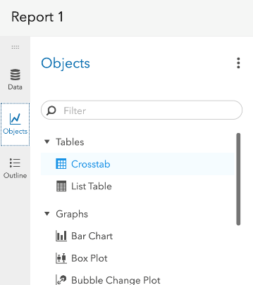
Step 1: Crosstab Objects
- Click on the Objects section of the left pane (red pane above)
The Crosstab is under the tables section of the object.
- Click and drag this to your workspace

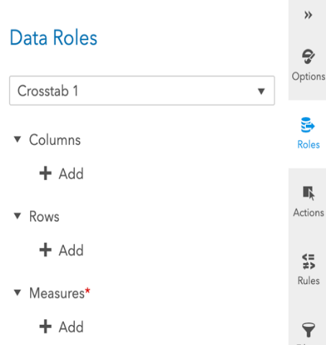
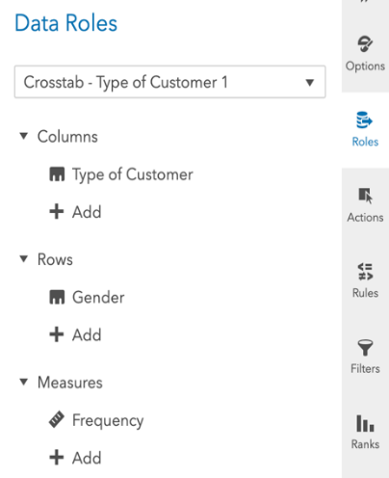
Step 2: Roles
- Click on the Roles area on the right-hand pane to begin filling in the crosstab
In our use case, we are going to use Gender and Type of Customer.
- Click on the + Add sign under “Columns”
- Select Type of Customer
- Click OK
Repeat the same process for Gender under “Rows”

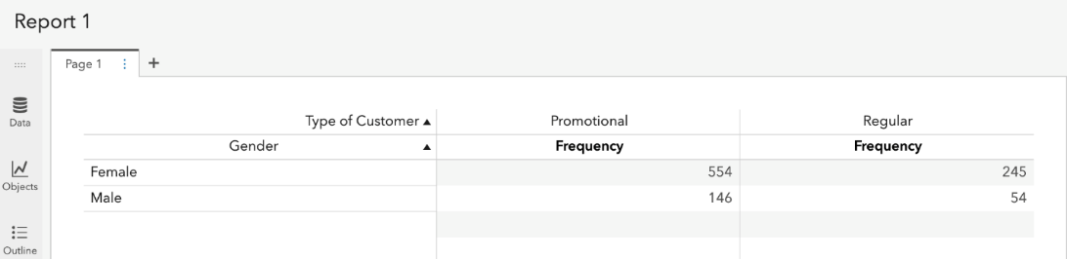
Once you begin adding data for your rows and columns, the crosstab will begin to fill based on the data that you have imported:

Step 3: Options
Once you have your data in place and roles assigned, you can adjust the various aspects of your crosstab through the Options pane. As an example, you can add a total column by:
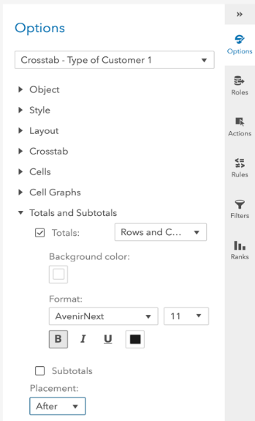
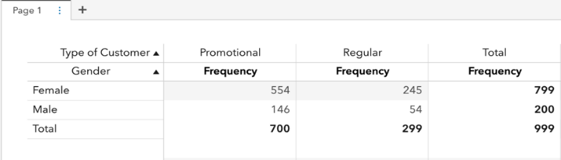
- Clicking on the Totals and Subtotals under the Options pane
- Checking the Totals box
- Select After under Placement

Congratulations, you have created a crosstab in VIYA!

