SASVIYA Exercise 05

Creating a histogram

(4/13/2020)

Sources
Steve Nolan, Ron Freeze, Elizabeth Keiffer, Michael Gibbs, Matias Delay
Enterprise Systems, Sam M. Walton College of Business, University of Arkansas, Fayetteville
SAS® VIYA 8.2 Release V03

Copyright © 2018 For educational uses only - adapted from sources with permission. No part of this publication may be reproduced, stored in a retrieval system, or transmitted, in any form or by any means, electronic, mechanical, photocopying, or otherwise, without the prior written permission from the author/presenter.

Use Case
Razorback Stores is a local department store serving a metropolitan area. As a department store, they offer a wide variety of items and services and track sales through a point of sale system. Over the past several months, Razorback Stores performed a marketing campaign designed to promote and incentivize a loyalty program.
For this exercise, Razorback Stores is interested to see what the distribution of their net sales are. This will provide a visualization for management to quickly see how much customers are purchasing that they can use to help make business decisions.

Step 0:
Following the guide of importing data and import your chosen dataset. See Viya 02 – Importing data for specific steps.
Once your data is imported, you will be presented with the working report screen. The screen is broken out into three key areas:
- Left pane (Red) – This is where you can manipulate your data elements, choose objects to work with, and see an outline of the work you are creating.
- Middle pane (Blue) – This is the workspace. This is where you drag objects to and begin to build your visualizations and models
- Right pane (Green) – this is where you set various roles (for data mining) and manipulate and enhance chart features (options). You can also filter pieces of data as well.
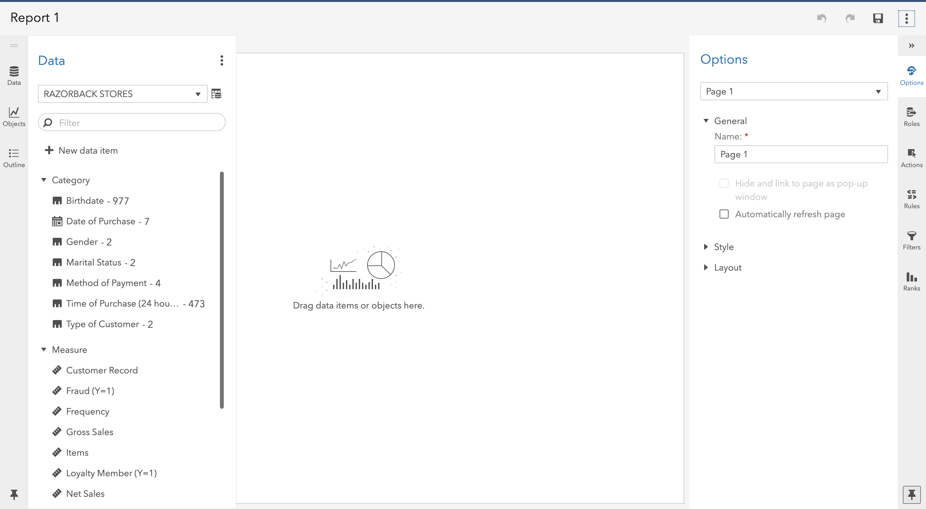

Step 1:
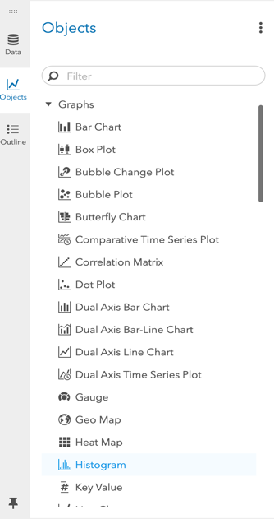
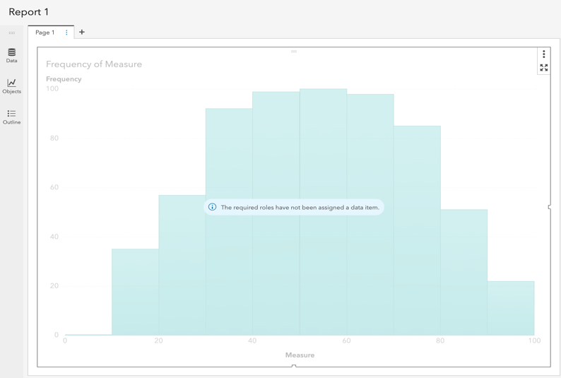
Under the Objects panel on the left-hand side, you can select Histogram located under the Graphs area of the objects. Click and drag Histogram to your workspace in the middle. Your screen will look like the following:

Step 2:
Once the histogram is in the workspace, you can set a role of net sales for this use case by selecting roles and then net sales as the measure. The chart will update automatically with the data:
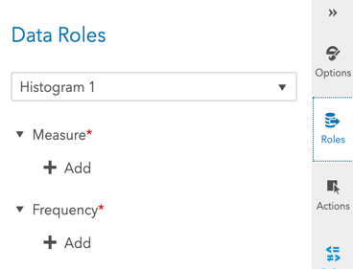
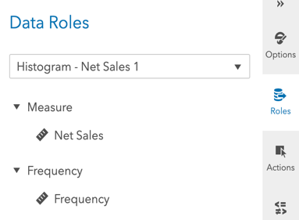

Now your screen should look like the following:
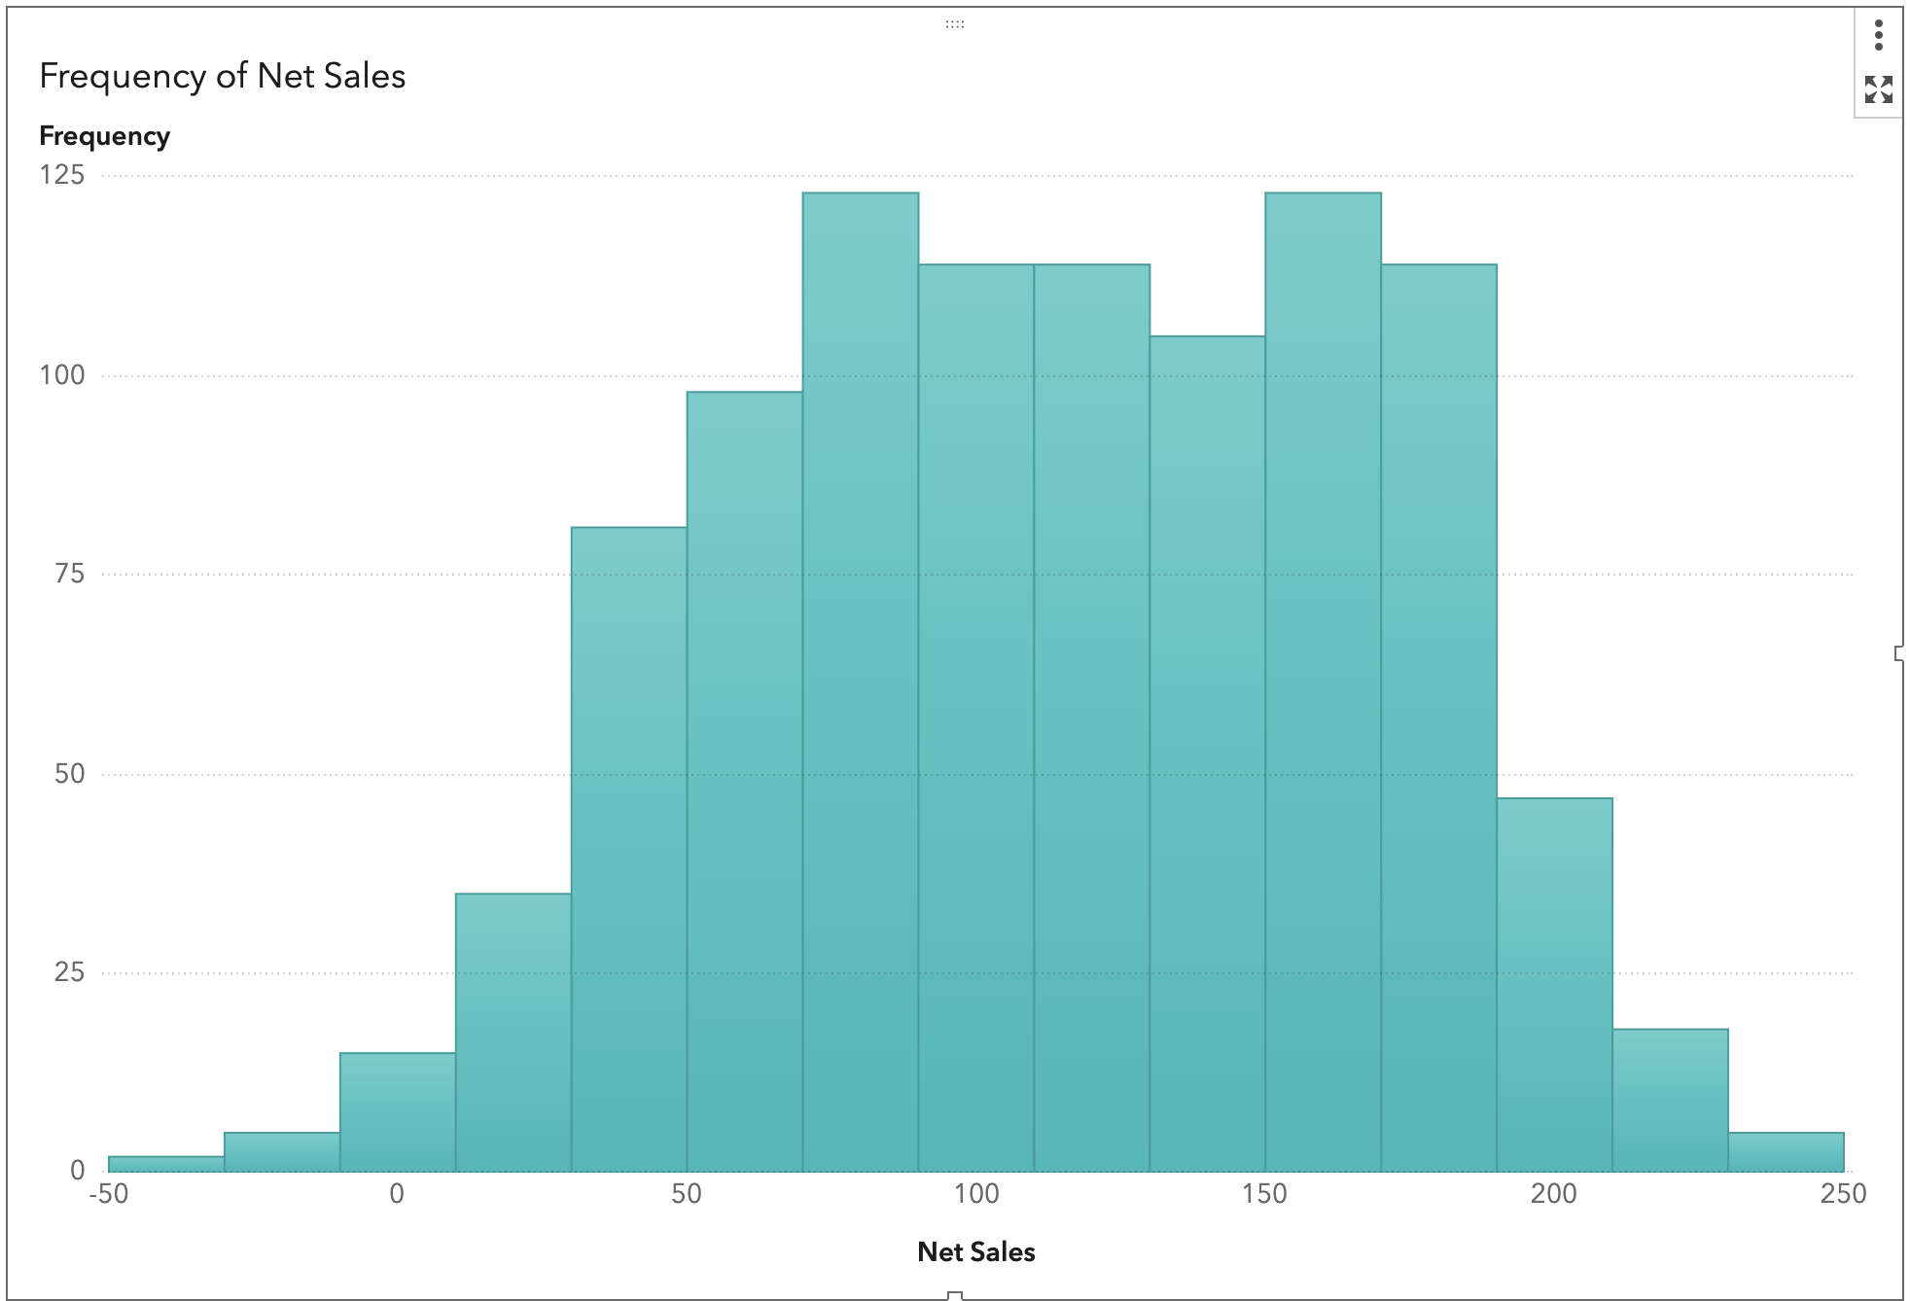

Step 3:
From here, you can go to the options menu and manipulate your visualization to provide even more insight, such as a better-informed title, color, and fixed bin sizes.
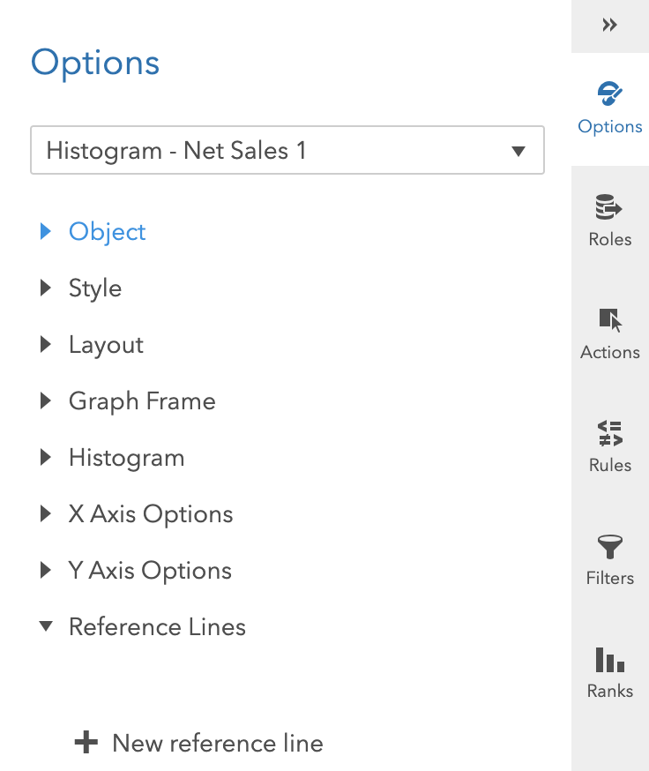
Congratulations, you have created a histogram in VIYA!

