SASVIYA Exercise 06

Filtering Data in a Visual

(4/13/2020)

Sources
Steve Nolan, Ron Freeze, Elizabeth Keiffer, Michael Gibbs, Matias Delay
Enterprise Systems, Sam M. Walton College of Business, University of Arkansas, Fayetteville
SAS® VIYA 8.2 Release V03

Copyright © 2018 For educational uses only - adapted from sources with permission. No part of this publication may be reproduced, stored in a retrieval system, or transmitted, in any form or by any means, electronic, mechanical, photocopying, or otherwise, without the prior written permission from the author/presenter.

Use Case
Razorback Stores is a local department store serving a metropolitan area. As a department store, they offer a wide variety of items and services and track sales through a point of sale system. Over the past several months, Razorback Stores performed a marketing campaign designed to promote and incentivize a loyalty program.
For this exercise, Razorback Stores would like to know what the net sales are for only their promotional customers. They are hoping to do this using filtering.

Step 0: Getting Started
Following the guide of importing data and import your chosen dataset. See Viya 02 – Importing data for specific steps.

Step 1: Navigation
Once your data is imported, you will be presented with the working report screen. The screen is broken out into three key areas:
- Left pane (Red) – This is where you can manipulate your data elements, choose objects to work with, and see an outline of the work you are creating.
- Middle pane (Blue) – This is the workspace. This is where you drag objects to and begin to build your visualizations and models
- Right pane (Green) – this is where you set various roles (for data mining) and manipulate and enhance chart features (options). You can also filter pieces of data as well.
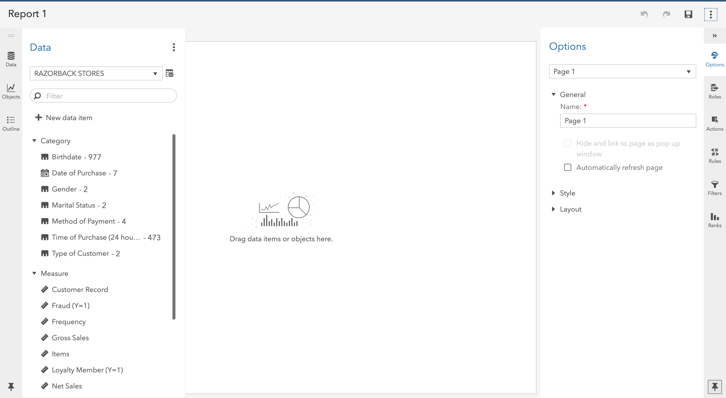

Step 2: Create Histogram
Under the Objects panel on the left-hand side, you can select Histogram located under the Graphs area of the objects. Click and drag Histogram to your workspace in the middle. Your screen will look like the following:
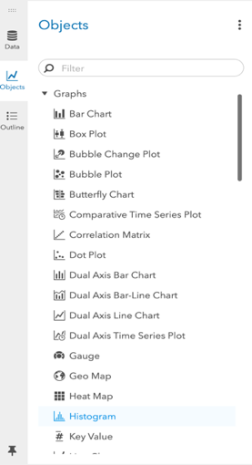
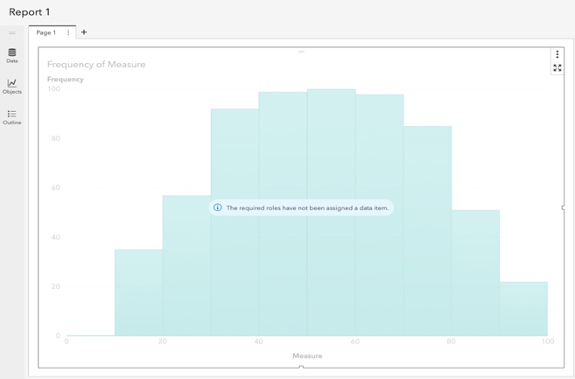

Once the histogram is in the workspace, you can set a role of net sales for this use case by selecting roles and then net sales as the measure. The chart will update automatically with the data:
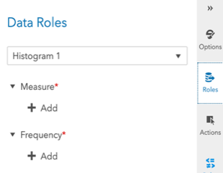
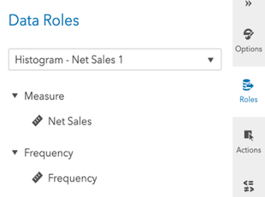

Now your screen should look like the following:
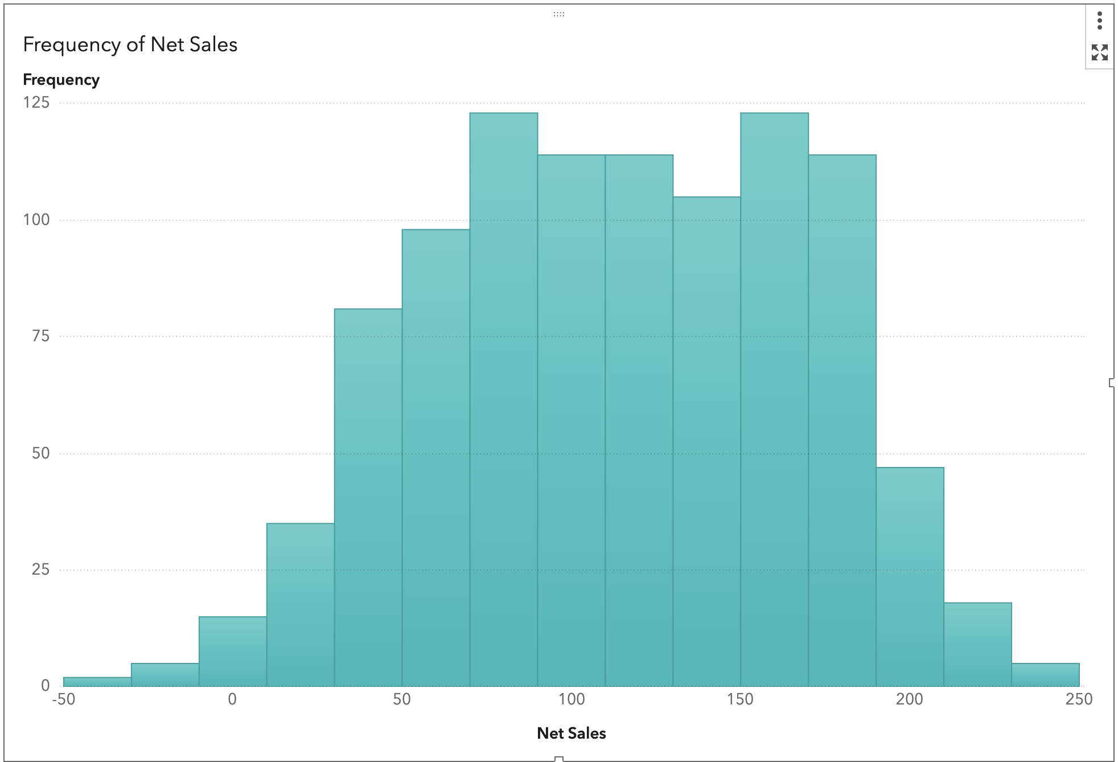

Step 3: Select and Create Filter
Now that we have a visualization of all net sales, we need to place a filter to show only the net sales from promotional customers. To do this, ensure that you have the graph selected.
- Choose Filters on the right-hand bar
- Click + New filter.
- On the drop-down menu, select Type of Customer.
- Uncheck the Regular type of customer box.
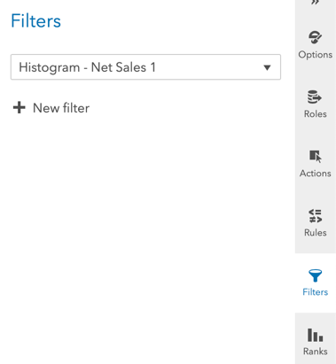
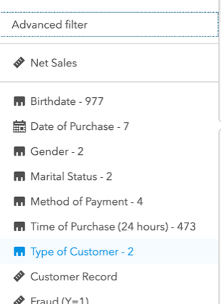
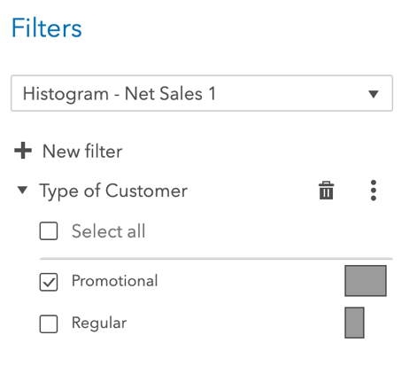

Step 5: Promotional Customer Histogram
We now have a filter in place! That provides a visual on the # of Promotional Customers.
