SAS VIYA Exercise 06

Histograms & Filtering Data in a Visual

(7/22/2020)

Sources
Steve Nolan, Ron Freeze, Elizabeth Keiffer, Michael Gibbs, Matias Delay, Jorge Moreda
Enterprise Systems, Sam M. Walton College of Business, University of Arkansas, Fayetteville
SAS® Visual Analytics. Release 8.5
SAS® Viya® release V.03.05

Copyright © 2018 For educational uses only - adapted from sources with permission. No part of this publication may be reproduced, stored in a retrieval system, or transmitted, in any form or by any means, electronic, mechanical, photocopying, or otherwise, without the prior written permission from the author/presenter.

Use Case – Histograms & Filtering
Razorback Stores is a local department store serving a metropolitan area. As a department store, they offer a wide variety of items and services and track sales through a point of sale system. Over the past several months, Razorback Stores performed a marketing campaign designed to promote and incentivize a loyalty program.
For this exercise, Razorback Stores is interested to see what the distribution of their net sales are. This will provide a visualization for management to quickly see how much customers are purchasing that they can use to help make business decisions. They also would like to know what the net sales are for only their promotional customers. They are hoping to do this using filtering.

Step 0: Import Data
Following the guide of importing data and import your chosen dataset. See Viya 02a – Importing data for specific steps. In this tutorial the dataset used is RAZORBACK STORES.

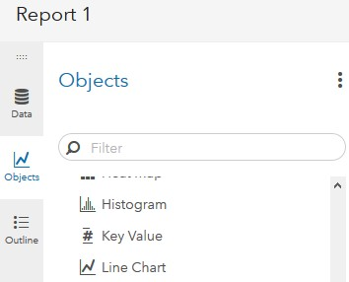
Step 1: Create Histogram
Under the Objects panel on the left-hand side, you can select Histogram located under the Graphs area of the objects.
- Click Objects
- Scroll to find Histogram
- Click and drag Histogram to your workspace in the middle
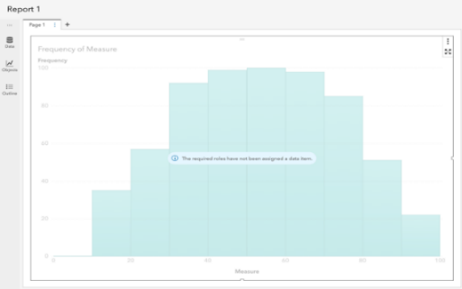
Your screen will look like the following:

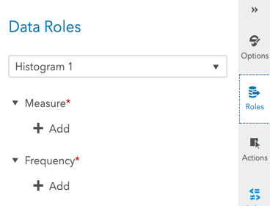
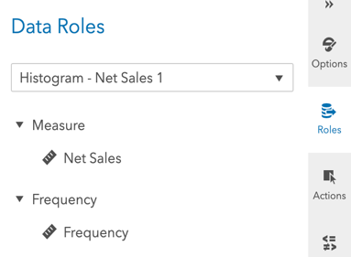
Once the histogram is in the workspace, you can set a role of net sales for this use case by:
- selecting Roles and then,
- click on + Add under Measure
- select Net Sales as the measure
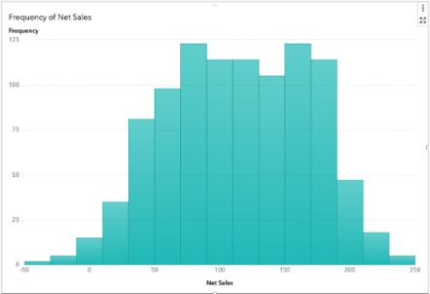
The chart will update automatically with the data.
Now your screen should look like the following:

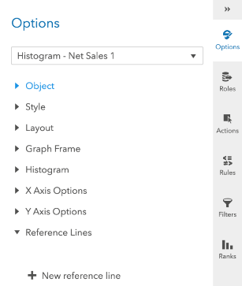
From here, you can go to the options menu and manipulate your visualization to provide even more insight, such as a better-informed title, color, and fixed bin sizes.

Step 2: Select and Create Filter
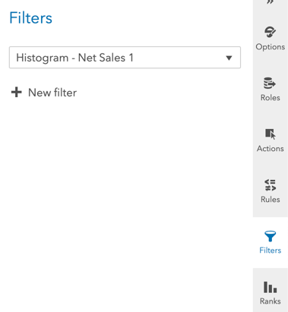
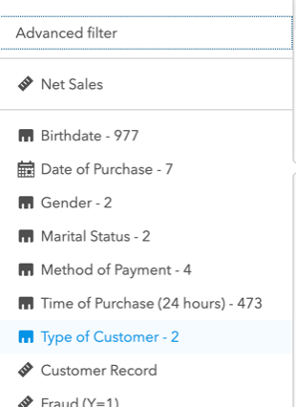
Now that we have a visualization of all net sales, we need to place a filter to show only the net sales from promotional customers. To do this, ensure that you have the graph selected.
- Choose Filters on the right-hand bar
- Click + New filter
- On the drop-down menu, select Type of Customer
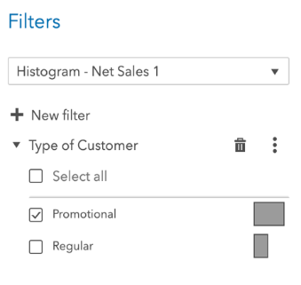
- Uncheck the Regular type of customer box

Step 3: Promotional Customer Histogram
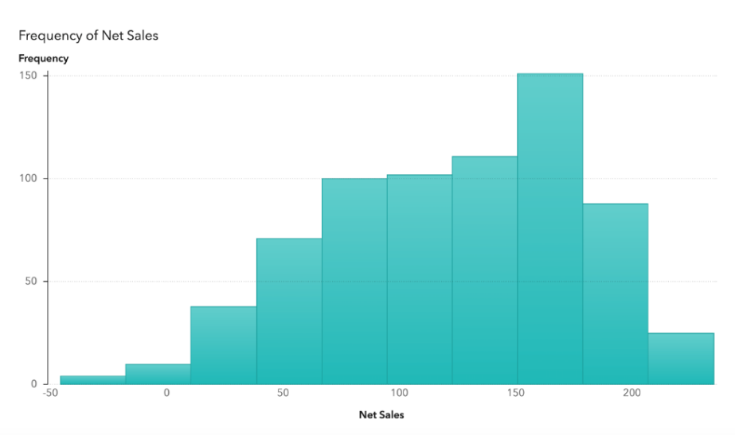
We now have a filter in place! That provides a visual on the # of Promotional Customers.

Congratulations, you have created a histogram and filtered data in VIYA!

