SASVIYA Exercise

Setting a Data Partition

(7/24/2019)

Sources
Steve Nolan, Ron Freeze, Elizabeth Keiffer, Michael Gibbs
Enterprise Systems, Sam M. Walton College of Business, University of Arkansas, Fayetteville
SAS® VIYA 8.2 Release V03

Copyright © 2018 For educational uses only - adapted from sources with permission. No part of this publication may be reproduced, stored in a retrieval system, or transmitted, in any form or by any means, electronic, mechanical, photocopying, or otherwise, without the prior written permission from the author/presenter.

Use Case
Razorback Stores is a local department store serving a metropolitan area. As a department store, they offer a wide variety of items and services and track sales through a point of sale system. Over the past several months, Razorback Stores performed a marketing campaign designed to promote and incentivize a loyalty program.
Before we attempt to answer any business questions, we need to create a data partition in preparation for data mining. The partition will randomly separate our data into groups to train our supervised models and check for accuracy.

Step 1:
Go to the data tab on the left-hand pane.
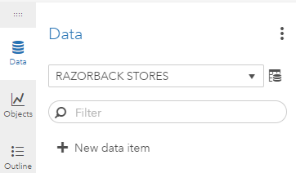
Step 2:
From here you can select “Add partition data item” from the drop down
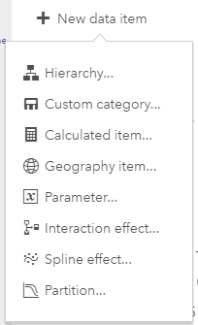
Step 3:
From here, you can give the partition a name and designate how many partitions you wish to have. In our use case, we will have 2, one for the training and one for validation. You then set the amount of data that will go to the training data, which I will set to 70%. Keep the Sampling method set as Simple random sampling.
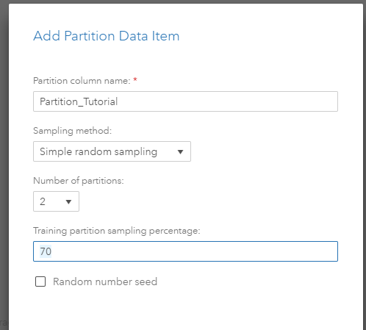
Step 4:
Click ok once you have entered in your settings and a new categorical variable has been created. This will be used in modeling when it asks for a partition variable once you begin your modeling.
