SAS VIYA Exercise 07

Setting a Data Partition

(7/22/2020)

Sources
Steve Nolan, Ron Freeze, Elizabeth Keiffer, Michael Gibbs, Matias Delay, Jorge Moreda
Enterprise Systems, Sam M. Walton College of Business, University of Arkansas, Fayetteville
SAS® Visual Analytics. Release 8.5
SAS® Viya® release V.03.05

Copyright © 2018 For educational uses only - adapted from sources with permission. No part of this publication may be reproduced, stored in a retrieval system, or transmitted, in any form or by any means, electronic, mechanical, photocopying, or otherwise, without the prior written permission from the author/presenter.

Use Case – Data Partitions
Razorback Stores is a local department store serving a metropolitan area. As a department store, they offer a wide variety of items and services and track sales through a point of sale system. Over the past several months, Razorback Stores performed a marketing campaign designed to promote and incentivize a loyalty program.
Before we attempt to answer any business questions, we need to create a data partition in preparation for data mining. The partition will randomly separate our data into groups to train our supervised models and check for accuracy.

Step 0: Import Data
Following the guide of importing data and import your chosen dataset. See Viya 02a – Importing data for specific steps. In this tutorial we will be using the RAZORBACK STORES dataset.

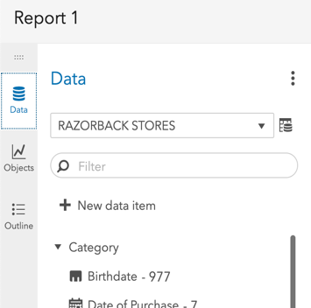
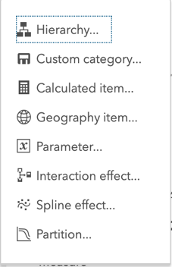
Step 1: Create Partition
- Go the Data tab on the left-hand pane and
- Click on + New Data Item
At the bottom of the drop-down menu that will appear,
- Select Partition....

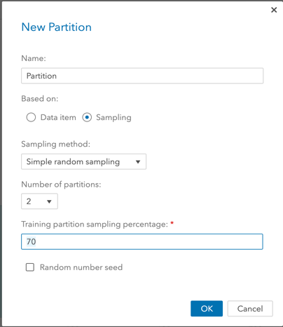
Step 2: Modify Partition Settings
A new window will open where you can give the partition a name and designate how many partitions you wish to have. In our use case, we will have 2, one for the training and one for validation. Also, we want to set our training data to account for 70% of the data:
- Select 2 as Number of partitions
- Write 70 under Training partition sampling percentage
- Click Ok

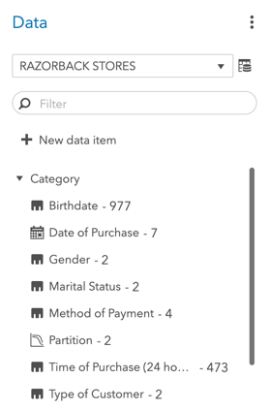
Step 3: Apply Partition
When you create a partition, a new categorical variable is created. In this example it is labeled as “Partition – 2”
This will be used in modeling when it asks for a partition variable once you begin your modeling.
For instance, if we were working with decision trees, under Roles in the right pane, we would have the option to add a partition under Partition ID as follows:
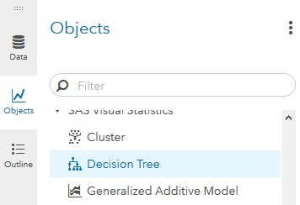
- Click Objects on the left pane
- Scroll to find Decision Tree
- Click and drag into the middle pane
- Click Roles on the right of the screen
- Click on + Add under Partition ID
- Select the partition you created in step 1 and step 2
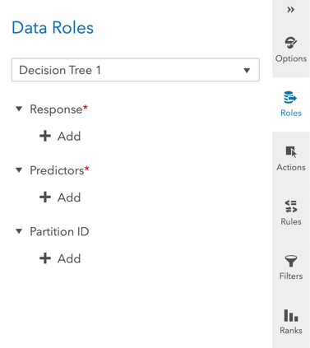
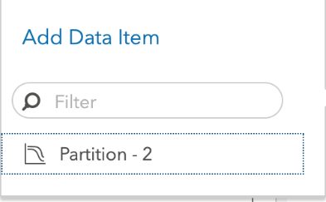
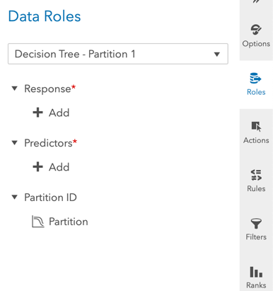

Congratulations, you have created a data partition in VIYA!

