SASVIYA Exercise 08

Correlation Matrix

(4/13/2020)

Sources
Steve Nolan, Ron Freeze, Elizabeth Keiffer, Michael Gibbs, Matias Delay
Enterprise Systems, Sam M. Walton College of Business, University of Arkansas, Fayetteville
SAS® VIYA 8.2 Release V03

Copyright © 2018 For educational uses only - adapted from sources with permission. No part of this publication may be reproduced, stored in a retrieval system, or transmitted, in any form or by any means, electronic, mechanical, photocopying, or otherwise, without the prior written permission from the author/presenter.

Use Case
Razorback Stores is a local department store serving a metropolitan area. As a department store, they offer a wide variety of items and services and track sales through a point of sale system. Over the past several months, Razorback Stores performed a marketing campaign designed to promote and incentivize a loyalty program.
For this case, management is interested in looking at the relationship between several key variables.

Step 0: Getting Started
Following the guide of importing data and import your chosen dataset. See Viya 02 – Importing data for specific steps. In this tutorial we will be using Razorbacks Stores dataset.

Step 1: Navigation
Once your data is imported, you will be presented with the working report screen. The screen is broken out into three key areas:
- Left pane (Red) – This is where you can manipulate your data elements, choose objects to work with, and see an outline of the work you are creating.
- Middle pane (Blue) – This is the workspace. This is where you drag objects to and begin to build your visualizations and models
- Right pane (Green) – this is where you set various roles (for data mining) and manipulate and enhance chart features (options). You can also filter pieces of data as well.
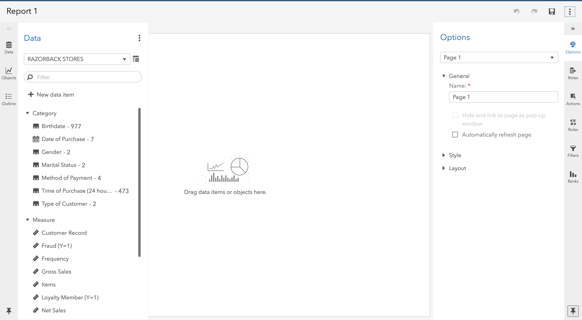

Step 2: Select Correlation Matrix
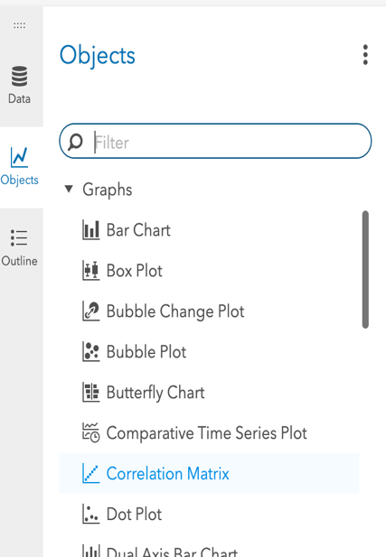
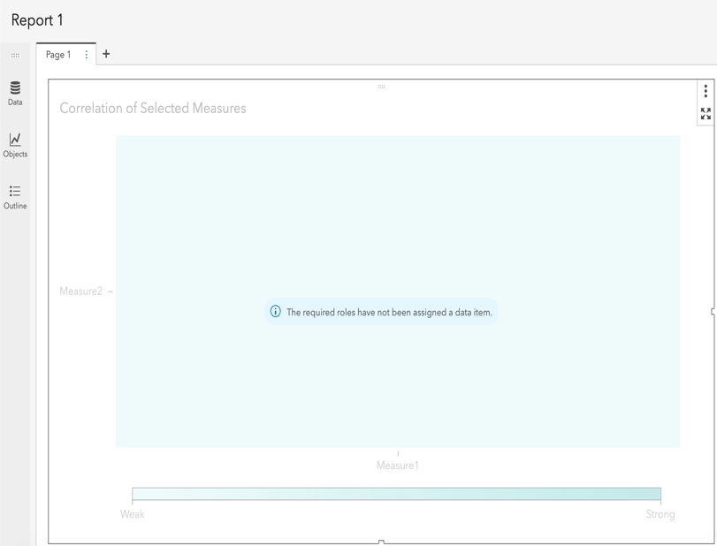
To begin, we will go to the Objects icon located on the left-hand pane and look for Correlation Matrix under Graphs. Once found, drag and drop it into our workspace in the middle pane.

Step 3: Add Measures
Once we have our matrix in our workspace, we can select our data roles on the right-hand pane. You can select 2 or you can select many measures to determine the correlation:
- Select Roles in the right-pane.
- Under Measures click on + Add.
- Select Customer Record and keeping “shift” pressed, click on Total Discount (this will select all variables without you having to click on every single one of them)
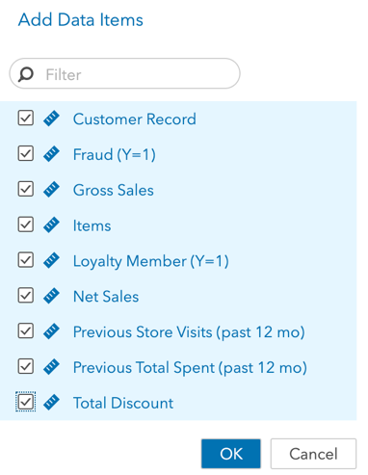
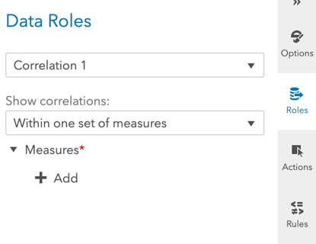
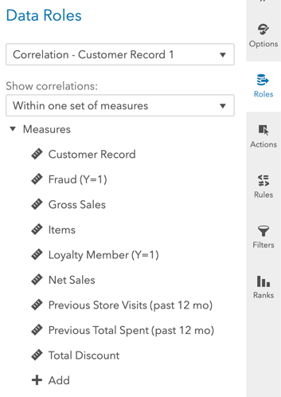
- Click Ok.

Step 4: Visualize
Once you have selected your measures, a matrix will display showing the correlations and a color scheme showing weak correlations to strong correlations

