SAS VIYA Exercise 08

Correlation Matrix

(7/22/2020)

Sources
Steve Nolan, Ron Freeze, Elizabeth Keiffer, Michael Gibbs, Matias Delay, Jorge Moreda
Enterprise Systems, Sam M. Walton College of Business, University of Arkansas, Fayetteville
SAS® Visual Analytics. Release 8.5
SAS® Viya® release V.03.05

Copyright © 2018 For educational uses only - adapted from sources with permission. No part of this publication may be reproduced, stored in a retrieval system, or transmitted, in any form or by any means, electronic, mechanical, photocopying, or otherwise, without the prior written permission from the author/presenter.

Use Case – Correlation Matrix
Razorback Stores is a local department store serving a metropolitan area. As a department store, they offer a wide variety of items and services and track sales through a point of sale system. Over the past several months, Razorback Stores performed a marketing campaign designed to promote and incentivize a loyalty program.
For this case, management is interested in looking at the relationship between several key variables.

Step 0: Import Data
Following the guide of importing data and import your chosen dataset. See Viya 02 – Importing data for specific steps. In this tutorial we will be using the RAZORBACK STORES dataset.

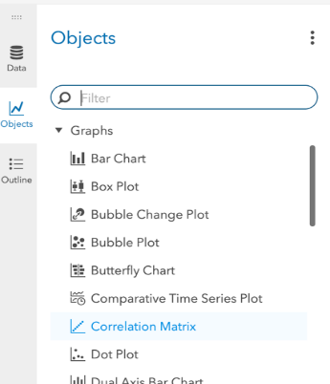
Step 1: Select Correlation Matrix
- To begin, click on the Objects icon located on the left-hand pane
- Scroll down and look for Correlation Matrix under Graphs
Once found,
- Drag and drop it into our workspace in the middle pane

Step 2: Add Measures
Once we have our matrix in our workspace, we can select our data roles on the right-hand pane. You can select 2 or you can select many measures to determine the correlation:
- Select Roles in the right-pane
- Under Measures click on + Add
- Select Customer Record and keeping “shift” pressed, click on Total Discount (this will select all variables without you having to click on every single one of them)
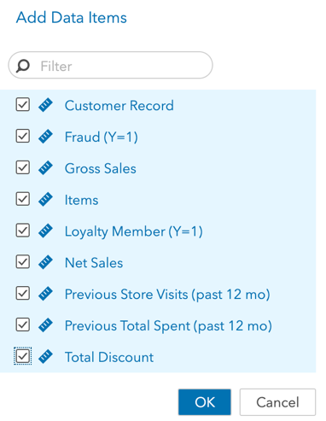
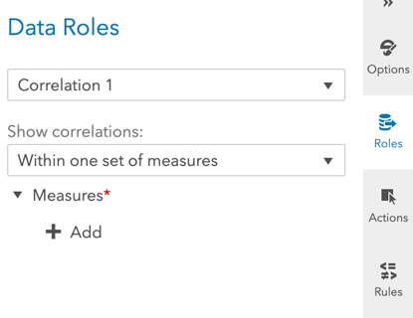
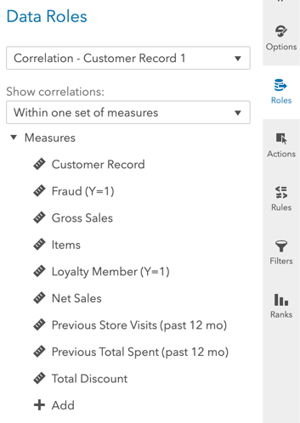
- Click Ok

Step 3: Visualize
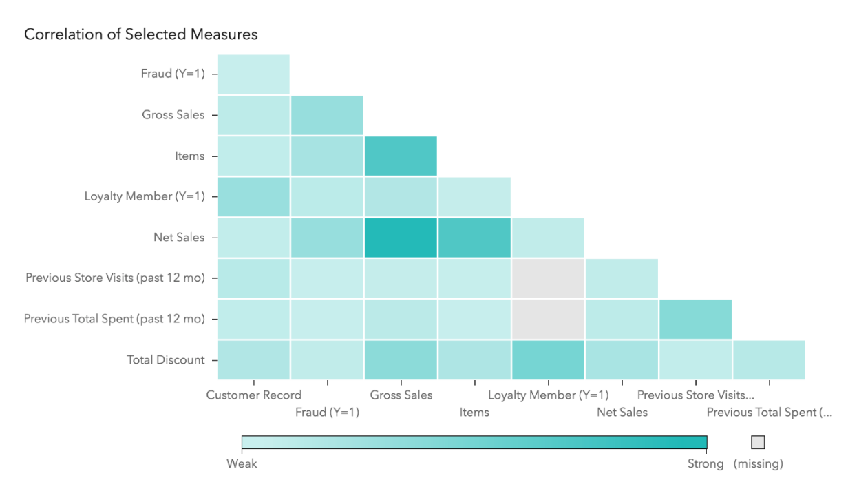
Once you have selected your measures, a matrix will display showing the correlations and a color scheme showing weak correlations to strong correlations.

Congratulations, you have created a correlation matrix in VIYA!

