SASVIYA Exercise 09

Linear Regression

(3/31/2020)

Sources
Steve Nolan, Ron Freeze, Elizabeth Keiffer, Michael Gibbs
Enterprise Systems, Sam M. Walton College of Business, University of Arkansas, Fayetteville
SAS® VIYA 8.2 Release V03

Copyright © 2018 For educational uses only - adapted from sources with permission. No part of this publication may be reproduced, stored in a retrieval system, or transmitted, in any form or by any means, electronic, mechanical, photocopying, or otherwise, without the prior written permission from the author/presenter.

Use Case
Razorback Stores is a local department store serving a metropolitan area. As a department store, they offer a wide variety of items and services and track sales through a point of sale system. Over the past several months, Razorback Stores performed a marketing campaign designed to promote and incentivize a loyalty program.

Step 0: Getting Started
Following the guide of importing data and import your chosen dataset. See Viya 02 – Importing data for specific steps. In this tutorial we will be using Razorbacks Stores dataset.

Step 1: Navigation
Once your data is imported, you will be presented with the working report screen. The screen is broken out into three key areas:
- Left pane (Red) – This is where you can manipulate your data elements, choose objects to work with, and see an outline of the work you are creating.
- Middle pane (Blue) – This is the workspace. This is where you drag objects to and begin to build your visualizations and models
- Right pane (Green) – this is where you set various roles (for data mining) and manipulate and enhance chart features (options). You can also filter pieces of data as well.
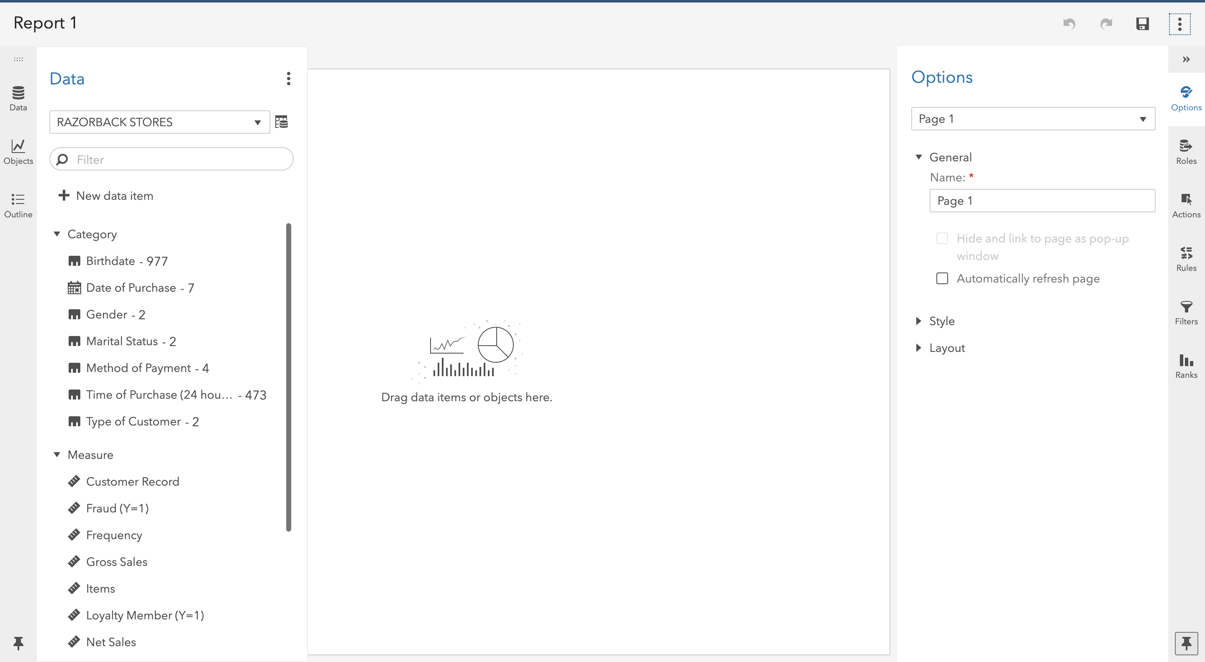

Step 2: Create a Partition
Refer back to Viya 07 – Create Partitions or follow the steps below to create a partition.
- On the left-pane click Data and then click on + New Data Item.
- In the drop-down menu that will appear, select Partition.
- A new window will open called New Partition
- Select 2 as Number of Partitions.
- Write 70 under Training partition sampling percentage.
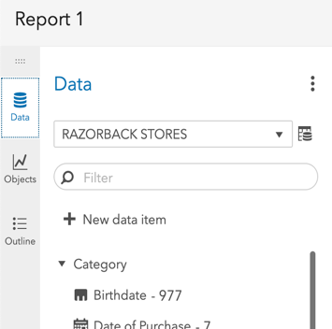
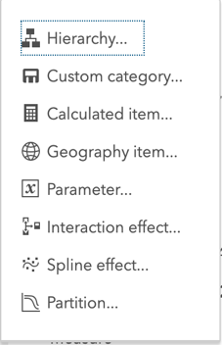
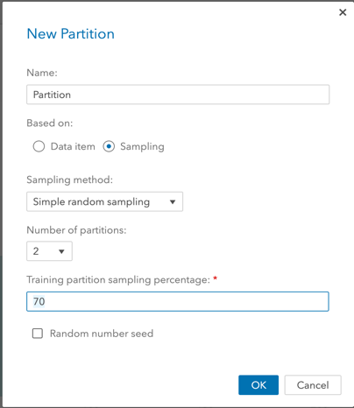
- Click Ok.

Step 3: Select a Model (Linear Regression)
Since we are interested in performing a Linear Regression, we need to find and set this model in our working space:
- On the left-pane, click Objects and find Linear Regression (located under SAS Visual Statistics).
- Drag and Drop Linear Regression to the working space in the middle-pane.
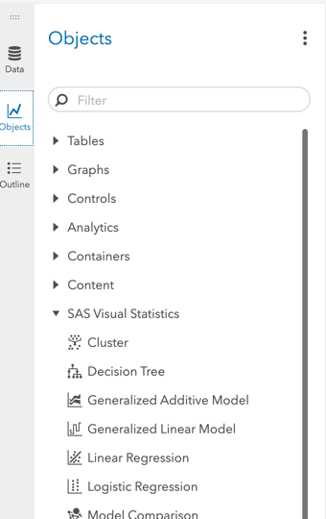
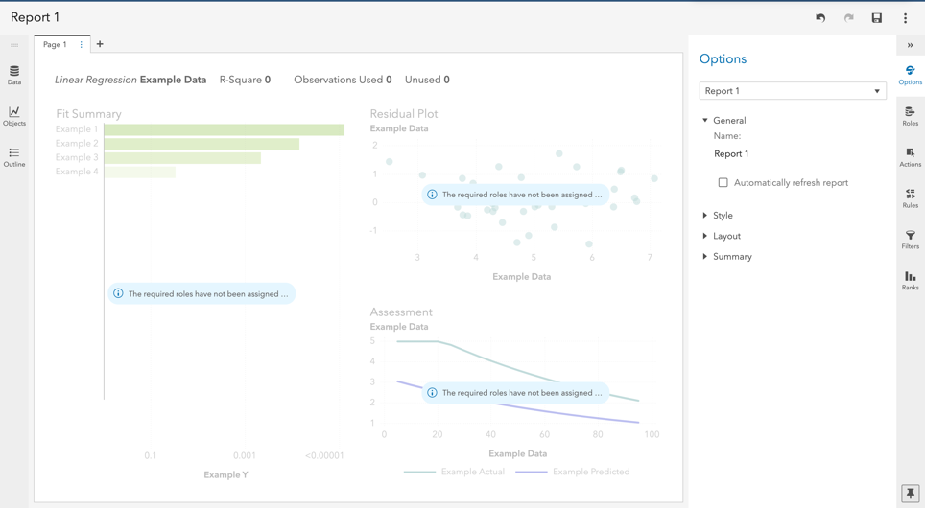
- Now you have set your working space for Linear Regression model.

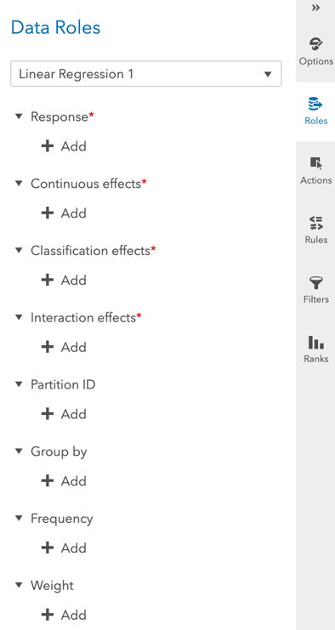
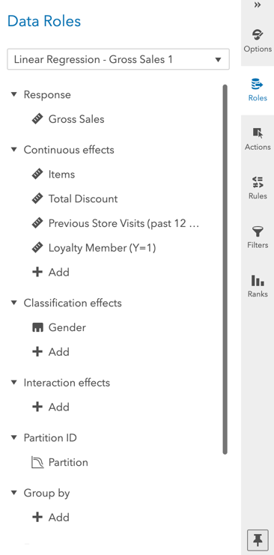
Step 4: Select Variables
So far, we have created a partition and set a Linear Regression model in our working space. The next step is to select the variables we want to work with and set our partition to the model.
- On the right-pane, click on Roles (make sure you have clicked on the working space before doing this).
- A new window named Data Roles will appear for you to add variables.
- To add a variable simply click on + Add under each subtitle.
- Add Gross Sales under Response (dependent variable).
- Add Age, Total Discount, Items, Loyalty Member, and Previous Store Visits under Continuous effects (continuous independent variables).
- Add Gender under Classification Effects (classification independent variables).
- Finally, under Partition, add the partition we previously created in Step 1.
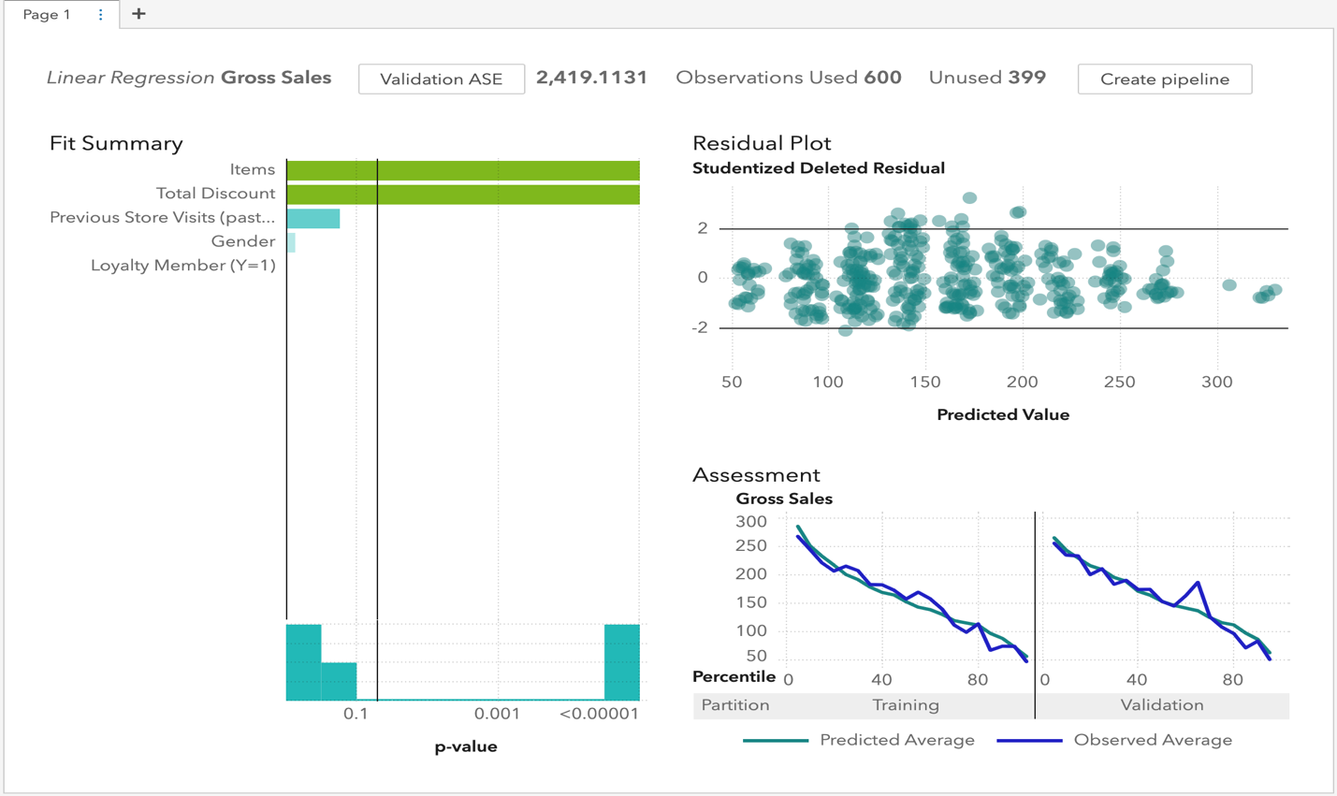
When finished, your working space should look similar to the figure below:

Step 5: Review Results

Key things to keep in mind:
Residual Plots
Residual plots are displayed in the upper-right hand part of the display. This is used to check to ensure residuals do not have a pattern.
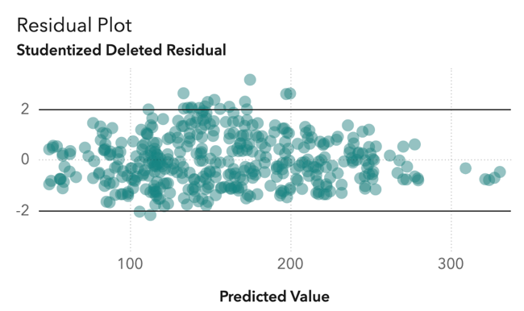

Lift Chart
Lift chart is used to evaluate overfitting. The chart is in the bottom-right hand corner of your screen. Ensure that the validation data is not overfitting.
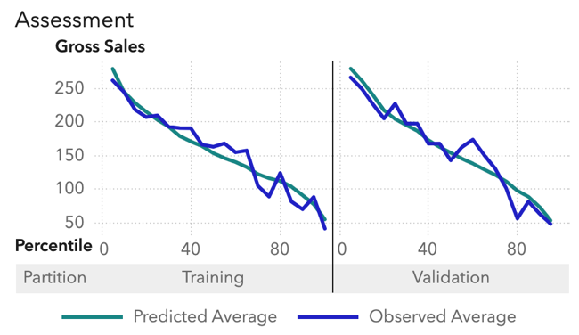

Fit Summary
The fit summary shows you variable importance and the p-value threshold for statistical significance. You can adjust the p-value significance by using sliding the vertical bar.
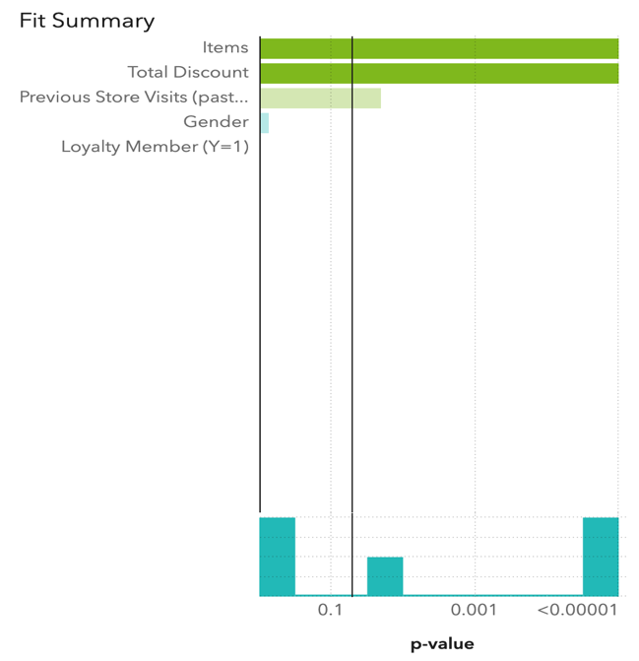

Options
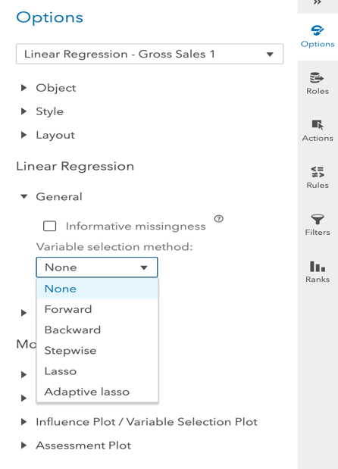
Options
On the right-panel under Options, you can modify your work in different ways. For instance:
- Click Options in the right-pane.
- Under Linear Regression subtitle, click on General.
- Under Variable Selection Method:, you can select various regression methods such as:
  - Forward
  - Backward
  - Stepwise
  - …
(Note: Make sure you have selected the report in order for the Options to be available.)

Patterns
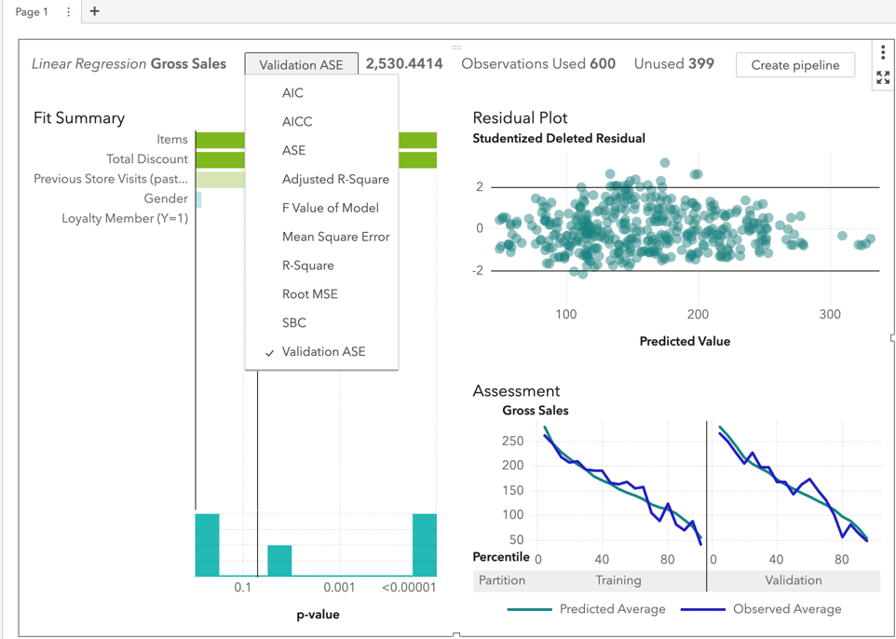
As part of the review process you can click on the textbox at the top of the screen and change the shown parameter to several different options.
- Click on R-square to display the R-square value of the current model.
If you wish to look at the Adjusted R-Square value, simply click on it like you did previously with R-Square.

Step 6: Evaluate Model
Now that the settings are in place, we can evaluate the predictive model.
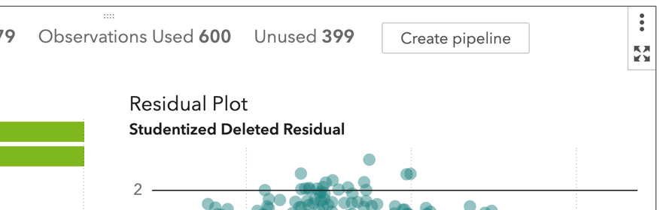
- Click on the icon below that is located in the upper-right corner of the modeling screen: This will bring up the evaluations table at the bottom of your screen.
v
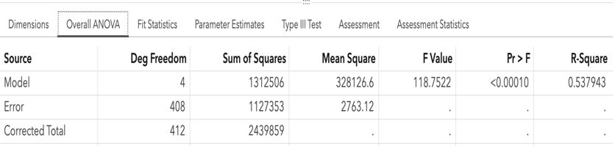
- Under Overall ANOVA, you can find the R-Square value as well as the Sum of Squares, p-Value, and Mean Square of the model.
v

v
v

v

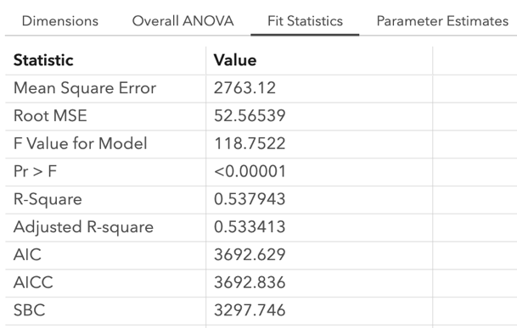
- Under the Fit Statistics tab. you can find information such as your Root Mean Square Error and Adjusted R-Square
v
v
v

- Under the Parameters Estimate tab, you can review the linear regression formula. Be sure to check P-value significance of the variables.
  - Regression Equation
The above example would produce this formula:
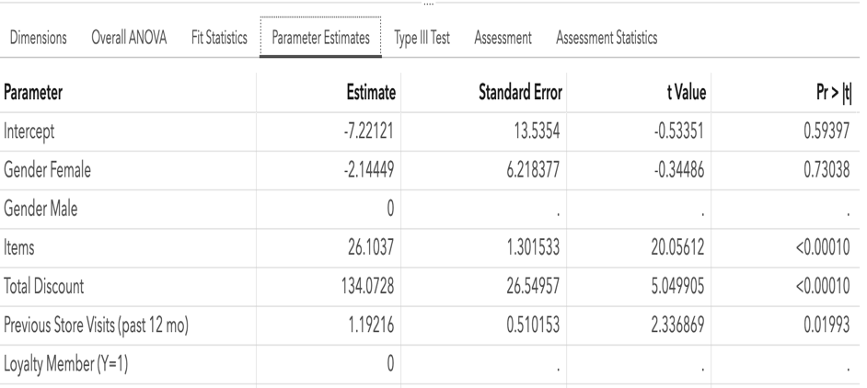
Gross Sales = -7.22 – 2.14*(Female Gender) + 0*(Male Gender) + 26.10*(Items) + 134.07*(Total Discount) + 1.19 *(Previous store visits)
v
v
v
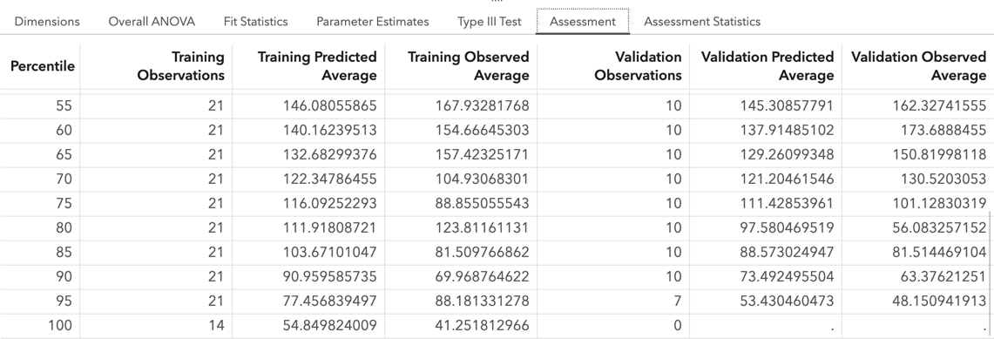
- On the Assessment tab, you can review the predicted average of an observation against the observed average. This shows a visual of your predictive model and how well it is performing.
v
v
v

