SAS VIYA Exercise 09

Linear Regression

(7/22/2020)

Sources
Steve Nolan, Ron Freeze, Elizabeth Keiffer, Michael Gibbs, Jorge Moreda
Enterprise Systems, Sam M. Walton College of Business, University of Arkansas, Fayetteville
SAS® Visual Analytics. Release 8.5
SAS® Viya® release V.03.05

Copyright © 2018 For educational uses only - adapted from sources with permission. No part of this publication may be reproduced, stored in a retrieval system, or transmitted, in any form or by any means, electronic, mechanical, photocopying, or otherwise, without the prior written permission from the author/presenter.

Use Case – Linear Regression
Razorback Stores is a local department store serving a metropolitan area. As a department store, they offer a wide variety of items and services and track sales through a point of sale system. Over the past several months, Razorback Stores performed a marketing campaign designed to promote and incentivize a loyalty program.

Step 0: Import Data
Following the guide of importing data and import your chosen dataset. See Viya 02a – Importing data for specific steps. In this tutorial we will be using the RAZORBACK STORES dataset.

Step 1: Create Partition
Refer back to Viya 07 – Creating Partitions to create a partition.

Step 2: Select a Model (Linear Regression)
Since we are interested in performing a Linear Regression, we need to find and set this model in our working space:
- On the left-pane, click Objects and find Linear Regression (located under SAS Visual Statistics)
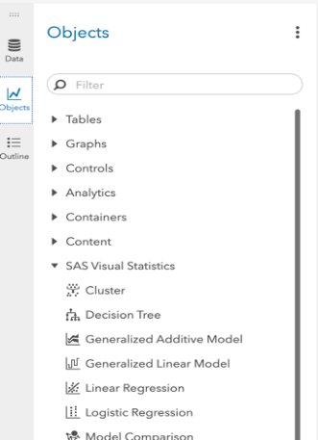
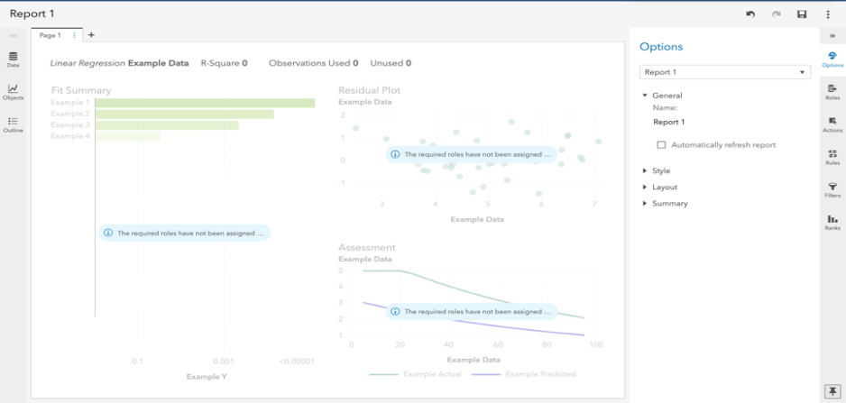
- Drag and drop Linear Regression to the working space in the middle-pane
Now you have set your working space for Linear Regression model.

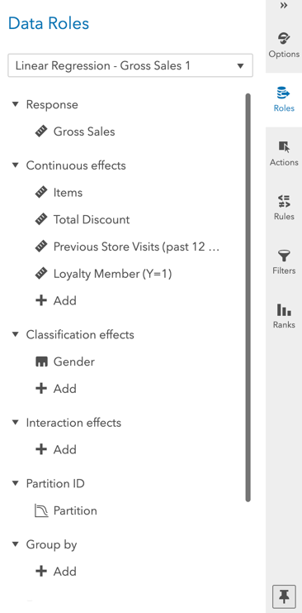
Step 3: Select Variables
So far, we have created a partition and set a Linear Regression model in our working space.
The next step is to select the variables we want to work with and set our partition to the model.
- On the right-pane, click on Roles (make sure you have clicked on the working space before doing this)
A new window named Data Roles will appear for you to add variables.
- Click on + Add under Response
- Add Gross Sales (dependent variable)
- Click on + Add under Continuous effects
- Add Total Discount, Items, Loyalty Member, and Previous Store Visits (continuous independent variables)
- Click on + Add under Classification effects
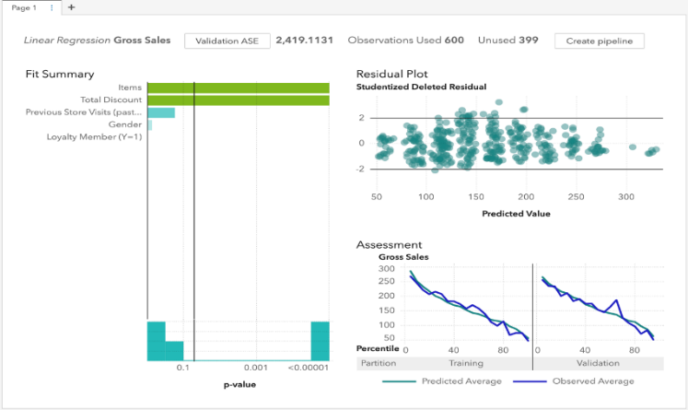
- Add Gender (classification independent variables)
- Finally, click on + Add under Partition ID
- Add the partition we previously created in Step 1
When finished, your working space should look similar to the following figure:

Step 4: Review Results
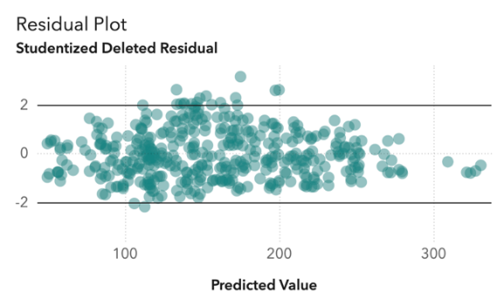
Key things to keep in mind:
Residual Plots
Residual plots are displayed in the upper-right hand part of the display. This is used to check to ensure residuals do not have a pattern.

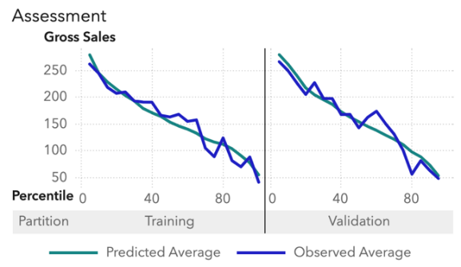
Lift Chart
Lift chart is used to evaluate overfitting. The chart is in the bottom-right hand corner of your screen. Ensure that the validation data is not overfitting.

Fit Summary
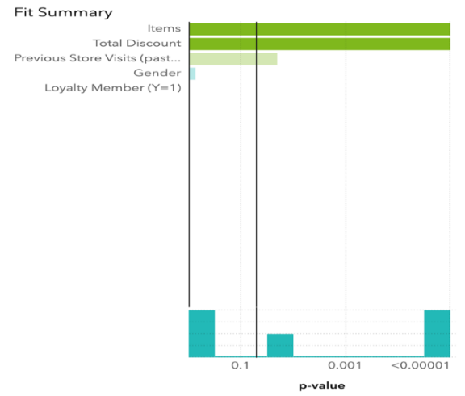
The fit summary shows you variable importance and the p-value threshold for statistical significance. You can adjust the p-value significance by sliding the vertical bar.

Options
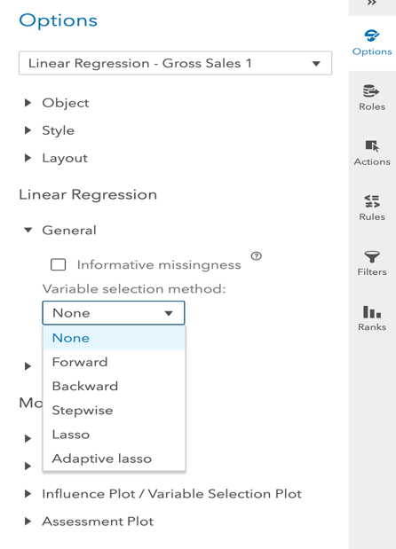
On the right-panel under Options, you can modify your work in different ways. For instance:
- Click Options in the right-pane
Under Linear Regression subtitle,
- Click on General
Under Variable Selection Method:, you can select various regression methods such as:
  - Forward
  - Backward
  - Stepwise
  - …
(Note: Make sure you have selected the report in order for the Options to be available.)
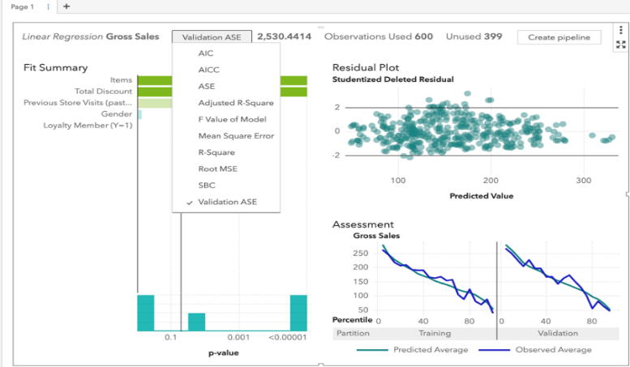
Patterns
As part of the review process you can
- Click on the Validation ASE textbox at the top of the screen
- Click on R-square to display the R-square value of the current model
- If you wish to look at the Adjusted R-Square value, simply click on it like you did previously with R-Square

Step 5: Evaluate Model
Now that the settings are in place, we can evaluate the predictive model.
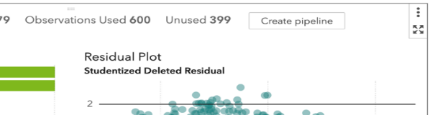
- Click on the icon located in the upper-right corner of the modeling screen
v
- This will bring up the evaluations table at the bottom of your screen.
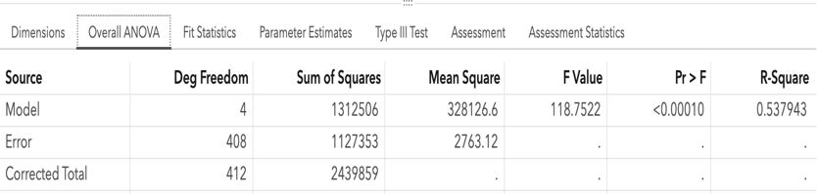
- Click Overall ANOVA
v

v
v

v
Here you can find the R-Square value as well as the Sum of Squares, p-Value, and Mean Square of the model.

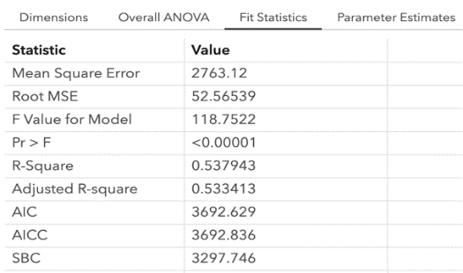
- Click on the Fit Statistics tab
v
v
v

Here you can find information such as your Root Mean Square Error and Adjusted R-Square.
- Click on the Parameter Estimates tab
Here you can review the linear regression formula.
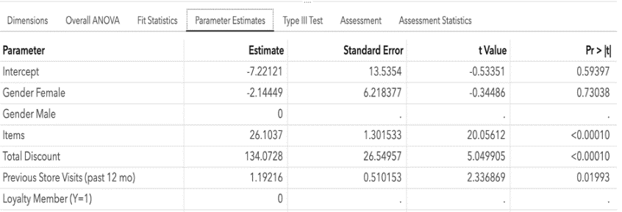
Be sure to check P-value significance of the variables.
v
v
v

Regression Equation
The above example would produce this formula:
Gross Sales = -7.22 – 2.14*(Female Gender) + 0*(Male Gender) + 26.10*(Items) + 134.07*(Total Discount) + 1.19 *(Previous store visits)
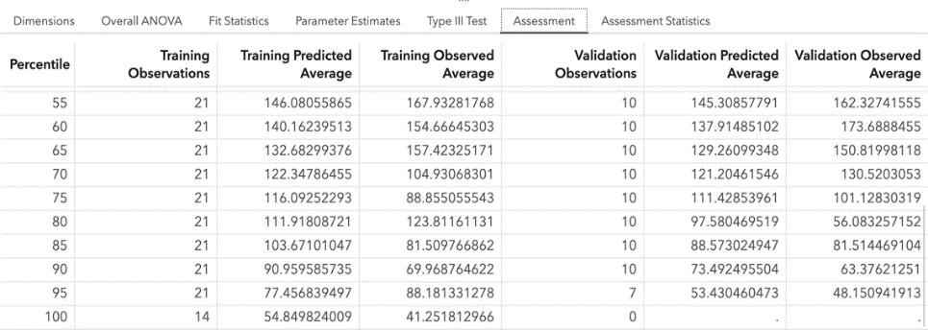
- Click on the Assessment tab
v
v
v
Here you can review the predicted average of an observation against the observed average.
This shows a visual of your predictive model and how well it is performing.

Congratulations, you have created a linear regression in VIYA!

