SAS VIYA Exercise 11

Decision Trees

(7/22/2020)

Sources
Steve Nolan, Ron Freeze, Elizabeth Keiffer, Michael Gibbs, Jorge Moreda
Enterprise Systems, Sam M. Walton College of Business, University of Arkansas, Fayetteville
SAS® Visual Analytics. Release 8.5
SAS® Viya® release V.03.05

Copyright © 2018 For educational uses only - adapted from sources with permission. No part of this publication may be reproduced, stored in a retrieval system, or transmitted, in any form or by any means, electronic, mechanical, photocopying, or otherwise, without the prior written permission from the author/presenter.

Use Case – Decision Tree
Universal Bank is a banking dataset with the goal of identifying if a customer accepted a personal loan from a marketing campaign.

Step 0: Import Data
Following the guide of importing data and import your chosen dataset. See Viya 02a – Importing data for specific steps. In this tutorial the dataset used is UNIVERSALBANK.sashdat.

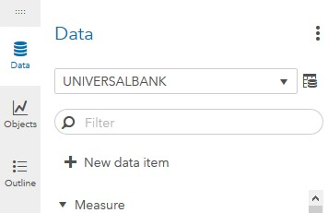
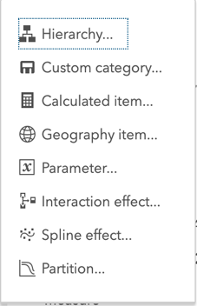
Step 1: Create Partition
Refer back to Viya 07 – Create Partitions or follow the steps below to create a partition.
- Go the Data tab on the left-hand pane and
- Click on + New Data Item
At the bottom of the drop-down menu that will appear,
- Select Partition...
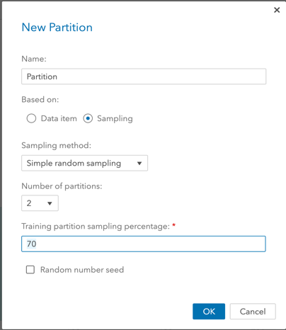
A new window will open where you can give the partition a name and designate how many partitions you wish to have. In our use case, we will have 2, one for the training and one for validation. Also, we want to set our training data to account for 70% of the data:
- Select 2 as Number of partitions
- Write 70 under Training partition sampling percentage
- Click Ok

Step 2: Category Conversion
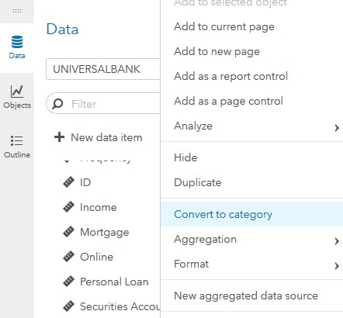
- Click on Data
- Right-click on Personal Loan
- Left-click on Convert to category
Perform the same right-click and left-click actions to similarly convert the following measures into categories: CD Account, CreditCard, Education, Family, Online, and Securities Account.

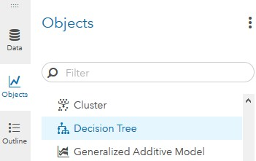
Step 3: Decision Tree Object
- On the left-pane, click Objects
- Scroll down to find Decision Tree
- Drag and drop it to the working space in the middle-pane

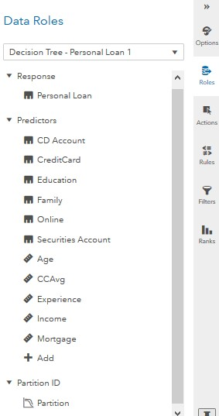
Step 4: Variables
Once you have the decision tree in the workspace, you can designate a response variable (dependent variable) and predictor variables (independent variables). You can also add a partition ID if you have one available.
- On the right-pane, click on Roles (make sure you have clicked on the working space before doing this)
- Click on + Add under Response
- Add Personal Loan (dependent variable)
- Click on + Add under Predictors
- Add CD Account, CreditCard, Education, Family, Online, Securities Account, Age, CCAvg, Experience, Income, Mortgage (independent variables)
- Click on + Add under Partition ID
- Add the partition you created in Step 1

Step 5: Options
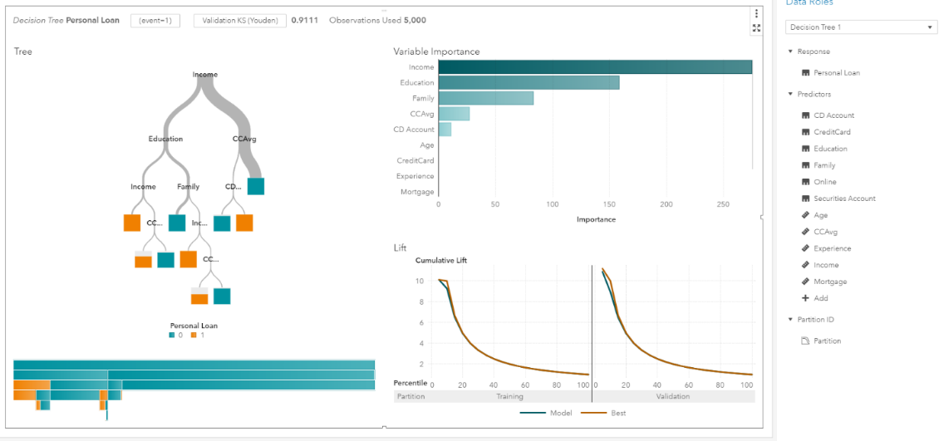
Once you have selected your data, the decision tree will update and display various pieces of information.
Your tree displays the variable importance as well as the various splitting rules.
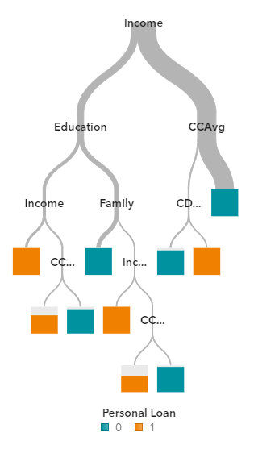
You also have the option to change the desired event as well as the primary evaluation metric.
In this example, we would like to see the misclassification rate.
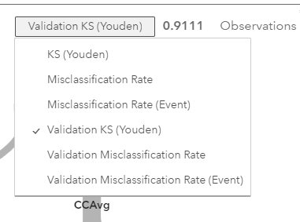
- Click on Validation KS (Youden)
- Click on Validation Misclassification Rate

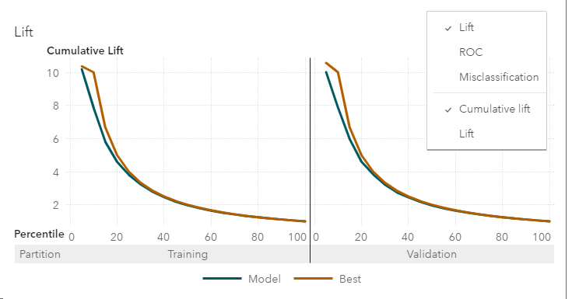
You can change the lift chart into the ROC curve by hovering over the graph and,
- Selecting the three vertical dots in the upper right-hand corner
- Click the ROC option

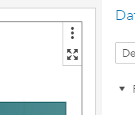
Step 6: Details
- Click on the maximize button in the upper-right corner of your decision tree to get additional details about your decision tree, for example:
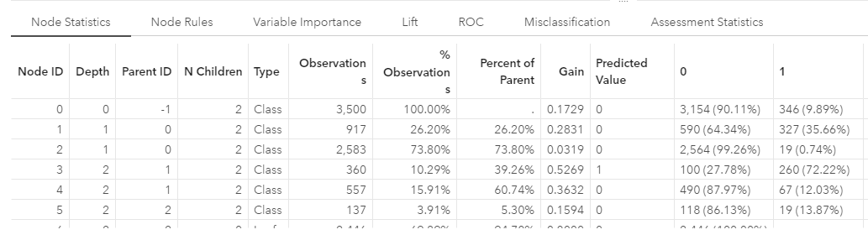
- Click on Node Statistics
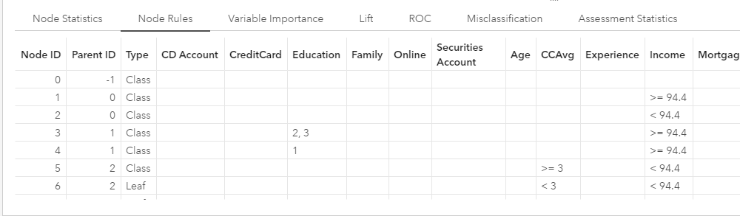
- Click on Node Rules
- Click on Misclassification
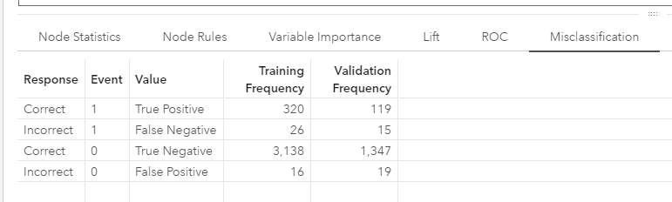
The misclassification tab shows the confusion matrix for your data
From here, you can adjust various options about your decision tree in the options panel on the right side.

Congratulations, you have created a decision tree in VIYA!

