SAS VIYA Exercise 12

Clustering

(1/31/2023)

Sources
Steve Nolan, Ron Freeze, Elizabeth Keiffer, Michael Gibbs, Jorge Moreda, Shubhashree Sahoo
Enterprise Systems, Sam M. Walton College of Business, University of Arkansas, Fayetteville
SAS® Visual Analytics. Release 8.5
SAS® Viya® release V.03.05

Copyright © 2018 For educational uses only - adapted from sources with permission. No part of this publication may be reproduced, stored in a retrieval system, or transmitted, in any form or by any means, electronic, mechanical, photocopying, or otherwise, without the prior written permission from the author/presenter.

Use Case - Clustering
Razorback Stores is a local department store serving a metropolitan area. As a department store, they offer a wide variety of items and services and track sales through a point of sale system. Over the past several months, Razorback Stores performed a marketing campaign designed to promote and incentivize a loyalty program.
Razorback Stores would like to know if there are specific groups of customers that they should incentivize to shop at their stores.

Step 0: Import Data
Following the guide of importing data and import your chosen dataset. See Viya 02a – Importing data for specific steps. In this tutorial we will be using Razorbacks Stores dataset.

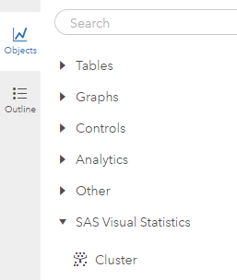
Step 1: Cluster Object
- On the left-pane, click Objects
- Scroll down to find Cluster
Or search for Cluster
- Drag and drop the cluster visual into the center of the screen

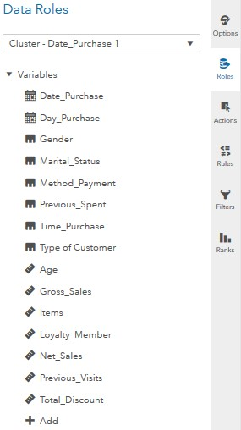
Step 2: Roles
- On the right-pane, click on Roles (make sure you have clicked on the working space before doing this)
A new window named Data Roles will appear for you to add variables.
- Click on + Add under Variables
This is going to be all the variables that you wish to include in your cluster analysis.
- Add Date_Purchase, Day_Purchase, Gender, Marital_Status, Method_Payment, Previous_Spent, Time_Purchase, Type of customer, Age, Gross_Sales, Items, Loyalty_Member, Net_Sales, Previous_Visits, and Total_Discount.

Step 3: Options
Now that you have variables, the cluster analysis will begin to build.
- On the right-pane, click on Options
From here, there are various options that you can manipulate in order to achieve the desired results.

Step 4: Variables
- Click on the maximize button
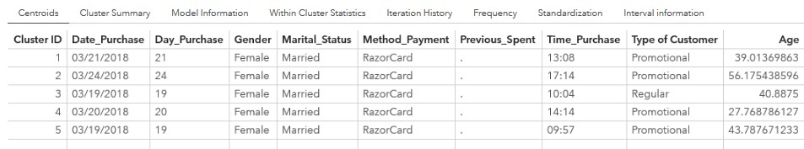
From here, under the centroids tab, you can view variables that make up each cluster.

Congratulations, you have created a clustering analysis in VIYA!

