SAS VIYA Exercise 16

Collaborative Folder

(1/27/2023)

Sources
Ron Freeze, Michael Gibbs, Darby Shade, Shubhashree Sahoo
Enterprise Systems, Sam M. Walton College of Business, University of Arkansas, Fayetteville
SAS® Visual Analytics. Release 8.5
SAS® Viya® release V.03.05

Copyright © 2018 For educational uses only - adapted from sources with permission. No part of this publication may be reproduced, stored in a retrieval system, or transmitted, in any form or by any means, electronic, mechanical, photocopying, or otherwise, without the prior written permission from the author/presenter.

Creating a Collaborative Folder
A collaborative folder is a way to store files that you want other people to see or be able to edit. This is a great option for teams that will primarily be doing work in SAS Viya.
There are two avenues to create a shared folder. Either you can create inside your folder i.e. “My Folder” or inside “SAS” Content folder. The difference is, while you can share your folder in My Folder, everyone does not have the same privileges for that folder. Rather, if you set up a shared folder under SAS Content, everyone can modify access to the folder.

Step 1: Share and Collaborate
- Click on the three parallel lines
- Select Share and Collaborate

Out of the two ways discussed above, we will see an example of creating a collaborative folder in My Folder. You can follow the same steps for SAS Content.
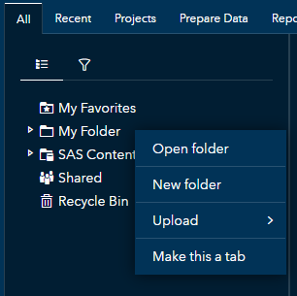

Step 2: Creating a New Folder
- On the left side of the screen, right click on My Folder
- Select New Folder

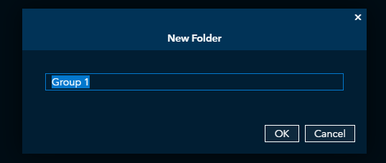
Step 3: Naming Folder
A pop-up box will appear to name your folder.
- After naming, click OK
The folder you created will now be under your “My Folder” tab. This may take a few minutes to show up.

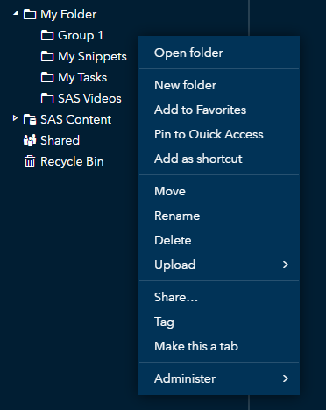
Step 4: Sharing Folder
Now that the folder is created, you need to give your team members access to it.
- Right click the folder you just created
- Click Share

Step 5: Granting access to team members
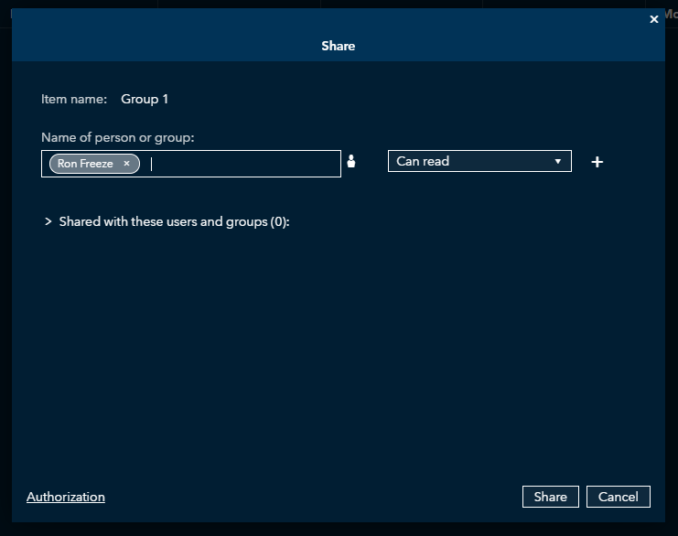
A pop up will appear. This is where you can add all your team members in the left side. And, in the right side, you can change the amount of access your team members have to your files.
If you would like them to only be able to read the files in the folder, then
- Click on the dropdown traingle
- Select Can read
Once all team members are added
- Click Share
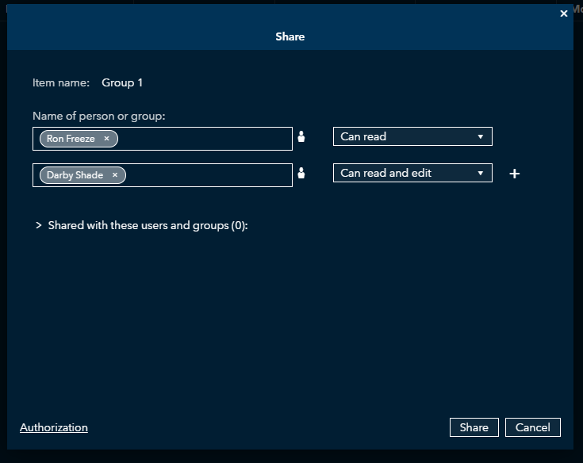
You can give different people different permissions as well.
Example: Dr. Ron Freeze can only see the files. However, Darby can read and edit the files in the folder.

Congratulations, you have created collaborative folder!

