SASVIYA Exercise 03

Running Descriptive Statistics

(1/17/2019)

Sources
Steve Nolan, Ron Freeze, Elizabeth Keiffer, Michael Gibbs
Enterprise Systems, Sam M. Walton College of Business, University of Arkansas, Fayetteville
SAS® VIYA 8.2 Release V03

Copyright © 2018 For educational uses only - adapted from sources with permission. No part of this publication may be reproduced, stored in a retrieval system, or transmitted, in any form or by any means, electronic, mechanical, photocopying, or otherwise, without the prior written permission from the author/presenter.

Use Case – Descriptive Statistics
Razorback Stores is a local department store serving a metropolitan area. As a department store, they offer a wide variety of items and services and track sales through a point of sale system. Over the past several months, Razorback Stores performed a marketing campaign designed to promote and incentivize a loyalty program.
Razorback Stores is interested in learning some general descriptive information about their data.

Step 1: New Report
Once you are logged into the VIYA system, you will click on “New” in the upper left hand side of the screen and choose Report:

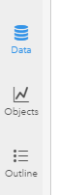

Step 2: Choose Data Source
You will be now be on the report window. From here, you can choose to choose a new data source, create a new object, or view the outline. Click on the data icon:

Step 3: Select Data Set
Once you have clicked on the data, you will be presented with available data to use. Click on your chosen dataset. If no dataset is available, please see our tutorial 02: Importing data:
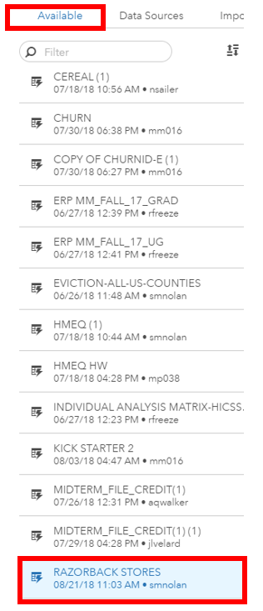

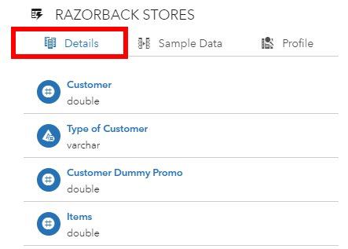
Step 4: List Variables
Once you have chosen a dataset, in our case the razorback stores dataset, the right-hand pane will display a listing of variables from the dataset with corresponding datatypes under the details tab. This will show you the various variables from your dataset and the datatypes that have been denoted by the system:

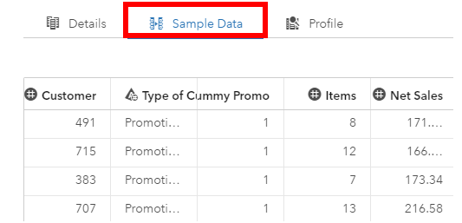
Step 5: View Data
You can also click on the “sample data” tab to get a snapshot of the data:

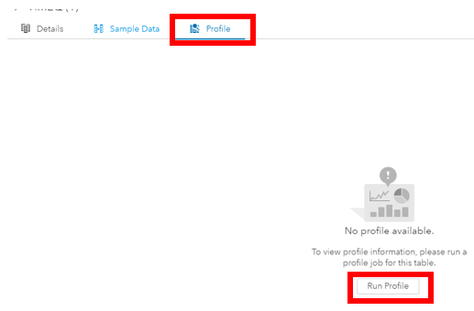

Step 6: Run Profile
Now, click on the Profile tab and run the profile:

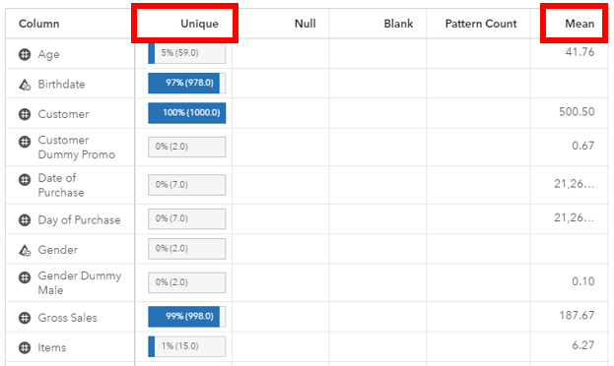
Step 7: View Descriptives
The outputed report will provide you basic descriptive statistics such as mean, median, and mode. It will also give you unique counts and other useful descriptive statistics. Congratulations, you have successfully ran descriptive statistics in VIYA!

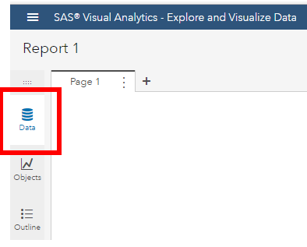

Step 8: Re-run Descriptives
If at any point in time you wish to re-run or forgot to run descriptive statistics, you can always click on the data button located in the visual analytics left hand pane. From here, you will follow this tutorial:

You can also click on the data icon located on the data tab and choose view measure details:
