SASVIYA Exercise 04 – Creating Crosstabulation

(9/24/2018)

Sources
Steve Nolan, Ron Freeze, Elizabeth Keiffer, Michael Gibbs
Enterprise Systems, Sam M. Walton College of Business, University of Arkansas, Fayetteville
SAS® VIYA 8.2 Release V03

Copyright © 2018 For educational uses only - adapted from sources with permission. No part of this publication may be reproduced, stored in a retrieval system, or transmitted, in any form or by any means, electronic, mechanical, photocopying, or otherwise, without the prior written permission from the author/presenter.

Use Case
Razorback Stores is a local department store serving a metropolitan area. As a department store, they offer a wide variety of items and services and track sales through a point of sale system. Over the past several months, Razorback Stores performed a marketing campaign designed to promote and incentivize a loyalty program.
For this exercise, Razorback Stores has asked us to run a crosstab table to look at types of customers by gender. This will help them in their marketing campaigns.
Step 0:
Following the guide of importing data and import your chosen dataset. See Viya 02 – Importing data for specific steps.
Once your data is imported, you will be presented with the working report screen. The screen is broken out into three key areas:
Left pane (Red) – This is where you can manipulate your data elements, choose objects to work with, and see an outline of the work you are creating.
Middle pane (Blue) – This is the workspace. This is where you drag objects to and begin to build your visualizations and models
Right pane (Green) – this is where you set various roles (for data mining) and manipulate and enhance chart features (options). You can also filter pieces of data as well.

Step 1:
For crosstab, click on the objects section of the left pane. The crosstab is under the tables section of the object. Click and drag this to your workspace
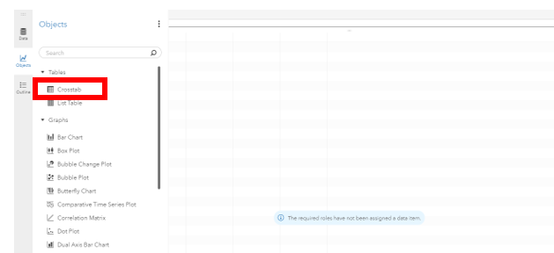
Step 2:
From here, click on the roles area on the right-hand pane to begin filling in the crosstab. In our use case, we are going to use gender and type of customer:
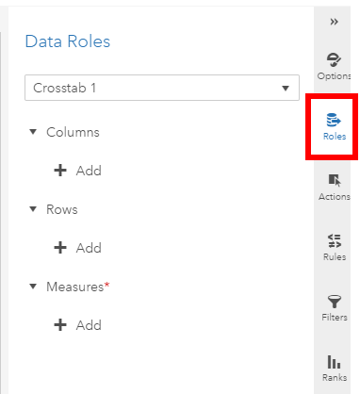
Once you begin adding data for your rows and columns, the crosstab will begin to fill based on the data that you have imported. For the example below, we added type of customer and gender.
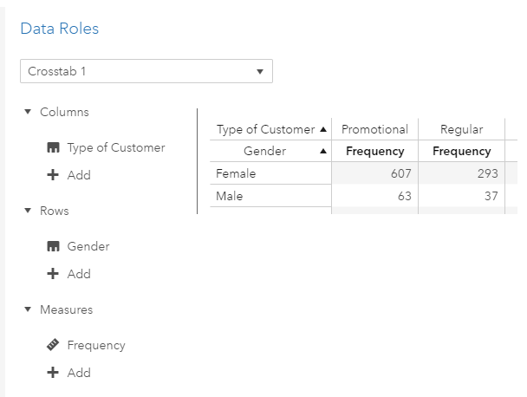

Step 3:
Once you have your data in place and roles assigned, You can adjust the various aspects of your crosstab through the options pane. As an example, you can add a total column by clicking on the “Totals and Subtotals” from down and checking the totals box.
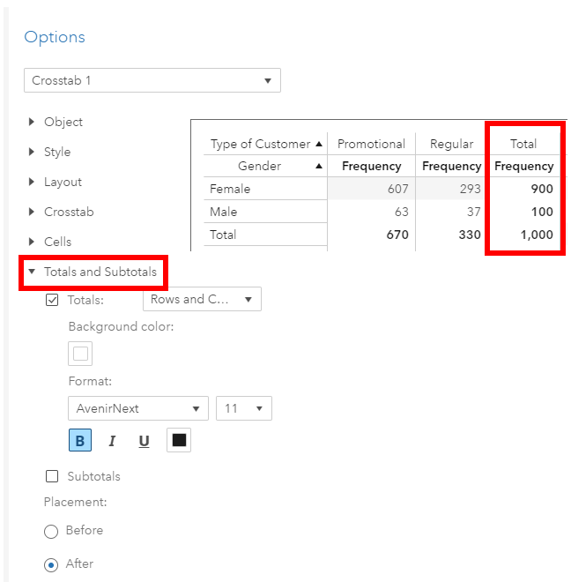

Congratulations, you have created a crosstab in VIYA!

