SASVIYA Exercise 05 – Creating a histogram

(1/19/2019)

Sources
Steve Nolan, Ron Freeze, Elizabeth Keiffer, Michael Gibbs
Enterprise Systems, Sam M. Walton College of Business, University of Arkansas, Fayetteville
SAS® VIYA 8.2 Release V03

Copyright © 2018 For educational uses only - adapted from sources with permission. No part of this publication may be reproduced, stored in a retrieval system, or transmitted, in any form or by any means, electronic, mechanical, photocopying, or otherwise, without the prior written permission from the author/presenter.

Use Case
Razorback Stores is a local department store serving a metropolitan area. As a department store, they offer a wide variety of items and services and track sales through a point of sale system. Over the past several months, Razorback Stores performed a marketing campaign designed to promote and incentivize a loyalty program.
For this exercise, Razorback Stores is interested to see what the distribution of their net sales are. This will provide a visualization for management to quickly see how much customers are purchasing that they can use to help make business decisions.
Step 1: Following the guide of importing data and import your chosen dataset. See Viya 02 – Importing data for specific steps.
Step 2: Once your data is imported, you will be presented with the working report screen. The screen is broken out into three key areas:
Left pane (Red) – This is where you can manipulate your data elements, choose objects to work with, and see an outline of the work you are creating.
Middle pane (Blue) – This is a blank workspace. This is where you drag objects to and begin to build your visualizations and models.
Right pane (Green) – This is where you set various roles (for data mining) and manipulate and enhance chart features (options). You can also filter subsets of data as well.

Step 3: Under the objects panel on the left-hand side, you can select histogram located under the graphs area of the objects. You can click and drag this to your workspace in the middle:
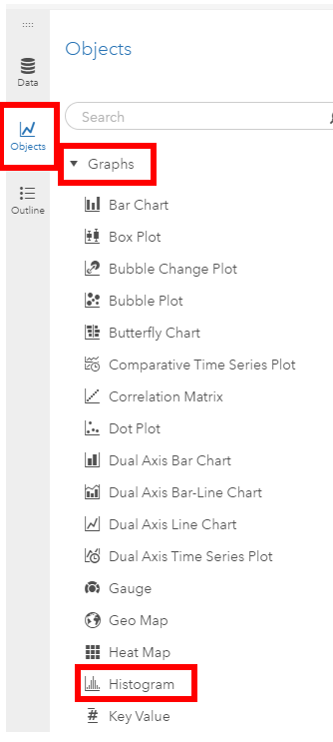

Step 4: Once the histogram is in the workspace, you can set a role of net sales for this use case by selecting roles and then net sales as the measure. The chart will update automatically with the data:

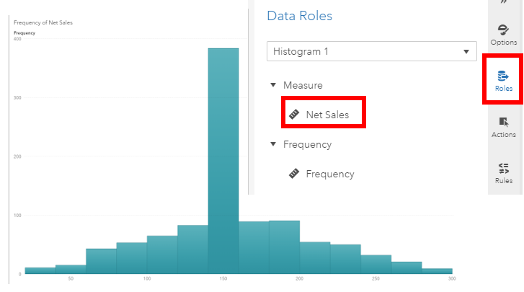
Step 5: From here, you can go to the options menu and manipulate your visualization to provide even more insight, such as a better-informed title, color, and fixed bin sizes. Congratulations, you have created a histogram in VIYA!

