SASVIYA Exercise 06

Filtering Data in a Visual

(1/28/2019)

Sources
Steve Nolan, Ron Freeze, Elizabeth Keiffer, Michael Gibbs
Enterprise Systems, Sam M. Walton College of Business, University of Arkansas, Fayetteville
SAS® VIYA 8.2 Release V03

Copyright © 2018 For educational uses only - adapted from sources with permission. No part of this publication may be reproduced, stored in a retrieval system, or transmitted, in any form or by any means, electronic, mechanical, photocopying, or otherwise, without the prior written permission from the author/presenter.

Use Case – Filtering Data
Razorback Stores is a local department store serving a metropolitan area. As a department store, they offer a wide variety of items and services and track sales through a point of sale system. Over the past several months, Razorback Stores performed a marketing campaign designed to promote and incentivize a loyalty program.
For this exercise, Razorback Stores would like to know what the net sales are for only their promotional customers. They are hoping to do this using filtering.

Step 1: Getting Data
Following the guide of importing data and import your chosen dataset (Razorback Stores).
See Viya 02 – Importing Data for specific steps.

Step 2: Navigation
Once your data is imported, you will be presented with the working report screen. The screen is broken out into three key areas:
Left pane (Red) – This is where you can manipulate your data elements, choose objects to work with, and see an outline of the work you are creating.
Middle pane (Blue) – This is the workspace. This is where you drag objects to and begin to build your visualizations and models
Right pane (Green) – This is where you set various roles (for data mining) and manipulate and enhance chart features (options). You can also filter pieces of data as well.

Step 3: Create Histogram
Drag net sales over into the objects area. This will automatically create a histogram:
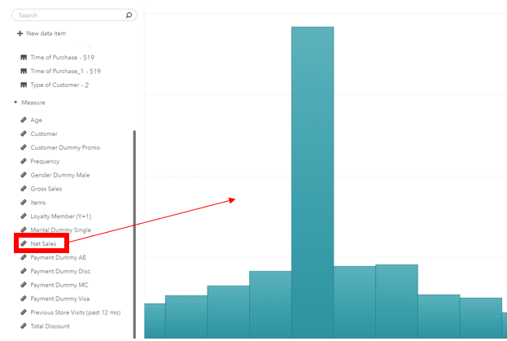

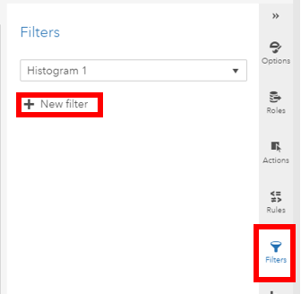
Step 4: Select Filter
Now that we have a visualization of all net sales, we need to place a filter to show only the net sales from promotional customers. To do this, ensure that you have the graph selected. Choose filters on the right-hand bar. Select new filter:

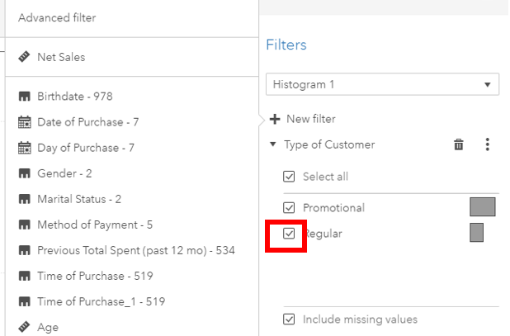
Step 5: Create Filter
Now we can choose “type of customer” as our category that we wish to filter. Once selected, we have options to filter out various items. We are going to uncheck regular customers so that we only have promotional customers in our chart.

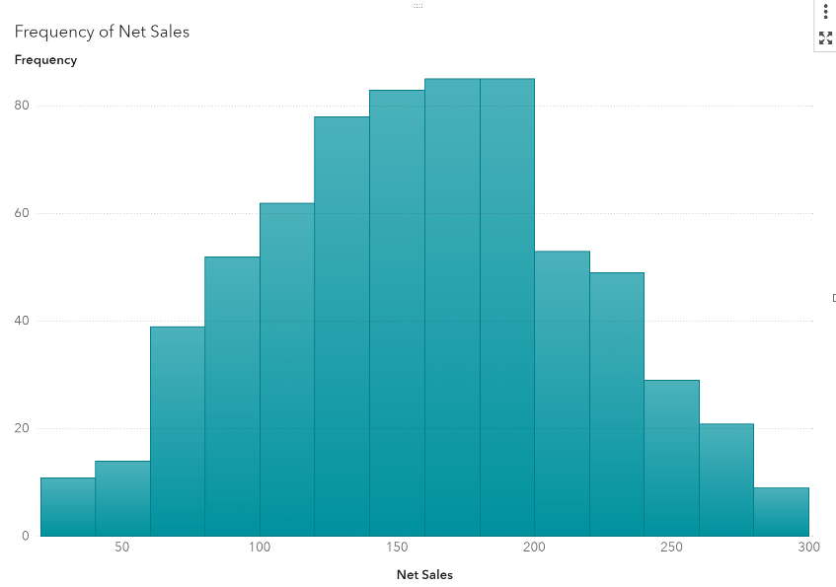
Step 6: Promotional Customer Histogram
We now have a filter in place! That provides a visual on the # of Promotional Customers.

